IPP Get-User-Printer-Attributes Operation
(USEROP)

Status: Initial

Abstract: This document proposes a new Get-User-Printer-Attributes IPP operation that allows an IPP Client to retrieve the Printer's settings that are available to the Client's current User.
This document is a White Paper. For a definition of a "White Paper", see: http://ftp.pwg.org/pub/pwg/general/pwg-process30.pdf
This document is available electronically at:
https://ftp.pwg.org/pub/pwg/ipp/whitepaper/tb-userop-20170404.odt
https://ftp.pwg.org/pub/pwg/ipp/whitepaper/tb-userop-20170404.pdf

Copyright © 2017 The Printer Working Group. All rights reserved.
Title: IPP Get-User-Printer-Attributes Operation (USEROP)
The material contained herein is not a license, either expressed or implied, to any IPR owned or controlled by any of the authors or developers of this material or the Printer Working Group. The material contained herein is provided on an “AS IS” basis and to the maximum extent permitted by applicable law, this material is provided AS IS AND WITH ALL FAULTS, and the authors and developers of this material and the Printer Working Group and its members hereby disclaim all warranties and conditions, either expressed, implied or statutory, including, but not limited to, any (if any) implied warranties that the use of the information herein will not infringe any rights or any implied warranties of merchantability or fitness for a particular purpose.

Table of Contents
1 Introduction 4
2 Terminology 4
2.1 Protocol Roles Terminology 4
2.2 Other Terms Used in This Document 4
2.3 Acronyms and Organizations 4
3 Rationale for IPP Get-User-Printer-Attributes Operation 5
3.1 Use Cases 5
3.1.1 Print Policy For User Limits Print Capabilities 5
3.1.2 Print Policy For User Expands Print Capabilities 7
3.1.3 Print Policy Matching Job Accounting Attributes 9
3.1.4 User Print Policy from Separate Print Policy Service 10
3.1.5 User Not Listed In Print Policy or Legacy Client Allowed To Print 12
3.1.6 User Not Listed in Print Policy Denied Ability to Print 14
3.2 Exceptions 16
3.3 Out of Scope 16
3.4 Design Requirements 16
4 Technical Solutions/Approaches 16
5 IPP Operations 17
5.1 Get-User-Printer-Attributes Operation 17
6 IPP Attributes 17
6.1 user-options-token (integer) 17
7 Internationalization Considerations 17
8 Security Considerations 17
9 References 17
10 Authors' Addresses 18
11 Change History 20
11.1 February 1, 2017 20
11.2 January 30, 2017 20

List of Figures
Figure 3.1 : Use Case 3.1.1 Sequence Diagram 6
Figure 3.2 : Use Case 3.1.2 Sequence Diagram 8
Figure 3.3 : Use Case 3.1.3 Sequence Diagram 9
Figure 3.4 : Use Case 3.1.4 Sequence Diagram 11
Figure 3.5 : Use Case 3.1.5 Sequence Diagram 13
Figure 3.6 : Use Case 3.1.6 Sequence Diagram 15

List of Tables

- Introduction
This document proposes a new Get-User-Printer-Attributes IPP operation that allows an IPP Client to retrieve the Printer's settings that are available to the Client's current User. It is semantically identical to the existing Get-Printer-Attributes IPP operation [RFC8011], with the key difference that the Printer will always respond with an authentication challenge. Once the Client has authenticated using the User's credentials, the Printer will respond with the settings for that user.
- Terminology
  - Protocol Roles Terminology
This document defines the following protocol roles in order to specify unambiguous conformance requirements:
Client: Initiator of outgoing IPP session requests and sender of outgoing IPP operation requests (Hypertext Transfer Protocol -- HTTP/1.1 [RFC7230] User Agent).
Printer: Listener for incoming IPP session requests and receiver of incoming IPP operation requests (Hypertext Transfer Protocol -- HTTP/1.1 [RFC7230] Server) that represents one or more Physical Devices or a Logical Device.
  - Other Terms Used in This Document
User: A person or automata using a Client to communicate with a Printer.
  - Acronyms and Organizations
IANA: Internet Assigned Numbers Authority, http://www.iana.org/
IETF: Internet Engineering Task Force, http://www.ietf.org/
ISO: International Organization for Standardization, http://www.iso.org/
PWG: Printer Working Group, http://www.pwg.org/

- Rationale for IPP Get-User-Printer-Attributes Operation
While there are many solutions, both standard and non-standard, for creating print policies that provide a way to specify allowed or disallowed features according to individual users, systems, applications and so forth, there is no established method that is in-band of IPP. Having a print policy method using IPP would better support systems such as IPP Everywhere [PWG5100.14] in print infrastructures provided by public print providers, enterprises or educational environments such as university settings.
Use Cases
The need for solutions to these use cases emerged during the process of writing the IPP Implementor's Guide v2 [PWG5100.19].
    - Print Policy For User Limits Print Capabilities
Sue is a university graduate student, and wants to print her report on her department's workgroup printer. She wants to print in color because the report contains color graphs. However, she has abused her printing privileges, so her department head has instructed the network administrator to limit her ability to print in color. Her account is added to a “print feature black list” that will restrict access to some printing features for her account.
Sue opens the document on her laptop, chooses to print, and selects the desired Printer, which is in the department office common room. The Printer authenticates the laptop using Sue's credentials, and then provides the laptop with the print choices available for Sue's account, which are more limited than what others are allowed. Sue decides whether to print it in black-and-white anyway or to print from one of the campus print centers, where she can pay to print in color.
Bob is an associate professor in the same department as Sue. His account is not included in the “feature black list”, so he has no printing limitations. He opens a document on his tablet, taps to print, and selects the department's workgroup printer. His tablet presents print options including printing in color. Bob chooses color and prints his document, which prints in color as he expects.
Figure 3.1 illustrates this use case with a sequence diagram.
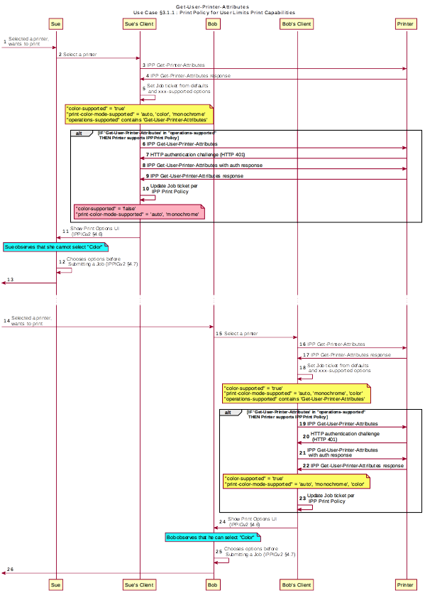Figure 3.1 : Use Case 3.1.1 Sequence Diagram
    - Print Policy For User Expands Print Capabilities
Jonah is at his office and wants to print a 32 page draft specification document to review it in hardcopy form. His office user account has not been granted permission to print in color by his office network administrator, who has also set the default configuration for the ability to print in color to “off” (“false”). Jonah opens the document on his laptop, selects the printer he wishes to use, and the laptop presents the printer features available to him as per his user account's print policy, which doesn't include an option to print in color. He submits the print job to the Printer, which prints it in monochrome. Jonah picks up his hardcopy and goes to the cafeteria with a pen and highlighter to read it over a cup of tea.
Duncan is also at the office and needs to print a 5 page report that contains color diagrams before his next meeting. His office user account has been granted permission by his office network administrator to print in color. Duncan opens the document on his tablet, taps to print, and selects the desired Printer, which is the same printer that Jonah used. The tablet fetches the Printer's default capabilities, which are restricted, and then authenticates using Duncan's user account, which has a print policy that provides a broader set of print options than the defaults, including the option to print in color or monochrome. He prints the document using the color option, retrieves the hardcopy from the printer, and then goes on to his meeting.
Figure 3.2 illustrates this use case with a sequence diagram.
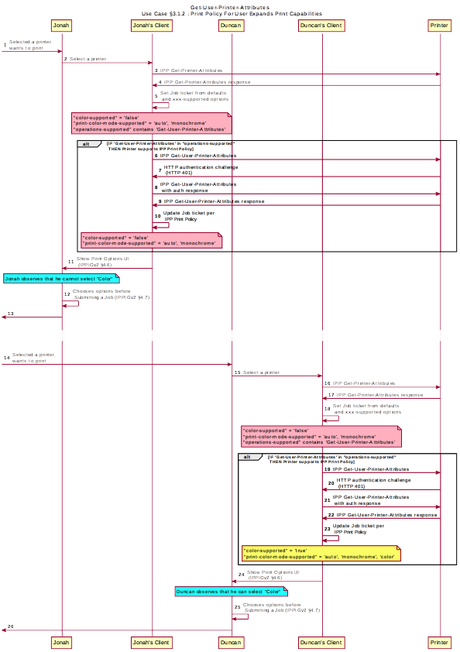Figure 3.2 : Use Case 3.1.2 Sequence Diagram
    - Print Policy Matching Job Accounting Attributes
Duncan receives some pictures via MMS text message from his wife, with the message that she would like him to print them on the office printer. He opens the pictures in his photo app, taps to print, and selects the same printer he was using earlier. The network administrator has restricted the Printer from processing print jobs that were created using the photo app. Duncan is presented only with the option to print in monochrome. He abandons printing the photos.
Figure 3.3 illustrates this use case with a sequence diagram.
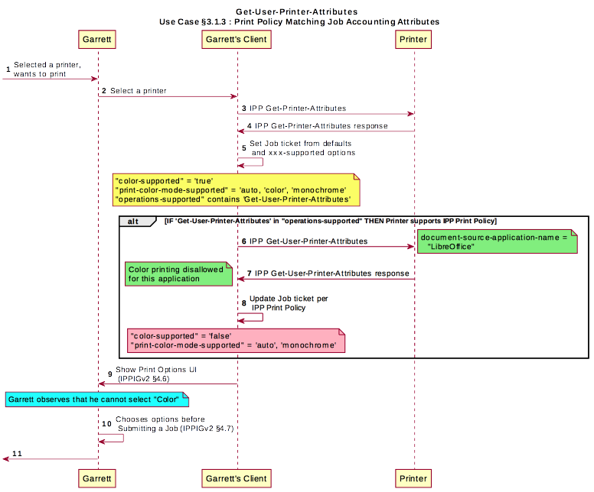Figure 3.3 : Use Case 3.1.3 Sequence Diagram

    - User Print Policy from Separate Print Policy Service
Helen is a network administrator who is implementing IPP Print Policy. In her environment, users print to many isolated printers directly, rather than printing through queues hosted on a central print server. She wishes to centralize the print policy management in a separate policy server rather than needing to push the configurations out to each of the printers or requiring that the printers check with the policy server behind the scenes when a Client requests the IPP Print Policy.
Helen configures the printers to refer the Client to a separate IPP Print Policy service hosted on a separate system. Clients requesting the policy from a Printer will be redirected to that policy service, which will also provide tokens to prove to the Printer that they have acquired a legitimate print policy.
Garrett is at his office, and wishes to print a 10 page report. Garrett opens the document on his laptop, chooses to print, and selects the desired Printer.
When the laptop attempts to retrieve the print policy from the Printer, the Printer redirects the laptop to a separate “Print Policy Service”. The laptop authenticates with the Print Policy Service using Garrett's credentials, and then provides the laptop with the print policy for Garrett's account, which includes the option to print in color or monochrome.
Garrett makes his selections, and then submits the Job to the Printer. The Job information from the laptop includes a unique print policy token that the Printer uses to validate that the choices conform to a legitimate print policy.
Figure 3.4 illustrates this use case with a sequence diagram.
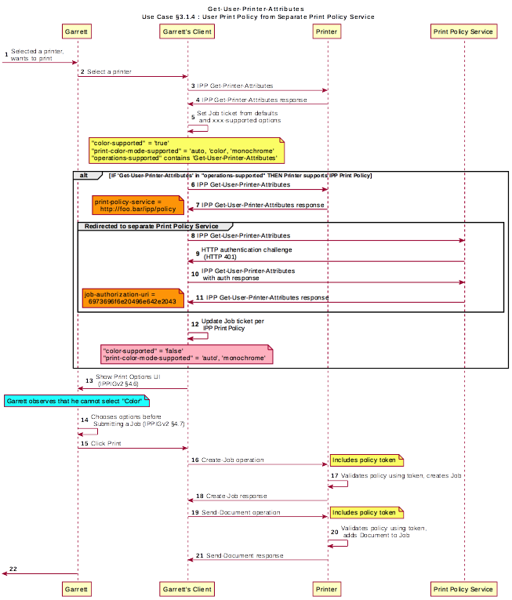Figure 3.4 : Use Case 3.1.4 Sequence Diagram
    - User Not Listed In Print Policy or Legacy Client Allowed To Print
In this use case, a user who is not named in the print policy system is still able to print using existing conventional IPP print protocol use. The Client may implement support for IPP Print Policy but authentication may fail, or the Client may have not implemented support for IPP Print Policy.
Sue is a university graduate student, and wants to print her report on her department's workgroup printer. She wants to print in color because the report contains color graphs. However, she has abused her printing privileges, so her department head has instructed the network administrator to limit her ability to print in color. Her account is added to a “print feature black list” that will restrict access to some printing features for her account.
Hermann is a visiting professor in Sue's university department. He wishes to print a slide set in color. Since he doesn't have a local account, he has no credentials with which to authenticate with the print policy system. Hermann opens the slide set document on his laptop, chooses to print, and selects the desired Printer. His laptop does not authenticate his user account with the Printer. Hermann's laptop gets a listing of all the possible print capabilities provided by that Printer. Hermann chooses his print options, and sends the job to the Printer. The job prints successfully according to Hermann's intent.
Figure 3.5 illustrates this use case with a sequence diagram.
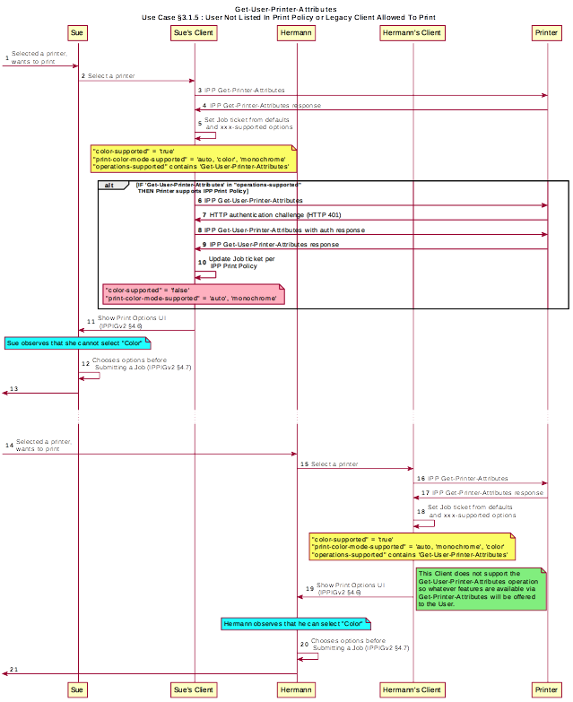Figure 3.5 : Use Case 3.1.5 Sequence Diagram
User Not Listed in Print Policy Denied Ability to Print
In this use case, a user who is not named in the print policy system is denied the ability to print using existing conventional IPP print protocol use. The Client may implement support for IPP Print Policy but authentication may fail, or the Client may have not implemented support for IPP Print Policy.
Ed is visiting Duncan's office and needs to print a 3 page document. Ed is not listed as a user in the print policy. Ed opens the document on his laptop, clicks to print, and selects the Printer recommended by Duncan. The laptop is challenged to authenticate but has no valid credentials. The Printer indicates to Ed via his laptop that he has no rights to print from this Printer.
Figure 3.6 illustrates this use case with a sequence diagram.
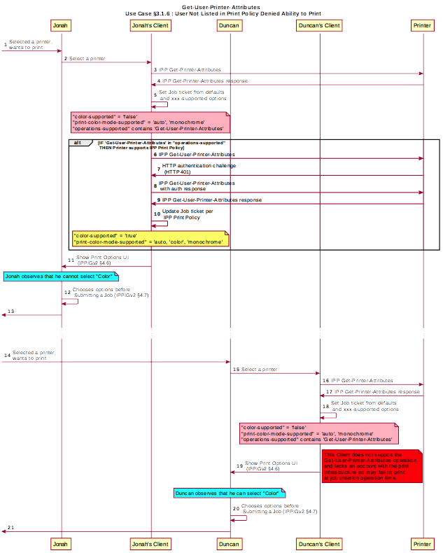Figure 3.6 : Use Case 3.1.6 Sequence Diagram
  - Exceptions
There are no exceptions to the use cases in section .
  - Out of Scope
The following are considered out of scope for this document:
- Definition of print policies.
- Definition of non-IPP protocols that can provide similar functionality.
  - Design Requirements
The design requirements for this document are:
- Identify an appropriate set of IPP operations that allow a Client to acquire the set of print features available from a particular Printer for a particular User.
  - Scope of differences
    - Average Client has more capabilities than a specific Client
    - Average Client has fewer capabilities than a specific Client
  - Client that is unaware of this new system can still be a legitimate actor in the print policy system.
- Identify an appropriate set of IPP operations and attributes that allow a Printer to refer a Client to a trusted IPP Print Policy Service, such that the Client can assert that the options it provides with a submitted job do comply with a policy originating from that trusted policy server.
- Register all attributes and operations with IANA.
The design recommendations for this document are:
- Recommend suitable authentication methods and guidelines that could help the Client to provide a high quality user experience.
- Technical Solutions/Approaches
The existing Get-Printer-Attributes operation itself has the correct semantics, but the expectation of all legacy Clients is that the Printer will not respond to a Get-Printer-Attributes operation with an HTTP challenge. Adding additional operation attributes to the Get-Printer-Attributes operation to allow that operation to be used for this purpose was similarly deemed inappropriate. As such, a new operation was deemed necessary.
- IPP Operations
  - Get-User-Printer-Attributes Operation
This REQUIRED operation allows a Client to request the values of the attributes of a Printer. The semantics of this operation are identical to the semantics for the Get-Printer-Attributes operation, with the difference that the Client MUST be prepared to respond to an HTTP authentication challenge. The Client detects whether the Printer supports this operation by examining the “operations-supported” attribute [RFC8011].
If the Client initiates the Get-User-Printer-Attributes operation over a non-TLS connection, the Client MUST be prepared to receive an HTTP 426 response to upgrade the connection to TLS [RFC2817].
- IPP Attributes
  - user-options-token (integer)
The “user-options-token” attribute is used in two contexts. In the first context, a Printer includes this attribute in a Get-User-Printer-Attributes operation response, to identify a session where a Client has requested print options for a particular user. In the second context, a Client includes it in a Validate-Job operation request and/or in a Job Creation operation request, to prove that these options were authorized by an earlier Get-User-Printer-Attributes operation.
- Internationalization Considerations
For interoperability and basic support for multiple languages, implementations use the “Universal Character Set (UCS) Transformation Format -- 8 bit (UTF-8)” [RFC3629] encoding of Unicode [UNICODE] [ISO10646] and the Unicode Format for Network Interchange [RFC5198].
- Security Considerations
The security considerations for the Get-User-Printer-Attributes operation are identical to those listed for IPP/1.1 [RFC8011] and IPP/2.0 [PWG5100.12].
- References
[ISO10646] "Information technology -- Universal Coded Character Set (UCS)", ISO/IEC 10646:2011
[PWG5100.12] R. Bergman, H. Lewis, I. McDonald, M. Sweet, "IPP/2.0 Second Edition", PWG 5100.12-2011, February 2011, http://ftp.pwg.org/pub/pwg/candidates/cs-ipp20-20110214-5100.12.pdf
[PWG5100.14] M. Sweet, I. McDonald, A. Mitchell, J. Hutchings, "IPP Everywhere", 5100.14-2013, January 2013, http://ftp.pwg.org/pub/pwg/candidates/cs-ippeve10-20130128-5100.14.pdf
[PWG5100.19] S. Kennedy, "IPP Implementor's Guide v2.0", PWG 5100.19-2015, August 2015, http://ftp.pwg.org/pub/pwg/candidates/cs-ippig20-20150821-5100.19.pdf
[RFC2817] R. Khare, S. Lawrence, “Upgrading to TLS Within HTTP/1.1”, RFC 2817, May 2000, https://www.ietf.org/rfc/rfc2817.txt
[RFC3629] F. Yergeau, “UTF-8, a transformation format of ISO 10646”, RFC 3629, November 2003, https://www.ietf.org/rfc/rfc3629.txt
[RFC5198] J. Klensin, M. Padlipsky, “Unicode Format for Network Interchange”, RFC 5198, March 2008, https://www.ietf.org/rfc/rfc5198.txt
[RFC7230] R. Fielding, J. Reschke, "Hypertext Transfer Protocol (HTTP/1.1): Message Syntax and Routing", RFC 7230, June 2014, http://www.ietf.org/rfc/rfc7230.txt
[RFC8010] M. Sweet, I. McDonald, “Internet Printing Protocol/1.1: Encoding and Transport”, RFC 8010, January 2017, https://www.ietf.org/rfc/rfc8010.txt
[RFC8011] M. Sweet, I. McDonald, “Internet Printing Protocol/1.1: Model and Semantics”, RFC 8011, January 2017, https://www.ietf.org/rfc/rfc8011.txt
[UNICODE] The Unicode Consortium, “The Unicode Standard, Version 6.2.0”, ISBN 978-1-936213-07-8, September 2012, http://www.unicode.org/versions/Unicode6.2.0/
- Authors' Addresses
Primary authors:
Smith Kennedy
11311 Chinden Blvd. MS 506
Boise, ID 83714
smith.kennedy@hp.com
The authors would also like to thank the following individuals for their contributions to this standard:
Turanga Leela - Planet Express
Zapp Brannigan - Democratic Order of Planets
- Change History
  - April 4, 2017
Updated with new and elaborated use cases and accompanying sequence diagrams to better articulate the breadth of the problem space.
  - February 1, 2017
Editorial changes.
  - January 30, 2017
Initial draft.

