Cloud Printing Requirements and Model

Status: Interim

Abstract: This document contains specifications to support Cloud based printing using the PWG semantic model.

This document is a PWG Working Draft. For a definition of a "PWG Working Draft", see: ftp://ftp.pwg.org/pub/pwg/general/pwg-process30.pdf
This document is available electronically at:
ftp://ftp.pwg.org/pub/pwg/cloud/wd-cloudmodel10-20120808.docx
ftp://ftp.pwg.org/pub/pwg/cloud/wd-cloudmodel10-20120808.pdf
- Requirements
  - Rationale for Cloud Print Model and Requirements
Cloud-based applications and solutions are increasingly common, and Cloud-based printing, scanning, and facsimile (collectively called "Cloud Imaging") are emerging in several different forms. Adopting standard protocols and schemas now will help interoperability, speed adoption, and address privacy, security, and legal issues involved in Cloud Imaging.
Cloud printing has many potential implementation methods to comply with the need for security, and that the components can be located or contained within different locations.
The cloud can be a private cloud, a public cloud, or some hybrid federation of the two. The actual print device may be located at the users location, part of the service provider, at a remote user’s location, or remotely as a pay to print destination.
  - Consideration of Print Use Cases
Each of the Cloud Printing use cases in this section require establishing a connection to a Cloud-based entity (typically involving authentication and authorization of the prospective Job Originator ), although it is possible that this connection may not have been made specifically for printing. A printing process is initiated by selecting a Print Device (section 2.2) on the basis of the Device status, capabilities and status information. Each use case generally ends with the Job Originator or someone delegated by the Job Originator collecting the printout from the Device.
In many use cases, the interaction between the Job Originator and the Cloud (front end) can be considered independently from the interaction between the Cloud and the Device (back end). In such use cases, front end interactions can mate with different back end interactions. To simplify use case consideration, use cases are identified as “Front End’, “Back End”, both (if the example encompasses independent front and back end relationships) or, if the use case is such that front and back ends must be considered together, as “End-to-End” relationships.
Further, although identified use cases assume a problem-free sequence in implementation, problems do arise and the requirements must address them. Rather than complicate each use case discussion with consideration of the various problems, a separate section identifies “exceptions”, essentially problems that may occur in addressing different use cases.
    - Common Preconditions
For all of the following use cases:
- The Device must be Visible to the Client to be selected, either directly or through an intermediate Service.
- The document to be printed must be able to become Visible to the Device.
- The document to be printed must be in a format suitable for the Device; or the Client or Service must be able to convert the document into a suitable format.
    - Specific Use Cases
      - Print a Document
Jane has a mobile device connected to the Wi-Fi network in her business. She wishes to print a document prior to a meeting and either has it in or can access it from her mobile device. Jane initiates a print request from the mobile device, having chosen a Printer on the basis of its capabilities, availability and cost to use. She submits the document to be printed from her mobile device.
This is a “front-end” scenario reflecting traditional printing, whereby the document content to be printed is included in the print request to the Print Service, except that it is now being sent through the Cloud, as represented in Figure 1a.
      - Print a Document by Reference
Joan has a mobile device connected to the Wi-Fi network in her business. She is viewing a document on a server and would like to print it. She initiates a print request from the mobile device and submits the print job request containing a link to the desired document.
This is a “front-end” scenario of what is traditionally called Print by Reference, as represented in Figure 1b. Back-end variations have the Cloud-based service pulling the referenced document content (Figure 2a), or the Printer Device pulling the referenced document content (Figure 2b) from the location identified by the User.
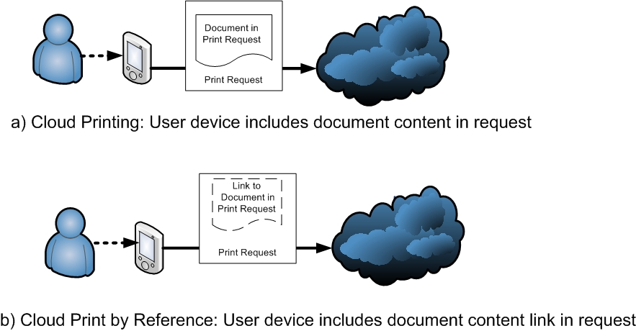
Figure 1 Front Ends for Printing and for Printing by Reference

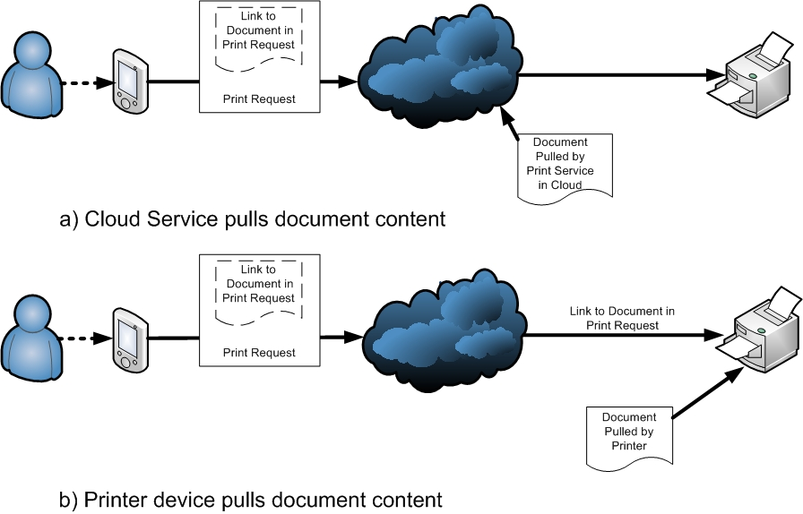
Figure 2 Two Back End Use Cases for Cloud Printing by Reference

      - Print a Photo
Jack is viewing a photo and would like to print the photo on the largest borderless photographic media available on an accessible printer Device. He selects a Printer with the necessary capabilities, selects values of job ticket options such as print quality and media size, and submits the photo for printing. This is a front end use case.
      - Secure Print on Custom Media
The treasurer of a small company that is holding a meeting at a resort needs to print 20 checks for company personnel. He uses a Cloud-based accounting program to enter the hours worked, bonuses, reimbursable expenses, and so forth. The program provides paginated, formatted content appropriate for printing on the company’s check blanks. Using a Cloud Printing capability, the treasurer prints the checks on a printer at the resort using the check blanks he brought to the meeting.
Submitting a print job from a Cloud based application is a front-end use case. Printing to customer supplied media is a back-end use case.
      - Sending Out Photographs for Printing at Remote Location
Janet has taken pictures of her children on her smart phone. She wants prints to be made by a photo printing service at a drug store local to the children’s grandmother. Janet selects a close-by target printer based on Cloud printing service information regarding the geographic location of the printer. She configures the print job request, providing a payment method, identifying the grandmother as the person to pick up the prints and asking to be notified when the photos are ready. Once the Cloud printing service determines that the settings are valid and charges are paid, the job is sent to the targeted device and printed. Janet is notified that the job is ready and lets the grandmother know. An attendant at the drug store receives the print job at the targeted printer and gives it to Grandma Jones after she has identified herself. This is an end-to-end use case.
      - Print and Select at Device
Joe wishes to print out his job at any one of several Devices that are part of geographically distributed network of Printer Devices. He connects to an appropriate Cloud Service, specifies the processing intent, determines a PIN for the Job and submits and confirms the print request. The Service validates the Job Ticket and document data and then holds the document until released by the Joe at the Device he eventually selects. He releases the job for printing at a specific Device by providing the PIN and possibly other unique identification/authorization information such as a username and password or ID card. This is an end-to-end use case.
      - Print to a Service
John is flying to New York for a presentation and doesn't want to carry the printed copies of his presentation material. When he arrives in New York, he goes online with his mobile phone, selects a local print provider with which his company has a relationship and submits his document for printing. He specifies that he needs 10 color copies, printed duplex and stapled on the left side. He also specifies the covers to be 80lb. stock, and the internal pages to be 24lb. stock. John arrives at the provider facility and picks up the printed presentations, paying with his corporate credit card. The significant aspect of this use case is the back-end handling.
      - Job Cancel
At some time after a print job has been submitted to a Cloud Service, the User decides to cancel the job. This might be because of a change of mind or because the User was informed of some issue with the handling of the job. This is a front-end use case. How it is handled depends on many things, such as how far processing of the print request has progressed, the specific nature of the Cloud entities involved in the request, what payment arrangements have been made, whether the User was informed of some job handling difficulty, etc.
    - Exceptions
Exceptions are events or circumstances that may occur during the satisfaction of use cases, that interfere with the normal progress of the print submission process.
      - Printer No Longer Visible after Selection
After selecting a Printer, the Printer is no longer Visible to the Job Originator.
      - Job Originator Not Authorized
After the print request is submitted, the Cloud responds that the Job Originator is not authorized to print the document as requested. The reason for the authorization failure may involve general access to the Printer or disallowed Job Ticket values; for example, site Policy may disallow a particular User from printing in color, printing on certain media, or printing more than a given number of pages within a period.
      - Not Accepting Jobs
After accepting the print request, the Job Originator discovers that the Printer is no longer accepting jobs.
      - Printer Capabilities Change
After the Job Originator has submitted the print request, the Printer rejects the request because an element in the job ticket requires a capability that is no longer supported by the specific Printer.
      - Job or Document Processing Failures
A job processing failure occurs while processing a job. Processing failures include out-of-memory, missing resource, and other conditions that prevent a particular Job or document from printing.
      - Printer Warning or Fault
While processing a Job, the Cloud reports a printer warning or fault. Printer faults include "out of paper" and other conditions that stop the processing of Jobs.
      - Printer Removed from Cloud Service
After the Job Originator has submitted the print request, the Cloud elements recognize that the Printer has been removed from service.
  - Out of Scope
From the Charter of the Cloud Imaging working group [ ] and the recognition that Cloud Printing may use different paths and elements within the cloud that are not within the province of the Printer Working Group, the detailed definition of the following elements and aspects of Cloud Printing is out of scope for this specification, although the general functions performed by these things in Cloud Printing may be identified in the Model discussion.
- OOS-1: Defining Cloud federation interfaces and associated protocols and technologies.
- OOS-2: Defining the interface between the physical Printer Device and the component that provides the interface between the Printer and the Cloud (later called the Cloud Imaging Manager); this component may be part of the Printer device in which case it is an “internal” interface; or it may be external, possibly serving multiple physical Printers, in which case it is assumed to use already standardized Printer interfaces.
- OOS-3: Defining new protocols for authentication, authorization, and access control (AAA), enumeration, transport, notification, or device management.
- OOS-4: Defining new document file formats.
- OOS-5: Defining new abstract job tickets.
- OOS-6: Defining specific interfaces within the Cloud Environment established to support Cloud Printing (later termed the Cloud Print Provider).
- OOS-7: Defining the interface by which Printers are registered with the Cloud.
- OOS-8: Defining the interface by which Users, including potential Job Originators are associated with the Cloud.
- OOS-9: Defining the interface between the User and the local component that provides the User’s interface with the cloud (the User Client), this being part of an application (or operating system) than can be assumed to be proprietary.
  - Design Requirements
As previously discussed, the scenarios in section 3.2 can be divided into series of “Front-end” interactions between the User and the Cloud and “Back-End” interactions between the Printer and the Cloud. Considering the Out-of-Scope items, the design requirements are limited to defining or referencing an existing the definition of the User Client-to Cloud interface on the Front end, and the Cloud to Cloud Print Manager interface on the Back End. These definitions will, however, assume or impose some characteristics of the otherwise out-of-scope components.
    - Front-End Design Requirements
In all of the scenarios, the User, operating though a Client, must establish a connection with the Cloud elements supporting the functions necessary for Cloud Printing. The authentication and authorization of the User, and the methods by which the printers that he can use are located are out of scope. However, the following are in scope and must be addressed by this specification:
      - Selecting a Printer
The cloud can determine, on the basis of User Association and Printer Registration, what printers can be used by the User. The User will select a printer of group of printers, possibly indirectly on the basis of his requirements, or possible directly by reviewing the requested printer capabilities. This may be a multistep process, often including a query of printer status.
Req 1. The User, operating though the user Client, must be able to communicate to the Cloud the attributes needed of the printer, and the Cloud must be able to provide a list of printers that can be used by the User that include the required attribute values. From the scenarios, attributes include but are not limited to the applicable items in the Standard set of printing capabilities (e.g., Table 8 in IPP/2.0 [PWG5100.12]), and those identified in Section 5.6 of JPS3 [PWG 5100.13].

Req 2: The User, operating through the client, must be able obtain the values of specific configuration, capabilities and/or status items of an identified printer. The values that may be queried include but are not limited to the applicable attributes in the Standard set of printing capabilities (e.g., Table 8 in IPP/2.0 [PWG5100.12]), and those identified in Section 5.6 of JPS3 [PWG 5100.13]. This requirement especially includes access to printer status element values
      - Determining Job Request Status and Job Status
As part of the job request submission process, and possibly as an aspect of Printer selection, a Job Originator will want to check on the progress of his request.
Req 3: User, operating through the User Client, must be able to determine the status of a submitted Job Request, and if that request has been accepted by a printer, the status of the resulting Job.
Users with some administrative rights may want to check on the job and their status in a clod printing service or on a specific printer.
Req 4: Users with proper authorization must also be able to determine what Jobs and Job Requests exist within the printer or service they are authorized to access, and the state of these job requests and jobs.
      - Submitting a Job Request

      - Specifying Handling of the Printed Documents
Specifying to whom, when and where the printed job is to be made available.
    - Back End Requirements
Although the registration of the printer with the Cloud Service, including communication of printer capabilities and possibly User access restrictions, is out of scope, the communication of status and possibly changes in capabilities is not.
      - Communication Printer Status and Configuration Changes

      - Communicating Job Status

      - Handling a Job Request

      - Handling of Printed Document
(Accepting Specification Of How A Job Is To Be Delivered)
      - Access of a Referenced Document
Optional capability for printers capable of print-by-reference.
    - Transforms
?
    - Notification events
TBD
    - Privacy and security policies
TBD
    - Logging

