February 17, 2012

Candidate Standard 5108.06-2012

The Printer Working Group

System Object and
System Control Service
Semantics

Status: Approved

Abstract: Network print devices have evolved to support additional functions. The Multifunction Device (MFD) includes one or more services such as print, scan, copy and facsimile. The MFD Model and Common Semantics [PWG5108.1] extends the original PWG Semantic Model v1 [PWG5105.1] from printing to all of the services that typically may be performed by an MFD. We refer to a device hosting one or more of these services as an Imaging Device.
The [PWG5108.1] model extension requires a root element to represent the Imaging Device and to move the print service to be one of the hosted imaging related services. The root of the data model is the System Object. The System Object represents the Imaging Device. The System Object contains the elements that represent the Imaging Device status, description and services. The extension of the model includes bringing in elements that until now were primarily accessed via SNMP. This includes the configuration (i.e., Subunits) and conditions that are represented in the Printer MIB [RFC3805] as entries in the Alert Table (i.e., prtAlertTable). The System Object’s elements contain information that is not visible via any individual service. For example the Imaging Device total usage counters, all conditions from every service, and all Subunits.
The Imaging Device hosts a number of services. Many of these services are document related such as print, scan and copy. This specification defines the SystemControlService. The SystemControlService is needed to start (create) services and to restart services that have been previously shut down. It is desirable to be able to monitor and manage an Imaging Device as a whole or all the document related services at once. The Imaging Device’s SystemControlService provides this functionality.

This document is a PWG Working Draft. For a definition of "PWG
Working Draft", see:
ftp://ftp.pwg.org/pub/pwg/general/pwg-process30.pdf
This document is available electronically at:
ftp://ftp.pwg.org/pub/pwg/candidates/cs-sm20-system10-20120217-5108.06.pdf
Copyright © 2012 The Printer Working Group. All rights reserved.
This document may be copied and furnished to others, and derivative works that comment on, or otherwise explain it or assist in its implementation may be prepared, copied, published and distributed, in whole or in part, without restriction of any kind, provided that the above copyright notice, this paragraph and the title of the Document as referenced below are included on all such copies and derivative works. However, this document itself may not be modified in any way, such as by removing the copyright notice or references to the Printer Working Group, a program of the IEEE-ISTO.
Title: System Object and System Control Service Semantics
The IEEE-ISTO and the Printer Working Group DISCLAIM ANY AND ALL WARRANTIES, WHETHER EXPRESS OR IMPLIED INCLUDING (WITHOUT LIMITATION) ANY IMPLIED WARRANTIES OF MERCHANTABILITY OR FITNESS FOR A PARTICULAR PURPOSE.
The Printer Working Group, a program of the IEEE-ISTO, reserves the right to make changes to the document without further notice. The document may be updated, replaced or made obsolete by other documents at any time.
The IEEE-ISTO and the Printer Working Group, a program of the IEEE-ISTO take no position regarding the validity or scope of any intellectual property or other rights that might be claimed to pertain to the implementation or use of the technology described in this document or the extent to which any license under such rights might or might not be available; neither does it represent that it has made any effort to identify any such rights.
The IEEE-ISTO and the Printer Working Group, a program of the IEEE-ISTO invite any interested party to bring to its attention any copyrights, patents, or patent applications, or other proprietary rights, which may cover technology that may be required to implement the contents of this document. The IEEE-ISTO and its programs shall not be responsible for identifying patents for which a license may be required by a document and/or IEEE-ISTO Industry Group Standard or for conducting inquiries into the legal validity or scope of those patents that are brought to its attention. Inquiries may be submitted to the IEEE-ISTO by e-mail at:
info@ieee-isto.org
The Printer Working Group acknowledges that the IEEE-ISTO (acting itself or through its designees) is, and shall at all times, be the sole entity that may authorize the use of certification marks, trademarks, or other special designations to indicate compliance with these materials.
Use of this document is wholly voluntary. The existence of this document does not imply that there are no other ways to produce, test, measure, purchase, market, or provide other goods and services related to its scope.

About the IEEE-ISTO
The IEEE-ISTO is a not-for-profit corporation offering industry groups an innovative and flexible operational forum and support services. The IEEE-ISTO provides a forum not only to develop standards, but also to facilitate activities that support the implementation and acceptance of standards in the marketplace. The organization is affiliated with the IEEE (http://www.ieee.org/) and the IEEE Standards Association (http://standards.ieee.org/).
For additional information regarding the IEEE-ISTO and its industry programs visit:
http://www.ieee-isto.org
About the IEEE-ISTO PWG
The Printer Working Group (or PWG) is a Program of the IEEE Industry Standards and Technology Organization (ISTO) with member organizations including printer manufacturers, print server developers, operating system providers, network operating systems providers, network connectivity vendors, and print management application developers. The group is chartered to make printers and the applications and operating systems supporting them work together better. All references to the PWG in this document implicitly mean “The Printer Working Group, a Program of the IEEE ISTO.” In order to meet this objective, the PWG will document the results of their work as open standards that define print related protocols, interfaces, procedures and conventions. Printer manufacturers and vendors of printer related software will benefit from the interoperability provided by voluntary conformance to these standards.
In general, a PWG standard is a specification that is stable, well understood, and is technically competent, has multiple, independent and interoperable implementations with substantial operational experience, and enjoys significant public support.
For additional information regarding the Printer Working Group visit:
http://www.pwg.org
Contact information:
The Printer Working Group
c/o The IEEE Industry Standards and Technology Organization
445 Hoes Lane
Piscataway, NJ 08854
USA

About the Semantic Model Work Group
The Semantic Model Working Group is responsible for the modeling of the services - Print, Copy, Scan, Fax, Email, Resource, System Control, and Transform hosted on Multifunction Devices . Standardization of the Multifunction Device (MFD) model and semantics will support interoperability of devices and services in local and enterprise networks enabling improved job submission, job management, remote administration, and support. The goal of the project is to define a unified semantic model and set of abstract operations for the most common and essential service and device features of the Multifunction Device.
For additional information regarding Semantic Model visit:
http://www.pwg.org/mfd/
Implementers of this specification are encouraged to join the Semantic Model mailing list in order to participate in any discussions of the specification. Suggested additions, changes, or clarification to this specification, should be sent to the Semantic Model list for consideration.
Table of Contents
1 Introduction 7
2 Overview 7
3 Terminology 7
3.1 Conformance Terminology 7
3.2 Content Specific Terminology 7
4 Requirements 7
4.1 Rationale for System Object and System Control Service 7
4.2 Out of Scope for System Object and System Control Service 8
4.3 Conventions for Mapping the Model to XML Schema 8
4.4 Conventions used in figures 8
5 Imaging Device Model 8
6 System Object 9
6.1 SystemConfiguration 9
6.2 SystemDescription 10
6.3 SystemStatus 12
7 SystemControlService 14
7.1 SystemControlService Model 14
7.2 SystemControlServiceDescription 15
7.3 SystemControlServiceStatus 16
7.4 SystemControlService Operations 17
7.4.1 DeleteService 19
7.4.2 DisableAllServices 19
7.4.3 EnableAllServices 19
7.4.4 GetSystemElements 20
7.4.5 ListAllServices 21
7.4.6 PauseAllServices 21
7.4.7 PauseAllServicesAfterCurrentJob 21
7.4.8 RestartAllServices 21
7.4.9 RestartService 22
7.4.10 ResumeAllServices 22
7.4.11 ShutdownAllServices 22
7.4.12 ShutdownService 22
7.4.13 StartupAllServices 22
7.4.14 StartupService 22
7.4.15 SetSystemElements 23
8 Conformance Requirements 24
8.1 SystemControl Client Conformance Requirements 24
8.2 SystemControlService Conformance Requirements 24
8.2.1 Objects 24
8.2.2 Operations 25
8.3 Extensions 25
9 PWG Registration Considerations 25
10 Internationalization Considerations 25
11 Security Considerations 25
12 References 25
12.1 Normative References 25
13 Author’s Address 26

List of Figures
Figure 1 Model Conventions 8
Figure 2 System Object 9
Figure 3 SystemConfiguration 10
Figure 4 SystemDescription 11
Figure 5 SystemStatus 13
Figure 6 SystemControlService 15
Figure 7 SystemControlServiceDescription 16
Figure 8 SystemControlServiceStatus 17
Figure 9 Association Types 20

List of Tables
Table 1 SystemDescription Elements 11
Table 2 Optimistic Status Roll-up 12
Table 3 SystemStatus Elements 14
Table 4 Mandatory System Operations 18
Table 5 Optional System Operations 19
Table 6 SystemConfiguration sub-element associations 21
Table 7 SetSystemElements Contained/Referenced Datatypes 23

Introduction
This document specifies the PWG abstract model for the System Object and the SystemControlService of an Imaging Device. Included in this document is the content specific terminology, data model, the theory of operation, the SystemControlService interfaces and the conformance requirements.

Overview
The Imaging Device service addressed in this specification is the SystemControlService. The SystemControlService responds to queries about the System Object’s configuration, status and descriptive information. The SystemControlService acts upon requests to modify the System Object.
A client application interacting with the SystemControlService contains a SystemControl Client. A SystemControl Client interacts with the End User to obtain the End User’s directives and uses the SystemControl Client to communicate with the SystemControlService that will execute the directive.
The System scenarios addressed in this specification include walk-up users that use Imaging Device’s front panel to initiate requests, and remote users that use their computers to initiate requests. The assumption is that it is possible to implement a network-connected SystemControl Client that is accessible via the device’s front panel. The model also supports external security services that protect against unauthorized use of the SystemControlService and access to the System Object’s data.

Terminology

Conformance Terminology
See [RFC2119] for conformance terminology used. There are no SystemControlService specific conformance terms.

Content Specific Terminology
See [PWG5108.01] for common MFD terminology used. For this service the “<service>” in the MFD Terminology section is replaced with “System”.
Term | Definition
SystemControl Client | The local or remote software entity that interfaces with the User and interacts with the SystemControlService.

Requirements

Rationale for System Object and System Control Service
In order to support common functionality for managing and monitoring multifunction devices, there is a need to develop a semantic model and a set of abstract operations and elements for System related services. In order to implement an abstract model of the operations and elements for the the SystemControlService of the Imaging Device, there is need to map them to applications and communication protocols that support interactions between SystemControl Clients and SystemControlService. Associated with this specification is a binding of the abstract model into XML Schema. Associated with the SystemControlService’s operations is a Web Services Definition Language (WSDL) representation.

Out of Scope for System Object and System Control Service
The basic SystemControlService model defined in this document is targeted to support enterprise SystemControlService applications. However this document does not specify any application specific semantics. The following are out of scope:
- Semantics of any compound service such as Copy-And-Email.
- Semantics of any workflow protocol, i.e., sequencing and coordination of Jobs across multiple services.

Conventions for Mapping the Model to XML Schema
The SystemControlService model is described in this document as an XML schema. This is for the sake of convenience and does not require a protocol mapping involving XML. The elements such as System, PrintService, and InputTray can be represented in any number of ways. Abstractly they are objects which contain attributes or properties that express characteristics of the object. For the remainder of this document references to attribute or element refer to XML attributes and XML elements respectively. Either of these can be considered to be attributes or properties of objects.

Conventions used in figures
In the figures within this specification the following conventions are used. Required semantic elements (e.g., Element1) are shown in a solid box and optional elements (e.g., Element3) are shown in a dashed box. A sequence of elements (e.g., Element2, Element3, any) is represented by the connector to the right of Element1. When only one of a set of elements can be used (e.g., Element4 or Element5) that group is represented by the connector to the right of Element2. All sequences of lists have an extension point at the end (i.e., any) that allows vendors or sites to add their own properly qualified extensions. See PWG5108.1 section 10. All processing elements are decorated with the MustHonor attribute. The element may also be decorated with properly qualified vendor extension attributes.
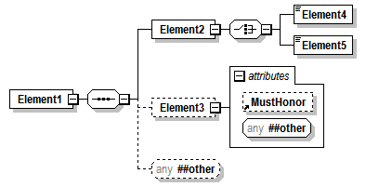
Figure 1 Model Conventions

Imaging Device Model
There is both a SystemControlService and a System Object in the Imaging Device Model. The distinction between them is that the System Object represents the Imaging Device as a whole and is the root container for all the Imaging Device attributes, components and services. The SystemControlService acts upon the System Object on behalf of SystemControl Clients to query the state of the System Object and to affect the System Object state through a well-defined set of operations
The SystemControlService fits within the Imaging Device model as one of a number of services that can be hosted on a multifunction device (i.e., System or System Object). One difference between the SystemControlService and other hosted services is that there can only be a single instance. Another difference is that that since this service is not job oriented there are no Jobs coming in or output produced and therefore no subordinate DefaultJobTicket or Capabilities. Since the SystemControlService provides a management interface for the entire Imaging Device, the mandatory SystemControlService is always active while the Imaging Device is available. (See [PWG5108.01])
Figure 2and §6 define the System Object schema which represents the Imaging Device.

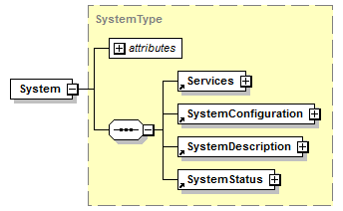
Figure 2 System Object

System Object
The System Object elements SystemConfiguration, SystemDescription and SystemStatus are defined in §6.1, §6.2 and §6.3 respectively. The Services element contains all the hosted services. See §7 below for the description of the SystemControlService.

SystemConfiguration
The System Object has a SystemConfiguration element that contains all the Subunits configured onSubunit the Imaging Device. (See Figure 3) Note that each service instance contains a service specific view of the Subunits used by that service instance. For example a PrintService has a Marker Subunit but ScanService does not. The MFD Model and Common Semanticsspecification [PWG5108.01] defines all the Subunits.
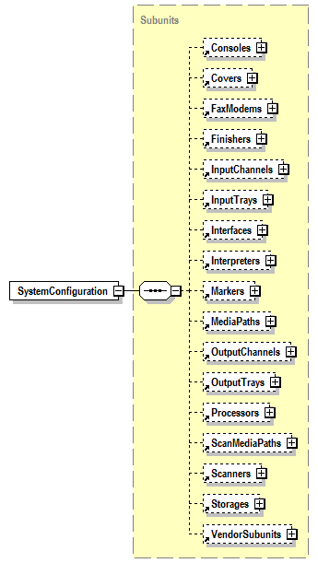
Figure 3 SystemConfiguration

SystemDescription
Figure 4 is a view of the Imaging Device’s SystemDescription. SystemDescription provides descriptive information for the entire Imaging Device. The element values are administratively set. The element values can be modified directly or modified indirectly through an operation. The SystemDescription group element includes descriptive information such as system name and location, and has an extension point for vendor specific information. The MFD Model and Common Semantics specification [PWG5108.01] defines most of the elements that are used in the SystemDescription element. Table 1 lists the SystemControlService specific SystemDescription elements.
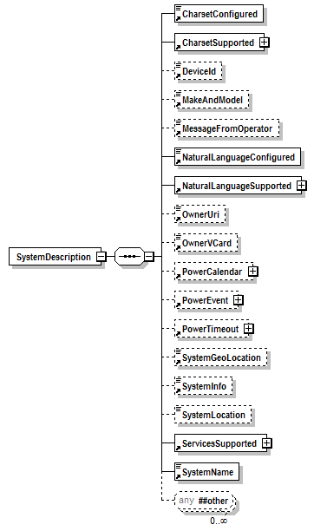
Figure 4 SystemDescription

Table 1 SystemDescription Elements
Element Name |  | Multivalued | Syntax | Constraint |  | Group | Reference
 | Description (values)
ServicesSupported |  | Yes | List of Keywords |  |  | Description
 | The list of types of services that can be administratively configured to run on this system. (Contains ServiceType)
ServiceType |  | No | Keyword | Type 3 |  | Description
 | The keyword for the type of configured service. Values: ServiceTypeWKV, KeywordNsExtensionPattern (e.g., Copy, EmailIn, EmailOut, FaxIn, FaxOut, Print, Resource, Scan, SystemControl, Transform, Vendor) (Included in ConfiguredServices)

SystemStatus
Figure 5 is a view of the Imaging Device’s SystemStatus. SystemStatus provides an optimistic roll-up of state information for the hosted services. What is meant by that is if any service is ‘Processing’, the SystemStatus State element will be ‘Processing’. This is the case even if one or more of the services are in the ‘Stopped’ state. Table 2 shows the conditions for all SystemStatus “State” values.
The elements values are maintained by automata and cannot be directly set. The element values can be modified indirectly through an operation. For example the PauseAllSystemServices operation on the SystemControlService may result in the change of the State and StateReasons elements. The MFD Model and Common Semantics specification [PWG5108.01] defines most of the the elements that are used in the SystemStatus element. Table 3 lists the new SystemControlService specific SystemStatus elements.

Table 2 Optimistic Status Roll-up
System Status | Condition
Unknown | Initialization phase. State of hosted services are not known
Down | All the hosted services are Down or Unknown. The System Service has completed initialization
Testing | All the hosted services are Testing, Down or Unknown. At least one hosted service state is Testing.
Stopped | All the hosted services are Stopped, Testing, Down or Unknown. At least one service state is Stopped.
Idle | All the hosted services are Idle, Stopped, Testing, Down or Unknown. At least one service state is Idle.
Processing | All the hosted services are Processing, Idle, Stopped, Testing, Down or Unknown. At least one service state is Processing.

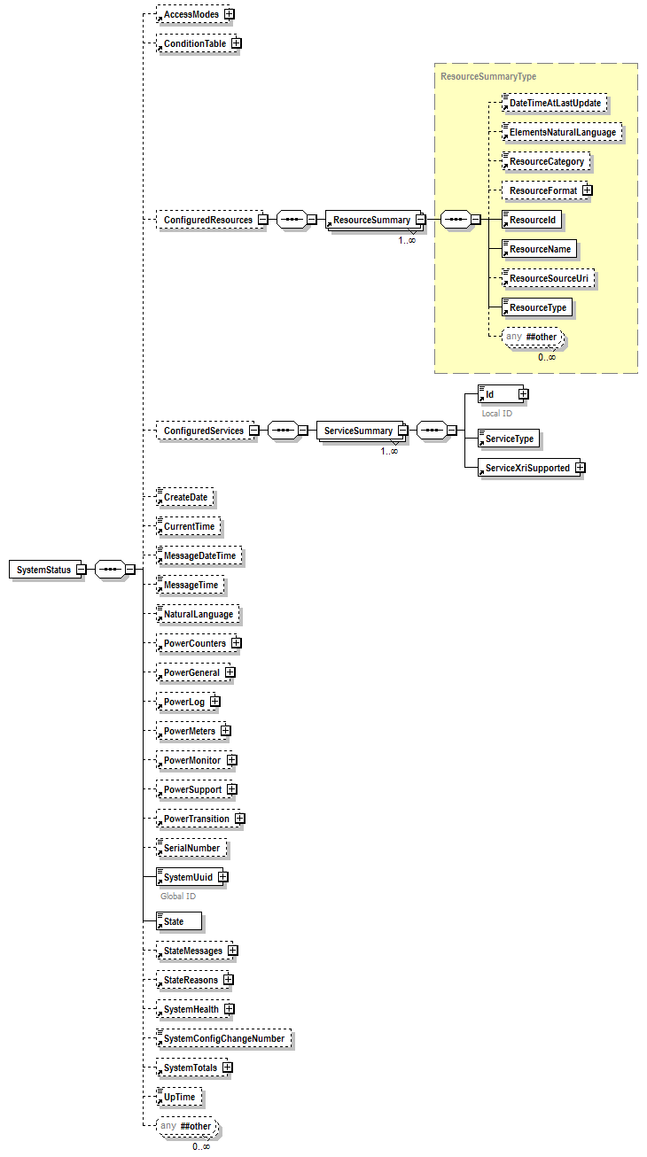
Figure 5 SystemStatus
Table 3 SystemStatus Elements
Element Name |  | Multivalued |  |  | Syntax | Constraint |  |  |  |  | Group |  | Reference
 | Description (values)
ConfiguredResources |  | Yes |  | List of ResourceSummary |  |  |  |  |  |  | Status
 | The list of summary information for the available resources of the system. (Contains ResourceSummary)
ResourceSummary |  | No |  |  | Complex |  |  |  | Status |  |  | [PWG5108.03] § 8.1.5.2, §7.4.2 (See also ResourceSourceUri below)
 | The summary information for the available resource. (Contains DateTimeAtLastUpdate, ElementsNaturalLanguage, ResourceCategory, ResourceFormat, ResourceId, ResourceName, ResourceSourceUri, ResourceType)
ResourceSourceUri |  | No |  |  | URI |  |  |  |  | Status
 | An identifier for the resource assigned by the creator/supplier of the resource. The value SHOULD be a URN.
ConfiguredServices |  | Yes |  | List of ServiceSummary |  |  |  |  |  |  | Status
 | The list of service that have been administratively configured to run on this system instance. (Contains ServiceSummary)
ServiceSummary |  | Yes |  |  | Complex |  |  |  |  |  | Status
 | Information about the services that have been administratively configured to run on this system instance. (Contains ServiceType, Id, ServiceXriSupported) (Included in ConfiguredServices)
ServiceType |  | No |  |  | Keyword | Type 3 |  |  |  |  | Status
 | The keyword for the type of configured service. Values: ServiceTypeWKV, KeywordNsExtensionPattern (e.g., Copy, EmailIn, EmailOut, FaxIn, FaxOut, Print, Resource, Scan, SystemControl, Transform, Vendor) (Included in ServiceSummary)
SystemConfigChangeNumber |  |  | No |  | Integer |  |  |  |  |  | Status |  | [RFC3805] §6
 | Counts configuration changes within the System. A configuration change is defined to be an action that results in a change to any element other than those that reflect status or level, or those that act as counters. (Maps to Printer MIB’s prtGeneralConfigChanges)
SystemTotals |  | No |  |  | Complex |  |  |  |  |  | Status |  | [PWG5106.1] §6.1
 | The SystemTotals counters aggregates counters from all the services offered by the System.

SystemControlService

SystemControlService Model
The Imaging Device supports exactly one SystemControlService (See Figure 6). A SystemControlService is hosted locally on an Imaging Device or remotely on another computer. The SystemControlService contains elements for SystemControlService status and description.
While the SystemControlService provides operations to obtain an Imaging Device wide view of the Subunits that are configured on the Imaging Device, they are not subordinate to the SystemControlService. The Subunits (i.e., SystemConfiguration) appear at the root of the model and are defined in §6.1.
The SystemControlServiceDescription group element includes descriptive information such as service name and information, and has an extension point for vendor specific information. These description elements are settable by Administrators. The details of the SystemControlServiceDescription elements are specified in §7.2.
The SystemControlServiceStatus group element is an extension of SystemServiceStatus class that includes elements such as ID, state, state messages and state reasons. State messages are localized state reasons. The details of the elements in the SystemControlServiceStatus group are specified in §7.3.
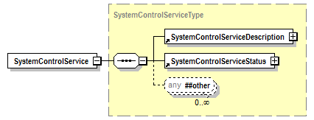
Figure 6 SystemControlService

SystemControlServiceDescription
Figure 7 is a view of the SystemControlServiceDescription. SystemControlServiceDescription provides Descriptive information for the SystemControlService. The element values are administratively set. The element values can be modified directly or modified indirectly through an operation. The SystemControlServiceDescription group element includes descriptive information such as service name and information, and has an extension point for vendor specific information. The MFD Model and Common Semantics specification [PWG5108.01] defines the SystemControlServiceDescription elements.

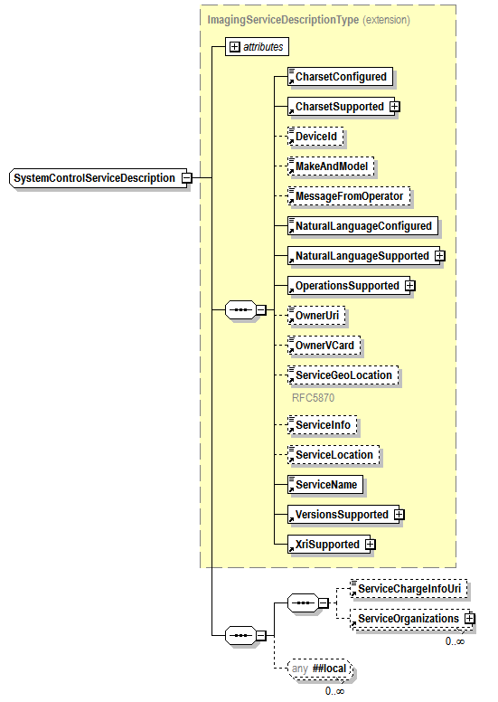
Figure 7 SystemControlServiceDescription
The elements common to all <service>ServiceDescriptions are defined in the MFD Model and Common Semantics specification [PWG5108.01]. Those elements are identified in the above diagram by being included in the yellow box. The remaining elements also are taken from <service> ServiceDescription. These elements are defined in the MFD Model and Common Semantics specification [PWG5108.01].

SystemControlServiceStatus
Figure 8 is a view of the SystemControlService’s SystemControlServiceStatus. SystemControlServiceStatus provides state information for the SystemControlService. The elements values are maintained by automata and cannot be directly set. The element values can be modified indirectly through an operation. For example PauseAllServices operation on the SystemControlService may result in the change of the State and StateReasons elements.
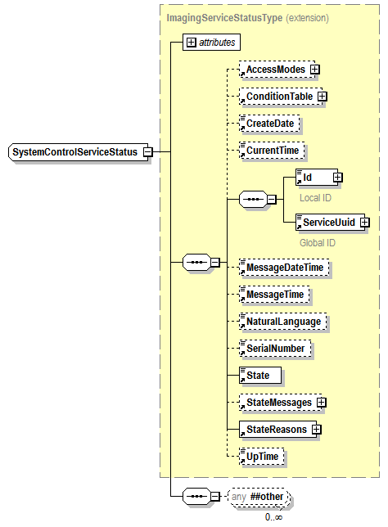
Figure 8 SystemControlServiceStatus
The elements common to all <service>ServiceStatus are defined in the MFD Model and Common Semantics specification [PWG5108.01]. Those elements are identified in the above diagram by being included in the yellow box. There are no elements specific to the SystemControlServiceStatus except the usual extension point (i.e., Any).

SystemControlService Operations
The SystemControlService provides a service interface that is the same for a co-located local SystemControl Client or a Remote SystemControl Client via a local interface, a local area network, or the Internet. A user makes a SystemControlService request by interacting directly with the SystemControlService or indirectly through a local SystemControl Client via the Imaging Device UI or a Remote SystemControl Client via its software application UI.
Table 4 and Table 5 list the input and output parameters for the defined operations. Responses to operations that fail are expected to return a fault.
The semantics for these operations are similar to the operations specified in the MFD Model and Common Semantics specification [PWG5108.01]. One difference is that many of the operations affect all the hosted document related services instead of an individual service. In the tables below the required parameters are in bold and optional parameters are in normal font.
Notes for Table 4 follow Table 5
Table 4 Mandatory System Operations
User  Operation Name | Input Parameters | Output Parameters
DisableAllServices ¹ | ElementsNaturalLanguage, Message, RequestingUserName
EnableAllServices ¹ | ElementsNaturalLanguage, Message, RequestingUserName
GetSystemElements | ElementsNaturalLanguageRequested, RequestedElements, RequestingUserName | ElementsNaturalLanguage, System Elements,
ListAllServices | ElementsNaturalLanguageRequested, , RequestingUserName | ElementsNaturalLanguage, List of service summary,
PauseAllServices ² | ElementsNaturalLanguage, Message, RequestingUserName
RestartAllServices ^{1, 5, 6, 7} | ElementsNaturalLanguage,  IsAcceptingJobs | IsAcceptingResources, Message, RequestingUserName, StartServicePaused
RestartService ^{3, 4, 5, 6, 7} | ElementsNaturalLanguage, Id,  IsAcceptingJobs | IsAcceptingResources, Message, RequestingUserName, ServiceType, StartServicePaused
ResumeAllServices ² | ElementsNaturalLanguage, Message, RequestingUserName
ShutdownAllServices ¹ | ElementsNaturalLanguage, Message, RequestingUserName
ShutdownService^{1, 8} | ElementsNaturalLanguage, Id, Message, RequestingUserName ServiceType
StartupAllServices ^{1, 5, 6, 7} | ElementsNaturalLanguage, IsAcceptingJobs, Message, RequestingUserName, StartSystemPaused
StartupService ^{1, 5, 6, 7} | ElementsNaturalLanguage, IsAcceptingJobs, Message, RequestingUserName ServiceType, StartServicePaused | Id

Notes for Table 5 follow Table 5
Table 5 Optional System Operations
Administrative  Operation Name | Input Parameters | Output Parameters
DeleteService ^{1, 8} | Id, ElementsNaturalLanguage, Message, RequestingUserName, ServiceType
PauseAllServicesAfterCurrentJob ² | ElementsNaturalLanguage, Message, RequestingUserName
SetSystemElements | ElementsNaturalLanguage, Message, OperationMode, RequestingUserName SystemElements | UnsupportedElements

Notes for Table 4 and Table 5:
1 The operations do not apply to the SystemControlService.
2 The operation only applies to Job based services (e.g., CopyService, FaxOutService, FaxInService, PrintService, ScanService, and TransformService),
3 When the target service is the SystemControlService the implementation MUST restart the SystemControlService and MAY restart the other services as well.
4 When the target service is the SystemControlService the implementation of the restart may be soft (i.e., affects software only) or hard (i.e., hardware and software reinitialized).
5 When the service startup is complete the service state is ‘Idle’ (See note 6). The service will then follow the service state model as defined in section 7.2.1 of [PWG5108.01]
6 When the operation contains the “StartServicePaused” parameter and it is set to ‘true’, the resulting service state is ‘Stopped’ (i.e., transitions from ‘Down’ to ‘Idle’ then immediately to ‘Stopped’). The service will then follow the service state model as defined in section 7.2.1 of [PWG5108.01]
7 When the operation contains the “IsAcceptingJobs” or “IsAcceptingResources” parameter and it is set to ‘false’, the service state is ‘Idle’ (See note 6). The service will then follow the behaviors as defined in section 7.3.2.2 of [PWG5108.01] or section 8.2.1 of [PWG5108.03] respectively.
8 This operations results in an error when applied to the SystemControlService.

DeleteService
The DeleteService operation removes an instance of a service. The result is that all data associated with the service is deleted and the service can no longer be restarted. It is an error to specify a service that is not shutdown or to specify the SystemControlService itself.

DisableAllServices
The DisableAllServices operation is consistent with the operation Disable<service>Service specified in [PWG5108.01]. If the requestor is determined to have proper access, the SystemControlService MUST accept this request and MUST set the IsAcceptingJobs/ IsAcceptingResources Element to ‘false’ for all hosted services. This operation does not affect the SystemControlService itself. This operation has no effect upon the Services’ State elements.

EnableAllServices
The EnableAllServices operation is consistent with the operation Enable<service>Service specified in [PWG5108.01]. If the requestor is determined to have proper access, the SystemControlService MUST accept this request and MUST set the IsAcceptingJobs/ IsAcceptingResources Element to ‘true’ for all hosted services. This operation has no effect upon the Services’ State elements. This operation does not affect the SystemControlService itself.

GetSystemElements
Unlike the Get<service>ServiceElements [PWG5108.01] operation that allows access to only the elements of the specified <service>, the GetSystemElements operation allows a SystemControl Client to obtain detailed information about the System Object as well as the SystemControlService.
For the SystemControlService, this operation can request the elements directly below the SystemControlService element (e.g., ServiceDescription, ServiceStatus). This operation MUST NOT query information from any other Service.
For the System Object, this operation can request the elements directly below the System element (e.g., SystemConfiguration, SystemDescription, and SystemStatus).
The elements constitutingSystemConfiguration have a special representation. Some SystemConfiguration Subunits contain complex groups that have either “referenced” or “contained” associations. Examples of the two types of associations are represented in the simplified figure below (Figure 9). A referenced association is a pointer to another Subunit as shown for InputChannelInterface. For Subunits with a contained association, the constituents of the complex element (e.g., MarkerColorants) are fully contained within the Subunit (e.g., Marker). Table 6 list all the SystemConfiguration sub-elements with an association and their type.
When the GetSystemElements operation accesses a Subunit with a referenced association, it follows the reference and responds with the contained elements conceptually in that Subunit. This was done so that references would not have to be chased by SystemControl Client software and so that a Subunit element such as InputChannel would contain all its associated information. Note that this dereferencing is not done for the SetSystemElements operation; see § 7.4.15 for SetSystemElement’s handling of a referenced association.

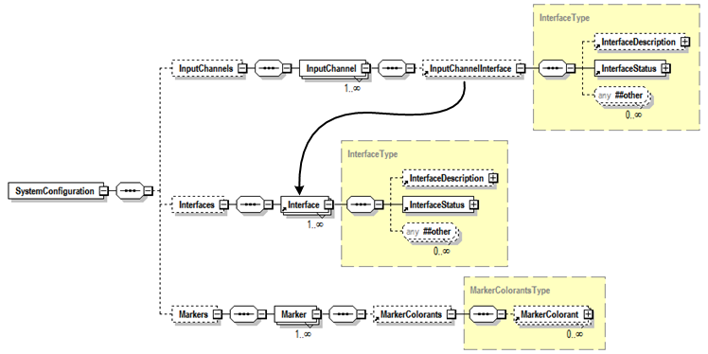
Figure 9 Association Types

Table 6 SystemConfiguration sub-element associations
Element Name | Association Type
FinisherSupply | Contained
FinisherSupplyMediaInput | Contained
InputChannelInterface | Referenced
InputChannelDefaultJobControlLanguage | Referenced
InputChannelDefaultPageDescriptionLanguage | Referenced
MarkerColorant | Contained
MarkerSupply | Contained
OutputChannelInterface | Referenced
OutputChannelDefaultJobControlLanguage | Referenced

ListAllServices
This operation is unique to the SystemControlService. This operation provides summary information on all Imaging Device hosted services including the SystemControlService. The response returns a ServiceSummary for each service that includes Id, ServiceName, ServiceState, ServiceStateReasons for the service’s endpoint and other general information.

PauseAllServices
The PauseAllServices operation is consistent with the operation Pause<service>Service specified in [PWG5108.01]. If the requestor is determined to have proper access, the SystemControlService MUST accept this request and transition all the currently active job based Services (e.g., CopyService, FaxOutService, FaxInService, PrintService, ScanService, TransformService) to the Stopped state. During the transition each <service>ServiceStateReasons MUST contain the reason ‘MovingToPaused’. This operation does not affect the SystemControlService.

PauseAllServicesAfterCurrentJob
The PauseAllServicesAfterCurrentJob operation is consistent with the operation Pause<service>ServiceAfterCurrentJob specified in [PWG5108.01]. If the requestor is determined to have proper access, the SystemControlService MUST accept this request and transition all the currently active job based Services (e.g., CopyService, FaxOutService, FaxInService, PrintService, ScanService, TransformService) to the Stopped state in an orderly manner. During the transition each <service>ServiceStateReasons MUST contain the reason ‘MovingToPaused’. No pending jobs may be scheduled and all processing jobs will complete. This operation does not affect the SystemControlService.

RestartAllServices
The RestartAllServices operation is consistent with the operation Restart<service>Service specified in [PWG5108.01]. This operation does not affect the SystemControlService. If the requestor is determined to have proper access, the SystemControlService MUST accept this request and MUST reinitialize all hosted services, except the SystemControlService. This includes setting the State to ‘Idle’, clearing the StateReasons Element and setting the IsAcceptingJobs/IsAcceptingResources Element to ‘true’ if applicable. Note that parameters control subsequent service behavior (See the last paragraph in this section). When the service startup is complete the service state is ‘Idle’ (See below). The service will then follow the service state model as defined in section 7.2.1 of [PWG5108.01].
When the operation contains the “StartServicePaused” parameter and it is set to ‘true’, the resulting service state is ‘Stopped’ (i.e., transitions from ‘Down’ to ‘Idle’ then immediately to ‘Stopped’). The service will then follow the service state model as defined in section 7.2.1 of [PWG5108.01]. When the operation contains the “IsAcceptingJobs” or “IsAcceptingResources” parameter and it is set to ‘false’, the service state is ‘Idle’ (See note 6). The service will then follow the behaviors as defined in section 7.3.2.2 of [PWG5108.01] or section 8.2.1 of [PWG5108.03] respectively. Parameters that do not apply to target service are silently ignored.

RestartService
The RestartService operation is consistent with operation Restart<service>Service specified in [PWG5108.01]. If the requestor is determined to have proper access, the SystemControlService MUST accept this request and MUST reinitialize the specified service State to ‘Idle’, clear the StateReasons Element and set the IsAcceptingJobs/IsAcceptingResources Element to ‘true’ if applicable. Note that parameters control subsequent service behavior (See the last paragraph in this section). When the service startup is complete the service state is ‘Idle’ (See below). The service will then follow the service state model as defined in section 7.2.1 of [PWG5108.01]. This operation can specify any service including the SystemControlService.
When the SystemControlService is the target of this operation the system behavior is implementation specific. The implementation may reinitialize the existing service or shutdown and instantiate the SystemControlService. It is also implementation specific whether or not restarting the SystemControlService also causes a restart of all the other hosted services.
When the operation contains the “StartServicePaused” parameter and it is set to ‘true’, the resulting service state is ‘Stopped’ (i.e., transitions from ‘Down’ to ‘Idle’ then immediately to ‘Stopped’). The service will then follow the service state model as defined in section 7.2.1 of [PWG5108.01]. When the operation contains the “IsAcceptingJobs” or “IsAcceptingResources” parameter and it is set to ‘false’, the service state is ‘Idle’ (See note 6). The service will then follow the behaviors as defined in section 7.3.2.2 of [PWG5108.01] or section 8.2.1 of [PWG5108.03] respectively. Parameters that do not apply to target service are silently ignored.

ResumeAllServices
The ResumeAllServices operation is consistent with the operation Resume<service>Service specified in [PWG5108.01]. If the requestor is determined to have proper access, the SystemControlService MUST accept this request and transition every job based Service (e.g., CopyService, FaxOutService, FaxInService, PrintService, ScanService, and TransformService) to the ‘Idle’ state. The service will then follow the service state model as defined in section 7.2.1 of [PWG5108.01]. This operation does not affect the SystemControlService.

ShutdownAllServices
The ShutdownAllServices operation is consistent with the operation Shutdown<service>Service specified in [PWG5108.01]. If the requestor is determined to have proper access, the SystemControlService MUST accept this request and forces each of the services, except the SystemControlService, to the ‘Down’ state from any state that it is in, in an orderly manner. This operation does not affect the SystemControlService itself.

ShutdownService
The ShutdownService operation is consistent with the operation Shutdown<service>Service specified in [PWG5108.01]. If the requestor is determined to have proper access, the SystemControlService MUST accept this request and force the specified service to the ‘Down’ state from any state that it is in, in an orderly manner. It is an error to specify the SystemControlService itself.

StartupAllServices
The StartupAllServices operation initializes all the shutdown services and takes them through the ‘Down’ state to ‘Idle’, assuming that there are no inhibiting conditions See sections 7.2.1 of [PWG5108.01]. If the requestor is determined to have proper access, the SystemControlService MUST accept this request and initializes each of the services, except the SystemControlService. This operation does not affect the SystemControlService itself.

StartupService
The StartupService operation creates a new instance of the specified service type and takes it through the ‘Down’ state to ‘Idle’, assuming that there are no inhibiting conditions See section 7.2.1 of [PWG5108.01]. If the requestor is determined to have proper access, the SystemControlService MUST accept this request, create a new instance and initialize the service of the specified type. It is an error to specify the SystemControlService type.

SetSystemElements
Unlike the Set<service>ServiceElements [PWG5108.01] operation, the SetSystemElements operation allows a SystemControl Client to modify information about the System Object as well as the SystemControlService Elements.
For the SystemControlService, this operation can set the SystemControlService’s settable elements (i.e., elements in ServiceDescription and none in ServiceStatus). This operation MUST NOT set elements from any other service (i.e. any other service under the Services element at the System root).
For the System Object, this operation can set settable elements the elements directly below the System element (i.e., elements in SystemConfiguration and SystemDescription but not in SystemStatus). The SystemConfiguration element in a SetSystemElements operation has additional rules and an alternative syntax.
The alternative syntax for SystemConfiguration permits schema enforcement of setting only a few elements within a SystemConfiguration element. Although an element may be mandatory in the model, the SetSystemElements operation need not contain a mandatory element unless it is the element being set.
An alternative syntax is also used when an element is a reference to another element instead of a contained element (e.g., InputChannelInterface in System.SystemConfiguration.InputChannels.InputChannel). See § 7.4.4 for a discussion of elements with referenced associations versus elements with contained association. For simplicity and convenience of the GetServiceElements operation, when accessing an element with a referenced association to another element, the entire referenced element is replicated in place. Thus there is no need to use the reference identifier and make another query to obtain the information. However when the SetSystemElements operation acts upon an element with a referenced association, it action is to modify the reference identification and not the referenced element. Therefore when a SetSystemElements operation modifies an element with a referenced association, the element value will be an integer that corresponds to the identifier of the referenced element. To modify the referenced element itself, the elements themselves (e.g., Interface in System.SystemConfiguration.Interfaces) are modified using the SetSystemElements operation.

Table 7 SetSystemElements Contained/Referenced Datatypes
Element Name | Parent Element Name | Association Type | Name in SetSystemElements | Syntax in SetSystemElements
FinisherSupply | Finisher | Contained | FinisherSupply | FinisherSupplySet Type
FinisherSupplyMediaInput | FinisherSupply | Contained | FinisherSupplyMediaInput | FinisherSupply MediaInputSetType
InputChannelInterface | InputChannel | Referenced | InputChannelInterfaceId | Integer
InputChannelDefaultJob ControlLanguage | InputChannel | Referenced | InputChannelDefaultJob ControlLanguageId | Integer
InputChannelDefaultPage DescriptionLanguage | InputChannel | Referenced | InputChannelDefaultPageDescriptionLanguageId | Integer
MarkerColorant | Marker | Contained | MarkerColorant | MarkerColorantSet Type
MarkerSupply | Marker | Contained | MarkerSupply | MarkerSupplySet Type
OutputChannelInterface | OutputChannel | Referenced | OutputChannelInterfaceId | Integer
OutputChannelDefaultJob ControlLanguage | OutputChannel | Referenced | OutputChannelDefaultJob ControlLanguageId | Integer

The SetSystemElements operation has some special rules when setting a virtual row in a virtual table. In the Printer MIB these rows are represented as rows. In the schema associated with this specification the table is represented as an element whose name ends in ‘s’ (e.g., Finishers, InputChannels, Interfaces) that contains multiple instances of the element itself (e.g., Finisher, InputChannel, Interface). The elements in the row that can be directly set by an authorized client are grouped together in a Description element and the elements that are maintained by automata or can only be modified by a first class operation are grouped together in the Status element. When setting a row in a table the request MUST be limited to operate only on the one row in one table. It is an error to include multiple rows or to include elements not part of the row. The alternative schema for the SetSystemElements enforces this by limiting the element that represents rows to a single instance. Where applicable a choice construct is used to insure that when a row is the target of the operation no other elements can be included in the request.

Conformance Requirements
This section describes conformance requirements. This document introduces model entities such as SystemControl Clients, SystemControlService, objects, operations, elements and element values. The sections below describe the conformance requirements which apply to these model entities.

SystemControl Client Conformance Requirements
- A conforming client MUST support all REQUIRED operations as defined in this document. For each parameter included in an operation request, a conforming client MUST supply a value whose type and value syntax conforms to the requirements of the Model document as specified in Section 7.4.
- A client MUST be able to accept any of the elements defined in the model, including their full range that may be returned to it in a response from a SystemControlService.
- An operation response may contain elements and/or values that the client does not expect. Therefore, a conforming client implementation MUST gracefully handle such responses and not refuse to interoperate with a conforming SystemControlService that is returning extended elements and/or values that conform to Section 8.3. SystemControl Clients may choose to ignore any parameters, elements, or values that they do not understand.
- A conforming client MAY supply any extensions in an operation request, as long as they meet the requirements in Section 8.3.
- When sending a request, a conforming client MAY supply any parameters that are indicated as OPTIONAL to be supplied by the client.

SystemControlService Conformance Requirements
This section specifies the conformance requirements for conforming Imaging Device and SystemControlService implementations with respect to objects, operations, and extensions.

Objects
This section specifies the conformance requirements for conforming Imaging Device and SystemControlService implementations with respect to objects.
- Conforming implementations MUST implement all of the model objects and the mandatory elements they contain as defined in this specification in the indicated section 6.
- If an object supports an element, it MUST support only those values specified in this document or through the extension mechanism defined in section 8.3.
- If an object supports an element, it MAY support any non-empty subset of these values. That is, it MUST support at least one of the specified values.

Operations
This section specifies the conformance requirements for conforming Imaging Device and SystemControlService implementations with respect to operations.
- Conforming SystemControlService implementations MUST implement all of the REQUIRED SystemControlService operations, including REQUIRED requests and responses, as defined in this specification in Table 4.
- Conforming SystemControlService MUST support all REQUIRED operation elements and all values of such elements if so indicated in the description.
- Conforming SystemControlService MUST ignore all unsupported or unknown operation elements received in a request.

Extensions
This section specifies the conformance requirements for conforming Imaging Device and SystemControlService implementations with respect to extensions.
- To extend the model the extensions MUST be fully qualified.
- The qualified name MUST NOT be in the PWG target namespace.
- When extending the model with new elements the new elements MUST be added at the extension points at the end of the associated sequence of elements.
- Extended values for elements MUST conform to the extension patterns defined in the element schema.
- Conforming SystemControlService MAY support extensions.

PWG Registration Considerations
This specification is consistent with the guidelines set forth in the MFD Model and Common Semantics specification [PWG5108.01] (section 10).

Internationalization Considerations
This specification is consistent with the guidelines set forth in the MFD Model and Common Semantics specification [PWG5108.01] (section 11).

Security Considerations
This specification is consistent with the guidelines set forth in the MFD Model and Common Semantics specification [PWG5108.01] (section 12).

References

Normative References
[PWG5105.1]
PWG 5105.1-2004 Printer Working Group (PWG) Semantic Model version 1, January 20, 2004, P. Zehler, T.Hastings, S. Albright, ftp://ftp.pwg.org/pub/pwg/candidates/cs-sm10-20040120-5105.1.pdf
[PWG5106.2-2006]
PWG 5106.2-2006, "The Printer Working Group (PWG) Web-based Imaging Management Service v1.0", April 21, 2006, L Farrell, R. Landau, H. Lewis, I. McDonald, J. Thrasher, W. Wagner, and P. Zehler, ftp://ftp.pwg.org/pub/pwg/candidates/cs-wims10-20060421-5106.2.pdf
[PWG5108.01]
PWG 5108.1-2011 MFD Model and Common Semantics version 1, April 15, 2011, W. Wagner, P. Zehler
ftp://ftp.pwg.org/pub/pwg/candidates/cs-sm20-mfdmodel10-20110415-5108.1.pdf
[PWG5108.03]
PWG 5108.03-2009 Network Resource Service Semantic Model and Service Interface version 1, July 3, 2009, N. Chen, P. Zehler, I. McDonald
ftp://ftp.pwg.org/pub/pwg/candidates/cs-sm20-resource10-20090703-5108.03.pdf
[RFC2119]
S. Bradner, “Key words for use in RFCs to Indicate Requirement Levels”, RFC 2119, March 1997.

Author’s Address
Peter Zehler
Xerox Research Center Webster
Email: Peter.Zehler@Xerox.com
Voice: (585) 265-8755
US Mail: Peter Zehler
Xerox Corp.
800 Phillips Rd.
M/S 128-25E
Webster NY, 14580-9701

Additional contributors:
Michael Sweet – Apple
Ira McDonald – High North
Jerry Thrasher - Lexmark
Nancy Chen – OkiData
William Wagner - TIC

