Working Draft, October 24, 2003
Maturity Level: Stable

The Printer Working Group (PWG)
Semantic Model

Abstract: This document is a high level overview of the Semantic Model defined by the PWG. This document briefly describes the semantic elements defined in various PWG documents and PWG documents submitted to the IETF. The Semantic Model also incorporates additions made by other groups addressing print systems. With every semantic element included a reference is provided to the document and section that details the semantic definition.
The Semantic Model contains a high level description of the Actions that operate on the objects and attributes in the model. This document does not describe the mapping of the semantics onto a specific protocol or network environment.


Working Draft, October 24, 2003
The Printer Working Group (PWG)
Semantic Model

This version of the PWG Proposed Standard is available electronically at:
ftp://ftp.pwg.org/pub/pwg/Semantic-Model/wd-sm10-20031020.pdf, .doc
This document is a Working Draft for an IEEE-ISTO PWG Candidate Standard. For a definition of a "PWG Candidate Standard" and its transition to a "PWG Standard", see: ftp://ftp.pwg.org/pub/pwg/general/pwg-process.pdf. After approval by the PWG (by a Last Call) to transition a PWG Working Draft to a PWG Candidate Standard, the resulting PWG Candidate Standard will be available electronically at: ftp://ftp.pwg.org/pub/pwg/cs/. After approval by the PWG (by a Last Call) to transition a PWG Candidate Standard to a PWG Standard, the resulting PWG Standard will be available electronically at: ftp://ftp.pwg.org/pub/pwg/standards/.
Copyright (C) 2003, IEEE ISTO. All rights reserved.
This document may be copied and furnished to others, and derivative works that comment on, or otherwise explain it or assist in its implementation may be prepared, copied, published and distributed, in whole or in part, without restriction of any kind, provided that the above copyright notice, this paragraph and the title of the Document as referenced below are included on all such copies and derivative works. However, this document itself may not be modified in any way, such as by removing the copyright notice or references to the IEEE-ISTO and the Printer Working Group, a program of the IEEE-ISTO.
Title: The Printer Working Group Semantic Model
The IEEE-ISTO and the Printer Working Group DISCLAIM ANY AND ALL WARRANTIES, WHETHER EXPRESS OR IMPLIED INCLUDING (WITHOUT LIMITATION) ANY IMPLIED WARRANTIES OF MERCHANTABILITY OR FITNESS FOR A PARTICULAR PURPOSE.
The Printer Working Group, a program of the IEEE-ISTO, reserves the right to make changes to the document without further notice. The document may be updated, replaced or made obsolete by other documents at any time.
The IEEE-ISTO takes no position regarding the validity or scope of any intellectual property or other rights that might be claimed to pertain to the implementation or use of the technology described in this document or the extent to which any license under such rights might or might not be available; neither does it represent that it has made any effort to identify any such rights.
The IEEE-ISTO invites any interested party to bring to its attention any copyrights, patents, or patent applications, or other proprietary rights which may cover technology that may be required to implement the contents of this document. The IEEE-ISTO and its programs shall not be responsible for identifying patents for which a license may be required by a document and/or IEEE-ISTO Industry Group Standard or for conducting inquiries into the legal validity or scope of those patents that are brought to its attention. Inquiries may be submitted to the IEEE-ISTO by e-mail at:
ieee-isto@ieee.org.
The Printer Working Group acknowledges that the IEEE-ISTO (acting itself or through its designees) is, and shall at all times, be the sole entity that may authorize the use of certification marks, trademarks, or other special designations to indicate compliance with these materials.
Use of this document is wholly voluntary. The existence of this document does not imply that there are no other ways to produce, test, measure, purchase, market, or provide other goods and services related to its scope.
About the IEEE-ISTO

The IEEE-ISTO is a not-for-profit corporation offering industry groups an innovative and flexible operational forum and support services. The IEEE-ISTO provides a forum not only to develop standards, but also to facilitate activities that support the implementation and acceptance of standards in the marketplace. The organization is affiliated with the IEEE (http://www.ieee.org/) and the IEEE Standards Association (http://standards.ieee.org/).

For additional information regarding the IEEE-ISTO and its industry programs visit http://www.ieee-isto.org.

About the IEEE-ISTO PWG
The Printer Working Group (or PWG) is a Program of the IEEE Industry Standards and Technology Organization (ISTO) with member organizations including printer manufacturers, print server developers, operating system providers, network operating systems providers, network connectivity vendors, and print management application developers. The group is chartered to make printers and the applications and operating systems supporting them work together better. All references to the PWG in this document implicitly mean “The Printer Working Group, a Program of the IEEE ISTO.” In order to meet this objective, the PWG will document the results of their work as open standards that define print related protocols, interfaces, procedures and conventions. Printer manufacturers and vendors of printer related software will benefit from the interoperability provided by voluntary conformance to these standards.
In general, a PWG standard is a specification that is stable, well understood, and is technically competent, has multiple, independent and interoperable implementations with substantial operational experience, and enjoys significant public support.
For additional information regarding the Printer Working Group visit: http://www.pwg.org
Contact information:
Semantic Model Web Page: http://www.pwg.org/sm/
Semantic Model Mailing List: sm@pwg.org
To subscribe to the Semantic Model mailing list, send the following email:
1) send it to majordomo@pwg.org
2) leave the subject line blank
3) put the following two lines in the message body:
subscribe sm
end
Implementers of this specification are encouraged to join the Semantic Model Mailing List in order to participate in any discussions of clarifications or review of registration proposals for additional names. Requests for additional extensions, for inclusion in this specification, should be sent to the Semantic Model Mailing list for consideration. In order to reduce spam the mailing list rejects mail from non-subscribers, so you must subscribe to the mailing list in order to send a question or comment to the mailing list.
Table of Contents
1 Introduction 9
2 Terminology 9
3 Model Overview 10
4 Data Classes 11
4.1 Naming of Classes, Elements and Values 12
4.2 Printer Object Class 12
4.2.1 Printer Status Elements 12
4.2.2 Printer Description Elements 13
4.2.3 Printer Defaults, Supported and Ready Processing Elements 14
4.3 Job Object Class 15
4.3.1 Job Status Elements 15
4.3.2 Job Description Elements 16
4.4 Document Object Class 17
4.4.1 Document Status Elements 17
4.4.2 Document Description Elements 19
4.5 Processing Elements 19
4.5.1 Job Processing Elements 19
4.5.2 Document Processing Elements 20
4.6 Processing Actual Elements 21
4.6.1 Job Processing Actual Elements 21
4.6.2 Document Processing Actual Elements 21
5 Actions 22
5.1 Job Creation and document submission Actions 23
5.1.1 CreateJob 24
5.1.2 CloseJob 24
5.1.3 PrintJob 24
5.1.4 PrintUri 24
5.1.5 SendDocument 25
5.1.6 SendUri 25
5.1.7 ValidateDocument 25
5.1.8 ValidateJob 25
5.2 Job and Document Control Actions 25
5.2.1 CancelCurrentJob 25
5.2.2 CancelDocument 26
5.2.3 CancelJob 26
5.2.4 DeleteDocument 26
5.2.5 HoldJob 26
5.2.6 PromoteJob 26
5.2.7 ReleaseJob 26
5.2.8 ReprocessJob 26
5.2.9 RestartJob 26
5.2.10 ResumeJob 26
5.2.11 ScheduleJobAfter 26
5.2.12 SetDocumentElements 26
5.2.13 SetJobElements 27
5.2.14 SuspendCurrentJob 27
5.3 Status and information Actions 27
5.3.1 GetDocumentElements 27
5.3.2 GetDocuments 27
5.3.3 GetJobElements 27
5.3.4 GetJobs 27
5.3.5 GetPrinterElements 27
5.3.6 GetPrinterSettableElementValues 27
5.4 Printer Control Actions 28
5.4.1 ActivatePrinter 28
5.4.2 DeactivatePrinter 28
5.4.3 DisablePrinter 28
5.4.4 EnablePrinter 28
5.4.5 HoldNewJobs 28
5.4.6 PausePrinter 28
5.4.7 PausePrinterAfterCurrentJob 28
5.4.8 PurgeJobs 28
5.4.9 ReleaseHeldNewJobs 28
5.4.10 RestartPrinter 29
5.4.11 ResumePrinter 29
5.4.12 SetPrinterElements 29
5.4.13 ShutdownPrinter 29
5.4.14 StartupPrinter 29
6 Globalization 29
7 Summary of elements 30
7.1 Processing Elements (Job and Document) 30
7.2 Job Elements (Status and Description) 40
7.3 Document Elements (Status and Description) 46
7.4 Printer Elements (Status and Description) 51
8 Status Strings 58
9 Semantic Elements to be added 62
10 Change Log 62
11 References 64
12 Author's Addresses 66
12.1 Other Participants 66
13 Appendix A – UPnP Definitions 66
13.1 DeviceId 66
14 Appendix B – IPP Mapping 67
14.1 Changes to remove some IPP specific aspects 67
14.2 Attribute Group Mapping 68

Table of Figures
Figure 1 Model Overview 10
Figure 2 Data Classes 11
Figure 3 Printer Status Elements 12
Figure 4 - The "PrinterState" element and the Printer Life Cycle 13
Figure 5 Printer Description Elements 13
Figure 6 Job Status Elements 15
Figure 7 The "JobState" Job Element and the Job object life cycle 16
Figure 8 Job Description Elements 17
Figure 9 Document Status Elements 18
Figure 10 "DocumentState" Element and Document object life Cycle 18
Figure 11 Document Description Elements 19
Figure 12 Job Processing Elements 20
Figure 13 Document Processing Elements 21
Figure 14 Processing Instruction Processing 23

Table of Tables
Table 1-Integer syntax whose ProcessingElementSupported syntax isn’t RangeOfInteger 14
Table 2 - Summary of Actions 23
Table 3 - Processing Elements (Job and Document) 30
Table 4- Job Elements (Status and Description) 40
Table 5 – Document Elements (Status and Description) 46
Table 6 - Printer Elements (Status and Description) 52
Table 7 Status strings indicating some degree of success 58
Table 8 Status strings indicating error on the part of the Client 58
Table 9 Status strings indicating error on the part of the Printer 60

Introduction
This document is a high level overview of the Semantic Model defined by the PWG. This document briefly describes the semantic elements defined in various PWG documents and PWG documents submitted to the IETF. The Semantic Model also incorporates additions made by other groups addressing print systems. With every semantic element included a reference is provided to the document and section that details the semantic definition.
The Semantic Model contains a high level description of the Actions that operate on the objects and Elements in the model. This document does not describe the mapping of the semantics onto a specific protocol or network environment.

Terminology
Action | A request that a Print Client makes to an object to perform some activity. The object returns a response to the Print Client that contains some information about the effect of the action on the object.
Data Class | A template for data describing an object and representing its state. Each Element in the data class represents a semantic element of the associated object.
Document | An object containing descriptive and state information for a logical unit of information to be printed. The object may contain processing information. The document content is represented by a single data (e.g. PDL, image) file and contains Pages.
Document Processing Elements | Document Elements supplied by the Print Client to direct the printing of a Document that the Printer copies to the Document. Examples: Copies, Finishings, Media, NumberUp.
End User | A print client that has no special rights on the printer. The End User typically submits jobs. The End User is allowed to query the printer, jobs and documents and control jobs based on policy.
Element | In this Document element is used to describe a characteristic of an object. (In XML an element is a construct that defines a component of an object.)
Impression | Everything printed on a single side of a media
Job | An object that represents the submission of work for the printer. It contains descriptive and state information as well as default Document Processing Elements. Jobs contain one or more Documents
Job Description Elements | Job Elements supplied by the Print Client to describe the Job. Examples: JobName, RequestingUserName, JobRecipient
Job Processing Elements | Job Elements supplied by the Print Client to direct the printing of the Job as a whole that the Printer copies to the Job. Examples: JobHoldUntil, JobPriority, JobCopies, JobFinishings.
Object | A entity that instantiates a data class and implements the appropriate actions.
Operator | A print client that has special rights on the printer. The Operator typically oversees the printer. The Operator is allowed to query and control the printer, jobs and documents based on site policy.
MediaSheet | A sheet of paper, or other material, used for printing
Page | A logical entity that represents the information contained on a single side of a sheet of media. Note that this is the electronic form and that multiple pages can be rendered into a single impression through N-Up printing
PDL | (Page Description Language) A language that describes the content to be printed and how it will be laid out on a page (e.g. Adobe PostScript®, Hewlett Packard PCL®).
Print Client | An application or network entity that performs actions
Printer | An object that represents a printing device, set of printing devices, or a printing service and contains zero or more Jobs
Type 1 keyword | All the values are defined in the specification. Additional values require a new specification.
Type 2 keyword | An initial set of values is defined in the specification. This working group registers additional values after review. The initial versions of the specification will contain the values registered so far. After the specification is approved, this working group will register additional values after approval.
Type 3 keyword | An initial set of values is defined in the specification. Additional values are registered without working group review. The initial versions of the specification contain the values registered so far. After the specification is approved, this working group will register additional values without approval.

Model Overview
The Printer Working Group (PWG) has defined a simplified printing model. It represents printing in either a client/server print paradigm or a peer-to-peer print paradigm. The PWG model describes the device as a Printer object. A Printer object may represent one or more physical Printers. Another object is the Job. A Printer can contain zero or more Jobs and a Job is contained in only one Printer. Each Job can contain zero or more documents. A Job can contain zero or more Documents and a Document is contained in only one Printer. The PWG model contains methods that act upon these objects.
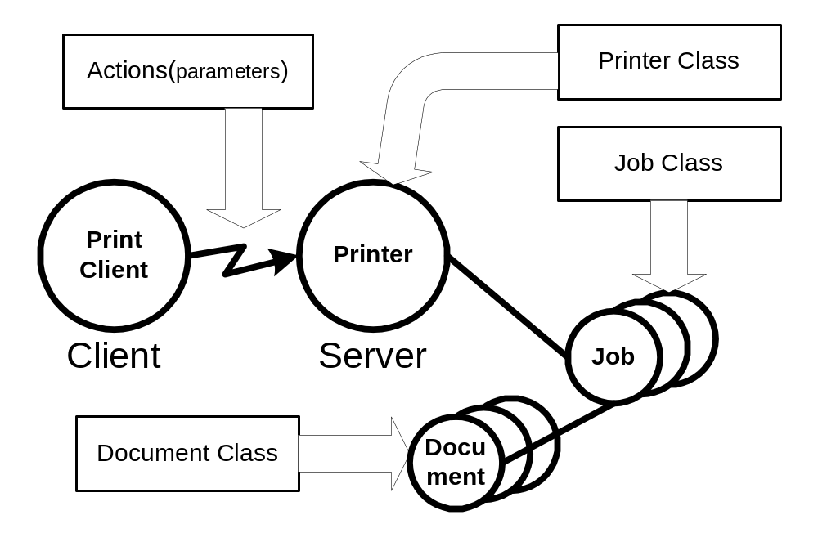
Figure 1 Model Overview
The objects are represented in the semantic model as data classes. The methods are represented as a set of actions that act upon those data classes. The actions permit the creation and control of Jobs and documents as well as the submission of Document data. The content of a Document is included in the submission or can be accessed via a URL reference. There are also actions to query a Printer, Job or Document to access their Elements or to list their contained objects.
The model uses a number of terms with specific meaning for a printer.

Data Classes
This section describes the data classes in the PWG semantic model. Some of the classes are taken from the model and semantics of IPP [rfc2911]. Figure 2 shows the data classes, their elements and the containment relationship between the classes
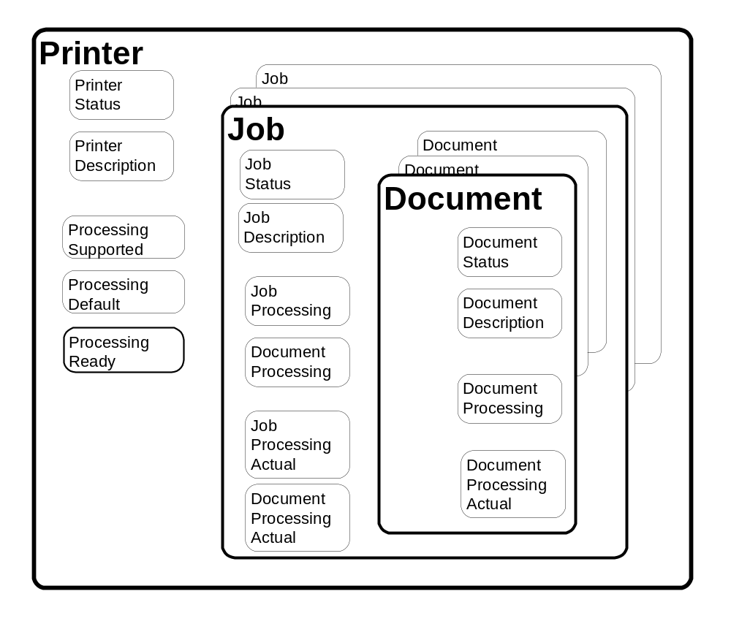
Figure 2 Data Classes

Naming of Classes, Elements and Values
The Action, Class, Element and Value keywords are shown here with mixed case for readability. For the purpose of matching, the case can be ignored. The names of clesses, elements and values must differ by more than just case. For example there can not be two values for JobStateReasons that differ only by case such as JobPrinting and jobprinting.
Specific mapping, of the Semantic Model, can mandate policy on case sensitivity. Mappings that impose case sensitivity for matching, such as XML, may simplify their implementations. Mappings that ignore case results in a server that will accept slightly malformed (i.e. case does not agree) requests. In either mapping, the keywords are semantically identical.

Printer Object Class
The Printer class is represented by a collection of elements as shown in Figure 2. The Printer Elements are presented in detail in Table 6. The printer object also contains elements that describe the valid processing element values. (See section 4.5 for processing elements) The Printer class is the container for Jobs.

Printer Status Elements
Figure 3 below shows the Printer Status Elements. These elements represent the state of the printer such as the number of jobs or existing error conditions. Automata change the values of the elements in this group. End Users cannot directly modify their values. The End User can affect the values of these elements through actions (e.g. PausePrinter can change the value of PrinterIsAcceptingJobs”). The semantics of the elements are summarized in Table 6.
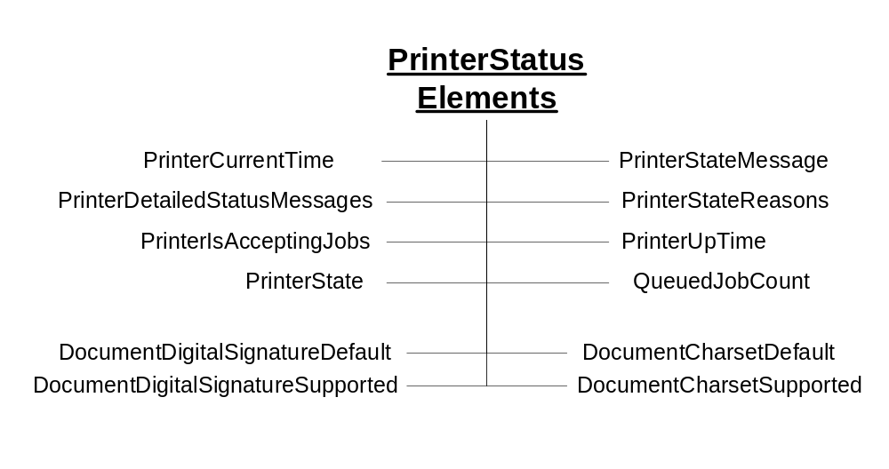
Figure 3 Printer Status Elements
The “PrinterState” element is one of the most important Printer Status elements. Figure 4 shows the values of the “PrinterState” element and the Printer life cycle as affected by actions on the Printer and job processing.
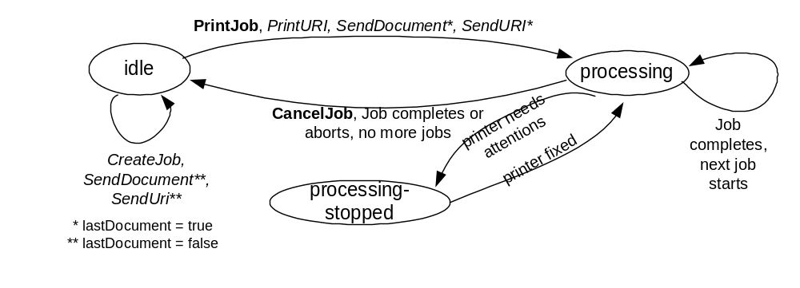
Figure 4 - The "PrinterState" element and the Printer Life Cycle

Printer Description Elements
Figure 5 below shows the Printer Description Elements. These elements contain information that describes the printer such as its make, where it’s located and its speed. An automaton controls some of the elements in this group (e.g. “PagesPerMinute”). Others elements in this group can be modified by Operators or Administrators (e.g. “PrinterName”). The semantics of the elements are summarized in Table 6.
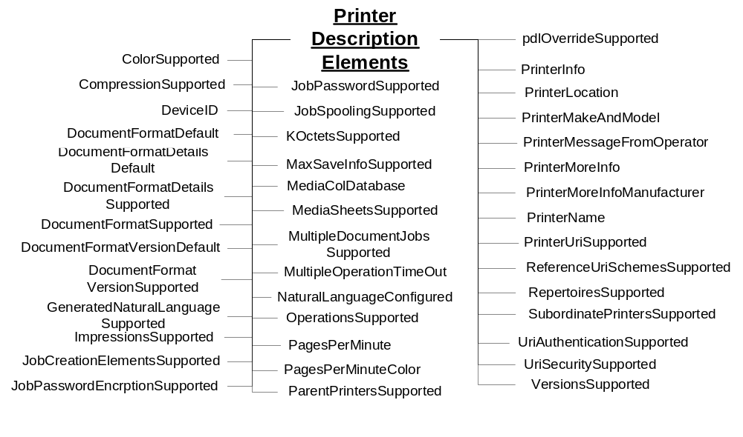
Figure 5 Printer Description Elements

Printer Defaults, Supported and Ready Processing Elements
See section 4.5 below for the elements that may comprise these groups. Processing Elements are the union of Job Processing Elements and Document Processing Elements. If a Processing element (e.g. Media) is supported, the Printer must have an associated Processing Supported Element (e.g. MediaSupported) and Processing Default Element (e.g. MediaDefault) Printer element. There may be an associated Processing Ready Element (e.g. MediaReady) Printer element. By retrieving the Printer Processing elements, a Client can determine all the Job and Document Processing elements and values that may be used in creating Jobs and Documents.
All Processing Supported, Processing Ready and Processing Default Elements have an associated Processing Element. There are Printer Description Elements with a “Supported” suffix (e.g. ImpressionsSupported). While they do list the valid values for the base element (e.g. Impressions), they are not Processing Supported Elements. The difference is the containing group for the base element. Note that the Impressions element is a member of the Job and Document Description groups.

Processing Supported Elements
These elements list all the currently configured valid values for each Job Processing Element and Document Processing Element. Though the Printer is configured to support the feature, human intervention may be required to process the job (e.g. selected paper may have to be loaded into a tray).
The syntax for Processing Elements Supported is multi-valued when the associated processing element is a string. When syntax of the processing element is an integer, the syntax of the corresponding Processing Supported Element is usually RangeOfInteger that indicates the minimum and maximum values supported by the Printer. However, there are some exceptions as indicated in Table 1.
Table 1-Integer syntax whose ProcessingElementSupported syntax isn’t RangeOfInteger
“xxx” element name | “xxx” syntax | “xxxSupported” syntax
JobPriority | Integer | Integer (Max value)
Copies | Integer | Integer (Max value)
PageRanges | RangeOfInteger (Multivalued) | Boolean (are PageRanges supported)

Processing Default Elements
These elements give the default value for the associated processing instruction if the Processing Element of the job and document are not supplied and the instructions is not embedded in the PDL. The syntax for the Processing Default Elements is the same as the corresponding Processing Element. The only exception is that the PageRanges element does not have a PageRangesDefault element.

Processing Ready Elements
These elements give the features available without human intervention. The syntax for a Processing Ready Element is the same as the corresponding Processing Element.

Job Object Class
The Job object class is represented by a collection of elements divided into six groups as shown in Figure 2. The Job class also contains the document class
Job Status Elements – See Section 4.3.1
Job Description Elements – See section 4.3.2.
Job Processing Elements – See section 4.5.1
Document Processing Elements – See section 4.5.2
Job Processing Actual Elements – See section 4.6.1
Document Processing Actual Elements – See section 4.6.2

Job Status Elements
Figure 6 below shows the Job Status Elements. These elements reflect the status of the Job as a whole. Automata primarily control the elements in this group. Clients cannot directly modify their values. The Client can affect the values of these elements through actions (e.g. CancelJob can change the value of JobStateReasons”). The semantics of the Job Status elements are summarized in Table 4.

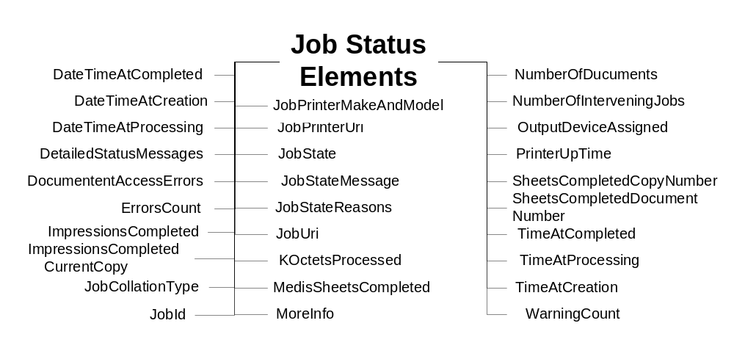
Figure 6 Job Status Elements

The Job Life Cycle
The “JobState” element is one of the most important Job Status elements. Figure 7 shows the values of the “JobState” element and the Job life cycle as affected by actions on the Job, Printer, and job processing.
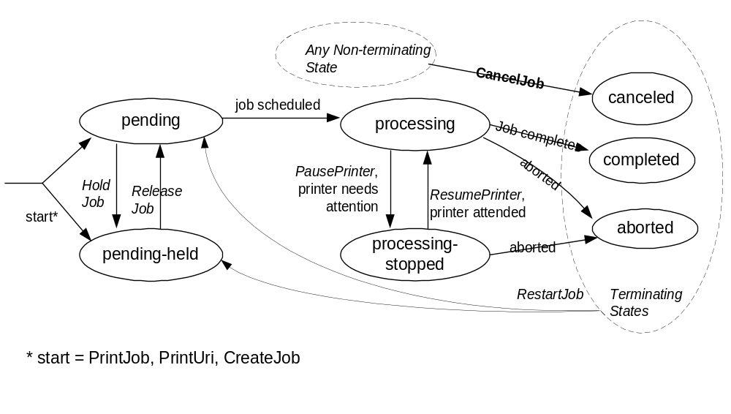
Figure 7 The "JobState" Job Element and the Job object life cycle

Job Description Elements
Figure 8 below shows the Job Description Elements. These elements contain information supplied by the Client at Job creation that describes the Job such as its name. The Printer may modify the value of some of the elements in this group (e.g. “KOctets”) if more reliable data is obtained. The semantics of the Job Description elements are summarized in Table 4.

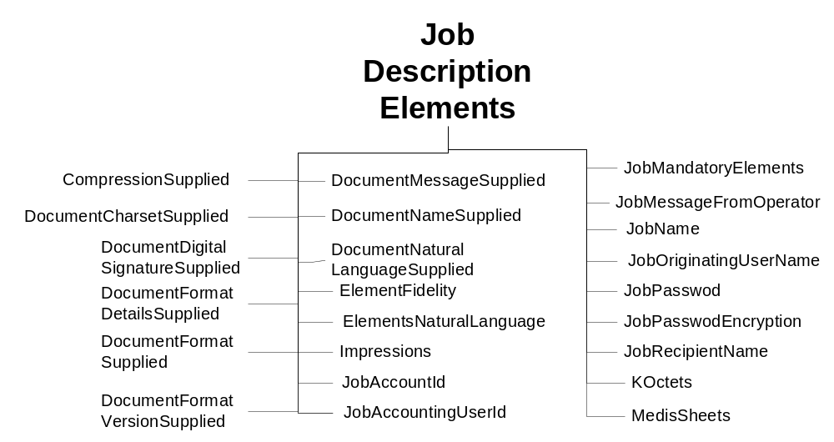
Figure 8 Job Description Elements

Document Object Class
The Document object class is represented by a collection of elements divided into four groups as shown in Figure 2. The Document class contains the document class
Document Status Elements – See Section 4.4.1.
Document Description Elements – See section 4.4.2.
Document Processing Elements – See section 4.5.2
Document Processing Actual Elements – See section 4.6.2

Document Status Elements
Figure 9 shows the Document Status Elements. These elements reflect the status of each Document indivually. Automata primarily control the elements in this group. Clients cannot directly modify their values. The Client can affect the values of these elements through actions (e.g. CancelDocument can change the value of DocumentState”). The semantics of the Document Status elements are summarized Table 5.
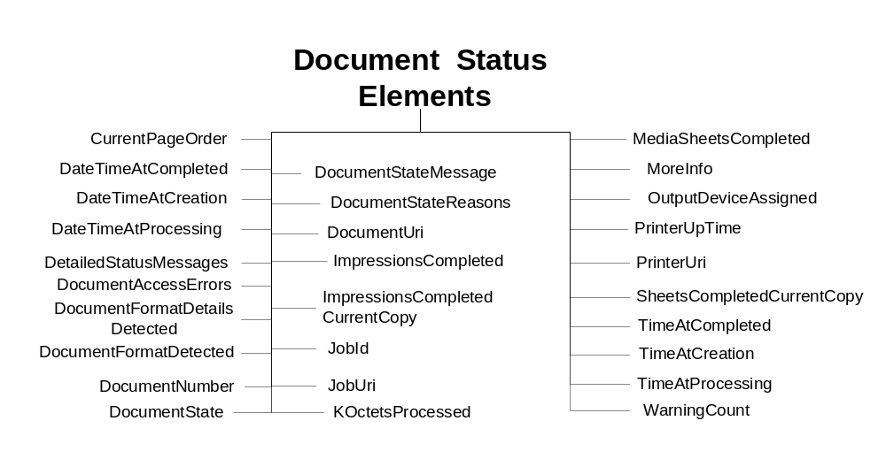
Figure 9 Document Status Elements

The Document Life Cycle
The “DocumentState” element is one of the most important Document Status Elements. Figure 10 shows the values of the “DocumentState” element and the Document life cycle as affected by Actions and job processing. Documents are not active objects and their life cycle is closely tied to the lifecycle of a Job. Documents basically have three states. The first is waiting to be processed by a Job (i.e., pending). The second state is from the time the Job first starts processing the Document (i.e., processing) and until it reaches its terminating state. The last state for a Document is its terminal state (i.e., completed, canceled, aborted)
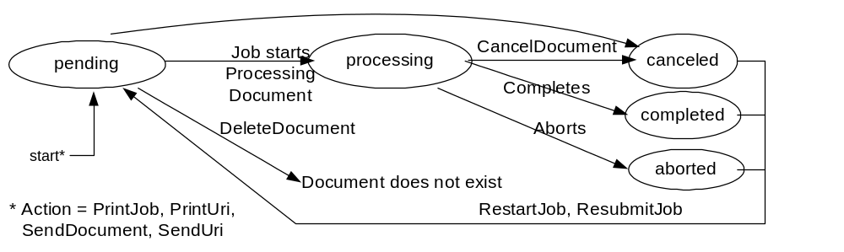
Figure 10 "DocumentState" Element and Document object life Cycle

Document Description Elements
Figure 11 below shows the Document Description Elements. These elements contain information supplied by the Client at Document creation that describes the document such as its size. The Printer may modify the value of some of the elements in this group (e.g. “KOctets”) if more reliable data is obtained. The semantics of the Document Description elements are summarized in Table 5.
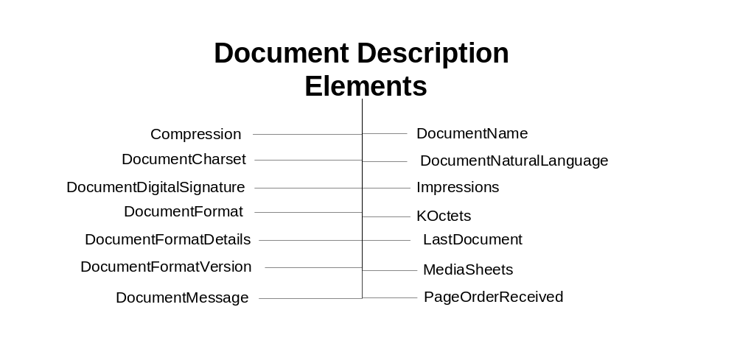
Figure 11 Document Description Elements

Processing Elements
Processing elements are instructions that the Client supplies to the Printer to be applied to jobs and documents. They indicate such things as the priority for scheduling a job or the number of copies for a document. A Printer should support each Processing Element that represents a feature of the Printer. The Processing elements are split into two groups. One groups applies to Jobs and the other to Documents.
- Job Processing Elements are processing instructions applied the Job level. See section 4.5.1.
- Document Processing Elements are specific to documents. See section 4.5.2.

Job Processing Elements
Figure 12 shows the Job Processing Elements. These elements define features supplied by the Client at Job creation. The Printer applies these elements to the Job as a whole (e.g., “JobPriority”) as opposed to each document in the Job (e.g., “Media”). The semantics of the Job Processing elements are summarized in Table 3.

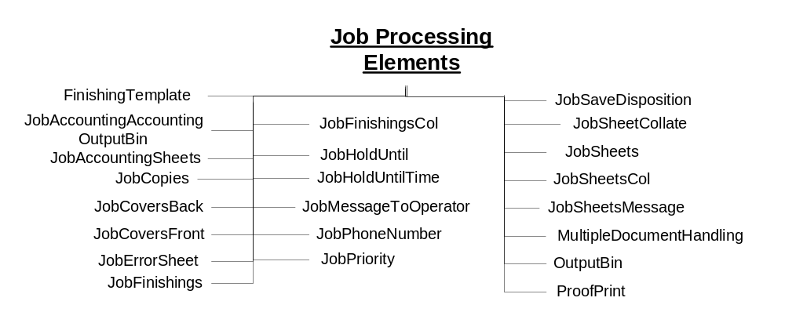
Figure 12 Job Processing Elements

Document Processing Elements
Figure 13 shows the Document Processing Elements. These elements define features supplied by the Client at Document creation. The Printer applies these element to each Document individually (e.g. “copies”) to create final output products. Included in these elements is how multiple physical sheets are manipulated or how the logical pages look on the output media or they determine the quality and resolution of how marks are made on a page. The semantics of the Document Processing elements are summarized in Table 3.
The Client supplies Document Processing Elements at the Job or Document level. If these elements are supplied at the Job level, the Printer applies them as the default values for all the Documents in the Job. If the elements are supplied at the Document level, the Printer applies them only to that Document.
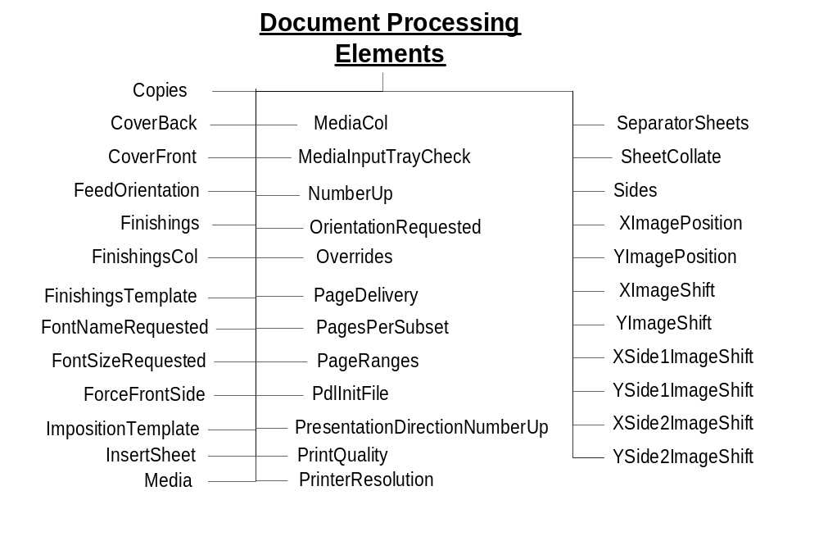
Figure 13 Document Processing Elements

Processing Actual Elements
See section 4.5 above for the elements that may map to elements in these groups. The Processing Actual elements are optional Job and Document element that records what processing elements were used in a Job and its Documents. The mapping between the Processing element and the Processing Actual element is by taking the Processing element name and appending the suffix “Actual”. The Processing Actual elements are always multivalued.
Any Processing element may have a related ProcessingActual element that shows what was applied to the Job or Document. It is not necessary for the Printer to support the Processing element for it to support the associated ProcessingActual element. By retrieving the Printer Processing Actual elements after a job completes, a Client can determine all the Job and Document Processing elements and values that were used in processing the Job and its Documents. (See [actual])

Job Processing Actual Elements
See section 4.5.1above for the base elements that map to elements in this group. The Job Processing Actual Element can only appear in the Job object.

Document Processing Actual Elements
See section 4.5.2 above for the base elements that map to elements in this group. The Document Processing Actual Element can appear in the Job and Document objects.

Actions
The PWG has defined a number of operations that affect Printers, Jobs and their document. Below is a description of the semantics of these Actions. Naturally different protocol bindings will use differing subsets of the Actions or define new ones. Another difference will be the precise parameters to the Actions. Below is an abstract definition of the Actions. Action Summary
The Print Service Interface [PSI] has introduced additional operations or PSI specific mappings of existing actions. These are included below to show a concrete mapping of the PWG Semantic Model and an application specific extension of the model. Consult the PSI specification [PSI] for the exact definitions.
This table summarizes the actions defined for the Job and Printer. The rest of section 5 provides more details on the semantic of the actions.
Job Creation and Document submission | Job and Document Control | Status and Information access | Printer Control
CreateJob | CancelCurrentJob | GetDocumentElements | ActivatePrinter
PrintJob | CancelDocument | GetDocuments | DeactivatePrinter
PrintUri | CancelJob | GetJobElements | DisablePrinter
SendDocument | DeleteDocument | GetJobs | EnablePrinter
SendURI | HoldJob | GetPrinterElements | HoldNewJobs
ValidateDocument | PromoteJob | GetPrinterSettableElementValues | PausePrinter
ValidateJob | ReleaseJob |  | PausePrinterAfter  CurrentJob
 | ReprocessJob |  | PurgeJobs
 | RestartJob |  | ReleaseHeldNew  Jobs
 | ResumeJob |  | RestartPrinter
 | ScheduleJobAfter |  | ResumePrinter
 | SetDocumentElements |  | SetPrinterElements
 | SetJobElements |  | ShutdownPrinter
 | SuspendCurrentJob |  | StartupPrinter
Table 2 - Summary of Actions

Job Creation and document submission Actions
This section describes the Job Creation actions that create a Job and the ones that create add Document to a Job. The Job Creation actions are: PrintJob, PrintUri, and CreateJob. The PrintJob action also submits the Document. The PrintUri action submits a URI reference to the Document that the Printer then retrieves when needed at a later time. The CreateJob action only creates the job and the Client must issue subsequent SendDocument and SendUri actions in order to submit document content or a URI reference, respectively, for a job.
Processing instructions and descriptive information contained in the arguments of the Job Creation action are combined with Printer supplied information to create a Job instance.
The last action in this section is ValidateJob. This operation allows a Client to send a request with all the information to create a Job, except the document content. The Printer does not create a Job but informs the client whether a CreateJob, PrintJob or PrintUri with the same information would have succeeded. This is useful for allowing a Client to verify the processing instructions before sending a large PrintJob request.
A concept that is important in the PWG model is a set of instructions that can be applied to a print job. Examples of these instructions include the number of copies and the media to use. These instructions are referred to as Processing Elements. The Processing Elements are made up of the Job Processing Elements (see section 4.5.1) and the Document Processing Elements (see section 4.5.2) sent in a Job or Document Creation Action.
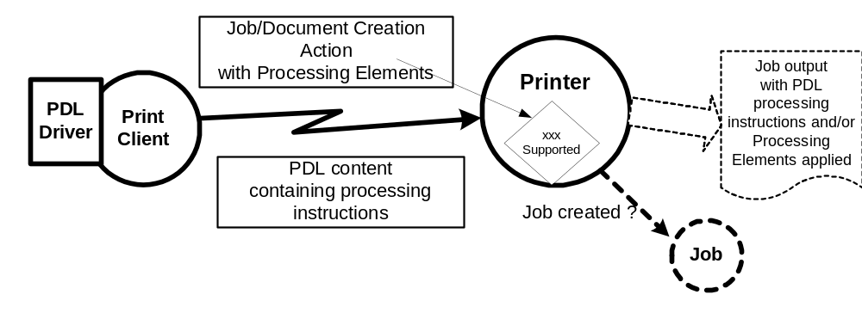
Figure 14 Processing Instruction Processing
In the real world, processing instructions are also contained in the document content for a job. Page Description Languages (PDL) such as PostScript® and PCL® often contain processing instructions. Some environments use a printer specific driver to generate the PDL stream based on feature selections made through a user interface. Given that processing instructions can occur in both the PDL and in an associated Job, the PWG model allows a Printer to declare its capability to resolve this conflict. The Printer’s element “PdlOverride” declares if an attempt will be made to override the instructions in the PDL with the instructions in the Job.
There are a wide variety of capabilities in Printers. An instance of a Printer is to subject to changes in its configured capabilities. An example would be an administrative change in the media the Printer supports or disabling two-sided printing. Clients need not check the capabilities of a Printer before creating their Job Processing Elements and submitting a job. Since this is a client/server paradigm, it is always possible that the capabilities could change after checking a Printer’s capabilities and before a Job is submitted. On the other hand, a client may use the Printer’s configured capabilities to create their Job Processing Elements and submit a job.
The PWG model allows a client to control the Printer’s acceptance of a job submission based on the job request and the Printer’s current configured capabilities as follows. When the client supplies a ‘true’ value for the “ElementFidelity” Job Processing element, the Printer must reject the job unless the Printer supports all of the supplied Job Processing elements and values. When the client supplies a ‘false’ value or omits the element, the Printer must accept the job submission and ignore or substitute elements and values, respectively, that it does not support. Note that the “ElementFidelity” Job Processing element covers only the creation of the Job. It is implementation specific how a Printer handles processing a job when the Printer encounters unsupported processing instructions in the document content.

CreateJob
([rfc2911] §3.2.4) Similar to the PrintJob operation (see section 5.1.3), except that in the CreateJob request the Client does not supply Document Data. The client supplies a single set of Job Processing elements that the Printer applies to the Output Document(s) of the job. The “MultipleDocumentHandling” Job Processing element controls whether the Printer produces separate Output Documents or combines the Input Documents into a single Output Document (see section 25).

CloseJob
([doc-obj] section 4.3) Closes a print job that was created with a CreateJob operation (see section 5.1.1) and one or more SendDocument and/or SendUri operations (see sections 5.1.5 and 5.1.6) This action sets the LastDocument element (see section 4.4.2) of the last Document in the Job to ‘true’. CloseJob is semantically equivalent to a SendDocument or SendUri action with the LastDocument element set to True. An explicit CloseJob is preferable to the implied closing of a Job using SendDocument or SendUri and the LastDocument element set to True.

PrintJob
([rfc2911] §3.2.1) Submit a print job with only one document and supply the document content data. If the Printer accepts the job, it creates the Job object and returns a unique “JobId” element for the Printer and a globally unique “JobUri” element. The Printer also sets the corresponding Job elements with these values.

PrintUri
([rfc2911] §3.2.2) Identical to the PrintJob operation (see section 5.1.3) except that a client supplies a URI reference to the document data.

The “MultipleDocumentHandling” Job Processing element
When a client submits a job with more than one Input Document, the “MultipleDocumentHandling” Job element allows the client to specify whether the Printer is to (1) produce corresponding separate Output Documents or (2) combine the Input Documents into a single Output Document. For example, the ‘single-document’ and ‘single-document-new-sheet’ values allow the client to staple all of the Input Documents into a single Output Document, with the latter value forcing each Input Document to start on a new sheet (useful when doing two-sided printing). When requesting multiple Copies, the ‘separate-document-uncollated-Copies’ value results in the Copies of each Input Document being together in an Output set, while the ‘separate-document-collated-Copies’ value keeps a copy of each Input Document together in an Output set. For example, a job with Input Documents A, B, C and “Copies” = 2 will result in A, A, B, B, C, C or A, B, C, A, B, C, respectively. If the Printer supports multiple documents per job, the Printer must support this Job Processing element with at least one value.

SendDocument
([rfc2911] §3.3.1, [doc-obj] §3) Submits the entire Document Content for the next Input Document of a job created by a previous CreateJob action (see section 5.1.1).

SendUri
([rfc2911] §3.3.2, [doc-obj] §3) Identical to the SendDocument operation (see section 5.1.5) except that a client supplies a URI reference to the Document Content data, instead of supplying the document content.

ValidateDocument
([doc-obj] §3) This operation is used only to verify capabilities of a Printer object against whatever elements are supplied by the client in the ValidateDocument request. By using the ValidateDocument action a client can validate that an identical SendDocument or SendUri would be accepted.

ValidateJob
([rfc2911] §3.2.3) This operation is used only to verify capabilities of a Printer object against whatever elements are supplied by the client in the ValidateJob request. By using the ValidateJob action a client can validate that an identical PrintJob, PrintUri or CreateJob would be accepted.

Job and Document Control Actions
This section describes the actions that allow a client to control a Job after it has been submitted: CancelJob, HoldJob, ReleaseJob, and RestartJob.

CancelCurrentJob
([admin-ops] §4.2) Allows a client to cancel the current Job in the “processing” or “processing-stopped” state.

CancelDocument
([doc-obj] §3) Prevents the processing of the specified Document if the Document has not yet been processed. Stops the processing of any active Document in an implementation specific manner.

CancelJob
([rfc2911] §3.3.3) Allows a client to cancel a Print Job from the time the Job is created up to the time it is completed, canceled, or aborted.

DeleteDocument
([doc-obj] §3) Removes the Document and its content from the Job.

HoldJob
([rfc2911] §3.3.5) Allows a client to hold a pending Job in the Printer so that it is not eligible for scheduling.

PromoteJob
([admin-ops] §4.4.1) Allows a client to make the pending target job be processed after the current job completes.

ReleaseJob
([rfc2911] §3.3.6) Release a previously held Job so that it is again eligible for scheduling.

ReprocessJob
([admin-ops] §4.1) Allows a client to re-process a copy of a job retained after processing was completed. This operation is the similar to RestartJob except that a new job that is a copy of the target job is created and processed.

RestartJob
([rfc2911] §3.3.7) Restart a job that is retained in the Printer after processing has completed.

ResumeJob
([admin-ops] §4.3.2) Resume the job at the point where it was suspended.

ScheduleJobAfter
([admin-ops] §4.4.2) Request the target job be processed immediately after the specified job

SetDocumentElements
([doc-obj] §3) Set the values of the supplied Document Processing and Document Description elements of the indicated Document. (Was SetDocumentAttributes)

SetJobElements
([rfc3380] §4.2) Set the values of the supplied Job Processing, Document Processing and Job Description elements of the indicated Job. (Was SetJobAttributes)

SuspendCurrentJob
([admin-ops] §4.4.2) Stop the current job and allow other jobs to be processed instead.

Status and information Actions
This section describes the actions that allow a client to obtain status and elements of Jobs and Printers: GetJobs, GetPrinterElements, GetJobElements and GetPrinterSupportedValues.

GetDocumentElements
([doc-obj] §3) Returns the requested Document elements or element groups in the indicated Document in the indicated Job. (Was GetDocumentAttributes)

GetDocuments
([doc-obj] §3) Returns the requested Document elements or element groups in all Documents in the indicated Job.

GetJobElements
([rfc2911] §3.3.4) Returns the values of the requested job elements and/or element groups of a Job (i.e., Job Description, Job Status, Job Processing and Document Processing). (Was GetJobAttributes)

GetJobs
([rfc2911] §3.3.4) Retrieve the list of Jobs belonging to the Printer. The Client may supply some simple filters (e.g. “MyJobs, “Limit) to control which jobs will be returned. The Client may supply a list of Job element and/or element group names to be returned in the response (See 5.3.3). A group of Job elements will be returned for each returned Job.

GetPrinterElements
([rfc2911] §3.2.5) Returns the values of the requested printer elements and/or element groups of a Printer (i.e. Printer Status, Printer Description, Processing Supported, Processing Default, Processing Ready). (Was GetPrinterAttributes)

GetPrinterSettableElementValues
([rfc3380] §4.3) Returns the possible values of each of the requested Printer Processing and Printer Description elements that may be set with the SetPrinterElements action. (Was GetPrinterSupportedValues)

Printer Control Actions
This section describes actions which allow a client to control a Printer and may require operator credentials: PausePrinter, ResumePrinter, PurgeJobs, DisablePrinter, EnablePrinter, and SetPrinterElements.

ActivatePrinter
([admin-ops] §3.4.2) The Printer will now start sending jobs to its Output Devices or Subordinate Printers and begin accepting all requests.

DeactivatePrinter
([admin-ops] §3.4.1) The Printer will now stop sending any more jobs to its Output Devices or Subordinate Printers and begin refusing all requests except ActivatePrinter, SendDocument, and SendUri requests and query requests.

DisablePrinter
([adm-ops] §3.1.1) Prevents the Printer from accepting any more Job Creation operations. The Printer sets the PrinterIsAcceptingJobs Printer Status element to ‘false’.

EnablePrinter
([adm-ops] §3.1.2) Allows the Printer to start accepting Job Creation operations. The Printer sets the PrinterIsAcceptingJobs Printer Status element to ‘true’.

HoldNewJobs
([admin-ops] §3.3.1) Complete the current 'pending' and 'processing' Jobs but do not start processing any subsequently created Jobs.

PausePrinter
([rfc2911] §3.2.7) Stops the Printer object from scheduling jobs. Job processing should also cease.

PausePrinterAfterCurrentJob
([admin-ops] §3.2.1) Stops the Printer from starting to send jobs to any of its Output Devices or Subordinate Printers.

PurgeJobs
([rfc2911] §3.2.9) Removes all jobs from the Printer, regardless of their state.

ReleaseHeldNewJobs
([admin-ops] §3.3.2) Undo the effect of HoldNewJobs and release all Jobs held as a consequence of HoldNewJobs.

RestartPrinter
([admin-ops] §3.5.1) This action has the effect of a software re-boot.

ResumePrinter
([rfc2911] §3.2.8) Resume the processing and scheduling of Jobs in the Printer.

SetPrinterElements
([rfc3380] §4.1) Set the values of the supplied Printer Processing and Printer Description elements. (Was SetPrinterAttributes)

ShutdownPrinter
([admin-ops] §3.5.2) Stop processing jobs without losing any jobs and make the Printer no longer available for any Actions.

StartupPrinter
([admin-ops] §3.5.3) Allows a hosted implementation of the Printer to be started after the host is available.

Globalization
The two aspects of globalization being addressed are the character sets and natural language of the human readable strings. Determining what character set is being used is left up to the protocol mapping of this semantic model. The natural language being used is represented in the Printer and the Job. The Printer declares the natural language it uses for all its semantic elements of type string. Administrators are free to change the localization and the values in the string elements. Each job creator declares the natural language for the Job and all its contained Documents. Not all string elements are treated the same.
Any semantic element that is labeled type1, type2 or type3 keyword in the constraint column is the following tables do not have any globalization issues from the Printer’s point of view. They are simply a sequence of octets that have a semantic meaning attached to them. The fact that the sequence of octets can be interpreted as ASCII strings is unimportant. The keywords are intended for consumption by automata. We leave it to Client implementations to determine how the keywords will be presented to end-users.
There are also strings with specific formats. These formats are URI, URI Scheme, MIME, IEEE 1284 and DateTime. Any semantic element whose string value must adhere to one of the previous formats is excluded from this discussion.
There are a few elements whose value is set by automata. Those values are “JobStateMessage”, “DocumentStateMessage” and “PrinterStateMessage”. If the semantic model is mapped to a protocol that allows the Client to request a language, the Printer will return these strings in the requested language if possible.
All the remaining Printer element strings are assumed to be in the Printer’s language. All the remaining Job element strings are assumed to be in the language of the Job.

Summary of elements
This section summarizes the elements for the Document, Job and Printer objects. Included in the definition are the processing elements that can be applied at either the Job or Document level. For each element, the tables contain the element name, whether the element is multi-valued, its syntax, constraints, a short description and a reference to the Document where the semantics of the element is completely specified. The basic syntax types are “Boolean”, “String” and “Integer”. “Complex” types are a container for elements of any type. Members are listed in the description field. “RangeOfInteger” is a complex type that contains “Upperbound” and “Lowerbound” integer value members. “Resolution” is a complex type that contains “CrossFeedDir” and “FeedDir” integer value members and a “Units” string value member.

Processing Elements (Job and Document)
* Group key: J=Job Processing Elements, D=Document Processing Elements
Table 3 - Processing Elements (Job and Document)
Processing Element Name |  |  |  | Multivalued |  |  |  |  |  |  | Syntax |  |  |  |  | Constraint |  |  | Group* |  |  |  |  |  | Reference
 | Description (values)
Copies |  |  |  |  |  |  |  |  | Integer |  |  |  |  |  |  | 1:MAX |  |  | D |  |  |  |  |  | [rfc2911] §4.2.5
 | The number of copies of the Output Document(s) to be printed. (See also JobCopies Job element)
CoverBack |  |  |  |  |  |  |  |  | complex |  |  |  |  |  |  |  |  |  | D |  |  |  |  |  | [PWG5100.3] §3.1
 | The back cover to apply this Document. (Includes Media/MediaCol, CoverType)
CoverFront |  |  |  |  |  |  |  |  | complex |  |  |  |  |  |  |  |  |  | D |  |  |  |  |  | [PWG5100.3] §3.1
 | The front cover to apply to this Document. (Includes Media/MediaCol, CoverType)
CoverType |  |  |  |  |  |  |  | String |  |  |  |  |  | Type2 keyword |  |  |  |  | D |  |  |  |  | [PWG5100.3] §3.1.2
 | Indicates if covers are requested and which sides will contain print stream pages. (Keywords: NoCover, PrintNone, PrintFront, PrintBack, PrintBoth) (See CoverBack & CoverFront for use)
DocumentCopies |  | Yes |  |  |  |  | RangeOfInteger |  |  |  |  |  |  |  |  |  |  |  | J |  |  |  |  | [PWG5100.4] §5.1.3
 | Specifies which copies of a Document to apply the override Processing elements. (See Overrides for use)
DocumentNumbers |  | Yes |  |  |  |  |  | RangeOfInteger |  |  |  |  |  |  |  |  | 1:MAX |  | D |  |  |  |  | [PWG5100.4] §5.1.2
 | Specifies the documents in a Job for override processing. (See Overrides for use)
FeedOrientation |  |  |  |  |  |  |  |  | String |  |  |  |  |  |  | Type3 keyword |  |  |  |  | D |  |  |  | [prod-print2] §5.1
 | Specifies the media edge that is fed into the print engine from the paper tray. (Keywords: LongEdgeFirst, ShortEdgeFirst).
Finishings |  |  |  | Yes |  |  |  |  | String |  |  |  |  |  |  | Type2 keyword |  |  |  |  | D |  |  |  | [rfc2911] §4.2.6  [PWG5100.1] §2
 | Identifies the finishings that the Printer uses for each copy of the Output Document. (See also JobFinishings Job element) (Keywords: Bale, Bind, BindBottom, BindLeft, BindRight, BindTop, BookletMaker, Cover, EdgeStitch, EdgeStitchBottom,EdgeStitchLeft, EdgeStitchRight, EdgeStitchTop, Fold, JogOffset, None, Punch, SaddleStitch, Staple, StapleBottomLeft, StapleBottomRight, StapleDualBottom, StapleDualLeft, StapleDualRight, StapleDualTop, StapleTopLeft, StapleTopRight, Trim)
FinishingsCol |  |  |  |  |  |  |  |  | complex |  |  |  |  |  |  |  |  |  | D |  |  |  |  |  | [PWG5100.3] §3.2
 | Enables an end user to specify detailed finishing options not possible with the “Finishings” element for the Output Document. (See also JobFinishingsCol Job element) (Includes FinishingTemplate, Stitching)
FinishingTemplate |  |  |  |  |  |  |  | String |  |  |  |  | Maxlength=1023 |  |  |  |  |  | J,D |  |  |  |  | [PWG5100.3] §3.2.1
 | A string specifying some particular finishing operation. (See FinishingsCol/JobFinishingsCol for use)
FontNameRequested |  |  |  |  |  |  |  |  | String |  |  |  |  | Maxlength=255 |  |  |  |  | D |  |  |  | [prod-print2] §5.2
 | Specifies the font name if the document data is in a format that does not have inherent font information (e.g., ‘text/plain’), otherwise, this element is ignored.
FontSizeRequested |  |  |  |  |  |  |  |  | Integer |  |  |  |  |  | 1:MAX |  |  |  | D |  |  |  | [prod-print2] §5.3
 | Specifies the font size in points (1/72 of an inch) if the document data is in a format that does not have inherent font information (e.g., ‘text/plain’), otherwise, this element is ignored.
ForceFrontSide |  |  |  | Yes |  |  |  |  | Integer |  |  |  |  |  |  | 1:MAX |  |  | D |  |  |  | [PWG5100.3] §3.3
 | Forces the specified pages to be printed on the front side of a sheet of media. The pages of the output document start at 1.
ImpositionTemplate |  |  |  |  |  |  |  |  | String |  |  |  |  | Type2 keyword |  |  |  |  |  | D |  |  |  | [PWG5100.3] §3.4
 | Specifies imposition method for laying out finished page images onto the surface of output media. (Keywords: None, Signature)
InsertAfterPageNumber |  |  |  |  |  |  |  |  | Integer |  |  |  |  |  |  | 0:MAX |  |  | D |  |  |  |  | [PWG5100.3] §3.5.1
 | Specifies the input page after which the Insert Sheet will be placed. Pages are numbered starting at 1. A 0 value means in front of the first page. (See InsertSheet for use)
InsertCount |  |  |  |  |  |  |  |  | Integer |  |  |  |  |  |  | 0:MAX |  |  | D |  |  |  |  | [PWG5100.3] §3.5.2
 | Specifies the number of Insert Sheet to insert. (See InsertSheet for use)
InsertSheet |  |  |  | Yes |  |  |  |  | complex |  |  |  |  |  |  |  |  |  | D |  |  |  |  | [PWG5100.3] §3.5
 | Specifies how Insert Sheets are to be inserted into the sequence of media sheets that are produced for each copy of the documents. (Includes InsertAfterPageNumber, InsertCount, Media/MediaCol)
JobAccountingOutputBin |  |  |  |  |  |  |  |  | String |  |  |  |  | Type3 keyword |  |  |  |  | J |  |  |  |  | [PWG5100.3] §3.8.3
 | Specifies the output bin where the accounting sheet is to be placed. (See JobAccountingSheet for use) (Keywords: Top, Middle, Bottom, Side, Left, Right, Center, Rear, FaceUp, FaceDown, Large-Capacity, MyMailbox, StackerN, MailboxN, TrayN *Note: N is replaced by a cardinal number, *Note: See [PWG5100.2 §2.1 for description of keywords)
JobAccountingSheets |  |  |  |  |  |  |  |  | complex |  |  |  |  |  |  |  |  |  | J |  |  |  |  |  | [PWG5100.3] §3.8
 | Specifies the accounting sheet for a job. (Includes JobAccountingSheetsType, Media/ MediaCol, JobAccountingOutputBin).
JobAccountingSheetsType |  |  |  |  |  |  |  |  | String |  |  |  |  | Type3 keyword |  |  |  |  | J |  |  |  |  | [PWG5100.3] §3.8.1
 | Specifies the accounting sheet format for a job. (See JobAccountingSheets for use) (Keywords: None, Standard)
JobCopies |  |  |  |  |  |  |  |  | Integer |  |  |  |  |  |  | 1:MAX |  |  | J |  |  |  |  |  | [jobx] §4.1.1
 | The number of copies of the Job to be printed. (See also Copies Document Processing element)
JobCoverBack |  |  |  |  |  |  |  |  | complex |  |  |  |  |  |  |  |  |  | J |  |  |  |  |  | [jobx] §4.1.2
 | The back cover to apply this Job. (Includes Media/MediaCol, CoverType)
JobCoverFront |  |  |  |  |  |  |  |  | complex |  |  |  |  |  |  |  |  |  | J |  |  |  |  |  | [jobx] §4.1.3
 | The front cover to apply to this Job. (Includes Media/MediaCol, CoverType)
JobErrorSheet |  |  |  |  |  |  |  |  | complex |  |  |  |  |  |  |  |  |  | J |  |  |  |  |  | [PWG5100.3] §3.9
 | Specifies the error sheet for a job. (Includes JobErrorSheetType, JobErrorSheetWhen, Media/MediaCol).
JobErrorSheetType |  |  |  |  |  |  |  |  | String |  |  |  |  | Type3 keyword |  |  |  |  | J |  |  |  |  | [PWG5100.3] §3.9.1
 | Specifies the error sheet format for a job. (See JobErrorSheet for use) (Keywords: None, Standard)
JobErrorSheetWhen |  |  |  |  |  |  |  |  | String |  |  |  |  | Type2 keyword |  |  |  |  | J |  |  |  |  | [PWG5100.3] §3.9.2
 | Specifies the accounting sheet format for a job. (See JobErrorSheet for use) (Keywords: OnError, Always)
JobFinishings |  |  |  | Yes |  |  |  |  | String |  |  |  |  |  |  | Type2 keyword |  |  |  |  | J |  |  |  | [jobx] §4.1.4
 | Identifies the finishing that the Printer uses for each job copy of the Job. (See also Finishings Document element) (Keywords: None, Staple, Punch, Cover, Bind, SaddleStitch, EdgeStitch, StapleTopLeft, StapleBottomLeft, StapleTopRight, StapleBottomRight, EdgeStitchLeft, EdgeStitchTop, EdgeStitchRight, EdgeStitchBottom, StapleDualLeft, StapleDualTop, StapleDualRight, StapleDualBottom)
JobFinishingCol |  |  |  |  |  |  |  |  | complex |  |  |  |  |  |  |  |  |  | J |  |  |  |  |  | [jobx] §4.1.5
 | Enables an end user to specify detailed finishing options not possible with the “JobFinishings” element. (See also FinishingsCol Document element) (Includes FinishingTemplate, Stitching)
JobHoldUntil |  |  |  |  |  |  |  |  | String |  |  |  |  | Type3 keyword |  |  |  |  | J |  |  |  |  |  | [rfc2911] §4.2.2
 | Specifies the named time period during which the Job must become a candidate for printing. (keywords: NoHold, Indefinite, DayTime, Evening, Night, Weekend, SecondShift, ThirdShift)
JobHoldUntilTime |  |  |  |  |  |  |  |  | String |  |  |  |  | DateTime [rfc1123] |  |  |  |  |  |  | J |  |  |  | [prod-print2] §5.4
 | Specifies the date and time after which the Job must become a candidate for printing. (example: Fri, 03 May 2002 08:49:37 GMT)
JobMessageToOperator |  |  |  |  |  |  |  |  |  | String |  |  |  | Maxlength=1023 |  |  |  |  |  |  | J |  |  | [PWG5100.3] §3.10
 | Message from the end user to indicate something about the processing of this Job. (example: “Call 555-1234 before running this job”)
JobPhoneNumber |  |  |  |  |  |  |  |  | String |  |  |  |  |  | Maxlength=127 |  |  |  |  |  | J |  |  |  | [prod-print2] §5.5
 | Contains the contact telephone number for this Job.
JobPriority |  |  |  |  |  |  |  |  | Integer |  |  |  |  |  |  | 1:100 |  |  | J |  |  |  |  |  | [rfc2911] §4.2.1
 | Priority for scheduling the Job. A higher value specifies a higher priority.
JobSaveDisposition |  |  |  |  |  |  |  |  | Complex |  |  |  |  |  |  |  |  |  | J |  |  |  |  |  | [prod-print2] §5.7
 | Specifies that the Printer is to save the job as a file that can be re-printed on demand anytime in the future using the Print-URI operation (see section 5.1.4). ) (Includes SaveDisposition, SaveInfo)
JobSheets |  |  |  |  |  |  |  |  | String |  |  |  |  | type3 keyword |  |  |  |  | J |  |  |  |  |  | [rfc2911] §4.2.3  [PWG5100.3] §6.2
 | Specifies which job start/end sheet(s), will be printed with a job. (Keywords: None, Standard, JobStartSheet, JobEndSheet, JobBothSheets, FirstPrintStreamPage)
JobSheetsCol |  |  |  |  |  |  |  |  | complex |  |  |  |  |  |  |  |  |  | J |  |  |  |  | [PWG5100.3] §3.11
 | Allows the client to specify the media for the JobSheet. (Includes JobSheets, Media/MediaCol)
JobSheetMessage |  |  |  |  |  |  |  |  | String |  |  |  |  | Maxlength=1023 |  |  |  |  |  | J |  |  |  | [PWG5100.3] §3.12
 | Conveys a message that is delivered with the job.
Media |  |  |  |  |  |  |  |  | String |  |  |  |  | type3 keyword |  |  |  |  | D |  |  |  |  |  | [rfc2911] §4.2.11
 | The name of the medium that the Printer uses for all impressions of the Job. (Keyword examples: na_letter_8.5x11in, iso_a4_210x297mm, na_monarch_3.875x7.5in, choice_iso_a4_210x297mm_na_letter_8.5x11in. See [pwg5101.1])
MediaCol |  |  |  |  |  |  |  |  | complex |  |  |  |  |  |  |  |  |  | D |  |  |  |  | [PWG5100.3] §3.13
 | Enables a client end user to submit a list of media characteristics to the Printer as a way to more completely specify the media to be used than the Media element. (Includes MediaBackCoating, MediaColor, MediaFrontCoating, MediaGrain , MediaHoleCount, MediaInfo, MediaKey, MediaMaterial, MediaOrderCount, MediaPrePrinted, MediaRecycled, MediaSize, MediaThickness, MediaTooth, MediaType, MediaWeightMetric)
MediaBackCoating |  |  |  |  |  |  | String |  |  |  |  |  | Type3 keyword |  |  |  |  | D |  |  |  | [PWG5100.3] §3.13.10
 | Indicates the pre-process coating applied to the back of the media. (See MediaCol for use) (Keywords: None, Glossy, HighGloss, SemiGloss, Satin, Matte)
MediaColor |  |  |  |  |  |  | String |  |  |  |  |  | Type3 keyword |  |  |  |  |  | D |  |  |  | [PWG5100.3] §3.13.4
 | Indicates the desired color of the media being specified. (See MediaCol for use) (Keywords: no-color, white, pink, yellow, blue, green, buff, goldenrod, red, gray, ivory, orange (See [pwg5101.1] §4))
MediaFrontCoating |  |  |  |  |  |  | String |  |  |  |  |  | Type3 keyword |  |  |  |  |  | D |  |  | [PWG5100.3] §3.13.10
 | Indicates the pre-process coating applied to the front of the media. (See MediaCol for use) (Keywords: None, Glossy, HighGloss, SemiGloss, Satin, Matte)
MediaGrain |  |  |  |  |  | String |  |  |  |  |  |  | Type3 keyword |  |  |  |  |  |  | D |  |  | [prod-print2] §8.4.2
 | Indicates the grain of the media. (See MediaCol for use) (Keywords: XDirection, YDirection)
MediaHoleCount |  |  |  |  |  |  | Integer |  |  |  |  |  | 0:MAX |  |  |  |  |  | D |  |  |  | [PWG5100.3] §3.13.6
 | Indicates the number of pre-drilled holes in the desired media. (See MediaCol for use)
MediaInfo |  |  |  |  |  |  | String |  |  |  |  |  |  | Maxlength=255 |  |  |  |  | D |  |  |  | [PWG5100.3] §3.13.3
 | Specifies information that helps describe the media instance. Intended for human consumption. (See MediaCol for use)
MediaInputTrayCheck |  |  |  |  |  |  | String |  |  |  |  |  |  | Type3 keyword |  |  |  |  | D |  |  | [PWG5100.3] §3.14
 | Indicates that the characteristics of the media in the identified input tray must match the characteristics of the media identified by the "media" or "media-col" element. (Keywords: Top, Middle, Bottom, Side, LargeCapacity, Envelope, Main, Manual. See [RFC2911] Appendix C)
MediaKey |  |  |  |  |  |  |  |  | String |  |  |  |  | Type3 keyword |  |  |  |  | D |  |  |  | [PWG5100.3] §3.13.1
 | The name of the media represented as a keyword or name. Values are the same as the keyword and name values for the Media Document Processing element and represent the same media, except for media size and input tray keywords. (See MediaCol for use)
MediaMaterial |  |  |  |  |  |  |  |  | String |  |  |  |  | Type3 keyword |  |  |  |  | D |  |  |  | [prod-print] §8.4.3
 | The material of the media. (See MediaCol for use) (Keywords: Aluminum, DryFilm, Paper, Polyester, WetFilm)
MediaOrderCount |  |  |  |  |  |  |  |  | Integer |  |  |  |  |  |  | 1:MAX |  |  | D |  |  |  | [PWG5100.3] §3.13.7
 | Indicates the number of sheets, within an ordered sequence of sheets; after which the sequence begins to repeat. (See MediaCol for use)
MediaPrePrinted |  |  |  |  |  |  |  |  | String |  |  |  |  | Type3 keyword |  |  |  |  | D |  |  | [PWG5100.3] §3.13.11
 | Indicates the pre-printed characteristics of the desired media. (See MediaCol for use) (Keywords: Blank, PrePrinted, LetterHead)
MediaRecycled |  |  |  |  |  |  |  |  | String |  |  |  |  | Type3 keyword |  |  |  |  | D |  |  | [PWG5100.3] §3.13.10
 | Indicates the recycled characteristics of the media. (See MediaCol for use) (Keywords: None, Standard)
MediaSize |  |  |  |  |  |  |  |  | Complex |  |  |  |  |  |  |  |  |  | D |  |  |  | [PWG5100.3] §3.13.8
 | Explicitly specifies the numerical media width and height dimensions in hundredth of a millimeter. (See MediaCol for use) (Includes XDimension, YDimension)
MediaSizeName |  |  |  |  |  |  |  |  | String |  |  |  |  | Type3 keyword |  |  |  |  | D |  |  |  |  |  | [doc-obj] §8.1.
 | The medium size that the Printer uses for all impressions of the Job. (See MediaCol for use) (Keywords: na_letter_8.5x11in. See [pwg5101.1] §5)
MediaThickness |  |  |  |  |  |  |  |  | Integer |  |  |  |  | 1:MAX |  |  |  |  | D |  |  |  |  | [prod-print2] §8.4.4
 | The thickness of the media in units of one hundredth of a millimeter. This unit is equivalent to 1/2540 th of an inch. (See MediaCol for use)
MediaTooth |  |  |  |  |  |  |  |  | String |  |  |  |  | Type3 keyword |  |  |  |  | D |  |  |  |  | [prod-print2] §8.4.1
 | The tooth (or roughness) of the media. (See MediaCol for use) (Keywords: Fine, Medium, Coarse)
MediaType |  |  |  |  |  |  |  |  | String |  |  |  |  | Type3 keyword |  |  |  |  | D |  |  |  | [PWG5100.3] §3.13.2
 | The medium type that the Printer uses for all impressions of the Job. (See MediaCol for use) (Keywords: stationery, transparency envelope, envelope-plain, envelope-window, continuous, continuous-long, continuous-short, tab-stock, pre-cut-tabs, full-cut-tabs, multi-part-forms, labels, multi-layer, screen, screen-paged, photographic, cardstock, other See also [pwg5101.1] §3)
MediaWeightMetric |  |  |  |  |  |  |  |  | Integer |  |  |  |  |  |  | 0:MAX |  |  | D |  |  |  | [PWG5100.3] §3.13.9
 | Indicates the weight of the desired media rounded to the nearest whole number of grams per square meter. (See MediaCol for use)
MultipleDocumentHandling |  |  |  |  |  |  |  |  | String |  |  |  |  | type2 keyword |  |  |  |  | J |  |  |  |  |  | [rfc2911] §4.2.4
 | Controls whether Input Document in multi-Document jobs are combined into a single Output Document or are kept as separate Output Document Useful for application of Finishings and the placement of one or more print-stream pages into impressions and onto media sheets for multi-Document Jobs. (Keywords: SingleDocument, SeparateDocumentUncollatedCopies, SeparateDocumentCollatedCopies, SingleDocumentNewSheet)
NumberUp |  |  |  |  |  |  |  |  | Integer |  |  |  |  |  |  | 1:MAX |  |  | D |  |  |  |  |  | [rfc2911] §4.2.9
 | Indicates the number of Input pages that the Printer is to image on one impression.
OrientationRequested |  |  |  |  |  |  |  |  | String |  |  |  |  | type2 keyword |  |  |  |  | D |  |  |  |  |  | [rfc2911] §4.2.10
 | The desired orientation for printed pages for document formats that don’t have a built-in orientation. (Keywords: Portrait, Landscape, ReverseLandscape, ReversePortrait)
OutputBin |  |  |  |  |  |  |  |  | String |  |  |  |  | Type2 keyword |  |  |  |  | J,D |  |  |  |  | [PWG5100.2] §2.1 [doc-obj] §8.1
 | Specifies the output bin where the job is to be delivered. (Keywords: Bottom, Center, FaceDown, FaceUp, LargeCapacity, Left, MailboxN*, Middle, MyMailbox, Rear, Right, Side, StackerN*, Top, TrayN*. *Note: N is replaced by a cardinal number)
OutputDevice |  |  |  |  |  |  |  |  | String |  |  |  |  | Maxlength=255 |  |  |  |  | J,D |  |  |  |  | [jobx] §4.2.1 [doc-obj] §8.1
 | Specifies the device where the pages of of a Job/Document will be printed.
Overrides |  |  |  | Yes |  |  |  |  | complex |  |  |  |  |  |  |  |  |  | D |  |  |  |  |  | [PWG5100.4] §5.2
 | Provides for the overriding of processing instructions on a page basis. (Includes Pages DocumentNumbers, DocumentCopies and any processing element that affects pages)
PageDelivery |  |  |  |  |  |  |  |  | String |  |  |  |  | Type2 keyword |  |  |  |  | D |  |  |  |  | [PWG5100.3] §3.15
 | Indicates whether the pages of the job are to be delivered to the output bin or finisher in the same page order as the original document and face up or face down. . See the PageOrderReceived Document Description element and the CurrentPageOrder Document Status element. (Keywords: ReverseOrderFaceDown, ReverseOrderFaceUp, SameOrderFaceDown, SameOrderFaceUp, SystemSpecified)
Pages |  | yes |  |  |  |  | RangeOfInteger |  |  |  |  |  |  |  |  | 1:MAX |  |  | D |  |  |  |  | [PWG5100.4] §5.2.4
 | Specifies a range of pages in the document PDL data. (See Overrides for use)
PagesPerSubset |  | yes |  |  |  |  | Integer |  |  |  |  |  |  |  |  | 1:MAX |  |  | D |  |  |  |  | [PWG5100.4] §5.3
 | Combines all of the Pages of all of the Documents into a single stream of -Pages. Then the Printer partitions that single stream into contiguous subsets of -Pages according to the list of integers. The list of integers is cyclical. When the last integer in the list is reached, the next subset uses the first.in the list. Common use of subsets is a single value in the list.
PageRanges |  | yes |  |  |  |  | RangeOfInteger |  |  |  |  |  |  |  |  | 1:MAX |  |  | D |  |  |  |  | [RFC2911] §4.2.7
 | Specifies a range of pages in the document data to be output.
PdlInitFile |  | Yes |  |  |  |  |  |  | Complex |  |  |  |  |  |  |  |  |  |  |  | D |  |  |  | [prod-print2] §5.8
 | Controls initialization of the Printer’s Page Description Language (PDL) interpreter. (Includes PdlInitFileEntry, PdlInitFileLocation. PdlInitFileName)
PdlInitFileEntry |  |  |  |  |  |  |  |  | String |  |  |  |  |  | Maxlength=255 |  |  |  |  |  | D |  | [prod-print2] §5.8.1.3
 | Specifies an entry point within the init file at which the PDL interpreter starts. (See PdlInitFile for use)
PdlInitFileLocation |  |  |  |  |  |  |  |  | String |  |  |  |  | Maxlength=1023 |  |  |  |  |  | D |  |  | [prod-print2] §5.8.1.1
 | Contains a URL that specifies the path to the directory where the initialization file for the Printer’s PDL interpreter will be found. (See PdlInitFile for use)
PdlInitFileName |  |  |  |  |  |  |  |  | String |  |  |  |  |  | Maxlength=255 |  |  |  |  | D |  |  | [prod-print2] §5.8.1.2
 | Specifies the name of the PDL interpreter’s initialization file within the directory specified by the PdlInitFileLocation element. (See PdlInitFile for use)
PresentationDirectionNumberUp |  |  |  |  |  |  |  |  | String |  |  |  |  | Type2 keyword |  |  |  |  | D |  |  |  |  | [PWG5100.3] §3.17
 | Specifies the placement order of the page images on a Finished-Page Image with the "number-up" element. (Keywords: TorightTobottom, TobottomToright, ToleftTobottom, TobottomToleft, TorightTotop, TotopToright, ToleftTotop)
PrintContent Optimize |  |  |  |  |  |  |  |  | String |  |  |  |  | type2 keyword |  |  |  |  | J,D |  |  |  |  |  | [jobx] §4.2.2 [doc-obj] §8.1
 | directs the type of optimization/processing that will be performed on the Document content. It does not necessarily mean the value describes the content.. (Keywords: Photo, Graphics, Text, TextAndGraphics)
PrintQuality |  |  |  |  |  |  |  |  | String |  |  |  |  | type2 keyword |  |  |  |  | D
 | The print quality that the Printer uses for the Job. (Keywords: Draft, Normal, High)
PrinterResolution |  |  |  |  |  |  |  |  | resolution |  |  |  |  |  |  |  |  |  | D |  |  |  |  |  | RFC2911] §4.2.12
 | The resolution that Printer uses for the Job in cross-feed and feed direction in units of dpi or dpcm.
ProofPrint |  |  |  |  |  |  |  |  | Complex |  |  |  |  |  |  |  |  |  |  |  | J |  |  | [prod-print2] §5.9
 | Specifies the elements for zero or more proof prints of the job that are to be printed prior to the printing the full run of the job. (Includes ProofPrintCopies , Media/MediaCol and any other Processing elements).
ProofPrintCopies |  |  |  |  |  |  |  |  | Integer |  |  |  |  |  | 0:MAX |  |  |  |  |  | J |  |  | [prod-print2] §5.9.1
 | Specifies the number of proof prints to be printed prior to the printing the full run of the job. (See ProofPrint for use)
SaveDisposition |  |  |  |  |  |  |  |  | String |  |  |  |  |  |  | type3 keyword |  |  | J |  |  |  |  | [prod-print2] §5.7.1.1
 | Specifies whether the Printer must print and/or save the job. (See JobSaveDisposition for use) (Keywords: None, PrintSave, SaveOnly)
SaveDocumentFormat |  |  |  |  |  |  | String |  |  |  |  | MimeMediaType [rfc2046], [rfc2048] |  |  |  |  |  | J |  |  |  | [prod-print2] §5.7.1.2.3.3
 | Indicates the document format in which the Printer saves the Document Data. (See DocumentFormat Document Description element) (See SaveInfo for use)
SaveInfo |  | Yes |  |  |  |  |  |  | complex |  |  |  |  |  |  |  |  |  | J |  |  |  |  | [prod-print2] §5.7.1.2
 | Contains sets of elements that each tells the Printer how to create each copy of the saved job. (See JobSaveDisposition for use) (Includes SaveLocation, SaveName, SaveDocumentFormat)
SaveLocation |  |  |  |  |  |  |  |  | String |  |  |  |  | Maxlength=1023 |  |  |  |  | J |  |  |  |  |  | [prod-print2] §5.7.1.2.3.1
 | Specifies the path to the directory as a URI where the Printer saves the Document Data and other Job information. (See SaveInfo for use)
SaveName |  |  |  |  |  |  |  |  | String |  |  |  |  |  |  | Maxlength=255 |  |  | J |  |  |  |  | [prod-print2] §5.7.1.2.3.2
 | Specifies the name of the saved job in the directory specified by the “save-location” member element. The value may be a relative path. (See SaveInfo for use)
SeparatorSheets |  |  |  |  |  |  |  |  | complex |  |  |  |  |  |  |  |  |  | D |  |  |  |  | [PWG5100.3] §3.18
 | Specifies the separator sheets to be printed with the Document. (Includes SeparatorSheetsType, Media/MediaCol)
SeparatorSheetsType |  |  |  |  |  |  |  |  | String |  |  |  |  | Type3 keyword |  |  |  |  | D |  |  |  | [PWG5100.3] §3.18.1
 | Specifies the separator sheets type. (See SeparatorSheets for use) (Keywords: None, SlipSheets, StartSheet, EndSheet, BothSheets)
SheetCollate |  |  |  |  |  |  |  |  | String |  |  |  |  | Type2 keyword |  |  |  |  | D |  |  |  | [rfc3381] §3.1
 | Specifies if the media sheets of each copy of each printed document in a job are to be in sequence. (Keywords: Uncollated, Collated)
Sides |  |  |  |  |  |  |  |  | String |  |  |  |  | type2 keyword |  |  |  |  | D |  |  |  |  |  | [rfc2911] §4.2.8
 | Indicates how an impression is to be placed upon the side(s) of the media. (Keywords: OneSided, TwoSidedLongEdge, TwoSidedShortEdge, TwoSidedLongEdge)
Stitching |  |  |  |  |  |  |  |  | complex |  |  |  |  |  |  |  |  |  | D |  |  |  |  | [PWG5100.3] §3.2.2
 | Provides detailed stitching parameters. (See FinishingsCol/JobFinishingsCol for use) (Includes StitchingReferenceEdge, StitchingOffset, StitchingLocations)
StitchingLocations |  |  |  | yes |  |  |  |  | Integer |  |  |  |  |  |  | 0:MAX |  |  | D |  |  |  | [PWG5100.3] §3.2.2.3
 | The distance along the stitching axis where a stitch will be placed in hundredths of a millimeter. (See Stitching for use)
StitchingOffset |  |  |  |  |  |  |  |  | Integer |  |  |  |  |  |  | 0:MAX |  |  | D |  |  |  | [PWG5100.3] §3.2.2.2
 | The perpendicular distance from the reference edge to the stitching axis in hundredths of a millimeter. (See Stitching for use)
StitchingReferenceEdge |  |  |  |  |  |  |  |  | String |  |  |  |  | type2 keyword |  |  |  |  | D |  |  |  | [PWG5100.3] §3.2.2.1
 | Specifies the stitching reference edge of the output media. (See Stitching for use) (Keyword: Bottom, Top, Left, Right)
XDimension |  |  |  |  |  |  |  |  | Integer |  |  |  |  |  |  | 0:MAX |  |  | D |  |  | [PWG5100.3] §3.13.8.1
 | Size of the media in hundredths of a millimeter along the bottom edge. (See MediaSize for use)
XImagePosition |  |  |  |  |  |  |  |  | String |  |  |  |  | type2 keyword |  |  |  |  | D |  |  |  | [PWG5100.3] §3.19.2
 | Causes the specified point of the Finished-Page Image to be positioned at a specified location. (Keywords: None, Center, Left, Right)
XImageShift |  |  |  |  |  |  |  |  | Integer |  |  |  |  |  |  | MIN:MAX |  |  | D |  |  |  | [PWG5100.3] §3.19.3
 | Causes the Finished-Page Image to be shifted in position with respect to the x-axis of the media. The unit of measure for this element is hundredths of a millimeter. The sign of the value indicates the direction of the shift.
Xside1ImageShift |  |  |  |  |  |  |  |  | Integer |  |  |  |  |  | MIN:MAX |  |  | D |  |  |  |  | [PWG5100.3] §3.19.4
 | Causes each Finished-Page Image that would be placed on the front side of a sheet to be shifted in position with respect to the x-axis of the media. The unit of measure for this element is hundredths of a millimeter. The sign of the value indicates the direction of the shift.
Xside2ImageShift |  |  |  |  |  |  |  |  | Integer |  |  |  |  |  | MIN:MAX |  |  | D |  |  |  |  | [PWG5100.3] §3.19.5
 | Causes each Finished-Page Image that would be placed on the backside of a sheet to be shifted in position with respect to the x-axis of the media. The unit of measure for this element is hundredths of a millimeter. The sign of the value indicates the direction of the shift.
YDimension |  |  |  |  |  |  |  |  | Integer |  |  |  |  |  |  | 0:MAX |  |  | D |  |  | [PWG5100.3] §3.13.8.2
 | Size of the media in hundredths of a millimeter along the left edge. (See MediaSize for use)
YImagePosition |  |  |  |  |  |  |  |  | String |  |  |  |  | type2 keyword |  |  |  |  | D |  |  |  | [PWG5100.3] §3.19.6
 | Causes the specified point of the Finished-Page Image to be positioned at a specified location. (Keywords: None, Center, Top, Bottom)
YImageShift |  |  |  |  |  |  |  |  | Integer |  |  |  |  |  |  | MIN:MAX |  |  | D |  |  |  | [PWG5100.3] §3.19.7
 | Causes the Finished-Page Image to be shifted in position with respect to the y-axis of the media. The unit of measure for this element is hundredths of a millimeter. The sign of the value indicates the direction of the shift.
Yside1ImageShift |  |  |  |  |  |  |  |  | Integer |  |  |  |  |  |  | MIN:MAX |  |  | D |  |  |  | [PWG5100.3] §3.19.8
 | Causes each Finished-Page Image that would be placed on the front side of a sheet to be shifted in position with respect to the y-axis of the media. The unit of measure for this element is hundredths of a millimeter. The sign of the value indicates the direction of the shift.
Yside2ImageShift |  |  |  |  |  |  |  |  | Integer |  |  |  |  |  |  | MIN:MAX |  |  | D |  |  |  | [PWG5100.3] §3.19.9
 | Causes each Finished-Page Image that would be placed on the backside of a sheet to be shifted in position with respect to the y-axis of the media. The unit of measure for this element is hundredths of a millimeter. The sign of the value indicates the direction of the shift.

Job Elements (Status and Description)
* Group Key: S=Status, D=Description
Table 4- Job Elements (Status and Description)
Job Element Name |  |  | Multivalued |  |  |  |  |  |  | Syntax |  |  |  |  | Constraint | Group* |  |  |  |  | Reference
 | Description (values)
CompressionSupplied |  |  |  |  |  |  |  |  |  | String |  |  |  | Type2 keyword |  |  | D |  |  | [jobx] §5.2.1
 | Default compression algorithm used for the Documents Data. (Keywords: None, Deflate, Gzip, Compress)
DateTimeAtCompleted |  |  |  |  |  |  |  |  | String |  |  |  | DateTime [rfc1123] |  |  |  |  | S |  | [rfc2911] §4.3.14.7
 | Indicates the date and time at which the Job completed. (example: Fri, 03 May 2002 08:49:37 GMT)
DateTimeAtCreation |  |  |  |  |  |  |  |  |  | String |  | DateTime [rfc1123] |  |  |  |  | S |  |  | [rfc2911] §4.3.14.5
 | Indicates the date and time at which the Job was created . (example: Fri, 03 May 2002 08:49:37 GMT)
DateTimeAtProcessing |  |  |  |  |  |  |  |  | String |  |  |  | DateTime [rfc1123] |  |  |  |  | S |  | [rfc2911] §4.3.14.6
 | Indicates the date and time at which the Job first began processing. (example: Fri, 03 May 2002 08:49:37 GMT)
DetailedStatusMessage |  |  |  | Yes |  |  |  |  |  | String |  |  | Maxlength=1023 |  |  |  | S |  |  | [rfc2911] §4.3.10
 | Specifies additional detailed and technical information about the job. Intended for use by the system administrator or other experienced technical persons and so is not localized by the Printer. (example: “PostScript error: stack overflow”) (Was JobDetailedStatusMessage)
DocumentAccessErrors |  |  |  |  | Yes |  |  |  |  | String |  |  | Maxlength=1023 |  |  |  | S |  |  | [rfc2911] §4.3.11
 | Information about each Document access error for this job encountered by the Printer. (example: “(404) http://www.company.com/pub/fileToPrint.pdf ”) (Was JobDocumentAccessErrors)
DocumentCharsetSupplied |  |  |  |  |  |  |  |  |  | String |  |  | Maxlength=63 |  |  |  | D |  |  | [jobx] §5.2.2
 | The default charset of the Documents content
DocumentDigitalSignatureSupplied |  |  |  |  |  |  |  |  |  |  | String |  |  | Type2 keyword |  |  | D |  |  | [jobx] §5.2.3
 | The type of digital signature, if any, used in the Document Content. (Keywords: dss, none, pgp, smime, xmldsig)
DocumentFormatDetailsSupplied |  |  |  |  | Yes |  |  |  | Complex |  |  |  | Complex |  |  |  | D |  |  | [jobx] §5.2.4
 | Summarizes the default distinct contained document formats when Document contains multiple files, i.e., the Document is a container DocumentFormat, such as ‘multipart/related’ or ‘application/zip’. For example, a container containing 100 PostScript files and 1 PCL file would have two sets of values. (Includes DocumentSourceApplicationName, DocumentSourceApplicationVersion, DocumentSourceOsName, DocumentSourceOsVersion, DocumentFormat, DocumentFormatDeviceId, DocumentFormatVersion, DocumentNaturalLanguage).
DocumentFormatSupplied |  |  |  |  |  |  |  | String |  |  |  | MimeMediaType [rfc2046], [rfc2048] |  |  |  |  | D |  |  | [jobx] §5.2.5
 | The default Document format (i.e., PDL) for Documents in the Job. The value “application/octet-stream” has a special meaning. This value is used to indicate that a Printer is capable of auto-sensing the format of the Document. The values “application/zip” and “multipart/related” are container formats for which DocumentContainerSummary gives additional information about the contained files. (Examples: application/octet-stream, application/postscript, application/vnd.hp-PCL, “text/plain; charset=utf-8”, application/zip, multipart/related)
DocumentFormatVersionSupplied |  |  |  |  |  |  |  |  | String |  |  | Maxlength=127 |  |  |  |  | D |  |  | [jobx] §5.2.6
 | The default level or version of the DocumentFormat. Values are either from the prtInterpreterLangLevel [rfc1759] or a standard designation. (examples: “3” for DocumentFormat=application/postscript’ “5e” for DocumentFormat=application/vnd.hp-pcl; “ISO 12639-1:1996” for TIFF/IT Profile 1)
DocumentMessageSupplied |  |  |  |  |  |  |  | String |  |  |  | Maxlength=1023 |  |  |  |  | D |  |  | [jobx] §5.2.7
 | A message from either (1) the user to the operator about the Documents or (2) from the operator, system administrator, or "intelligent" process to indicate to the end user the reasons for modification or other management action taken on the Documents.
DocumentNameSupplied |  |  |  |  |  |  |  | String |  |  |  | Maxlength=255 |  |  |  |  | D |  |  | [jobx] §5.2.8
 | The default name for the Documents in the Job to be used in an implementation specific manner.
DocumentNaturalLanguageSupplied |  |  |  |  |  |  |  |  |  |  | String |  |  | Maxlength=127 |  |  | D |  |  | [jobx] §5.2.9
 | Identifies the defailt Natural Language for the Documents in the Job.
ElementFidelity |  |  |  |  |  |  |  |  |  | Boolean |  |  |  |  |  | D |  |  |  | [rfc2911] §15.1,  [doc-obj] §8.1.1
 | Allows a user to control whether or not the Printer MUST honor all supplied Processing elements in the Job Creation operation. For a ‘true’ value the Printer rejects the job submission if any of the supplied Processing element values are unsupported. For a ‘false’ value the Printer MUST accept the job submission and do best effort. Default = ‘false’ NOTE: Use “JobMandatoryElements” to explicitly specify a subset of the supplied elements that the Printer MUST honor. (Was IPPAttributeFidelity)
ElementsNaturalLanguage |  |  |  |  |  |  |  |  | String |  |  |  | Natural language |  |  |  |  | D |  | [rfc2911] §4.3.20
 | Indicates the natural language of the elements with string syntax that were set by the End User. (Was AttributesNaturalLanguage)
ErrorsCount |  |  |  |  |  |  |  |  |  | Integer |  |  |  |  | MIN:MAX | S |  |  |  | [jobx] §5.1.1
 | The total number of errors that a Printer has generated while processing and printing a Job’s Document(s).
Impressions |  |  |  |  |  |  |  |  |  | Integer |  |  |  |  | 0:MAX |  | D |  |  | [rfc2911] §4.3.17.2
 | The total size in number of impressions in all the Job’s Document(s). (Was JobImpressions)
ImpressionsCompleted |  |  |  |  |  |  |  |  | Integer |  |  |  |  |  | 0:MAX |  | S |  |  | [rfc2911] §4.3.18.2
 | The number of impressions completed for the Job so far. (Was JobImpressionsCompleted)
ImpressionsCompletedCurrentCopy |  |  |  |  |  |  |  |  | Integer |  |  |  |  |  | 0:MAX |  | S |  |  | [rfc3381] §4.4
 | The number of impressions completed for the current iteration of this Job so far.
JobAccountId |  |  |  |  |  |  |  |  |  | String |  | Maxlength=255 |  |  |  | D |  |  | [PWG5100.3] §3.6
 | Account associated with this Job.
JobAccountingUserID |  |  |  |  |  |  |  |  | String |  |  | Maxlength=255 |  |  |  | D |  |  | [PWG5100.3] §3.7
 | Specifies the User ID associated with the “JobAccountId”.
JobCollationType |  |  |  |  |  |  |  |  | String |  |  | Type2 keyword |  |  |  | S |  |  | [rfc3381] §4.1
 | Identifies the collation type of the Job. (Keywords: Other, Unknown, UncollatedSheets, UncollatedDocuments, CollatedDocuments)
JobId |  |  |  |  |  |  |  |  |  | Integer |  |  |  |  | 1:MAX |  | S |  |  | [rfc2911] §4.3.2
 | The Printer sets this to the ID of this Job , which is unique for the Printer.
JobMandatoryElements |  |  |  |  | Yes |  |  |  | String |  |  | Type3 keyword |  |  |  | D |  |  |  | [doc-obj] §8.1
 | Allows a user to list which Processing elements the Printer must honor. The Printer rejects the job submission if any of the listed elements are unsupported or contain values that the Printer does not support. All of the remaining supplied elements are best effort. This element is ignored if ElementFidelity is supplied with a ‘true’ value. (See [rfc2911] §15.1) (Keywords: None and any Processing element names. Member elements of collection elements are named as Attr.Member. For example, JobSheetsCol.Media) NOTE: New element to align fidelity with FSG work was JobMandatoryAttributes).
JobMessageFromOperator |  |  |  |  |  |  |  |  |  | String |  | Maxlength=127 |  |  |  |  | D |  |  | [rfc2911] §4.3.16
 | Message to the end user indicating the reasons for any management action taken on this Job. (example: “Job canceled due to length”, “Pick job up in mailbox”)
JobName |  |  |  |  |  |  |  |  |  | String |  | Maxlength=255 |  |  |  |  | D |  |  | [rfc2911] §4.3.5
 | The Printer sets this to the client-supplied end-user friendly name for the Job, else the Printer must generate a name from other information. (example: “license agreement memo”)
JobOriginatingUserName |  |  |  |  |  |  |  |  |  | String |  |  | Maxlength=255 |  |  |  | D |  |  | [rfc2911] §4.3.6
 | The Printer sets this element to the most authenticated printable name that it can obtain (example: “John Doe”, \authDomain\John Doe”)
JobPassword |  |  |  |  |  |  |  |  |  | String |  |  | Maxlength=255 |  |  |  | D |  |  | [prod-print2] §4.1
 | Contains a password supplied by the client encrypted according to method specified by the client in the JobPasswordEncryption element.
JobPasswordEncryption |  |  |  |  |  |  |  |  |  | String |  |  | Type3 keyword |  |  |  | D |  |  | [prod-print2] §4.2
 | Specifies the type of encryption that the client is used for the supplied value of the JobPassword element. (Keywords: None, Md2, Md4, Md5, Sha)
JobPrinterMakeAndModel |  |  |  |  |  |  |  |  |  | String |  |  | Maxlength=127 |  |  |  | S |  |  | [prod-print] §6.1
 | Identifies the make and model of the output device that saved this Job according to the JobSaveDisposition Job Processing element.
JobPrinterUri |  |  |  |  |  |  |  |  |  | String |  |  |  |  | uri |  | S |  |  | [rfc2911] §4.3.3
 | The Printer set this to the URI of Printer that created this Job. (example: ipp://www.company.com/printer)
JobState |  |  |  |  |  |  |  |  |  | String |  |  | Type1 keyword |  |  |  | S |  |  | [rfc2911] §4.3.7
 | The current state of this Job (see section 4.3.1.1). See also JobStateReasons element below. (Keywords: Pending, Pending-Held, Processing, ProcessingStopped, Canceled, Aborted, Completed)
JobStateMessage |  |  |  |  |  |  |  |  |  | String |  |  | Maxlength=1023 |  |  |  | S |  |  | [rfc2911] §4.3.6
 | Specifies information about the "JobState" and "JobStateReasons" elements in human readable text localized by the Printer according to the natural language supplied in the client’s query request. (example: “Job completed successfully with warnings" for an English request)
JobStateReasons |  |  | Yes |  |  |  |  |  |  | String |  |  | type2 keyword |  |  |  | S |  |  | [rfc2911] §4.3.8
 | Provides additional information about this Job's current state. (Keywords: AbortedBySystem, CanceledAtDevice, CanceledByOperator, CanceledByUser, CompletedSuccessfully, CompletedWithErrors, CompletedWithWarnings, CompressionError, DigitalSignatureDidNotVerify, DigitalSignatureTypeNotSupported, DocumentAccessError, DocumentFormatError, ErrorsDetected, Incoming, Interpreting, JobDataInsufficient, JobDigitalSignatureWait, JobHoldUntilSpecified, JobPasswordWait, JobRestartable, JobResuming, JobSavedSuccessfully, JobSaveError, JobSaving, JobScheduling, JobSpooling, JobStreaming, JobSuspended, JobSuspendedByOperator, JobSuspendedBySystem, JobSuspendedByUser, JobSuspending, None, Outgoing, PrinterStopped, PrinterStoppedPartly, Printing, ProcessingToStopPoint, ProofPrintWait, Queued, QueuedForMarker, QueuedInDevice, ResourcesAreNotReady, ResourcesAreNotSupported, ServiceOffLine, Spooling, Streaming, SubmissionInterrupted, Transforming, UnsupportedCompression, UnsupportedDocumentFormat, WarningsDetected)
JobUri |  |  |  |  |  |  |  |  |  | String |  |  |  |  | uri |  | S |  |  | [rfc2911] §4.3.1
 | The Printer sets this to the URI for this Job. (example: ipp://www.company.com/printer/jobs/22) The URI is globally unique.
KOctets |  |  |  |  |  |  |  |  |  | Integer |  |  |  |  | 0:MAX |  | D |  |  | [rfc2911] §4.3.17.1
 | The total size of this Job’s Document(s) in integral units of 1024 octets. (Was JobKOctets)
KOctetsProcessed |  |  |  |  |  |  |  |  | Integer |  |  |  |  |  | 0:MAX |  | S |  |  | [rfc2911] §4.3.18.1
 | the total number of octets processed in integral units of 1024 octets so far. (Was JobKOctetsProcessed)
MediaSheets |  |  |  |  |  |  |  |  | Integer |  |  |  |  |  | 0:MAX |  | D |  |  | [rfc2911] §4.3.17.3
 | The total number of media sheets to be produced for this Job’s Document(s). . (Was JobMediaSheets)
MediaSheetsCompleted |  |  |  |  |  |  |  |  |  | Integer |  |  |  |  | 0:MAX |  | S |  |  | [rfc2911] §4.3.18.3
 | The media-sheets completed marking and stacking so far. (Was JobMediaSheetsCompleted)
MoreInfo |  |  |  |  |  |  |  |  |  | String |  |  |  |  | uri | S |  |  |  | [rfc2911] §4.3.4
 | URI used to obtain information intended for end user consumption about this specific Job/Document. (example: “http://www.company.com/printer/embededjobpage”) . (Was JobMoreInfo)
NumberOfDocuments |  |  |  |  |  |  |  |  |  | Integer |  |  |  |  | 0:MAX | S |  |  |  | [rfc2911] §4.3.12
 | The number of Documents in this Job.
NumberOfInterveningJobs |  |  |  |  |  |  |  |  |  | Integer |  |  |  |  | 0:MAX | S |  |  |  | [rfc2911] §4.3.15
 | The number of jobs that are "ahead" of this Job assuming the current scheduled order.
OutputDeviceAssigned |  |  |  |  |  |  |  |  |  | String |  |  | Maxlength=127 |  |  | S |  |  |  | [rfc2911] §4.3.13
 | Identifies the output device to which the Printer has assigned this Job (example: “Pete’s Printer”)
PrinterUpTime |  |  |  |  |  |  |  |  |  | Integer |  |  |  |  | 1:MAX | S |  |  |  | [rfc2911] §4.3.14.4
 | The amount of time (in seconds) that the Printer has been up and running. See Printer element “PrinterUpTime” (Was JobPrinterUpTime)
SheetsCompletedCopyNumber |  |  |  |  |  |  |  |  | Integer |  |  |  |  |  | 0:MAX | S |  |  |  | [rfc3381] §4.2
 | Number of the copy being stacked for the current Document.
SheetsCompletedDocumentNumber |  |  |  |  |  |  |  |  | Integer |  |  |  |  |  | 0:MAX | S |  |  |  | [rfc3381] §4.3
 | Number of the document in this Job currently being stacked. . The Documents in a Job are numbered 1, 2, 3. A 0 value means no Document is currently being stacked.
TimeAtCompleted |  |  |  |  |  |  |  |  |  | Integer |  |  |  |  | MIN:MAX | S |  |  |  | [rfc2911] §4.3.14.3
 | The time at which the Job completed in “PrinterUpTime” seconds.
TimeAtCreation |  |  |  |  |  |  |  |  |  | Integer |  |  |  |  | MIN:MAX | S |  |  |  | [rfc2911] §4.3.14.1
 | The time at which the Job was created in “PrinterUpTime” seconds.
TimeAtProcessing |  |  |  |  |  |  |  |  |  | Integer |  |  |  |  | MIN:MAX | S |  |  |  | [rfc2911] §4.3.14.2
 | The time at which the Job first began processing in “PrinterUpTime” seconds.
WarningsCount |  |  |  |  |  |  |  |  |  | Integer |  |  |  |  | MIN:MAX | S |  |  |  | [PWG5100.4 §6.1
 | The total number of warnings that a Printer has generated while processing and printing a Job’s Document(s). (Was JobWarningsCount)

Document Elements (Status and Description)
* Group Key: S=Status, D=Description. Reference is given to the Job Description attribute in [rfc2911] and [pwg5100.n] even when the [doc-obj] has a corresponding Document Description attribute defined, since the definitions are so parallel. Reference is given to [doc-obj] when the element is defined therein only.
Table 5 – Document Elements (Status and Description)
Document Element Name |  |  |  | Multivalued |  |  |  |  |  |  |  | Syntax |  |  |  | Constraint |  | Group* |  |  |  |  | Reference
 | Description (values)
Compression |  |  |  |  |  |  |  |  |  |  |  | String |  |  |  | Type2 keyword |  |  |  | D |  |  | [rfc2911] §4.4.32
 | Compression algorithm used on the Document Data, if any. (Keywords: None, Deflate, Gzip, Compress)
CurrentPageOrder |  |  |  |  |  |  |  |  |  |  |  | String |  | Type2 keyword |  |  |  |  | S |  |  | [PWG5100.3] §4.1
 | Indicates the page order of the pages in the document data. Initially set to PageOrderReceived and updated if data is transformed. (Keywords: 1ToNOrder, NTo1Order)
DateTimeAtCompleted |  |  |  |  |  |  |  |  | String |  |  |  |  | DateTime [rfc1123] |  |  |  |  |  | S |  |  | [rfc2911] §4.3.14.7
 | Indicates the date and time at which this Document completed. (example: Fri, 03 May 2002 08:49:37 GMT)
DateTimeAtCreation |  |  |  |  |  |  |  |  |  |  |  | String |  | DateTime [rfc1123] |  |  |  |  |  | S |  |  | [rfc2911] §4.3.14.5
 | Indicates the date and time at which this Document was created . (example: Fri, 03 May 2002 08:49:37 GMT)
DateTimeAtProcessing |  |  |  |  |  |  |  |  | String |  |  |  |  | DateTime [rfc1123] |  |  |  |  |  | S |  |  | [rfc2911] §4.3.14.6
 | Indicates the date and time at which this Document first began processing. (example: Fri, 03 May 2002 08:49:37 GMT)
DetailedStatusMessage |  |  |  |  | Yes |  |  |  |  | String |  |  |  | Maxlength=1023 |  |  |  |  |  | S |  |  | [rfc2911] §4.3.10
 | Specifies additional detailed and technical information about this Document. Intended for use by the system administrator or other experienced technical persons. (example: “PostScript error: stack overflow”) (Was JobDetailedStatusMessage)
DocumentAccessErrors |  |  |  |  |  | Yes |  |  |  |  |  | String |  | Maxlength=1023 |  |  |  |  |  | S |  |  | [rfc2911] §4.3.11
 | Information about each Document access error for this Document encountered by the Printer. (example: “(404) http://www.company.com/pub/fileToPrint.pdf ”) (Was JobDocumentAccessErrors)
DocumentCharset |  |  |  |  |  |  |  |  |  |  |  | String |  |  | Maxlength=63 |  |  |  |  | D |  |  | [jobx] §3.2.2 [doc-obj] §9.1.10
 | The charset of the Document content
DocumentDigitalSignature |  |  |  |  |  |  |  |  |  |  |  | String |  |  |  | Type2 keyword |  |  |  | D |  |  | [jobx] §3.2.3 [doc-obj] §9.1.11
 | The type of digital signature, if any, used in the Document Content. (Keywords: dss, none, pgp, smime, xmldsig)
DocumentFormat |  |  |  |  |  |  |  |  |  | String |  |  |  | MimeMediaType [rfc2046], [rfc2048] |  |  |  |  |  | D |  |  | [rfc2911] §3.2.1.1  [doc-obj] §9.1.12
 | The Document format (i.e., PDL) for this Document. The value “application/octet-stream” has a special meaning. This value is used to indicate that a Printer is capable of auto-sensing the format of the Document. The values “application/zip” and “multipart/related” are container formats for which DocumentContainerSummary gives additional information about the contained files. (Examples: application/octet-stream, application/postscript, application/vnd.hp-PCL, “text/plain; charset=utf-8”, application/zip, multipart/related)
DocumentFormatDetails |  |  |  |  |  | Yes |  |  |  | Complex |  |  |  |  |  |  |  |  |  | D |  |  | [jobx] §3.2.5 [doc-obj] §9.1.13
 | Summarizes the distinct contained document formats when the Document contains multiple files, i.e., the Document is a container DocumentFormat, such as ‘multipart/related’ or ‘application/zip’. For example, a container containing 100 PostScript files and 1 PCL file would have two sets of values. (Includes DocumentSourceApplicationName, DocumentSourceApplicationVersion, DocumentSourceOsName, DocumentSourceOsVersion, DocumentFormat, DocumentFormatDeviceId, DocumentFormatVersion, DocumentNaturalLanguage).
DocumentFormatDetailsDetected |  | Yes |  |  |  |  |  |  |  | Complex |  |  |  |  |  |  |  |  |  | S |  |  | [doc-obj] §9.1.14
 | Generated by the Printer to indicate the actual document format details of the Document object. (Includes DocumentCreatorApplicationName, DocumentCreatorApplicationVersion, DocumentCreatorOsName, DocumentCreatorOsVersion, DocumentFormat, DocumentFormatDeviceId, DocumentFormatVersion, DocumentNaturalLanguage).
DocumentFormatDetected |  |  |  |  |  |  |  |  |  | String |  |  |  | mimeMediaType [rfc2046], [rfc2048] |  |  |  |  |  | S |  |  | [doc-obj] §9.1.15
 | The Printer sets this to the actual DocumentFormat that the Printer detects when auto-sensing the document format, i.e., when the DocumentFormat is omitted or supplied as ‘application/octet-stream’. (example: ‘application/postscript’)
DocumentFormatDeviceId |  |  |  |  |  |  |  |  |  | String |  |  |  | Maxlength=127 |  |  |  |  |  | D |  |  | [doc-obj] §9.1.13
 | Identifies the type of device for which the document was formatted, including manufacturer and model, following the IEEE 1284-2000 Device ID string. (example: MANUFACTURER:ACME Co.;COMMAND SET:PS;MODEL:LaserBeam 9;) (See DocumentFormatDetails for use)
DocumentFormatVersion |  |  |  |  |  |  |  |  |  | String |  |  |  | Maxlength=127 |  |  |  |  |  | D |  |  | [doc-obj] §9.1.16
 | The level or version of the DocumentFormat. Values are either from the prtInterpreterLangLevel [rfc1759] or a standard designation. (examples: “3” for DocumentFormat=application/postscript’ “5e” for DocumentFormat=application/vnd.hp-pcl; “ISO 12639-1:1996” for TIFF/IT Profile 1)
DocumentFormatVersionDetected |  |  |  |  |  |  |  |  |  | String |  |  |  | Maxlength=127 |  |  |  |  |  | S |  |  | [doc-obj] §9.1.17
 | The Printer sets this to the actual DocumentFormat level or version that the Printer detects when auto-sensing the document format, i.e., when the DocumentFormat is omitted or supplied as ‘application/octet-stream’. (examples: “3” for DocumentFormat=application/postscript’ “5e” for DocumentFormat=application/vnd.hp-pcl; “ISO 12639-1:1996” for TIFF/IT Profile 1)
DocumentMessage |  |  |  |  |  |  |  |  |  | String |  |  |  | Maxlength=1023 |  |  |  |  |  | D |  |  | [doc-obj] §9.1.20
 | A message from either (1) the user to the operator about the Document or (2) from the operator, system administrator, or "intelligent" process to indicate to the end user the reasons for modification or other management action taken on the Document.
DocumentName |  |  |  |  |  |  |  |  |  | String |  |  |  | Maxlength=255 |  |  |  |  |  | D |  |  | [rfc2911] §3.2.1.1
 | Name for this Document to be used in an implementation specific manner.
DocumentNaturalLanguage |  |  |  |  |  |  |  |  |  |  |  | String |  |  |  | Maxlength=127 |  |  |  | D |  |  | [rfc2911] §3.2.1.1  [doc-obj] §9.1.22
 | Identifies the primary Natural Language of this Document.
DocumentNumber |  |  |  |  |  |  |  |  |  |  |  | integer |  |  |  |  |  |  | S |  |  | [PWG5100.4] §9.2, [doc-obj] §9.1.23
 | The order of this document within a job starting at a base of 1.
PrinterUri |  |  |  |  |  |  |  |  |  | String |  |  |  | Maxlength=1023 |  |  |  |  |  | S |  |  | [doc-obj] §9.1.24
 | The Printer sets this to the URI of the Printer, i.e., a copy of the Job’s JobPrinterUri element. (example: ipp://www.company.com/printers/myprinter) (was DocumentPrinterUri)
DocumentSourceApplicationName |  |  |  |  |  |  |  |  |  |  |  | String |  | Maxlength=255 |  |  |  |  |  | D |  |  | [doc-obj] §9.1.13
 | The name of the application that created the document, without its version number. (examples: “Photoshop”, “Microsoft Word”) (See DocumentFormatDetails for use)
DocumentSourceApplicationVersion |  |  |  |  |  |  |  |  |  |  |  |  | String |  | Maxlength=127 |  |  |  |  | D |  |  | [doc-obj] §9.1.13
 | The version of the application that created the document, without its name. (examples: 'V3.0.', ‘V6.0’) (See DocumentFormatDetails for use)
DocumentSourceOsName |  |  |  |  |  |  |  |  |  |  |  | String |  | Maxlength=40 |  |  |  |  |  | D |  |  | [doc-obj] §9.1.13
 | The name of the operating system, without version number, on which the document was generated (see IANA [os-names]). (examples: ‘LINUX’, ‘MACOS’, ‘NETWARE’, ‘WINDOWS’) (See DocumentFormatDetails for use)
DocumentSourceOsVersion |  |  |  |  |  |  |  |  |  |  |  | String |  | Maxlength=127 |  |  |  |  |  | D |  |  | [doc-obj] §9.1.13
 | The version of the operating system, without its name, on which the document was generated (see IANA [os-names]. (examples: For LINUX = ‘1.0’, 2.4’; For WINDOWS = ‘95’, ‘NT’, ‘NT-4’, ‘2000’, ‘XP’) (See DocumentFormatDetails for use)
DocumentState |  |  |  |  |  |  |  |  |  |  |  | String |  |  |  | Type1 keyword |  |  |  | S |  |  | [doc-obj] §9.1.25
 | The current state of this Document. See also DocumentStateReasons element below. (Keywords: Pending, Processing, Canceled, Aborted, Completed)
DocumentStateMessage |  |  |  |  |  |  |  |  |  |  |  | String |  |  | Maxlength=1023 |  |  |  |  | S |  |  | [doc-obj] §9.1.26
 | Specifies information about the "DocumentState" and "DocumentStateReasons" elements of this Document in human readable text localized by the Printer according to the language supplied in the client’s query request. (Example: “Document completed successfully with warnings" for an English request)
DocumentStateReasons |  |  |  | Yes |  |  |  |  |  |  |  | String |  |  |  | type2 keyword |  |  |  | S |  |  | [doc-obj] §9.1.27
 | Provides additional information about this Document’s current state. (Keywords: None, AbortedBySystem, CanceledAtDevice, CanceledByOperator, CanceledByUser, CompletedSuccessfully, CompletedWithErrors, CompletedWithWarnings, CompressionError, DocumentAccessError, DocumentFormatError, Incoming, Interpreting, Outgoing, Printing, Queued, QueuedForMarker, QueuedInDevice, ResourcesAreNotReady, ResourcesAreNotSupported, Spooling, Streaming, SubmissionInterrupted, Transforming, UnsupportedCompression, UnsupportedDocumentFormat, WarningsDetected)
DocumentUri |  |  |  |  |  |  |  |  |  |  |  | String |  |  | Maxlength=1023 |  |  |  |  | D |  |  | [rfc2911] §3.2.2  [doc-obj] §9.1.28
 | Reference to the Document to be printed (Print by reference) supplied by the Client.
ElementsCharset |  |  |  |  |  |  |  |  |  |  | String |  |  |  | Charset |  |  |  |  |  | D |  | [rfc2911] §4.3.19
 | Indicates the coded character set and encoding method of the elements in this Document object with string syntax that were set by the End User. (Was AttributesCharset)
ElementsNaturalLanguage |  |  |  |  |  |  |  |  |  |  | String |  |  |  | Natural language |  |  |  |  |  | D |  | [rfc2911] §4.3.20
 | Indicates the natural language of the elements in this Document object with string syntax that were set by the End User. (Was AttributesNaturalLanguage)
ErrorsCount |  |  |  |  |  |  |  |  |  |  |  | Integer |  |  |  |  | MIN:MAX |  | S |  |  |  | [doc-obj] §9.1.29
 | The total number of errors that a Printer has generated while processing and the Document.
Impressions |  |  |  |  |  |  |  |  |  |  |  | Integer |  |  |  | 0:MAX |  |  |  | D |  |  | [rfc2911] §4.3.17.2
 | The total size in number of impressions in this Document. (Was JobImpressions)
ImpressionsCompleted |  |  |  |  |  |  |  |  |  | Integer |  |  |  |  |  | 0:MAX |  |  |  | S |  |  | [rfc2911] §4.3.18.2
 | The number of impressions completed for this Document so far. (Was JobImpressionsCompleted)
ImpressionsCompletedCurrentCopy |  |  |  |  |  |  |  |  |  | Integer |  |  |  |  |  | 0:MAX |  |  |  | S |  |  | [rfc3381] §4.4
 | The number of impressions completed for the current iteration of this Document so far.
JobId |  |  |  |  |  |  |  |  |  | integer |  |  |  | 1:MAX |  |  |  |  |  | S |  |  | [doc-obj] §9.1.18
 | The Printer sets this to the ID of the Job containing this Document, i.e., a copy of the Job’s JobId. The ID is unique for the Printer. (Was DocumentJobId)
JobUri |  |  |  |  |  |  |  |  |  | String |  |  |  | Maxlength=1023 |  |  |  |  |  | S |  |  | [doc-obj] §9.1.19
 | The Printer sets this to the URI for the job, i.e., a copy of the Job’s JobUri. The URI is globally unique. (example: ipp://www.company.com/printers/myprinter/jobs/22) (Was DocumentJobUri)
KOctets |  |  |  |  |  |  |  |  |  |  |  | Integer |  |  |  | 0:MAX |  |  |  | D |  |  | [rfc2911] §4.3.17.1
 | The total size of this Document in integral units of 1024 octets. (Was JobKOctets)
KOctetsProcessed |  |  |  |  |  |  |  |  |  | Integer |  |  |  |  |  | 0:MAX |  |  |  | S |  |  | [rfc2911] §4.3.18.1
 | the total number of octets processed in integral units of 1024 octets so far. (Was JobKOctetsProcessed)
LastDocument |  |  |  |  |  |  |  |  |  |  |  | Boolean |  |  |  |  |  |  |  | D |  |  | [rfc2911] §3.3.1
 | Has a ‘true’ value if this Document is the last Input Document for the Job. Default = ‘false’.
MediaSheets |  |  |  |  |  |  |  |  |  | Integer |  |  |  |  |  | 0:MAX |  |  |  | D |  |  | [rfc2911] §4.3.17.3
 | The total number of media sheets to be produced for this Document. (was JobMediaSheets)
MediaSheetsCompleted |  |  |  |  |  |  |  |  |  |  |  | Integer |  |  |  | 0:MAX |  |  |  | S |  |  | [rfc2911] §4.3.18.3
 | The media-sheets completed marking and stacking for this Document so far. (Was JobMediaSheetsCompleted)
MoreInfo |  |  |  |  |  |  |  |  |  |  |  | String |  |  |  | uri |  | S |  |  |  |  | [rfc2911] §4.3.4
 | URI used to obtain information intended for end user consumption about this specific Document. (example: “http://www.company.com/printer/embededjobpage”) . (Was JobMoreInfo)
OutputDeviceAssigned |  |  |  |  |  |  |  |  |  |  |  | String |  |  | Maxlength=127 |  |  |  | S |  |  |  | [rfc2911] §4.3.13
 | Identifies the output device to which the Printer has assigned this Job (example: “Pete’s Printer”)
PageOrderReceived |  |  |  |  |  |  |  |  |  |  | String |  |  | Type2 keyword |  |  |  | D |  |  |  | [PWG5100.3] §3.16
 | Indicates the order of pages in this Document data as supplied with the job. (Keywords: 1ToNOrder, NTo1Order)
PrinterUpTime |  |  |  |  |  |  |  |  |  |  |  | Integer |  |  |  | 1:MAX |  |  |  | S |  |  | [rfc2911] §4.3.14.4
 | The amount of time (in seconds) that the Printer has been up and running. (See Printer element “PrinterUpTime”) (Was JobPrinterUpTime)
SheetsCompletedCopyNumber |  |  |  |  |  |  |  |  |  | Integer |  |  |  |  |  | 0:MAX |  | S |  |  |  |  | [rfc3381] §4.2
 | Number of the copy being stacked for this Document.
TimeAtCompleted |  |  |  |  |  |  |  |  |  |  |  | Integer |  |  |  | MIN:MAX |  |  | S |  |  |  | [rfc2911] §4.3.14.3
 | The time at which this Document completed.
TimeAtCreation |  |  |  |  |  |  |  |  |  |  |  | Integer |  |  |  | MIN:MAX |  |  | S |  |  |  | [rfc2911] §4.3.14.1
 | The time at which this Document was created in “PrinterUpTime” seconds.
TimeAtProcessing |  |  |  |  |  |  |  |  |  |  |  | Integer |  |  |  | MIN:MAX |  |  | S |  |  |  | [rfc2911] §4.3.14.2
 | The time at which this Document first began processing.
WarningCount |  |  |  |  |  |  |  |  |  |  |  | Integer |  |  |  | MIN:MAX |  |  | S |  |  |  | [PWG5100.4 §6.1
 | The total number of warnings that a Printer has generated while processing and printing the Document. (Was JobWarningCount)

Printer Elements (Status and Description)
* Group Key: S=Status, D=Description
Table 6 - Printer Elements (Status and Description)
Printer Element Name |  |  | Multivalued |  |  |  |  |  |  |  |  |  |  |  |  |  |  |  |  |  |  |  | Syntax |  |  |  |  |  |  |  |  |  |  |  | Constraint |  |  | Group* |  |  |  |  |  |  |  | reference
 | Description (values)
ColorSupported |  |  |  |  |  |  |  |  |  |  |  |  |  |  |  |  |  |  |  |  |  |  | boolean |  |  |  |  |  |  |  |  |  |  |  |  |  |  | D |  |  |  |  |  |  |  | [rfc2911] §4.4.26
 | Indicates if this Printer is capable of any type of color printing at all, including highlight color.
CompressionSupported |  |  | Yes |  |  |  |  |  |  |  |  |  |  |  |  |  |  |  |  |  |  |  | String |  |  |  |  |  |  |  |  | Type3 keyword |  |  |  |  |  |  |  | D |  |  |  |  |  | [rfc2911] §4.4.32
 | Identifies the set of Compression algorithms for Document content that this Printer supports. (Keywords: None, Deflate, Gzip, Compress)
DeviceId |  |  |  |  |  |  |  |  |  |  |  |  |  |  |  |  |  |  |  |  |  |  | String |  |  |  |  |  |  |  |  |  |  |  | IEEE 1284 |  |  | D |  |  |  |  |  |  |  | See Appendix 13.1
 | An identifier based on IEEE 1284 to identify the device that the Printer represents. Often used to load an appropriate driver on the client device. (example: “MANUFACTURER:ACME;COMMAND SET:PCL,PJL,PS,XHTML-Print+xml;MODEL:LaserBeam 9;COMMENT:example;ACTIVE COMMAND SET:PCL”)
DocumentCharsetDefault |  |  |  |  |  |  |  |  |  |  |  |  |  |  |  |  |  |  |  |  |  |  |  |  | String |  |  |  |  |  |  |  |  | Maxlength=63 |  |  |  |  |  |  |  | S |  |  |  | [jobx] §7.1
 | The default charset for Document content
DocumentCharsetSupported |  |  |  |  |  |  |  |  |  |  | Yes |  |  |  |  |  |  |  |  |  |  |  |  |  | String |  |  |  |  |  |  |  |  | Maxlength=63 |  |  |  |  |  |  |  | S |  |  |  | [jobx] §7.2
 | The allowed charsets for Document content
DocumentCreationElementsSupported |  |  |  |  |  |  |  |  |  |  | Yes |  |  |  |  |  |  |  |  |  |  |  |  |  | String |  |  |  |  |  |  |  |  | Type2 keyword |  |  |  |  |  |  |  | S |  |  |  | [doc-obj] §10.1
 | The Processing and Description elements that are allowed in a Document Creation operation (e.g. SendDocument, SendUri)
DocumentDigitalSignatureDefault |  |  |  |  |  |  |  |  |  |  |  |  |  |  |  |  |  |  |  |  |  |  |  |  | String |  |  |  |  |  |  |  |  |  |  |  | Type2 keyword |  |  |  |  | S |  |  |  | [jobx] §7.3
 | The default type of digital signature, if any, used in the Document Content. (Keywords: dss, none, pgp, smime, xmldsig)
DocumentDigitalSignatureSupported |  |  |  |  |  |  |  |  |  |  |  |  |  |  |  |  |  |  |  |  |  |  |  |  |  |  |  | String |  |  |  |  |  |  |  |  | Type2 keyword |  |  |  |  | S |  |  |  | [jobx] §7.4
 | The allowed types of digital signature, if any, for the Document Content. (Keywords: dss, none, pgp, smime, xmldsig)
DocumentFormatDefault |  |  |  |  |  |  |  |  |  |  |  |  |  |  |  | String |  |  |  |  |  |  |  |  |  |  |  |  |  | MimeMediaType [rfc2046], [rfc2048] |  |  |  |  |  |  |  |  |  | D |  |  |  |  |  | [rfc2911] §4.4.21
 | The document format (i.e. PDL) that this Printer has been configured to assume if the client does not specify a document format in any of the actions that supply document content for a Job. The value “application/octet-stream” has a special meaning. This value is used to indicate that a Printer is capable of auto-sensing the format of the document. (examples: application/octet-stream, application/postscript, application/vnd.hp-PCL, “text/plain; charset=utf-8”)
DocumentFormatDetailsDefault |  |  |  |  |  |  |  |  |  |  |  |  |  |  |  |  |  |  |  |  |  | Complex |  |  |  |  |  |  |  |  |  |  |  | Complex |  |  |  |  |  |  |  | D |  |  |  | [jobx] §7.5
 | The default distinct contained document formats when Document contains multiple files, i.e., the Document is a container DocumentFormat, such as ‘multipart/related’ or ‘application/zip’. (Includes DocumentSourceApplicationName, DocumentSourceApplicationVersion, DocumentSourceOsName, DocumentSourceOsVersion, DocumentFormat, DocumentFormatDeviceId, DocumentFormatVersion, DocumentNaturalLanguage).
DocumentFormatDetailsSupported |  |  |  |  |  |  |  |  |  |  |  |  |  | YES |  |  |  |  |  |  |  |  |  |  |  |  |  |  | String |  |  |  |  | Type2 keyword |  |  |  |  |  | D |  |  |  |  |  | [jobx] §7.6
 | Lists the type2 keyword names of the member attributes of DocumentFormatDetails that the Printer supports. (Examples: DocumentCreatorApplicationName, DocumentCreatorApplicationVersion, DocumentCreatorOsName, DocumentCreatorOsVersion, DocumentFormat, DocumentFormatDeviceId, DocumentFormatVersion, DocumentNaturalLanguage).
DocumentFormat  Supported |  | YES |  |  |  |  |  |  |  |  |  |  |  |  |  |  |  |  | String |  |  |  |  |  |  |  |  |  |  |  |  |  |  | MimeMediaType [rfc2046], [rfc2048] |  |  |  |  |  |  |  | D |  |  |  | [rfc2911] §4.4.22 .
 | Identifies both the Document and Image formats supported by this Printer. Specifies the set of Document formats that the Printer supports. (examples: application/octet-stream, application/postscript, application/vnd.hp-PCL, “text/plain; charset=utf-8”). Also specifies the set of Image formats that the Printer supports. (examples: ‘image/jpeg’ which is a registered MIME Media Type with IANA.
DocumentFormatVersionDefault |  |  |  |  |  |  |  |  |  |  |  |  |  |  |  |  |  |  |  |  |  |  |  |  |  |  |  |  | String |  |  |  |  | Maxlength=127 |  |  |  |  |  |  |  | D |  |  |  | jobx] §7.7
 | The default level or version of the DocumentFormats that the Printer will use if not supplied by the Client in DocumentFormatDetails. (examples: “3” for DocumentFormat=application/postscript’ “5e” for DocumentFormat=application/vnd.hp-pcl; “ISO 12639-1:1996” for TIFF/IT Profile 1)
DocumentFormatVersionSupported |  |  |  |  |  |  |  |  |  |  |  |  |  | YES |  |  |  |  |  |  |  |  |  |  |  |  |  |  | String |  |  |  |  | Maxlength=127 |  |  |  |  |  |  |  | D |  |  |  | jobx] §7.8
 | The level or version of the DocumentFormats that the Printer will accept if supplied by the Client in DocumentFormatDetails. (examples: “3” for DocumentFormat=application/postscript’ “5e” for DocumentFormat=application/vnd.hp-pcl; “ISO 12639-1:1996” for TIFF/IT Profile 1)
GeneratedNaturalLanguageSupported |  |  |  |  |  | YES |  |  |  |  |  |  |  |  |  |  |  |  |  | String |  |  |  |  |  |  |  |  |  | Natural Language |  |  |  |  |  |  |  |  |  | D |  |  |  |  |  | [rfc2911] §4.4.20
Identifies the natural language(s) that the Printer supports in returned values of messages generated by the Printer, that is, the JobStateMessage, DocumentStateMessage, and PrinterStateMessage elements.
ImpressionsSupported |  |  |  |  |  |  |  |  |  |  |  |  |  |  |  |  | RangeOfInteger |  |  |  |  |  |  |  |  |  |  |  |  |  |  |  |  |  |  | 0:MAX |  |  |  | D |  |  |  |  |  | [rfc2911] §4.4.34
 | Specifies the upper and lower bounds for the number of impressions allowed per job. (Was JobImpressionsSupported)
JobCreationElementsSupported |  |  |  |  |  |  |  |  | YES |  |  |  |  |  |  |  |  |  |  | String |  |  |  |  |  |  |  |  |  | Type2 keyword |  |  |  |  |  |  |  |  |  | D |  |  |  |  |  | [prod-print1] §7.1
 | Identifies the set of Job Processing and Job Description elements (but not member elements) that this Printer will accept in a JobCreation action (Was JobCreationAttributesSupported)
JobPasswordEncryptionSupported |  |  |  |  |  |  |  |  |  |  |  |  | Yes |  |  |  |  |  |  |  |  |  |  |  |  | String |  |  |  |  |  |  | type3 keyword |  |  |  |  |  |  |  |  |  | D |  |  | [prod-print1] §7.3
 | Identifies which encryption methods this Printer supports as values of the JobPasswordEncryption Job Description element for Secure Print. (Keywords: None, Md2, Md4, Md5, Sha)
JobPasswordSupported |  |  |  |  |  |  |  |  |  |  |  |  |  |  |  |  |  |  |  | Integer |  |  |  |  |  |  |  |  |  | 0:MAX |  |  |  |  |  |  |  |  |  | D |  |  |  |  |  | [prod-print1] §7.2
 | Indicates the maximum length that this Printer will accept for the unencrypted password which the client will encrypt as the value of the JobPassword Description Element.
JobSpoolingSupported |  |  |  |  |  |  |  |  |  |  |  |  |  |  |  |  |  |  |  | String |  |  |  |  |  |  |  |  |  | type2 keyword |  |  |  |  |  |  |  |  |  | D |  |  |  |  |  | [prod-print1] §7.4
 | Indicates whether or not the Printer spools Jobs before interpreting the document data (RIPing). (Keywords: Spool, Stream, Automatic)
KOctetsSupported |  |  |  |  |  |  |  |  |  |  |  |  |  |  |  |  | RangeOfInteger |  |  |  |  |  |  |  |  |  |  |  |  |  |  |  |  |  |  | 0:MAX |  |  |  | D |  |  |  |  |  | [rfc2911] §4.4.33
 | Specifies the allowable upper and lower bounds of the total size per Job in integral units of 1024 octets that this Printer will accept. (Was JobKOctetsSupported)
MaxSaveInfoSupported |  |  |  |  |  |  |  |  |  |  |  |  |  |  |  |  |  |  |  | Integer |  |  |  |  |  |  |  |  |  |  |  |  |  |  |  | 1:MAX |  |  |  | D |  |  |  |  |  | [prod-print1] §7.5
 | Identifies the maximum number of SaveInfo member element collections that this Printer can accept in a job request.
MediaColDatabase |  |  |  |  |  |  |  |  | Yes |  |  |  |  |  |  |  |  |  |  | Complex |  |  |  |  |  |  |  |  |  |  |  |  |  |  |  |  |  |  |  | D |  |  |  |  |  | [prod-print1] §7.6
 | Identifies all of the Media supported by this Printer using a collection value for each which identifies the media characteristics. This element is not returned when ‘all’ is requested. (Includes any of the MediaCol member elements)
MediaSheetsSupported |  |  |  |  |  |  |  |  |  |  |  |  |  |  |  |  | RangeOfInteger |  |  |  |  |  |  |  |  |  |  |  |  |  |  |  |  |  |  | 0:MAX |  |  |  | D |  |  |  |  |  | [rfc2911] §4.4.35
 | Specifies the upper and lower bounds for the number of media sheets allowed per job by this Printer. (Was JobMediaSheetsSupported)
MultipleDocumentJobsSupported |  |  |  |  |  |  |  |  |  |  |  |  |  |  |  |  |  |  |  |  |  |  |  |  |  |  | boolean |  |  |  |  |  |  |  |  |  |  |  |  | D |  |  |  |  |  | [rfc2911] §4.4.16
 | Indicates whether this Printer supports more than one Document per job, i.e., more than one SendDocument and/or SendUri request per job. A multi-Document per job Printer must implement this element and have a value of ‘true’. A single Document per job Printer may either not support this element or support it with a value of ‘false’.
MultipleOperationTimeOut |  |  |  |  |  |  |  |  |  |  |  |  |  |  |  |  |  |  |  |  |  |  |  | Integer |  |  |  |  |  |  |  |  |  |  |  | 1:MAX |  |  |  | D |  |  |  |  |  | [rfc2911] §4.4.31
 | Identifies the minimum time (in seconds) that this multi-Document per job Printer will wait between actions on an open job before timing out. The actions can add Document to the open Job or close the Job. Timeouts are handled in an implementation specific manner. Multi-Document per job Printers must implement this element. The recommended value is greater than 60 and less than 240.
NaturalLanguageConfigured |  |  |  |  |  |  |  |  |  |  |  |  |  |  |  |  |  |  |  |  | String |  |  |  |  |  |  |  |  |  |  |  | Natural language |  |  |  |  |  |  |  |  |  |  | D |  | [rfc2911] §4.4.19
 | Indicates the natural language of the elements with string syntax that were set by the Administrator or Manufacturer.
OperationsSupported |  |  |  | Yes |  |  |  |  |  |  |  |  |  |  |  |  |  |  |  |  |  |  |  | String |  |  |  |  |  |  | type2 keyword |  |  |  |  |  |  |  |  | D |  |  |  |  |  | [rfc2911] §4.4.15
 | The set of supported actions for the Printer and Job. (Keywords: PrintJob, PrintUri, CreateJob, SendDocument, SendURI, ValidateJob, ValidateDocument, CancelJob, HoldJob, ReleaseJob, RestartJob, SetJobElements, SetDocumentElements, CancelDocument, DeleteDocument, GetJobs, GetPrinterElements, GetJobElements, GetDocuments, GetDocumentElements, GetPrinterSupportedValues, PausePrinter, ResumePrinter, PurgeJobs, DisablePrinter, EnablePrinter, SetPrinterElements).
PagesPerMinute |  |  |  |  |  |  |  |  |  |  |  |  |  |  |  |  |  |  |  |  |  |  |  | Integer |  |  |  |  |  |  |  |  |  |  |  | 0:MAX |  |  |  | D |  |  |  |  |  | [rfc2911] §4.4.36
 | Specifies the nominal number of pages per minute which may be generated by this Printer.
PagesPerMinuteColor |  |  |  |  |  |  |  |  |  |  |  |  |  |  |  |  |  |  |  |  |  |  |  | Integer |  |  |  |  |  |  |  |  |  |  |  | 0:MAX |  |  |  | D |  |  |  |  |  | [rfc2911] §4.4.37
 | Specifies the nominal number of pages per minute which may be generated by this Printer when printing color.
ParentPrintersSupported |  |  |  | Yes |  |  |  |  |  |  |  |  |  |  |  |  |  |  |  |  |  |  |  | String |  |  |  |  |  |  |  |  |  |  |  | Uri |  |  |  | D |  |  |  |  |  | [admin-ops] §7.2
 | Contains the URI of the non-leaf Printer for which this Printer is the immediate subordinate.
PdlOverrideSupported |  |  |  |  |  |  |  |  |  |  |  |  |  |  |  |  |  |  |  |  |  |  |  | String |  |  |  |  |  |  | type2 keyword |  |  |  |  |  |  |  |  | D |  |  |  |  |  | [rfc2911] §4.4.28
 | Expresses the ability of this Printer to (1) guaranteed, (2) attempt to, or (3) not attempt to override a Document’s processing instructions with Job Processing Elements. (Keywords: Attempted, Guaranteed, NotAttempted)
PrinterCurrentTime |  |  |  |  |  |  |  |  |  |  |  |  |  |  |  |  |  |  |  |  |  |  |  | String |  |  |  |  |  |  | DateTime [rfc1123] |  |  |  |  |  |  |  |  |  | S |  |  |  |  | [rfc2911] §4.4.30
 | Indicates the current date and time. (example: Fri, 03 May 2002 08:49:37 GMT)
PrinterDetailedStatusMessages |  |  |  |  |  |  |  |  | Yes |  |  |  |  |  |  |  |  |  |  |  |  |  |  | String |  |  |  |  |  |  | Maxlength=1023 |  |  |  |  |  |  |  |  | S |  |  |  |  |  | [prod-print2] §7.7
 | Specifies additional detailed and technical information about this Printer for the technical staff.
PrinterDriverInstaller |  |  |  |  |  |  |  |  |  |  |  |  |  |  |  |  |  |  |  |  |  |  |  | String |  |  |  |  |  |  |  |  |  |  |  | Uri |  |  |  | D |  |  |  |  |  | [rfc2911] §4.4.8
 | Intended for consumption by automata to locate the driver installer for this Printer object. (example: “http://www.company.com/printer/installerProgram”) Note: This element has not been used by any known implementation and is therefore deprecated.
PrinterInfo |  |  |  |  |  |  |  |  |  |  |  |  |  |  |  |  |  |  |  |  |  |  |  | String |  |  |  |  |  |  | Maxlength=127 |  |  |  |  |  |  |  |  |  | D |  |  |  |  | [rfc2911] §4.4.6
 | Descriptive information about this Printer object.(example: “Out of courtesy for others, please print only small (1-5 page) jobs at this printer")
PrinterIsAcceptingJobs |  |  |  |  |  |  |  |  |  |  |  |  |  |  |  |  |  |  |  |  |  |  |  | Boolean |  |  |  |  |  |  |  |  |  |  |  |  |  |  |  | S |  |  |  |  |  | [rfc2911] §4.4.23
 | Indicates whether this Printer is currently able to accept jobs.
PrinterLocation |  |  |  |  |  |  |  |  |  |  |  |  |  |  |  |  |  |  |  |  |  |  |  | String |  |  |  |  |  |  | Maxlength=127 |  |  |  |  |  |  |  |  | D |  |  |  |  |  | [rfc2911] §4.4.5
 | Identifies the location of the device that this Printer represents. (Example: Pete’s Office)
PrinterMakeAndModel |  |  |  |  |  |  |  |  |  |  |  |  |  |  |  |  |  |  |  |  |  |  |  | String |  |  |  |  |  |  | Maxlength=127 |  |  |  |  |  |  |  |  | D |  |  |  |  |  | [rfc2911] §4.4.9
 | Identifies the make and model of the device that this Printer object represents. (Example: “Xerox Phaser 7700”, “HP LaserJet 1000”, “Lexmark Optra Color 45”)
PrinterMessageFromOperator |  |  |  |  |  |  |  |  |  |  |  |  |  |  |  |  |  |  |  |  |  |  |  | String |  |  |  |  |  |  | Maxlength=127 |  |  |  |  |  |  |  |  | D |  |  |  |  |  | [rfc2911] §4.4.25
 | End user information for this Printer. (Example: “printer unavailable until 1pm due to preventive maintenance”)
PrinterMoreInfo |  |  |  |  |  |  |  |  |  |  |  |  |  |  |  |  |  |  |  |  |  |  |  | String |  |  |  |  |  |  |  |  |  |  |  | uri |  |  | D |  |  |  |  |  |  | [rfc2911] §4.4.7
 | URI used to obtain information intended for end user consumption about this specific Printer. (Example: “http://www.company.com/printer/embeddedwebpage”)
PrinterMoreInfoManufacturer |  |  |  |  |  |  |  |  |  |  |  |  |  |  |  |  |  |  |  |  |  |  |  | String |  |  |  |  |  |  |  |  |  |  |  | uri |  |  | D |  |  |  |  |  |  | [rfc2911] §4.4.10
 | URI used to obtain more information for end user consumption about this type of device that this Printer represents. (Example: “http://www.xerox.com/go/xrx/template/012.jsp?Xcntry=USA&Xlang=en_US&prodID=7700”, “http://www.lexmark.com/US/products/overview/0,1224,MjQ5fDE=,00.html”)
PrinterName |  |  |  |  |  |  |  |  |  |  |  |  |  |  |  |  |  |  |  |  |  |  |  | String |  |  |  |  |  |  | Maxlength=127 |  |  |  |  |  |  |  | D |  |  |  |  |  |  | [rfc2911] §4.4.4
 | The end-user friendly name of this Printer object. (example: “Pete’s Printer”)
PrinterState |  |  |  |  |  |  |  |  |  |  |  |  |  |  |  |  |  |  |  |  |  |  |  | String |  |  |  |  |  |  | type1 keyword |  |  |  |  |  |  |  | S |  |  |  |  |  |  | [rfc2911] §4.4.11
 | Identifies the current state of the device(s) that this Printer represents (see Figure 4). (See “PrinterStateReasons” below) (Keywords: Idle, Processing, Stopped)
PrinterStateMessage |  |  |  |  |  |  |  |  |  |  |  |  |  |  |  |  |  |  |  |  |  |  |  | String |  |  |  |  |  |  | Maxlength=1023 |  |  |  |  |  |  |  |  | S |  |  |  |  |  | [rfc2911] §4.4.13
 | Information about the "printer- state" and "printer-state-reasons" elements in human readable text localized by the Printer according to the natural language supplied in the client’s query request. (Example: “Printer stopped due to paper jam” for an English request)
PrinterStateReasons |  |  |  | Yes |  |  |  |  |  |  |  |  |  |  |  |  |  |  |  |  |  |  |  | String |  |  |  |  |  |  | type2 keyword |  |  |  |  |  |  |  | S |  |  |  |  |  |  | [rfc2911] §4.4.12
 | Augments the "printer-state" element to give more detailed information about this Printer’s state. Each keyword value may have a suffix to indicate its level of severity. The three suffixes (levels) are: “Report” (least severe), “Warning”, and “Error” (most severe). Keywords without suffixes are assumed to be “Error” (most severe). See reference for semantics of defined keywords. (Keywords: Other, None,AttentionRequired, ConnectingToDevice, CoverOpen, Deactivated, DeveloperEmpty, DeveloperLow, DoorOpen, FuserOverTemp, FuserUnderTemp, HoldNewJobs, InputTrayMissing, InterlockOpen, InterpreterResourceUnavailable, MarkerSupplyEmpty, MarkerSupplyLow, MarkerWasteAlmostFull, MarkerWasteFull, MediaEmpty, MediaJam, MediaLow, MediaNeeded, MovingToPaused, OpcLifeOver, OpcNearEol, OutputAreaAlmostFull, OutputAreaFull, OutputTrayMissing, Paused, Shutdown, SpoolAreaFull, StoppedPartly, Stopping, TimedOut, TonerEmpty, TonerLow)
PrinterUpTime |  |  |  |  |  |  |  |  |  |  |  |  |  |  |  |  |  |  |  |  |  |  |  | integer |  |  |  |  |  |  | 1:MAX |  |  |  |  |  |  |  |  | S |  |  |  |  |  | [rfc2911] §4.4.29
 | The amount of time (in seconds) that this Printer has been up and running
PrinterUriSupported |  |  |  | Yes |  |  |  |  |  |  |  |  |  |  |  |  |  |  |  |  |  |  |  | String |  |  |  |  |  |  |  |  |  |  |  | uri |  |  |  | D |  |  |  |  |  | [rfc2911] §4.4.1
 | Contains at least one URI for this Printer object. The PrinterUriSupported, UriAuthenticationSupported and the UriSecuritySupported are parallel elements. Each of these elements must have the same cardinality. The “i”th value of each of these elements describes the URI for the printer, the authentication mechanism used and the security method used. (Example: ipp://www.company.com/printer)
QueuedJobCount |  |  |  |  |  |  |  |  |  |  |  |  |  |  |  |  |  |  |  |  |  |  |  | integer |  |  |  |  |  |  |  |  |  |  |  | 0:MAX |  |  |  | S |  |  |  |  |  | [rfc2911] §4.4.24
 | The number of jobs that this Printer has accepted but has not yet completed.
ReferenceUriSchemesSupported |  |  |  |  |  |  |  |  |  |  |  | Yes |  |  |  |  |  |  |  |  |  |  |  | String |  |  |  |  |  |  |  |  |  |  |  | UriScheme |  |  |  | D |  |  |  |  |  | [rfc2911] §4.4.27
 | Which URI schemes are supported by this Printer to retrieve Document This element must be supported if the Printer is capable of print by reference. (Example: ftp, http)
RepertoiresSupported |  |  |  |  |  |  |  |  |  |  |  | Yes |  |  |  |  |  |  |  |  |  |  |  | String |  |  |  |  |  |  |  |  |  |  |  | Repertoire |  |  |  | D |  |  |  |  |  | [Repertoire] §3.1
 | Indicates the subsets of characters that are actually present in the Printer. (Example: IANA: iso-8859-1, Unicode: Latin 1, Vendor: Oak Floral)
SubordinatePrintersSupported |  |  |  |  |  |  | Yes |  |  |  |  |  |  |  |  |  |  |  |  |  |  |  |  | String |  |  |  |  |  |  |  |  |  |  |  | Uri |  |  |  | D |  |  |  |  |  | [admin-ops] §7.1
 | Contains the URI of the immediate subordinate Printers associated with this Printer.
UriAuthenticationSupported |  |  |  |  |  |  |  |  | Yes |  |  |  |  |  |  |  |  |  |  |  |  |  |  | String |  |  |  |  |  |  | type2 keyword |  |  |  |  |  |  |  |  | D |  |  |  |  |  | [rfc2911] §4.4.2
 | The Client authentication mechanism that this Printer object uses to identify the user. (See PrinterUriSupported for additional information) (Keywords: None, Requesting-UserName, Basic, Digest, Certificate)
UriSecuritySupported |  |  |  | Yes |  |  |  |  |  |  |  |  |  |  |  |  |  |  |  |  |  |  |  | String |  |  |  |  |  |  | type2 keyword |  |  |  |  |  |  |  |  | D |  |  |  |  |  | [rfc2911] §4.4.3
 | Identifies the security mechanisms used for accessing this Printer object. (See PrinterUriSupported for additional information) (Keywords: None, Ssl3, Tls)
VersionsSupported |  |  |  | Yes |  |  |  |  |  |  |  |  |  |  |  |  |  |  |  |  |  |  |  | String |  |  |  |  |  |  | type2 keyword |  |  |  |  |  |  |  |  | D |  |  |  |  |  | [rfc2911] §4.4.14
 | The versions of the semantics that this Printer supports. (Keywords: 1.0, 1.1, etc. ).
WhichJobsSupported |  |  |  | Yes |  |  |  |  |  |  |  |  |  |  |  |  |  |  |  |  |  |  |  | String |  |  |  |  |  |  | type2 keyword |  |  |  |  |  |  |  |  | D |  |  |  |  | [prod-print2] §7.8
 | Contains the set of values that this Printer supports for the WhichJobs operation element that the client may supply in the Get-Jobs operation as a job filter. (Keywords: Aborted, All, Canceled, Completed, NotCompleted, Pending, PendingHeld, Processing, ProcessingStopped )

Status Strings
This Appendix lists the status strings that the Printer returns in each action response.
Table 7 Status strings indicating some degree of success
Status String |  |  | Actions where status may occur
Reference |  | Description of status
SuccessfulOk |  |  | Any
Rfc2911 | Action succeeded and no requested element were substituted or ignored.
SuccessfulOkConflictingElements |  |  | CreateJob, PrintJob, PrintUri, SendDocument, SendUri, ValidateDocument, ValidateJob
 | Action succeeded but some elements were conflicting and have been substituted or ignored.
SuccessfulOkIgnoredOrSubstitutedElements |  |  | CreateJob, PrintJob, PrintUri, SendDocument, SendUri, ValidateDocument, ValidateJob
 | Action succeeded but some unsupported elements were ignored or substituted.

Table 8 Status strings indicating error on the part of the Client
Status String |  |  | Actions where status may occur
 |  | Description of status
ClientErrorBadRequest |  |  | Any
 | Malformed syntax or constraint exceeded.
ClientErrorCharsetNotSupported |  |  | Any
 | The charset is not supported.
ClientErrorCompressionError |  |  | PrintJob, PrintUri, SendDocument, SendUri
 | An error occurred when uncompressing the Document Content.
ClientErrorCompressionNotSupported |  |  | PrintJob, PrintUri, SendDocument, SendUri
 | The compression of the Document Content is not supported.
ClientErrorConflictingElements |  |  | CreateJob, PrintJob, PrintUri, SendDocument, SendUri, SetDocumentElements, SetJobElements, SetPrinterElements, ValidateDocument, ValidateJob
 | Some supplied elements are conflicting. The Printer must return them in the Unsupported Elements group.
ClientErrorDocumentAccessError |  |  | PrintUri, SendUri
 | An error occurred when the Printer attempted to access the Document Content through the URI supplied.
ClientErrorDocumentFormatError |  |  | PrintJob, PrintUri, SendDocument, SendUri
 | An error occurred when interpreting the Document Content.
ClientErrorDocumentFormatNotSupported |  |  | CreateJob, PrintJob, SendDocument, SendUri, ValidateDocument, ValidateJob
 | The document format is not supported.
ClientErrorElementsNotSettable |  |  | SetDocumentElements, SetJobElements, SetPrinterElements
 | The supplied element(s) are not settable
ClientErrorElementsOrValuesNotSupported |  |  | CreateJob, PrintJob, PrintUri, SendDocument, SendUri, SetDocumentElements, SetJobElements, SetPrinterElements, ValidateDocument, ValidateJob
 | The supplied element(s) or Values are not supported
ClientErrorForbidden |  |  | Any
 | The Printer understood the request, but is refusing to fulfill it for authentication and/or authorization reasons. The client should not try again even with credentials.
ClientErrorGone |  |  | Any
 | The target object is no longer available.
ClientErrorJobNotAcceptingAdditionalDocuments |  |  | SendDocument, SendUri
 | Client attempted to add a Document to a Job after indicating the last document was sent
ClientErrorNotAuthenticated |  |  | Any
 | The request requires user authentication. The client may try again with suitable authentication.
ClientErrorNotAuthorized |  |  | Any
 | The requester is not authorized to perform the request. The Client should not try again.
ClientErrorNotFound |  |  | ActivatePrinter, CancelDocument, CancelJob, DeactivatePrinter, DeleteDocument, DisablePrinter, EnablePrinter, GetDocumentElements, GetDocuments, GetJobElements, GetJobs, GetPrinterElements, GetPrinterSettableElementValues, HoldJob, PromoteJob, ReleaseJob, ReprocessJob, RestartJob, ResumeJob, SendDocument, SendUri, SetDocumentElements, SetJobElements
 | The target object was not found.
ClientErrorNotPossible
 | The action cannot be performed, because of the state of the target object.
ClientErrorRequestEntityTooLarge |  |  | Any
 | The request and/or the Document Content is too large.
ClientErrorRequestValueTooLong |  |  | Any
 | An element value in the request is longer than the Printer supports.
ClientErrorTimeout |  |  | SendDocument, SendUri
 | The client did not produce a subsequent request within the time that the Printer was prepared to wait.
ClientErrorUnsupportedInterface
 | PSI specific error indicating a request for information for a non-existent interface
ClientErrorUriNotResolvable
 | PSI specific error indicating inability of PSI Server to communicate with a Target Device
ClientErrorUriSchemeNotSupported |  |  | PrintUri, SendUri
 | The URI scheme is not supported.
ClientInvalidUri
 | PSI specific error indicating the URI provided is not well formed

Table 9 Status strings indicating error on the part of the Printer
Status String |  | Actions where status may occur
Reference | Description of status
ServerErrorBusy |  | Any
 | A temporary error indicating that the Printer is too busy processing jobs and/or other requests. A Client should try again later.
ServerErrorDeviceError |  | CreateJob, PrintJob, PrintUri, SendDocument, SendUri
 | The Printer encountered a device error that causes it to be unable to accept a new request. For example, a paper jam for a Printer that doesn’t spool and so cannot accept a new job submission until the jam is fixed.
ServerErrorInternalError |  | Any
 | An unexpected internal error occurred.
ServerErrorJobCanceled |  | CancelDocument, CancelJob, DeleteDocument, SendDocument, SendUri, SetDocumentElements, SetJobElements
 | The job has been canceled by an operator or aborted by the system. For example, while the Client is transmitting the Document Content to the Printer.
ServerErrorMultipleDocumentJobsNotSupported |  | SendDocument, SendUri
 | The Printer doesn’t support multiple document jobs and the client attempted to supply a second SendDocument or SendUri request. The Printer’s “MultipleDocumentJobsSupported” Printer Description element is ‘false’.
ServerErrorNotAcceptingJobs |  | CreateJob, PrintJob, PrintUri
 | The Printer is not currently accepting jobs. Its “PrinterIsAcceptingJobs” Printer Description element is ‘false’.
ServerErrorNotCancelableAtTargetDevice |  | CancelJob, CancelJob
 | PSI specific error indicating the Print Service is unable to direct the Target Device to cancel the Job.
ServerErrorOperationNotSupported |  | Any unsupported action
 | The Printer does not support the requested action.
ServerErrorPrinterIsDeactivated |  | Any except Activate-Printer
The Printer has been deactivated using the Deactivate-Printer
operation and is only accepting the Activate-Printer
ServerErrorServiceUnavailable |  | Any
 | The Printer is unable to service the request at this time due to overloading or maintenance. The client should try again later as per the “message” Operation element.
ServerErrorTargetDeviceNotReachable |  | CreateJob
 | PSI specific error indicating the Print Service is unable to communicate with the specified Target Device.
ServerErrorTargetDeviceUrlNotSupported |  | CreateJob
 | PSI specific error indicating the Print Service does not support the specified Target Device.
ServerErrorTemporaryError |  | Any
 | A temporary error such as a buffer full write error, a memory overflow, or a disk full condition.
ServerErrorTooManyDocuments |  | SendDocument, SendUri
 | An attempt to create a Document in a Job failed because it exceeded the Printer’s capacity for this Job at this time..
ServerErrorTooManyJobs |  | PrintJob, PrintUri, CreateJob
 | An attempt to create a Job in a Job failed because it exceeded the Printer’s capacity at this time..
ServerErrorVersionNotSupported |  | Any
 | The Printer doesn’t support the requested major version of the protocol and returns the closest version that it does support.

Semantic Elements to be added
- Color and Imaging (awaiting reference from CIP4/PWG )

Change Log
10/24/03 PJZ Clarified MediaSize units, added PrinterStateReason. Updated boiler plate
8/20/03 PJZ cross checked tables and figures
8/15/03 PJZ Synched specification with [jobx], [override] and [doc-obj],
6/30/03 PJZ Added Overrides
4/21/03 PJZ Removed Tumble value from Sides
3/31/03 PJZ Cleaned up Naming of Classes, Elements and Values (§ 4.1) and IPP Mapping (§14). Fixed case of element values in tables
3/26/03 PJZ Updated with changes from Document Object Specification
3/21/03 PJZ Added Character Repertoire
3/17/03 PJZ Removed PSI specific actions, corrected list of excluded elements in appendix B
3/16/03 TNH/PJZ Updated with the Document Object specifications. Added CloseJob that PSI is using. Renamed SendData to SendDocumentData to indicate what data. Prefixed JobId, JobPrinterUri, and JobUri Document Description elements with Document, so no Document attributes have a Job prefix. Added the following Document Description elements: DocumentContainerSummary, DocumentCreatorApplicationName, DocumentCreatorApplicationVersion, DocumentCreatorOsName, DocumentCreatorOsVersion, DocumentFormatDetected, DocumentFormatDeviceId, DocumentFormatVersion, DocumentIdUri, DocumentMessage, ElementNaturalLanguage.
1/29/03 PJZ Incorporated comments from Face to Face preparing document for Last Call. Updated abstract, introdusction and terminology sections. Added section to capture known semantic elements “waiting in the wings”. Sorted status strings alphabetically. Added PSI specific actions and status strings. Corected Job & Doc state transition diagrams.
1/13/03 PJZ Expanded on Processing Actual Element, Incorporated comments from teleconference
11/1/02 PJZ Fixed up status code tables. The DocumentProcessing subgroups were merged into the DocumentProcessing element. Moved fidelity elements to JobDescription. Finished incorporating Prod-Print2 and rfc3381 elements. Cross checked figures tables and associated schema. Added –Actual extension.
10/28/02 PJZ “XML”ified attributes and object & added IPP mapping information describing change. Completed adding [admin-ops], [PWG5100.1]. Rationalized “Pages” and “PageRanges”. Changed “State” groups to “Status” to avoid name collision with “State” elements (e.g. “JobState”)
10/14/01 TNH Fixed some Figure caption problems. Instead of deprecating AttributeFidelity, made it work with JobMandatoryAttributes. Added way to specify the member attribute in a collection attribute (Attr.Member). Clarified PagesPerSubset as combining all Input Documents into a single contiguous Input-Pages stream and then subsetting it into Output Documents. Added GeneratedNaturalLanguageSupported from RFC 2911.
10/07/02 PJZ Updated references. Added JobCoverFront, JobCoverBack, and natural language elements. Reworked section 5.3.5 GetPrinterSettableAttributeValues. Corrected Action table and section.
9/30/02 PJZ Began conversion of status string section to table. Corrected and updated figures. Removed detailed IPP encoding section. Added globalization section
9/27/02 TNH Version 0.11: Spell checked, corrected some misspelled attribute names,. Finished moving Compression and DocumentFormat from the Processing to the Document Description tables. Improved the attributes descriptions, especially those that are related to other attributes. Added the attributes and values from [prod-print2]. Added several attributes from IPP documents that were missing for some reason. Corrected a number of Maxlength values. Sorted the values of JobStateReasons, DocumentStateReasons, and PrinterStateReasons, so easier to keep track of. Add References: [adm-ops], [prod-print2].
9/16/02 PJZ Added more definitions and document actions. Incorporated the comments from teleconference and TH mail note. Updated references.
9/9/02 PJZ Final edits to ready document for review. Updated all figures and added highlighting of sections to review.
9/1/02 PJZ Changes from email input and PWG meeting. Printer/Job/Document Attribute groups broken out into State and Description groups
8/16/02 PJZ Changed Content back to document, Added PWG5100.1, PWG5100.2, PWG5100.3, PWG5100.4, job-progress to model. Filled out document object, added “Job Level” subcategory to Processing attributes
6/17/02 PJZ Added high level description of PWG Action semantics and Printer state transitions. Returned VersionsSupported and OperationsSupported.
6/4/02 SAA Modified to split the Job Attributes into 3 categories:
- Processing Attributes
- Content Attributes
- Job Attributes

The Processing Attributes were further split into 3 subcategories:
- Rendering attributes
- Imposition Attributes
- Finishing Attributes
Added attributes from UPnP Print Basic service template: MediaSize, MediaType, DeviceId attributes.
Removed references to Mandatory vs. Optional since a semantic model should not dictate what is used or not used by the future solutions targeted at specific markets. For example, UPnP picked specific attributes for the SOHO market and did not need all of the Mandatory IPP attributes.
Modified Printer Description Attributes with the following:
- Added in DeviceId.
- Changed Document* to Content*.
- Removed VersionsSupported and OperationsSupported since these are dependent on the interface used in specific solutions.
5/29/02 PJZ Incorporated comments prior to initial release
5/26/02 TH detailed review of the draft
5/23/02 TH re-organize draft with comments from Melinda Grant
5/16/02 PJZ original draft

References
[actual] D. Carney, H. Lewis, "Internet Printing Protocol (IPP): “-actual” attributes", February 12, 2003, ftp://ftp.pwg.org/pub/pwg/ipp/new_ACT/pwg-ipp-actual-attrs-v03-021216.pdf, work in progress.
[doc-obj] D. Carney, T. Hastings, and P. Zehler, "Internet Printing Protocol (IPP): Document Object", August 8, 2003, ftp://ftp.pwg.org/pub/pwg/ipp/new_DOC/wd-ippdoc10-20030808.pdf, work in progress.
[jobx] T. Hastings, and P. Zehler, "Internet Printing Protocol (IPP): Job Extentions", August 8, 2003, ftp://ftp.pwg.org/pub/pwg/ipp/new_JOBX/wd-ippjobx10-20030808.pdf, work in progress.
[ovride] P. Zehler, K. Ocke and R. Herriot, "Internet Printing Protocol (IPP): Page Overrides", August 8, 2003, ftp://ftp.pwg.org/pub/pwg/ipp/new_EXC/wd-ippOverride10-20030808.pdf, work in progress.
[prod-print2] T. Hastings, and D. Fullman, “Internet Printing Protocol (IPP): Production Printing Attributes - Set 2”, to become a PWG IEEE-ISTO standard, work in progress, August 21, 2002, ftp://ftp.pwg.org/pub/pwg/ipp/new_PPE/pwg-ipp-prod-print-set2-draft-v0_1-020821.pdf
[PSI] D. Hall, A. Berkema, “PrinterWorking Group Print Service Interface 1.0”,working draft to become a PWG IEEE-ISTO standard, work in progress, February 10, 2003, ftp://ftp.pwg.org/pub/pwg/ps/wd/wd-psi10-20030210.pdf
[PWG5100.1] IEEE-ISTO 5100.1-2001, "Internet Printing Protocol (IPP): “finishings” attribute values extension”, T. Hastings, and D. Fullman, February 5, 2001, ftp://ftp.pwg.org/pub/pwg/standards/pwg5100.1.pdf
[PWG5100.2] IEEE-ISTO 5100.2-2001, “Internet Printing Protocol (IPP): output-bin attribute extension”, February 7, 2001, Hastings, and R. Bergman, ftp://ftp.pwg.org/pub/pwg/standards/pwg5100.2.pdf
[PWG5100.3] IEEE-ISTO 5100.3-2001, "Internet Printing Protocol (IPP): Production Printing Attributes - Set1", February 12, 2001, K. Ocke, T. Hastings, ftp://ftp.pwg.org/pub/pwg/standards/pwg5100.3.pdf
[PWG5100.4] IEEE-ISTO 5100.4-2001, "Internet Printing Protocol (IPP): Override Attributes for Documents and Pages", February 7, 2001, R. Herriot, K. Ocke, ftp://ftp.pwg.org/pub/pwg/standards/pwg5100.4.pdf
[PWG5101.1] IEEE-ISTO 5101.1-2001 Media Standardized Names <work in progress>, ftp://ftp.pwg.org/pub/pwg/standards/pwg5101.1.pdf , .doc, .rtf for standardized names
[Repertoire] Working Draft: The Printer Working Group Standard for Character Repertoire Interoperability<work in progress>, March 17, 2003, E. Bradshaw
ftp://ftp.pwg.org/pub/pwg/Character-Repertoires/wd-pcr10-20030317.html
[rfc1123] RFC 1123 " Requirements for Internet Hosts -- Application and Support ", October 1989, Branden, R. , ftp://ftp.rfc-editor.org/in-notes/rfc1123.txt
[rfc2046] RFC 2046 "Multipurpose Internet Mail Extensions (MIME) Part Two: Media Types", November 1996, N. Freed, and N. Borenstein, ftp://ftp.rfc-editor.org/in-notes/rfc2046.txt
[rfc2048] RFC 2048 "Multipurpose Internet Mail Extension (MIME) Part Four: Registration Procedures", November 1996, N. Freed,, J. Klensin and J. Postel, ftp://ftp.rfc-editor.org/in-notes/rfc2048.txt
[rfc2911] RFC 2566 “Internet Printing Protocol/1.0 Model and Semantics”, March 1999 and RFC 2911 “Internet Printing Protocol/1.1 Model and Semantics”, September 2000, T. Hastings, R. Herriot, R. deBry, S. Isaacson, P. Powell, ftp://ftp.rfc-editor.org/in-notes/rfc2911.txt
[rfc3380] "Internet Printing Protocol (IPP): Job and Printer Set Operations", September 2002, T. Hastings, R. Herriot, C. Kugler, and H. Lewis, ftp://ftp.rfc-editor.org/in-notes/rfc3380.txt
[rfc3381]"Internet Printing Protocol (IPP): Job Progress Attributes", September 2002, T. Hastings, H. Lewis, and R. Bergman, ftp://ftp.rfc-editor.org/in-notes/rfc3381.txt

Author's Addresses

Peter Zehler  Xerox Corporation  800 Phillips Road  MS/128-30E  Webster, NY 14580  Phone: 585 265-8755  Fax: 585-422-7691  e-mail: pzehler@crt.xerox.com | Tom Hastings  Xerox Corporation  701 S. Aviation Blvd.  MS/ESAE-242  El Segundo, CA 90245  Phone: 310 333-6413  e-mail: thastings@cp10.es.xerox.com | Shivaun Albright  Hewlett Packard  e-mail: shivaun_albright@hp.com

Other Participants
Alan Berkema – Hewlett Packard | Elliott Bradshaw, Oak Technology
Lee Farrell - Canon Information Systems | Don Fullman - Xerox
Melinda Grant - Hewlett Packard | David Hall - Hewlett Packard
Harry Lewis - IBM | Ira Mcdonald – High North
Gail Songer - Netreon | Robert Taylor - Hewlett Packard
William Wagner - NetSilicon/DPI

Appendix A – UPnP Definitions

DeviceId
The value of this variable MUST exactly match the IEEE 1284-2000 Device ID string, except the length field MUST not be specified.. The value is assigned by the Printer vendor and MUST NOT be localized by the Print Service.
The IEEE 1284-2000 Device ID is a length field followed by a case-sensitive string of ASCII characters defining peripheral characteristics and/or capabilities. For the purposes of this specification, the length bytes MUST NOT be included. The Device ID sequence is composed of a series of keys and values of the form:
key: value {,value} repeated for each key
As indicated, each key will have one value, and MAY have more than one value. The minimum necessary keys (case-sensitive) are MANUFACTURER, COMMAND SET, and MODEL. (These keys MAY be abbreviated as MFG, CMD, and MDL respectively.) Each implementation MUST supply these three keys and possibly additional ones as well. Each key (and each value) is a string of characters. Any characters except colon (:), comma (,), and semi-colon (;) MAY be included as part of the key (or value) string. Any leading or trailing white space (SPACE[x'20'], TAB[x'09'], VTAB[x'0B'], CR[x'0D'], NL[x'0A'], or FF[x'0C']) in the string is ignored by the parsing program (but is still counted as part of the overall length of the sequence).
An example ID String, showing optional comment and active command set keys and their associated values (the text is actually all on one line):

MANUFACTURER:ACME Manufacturing;
COMMAND SET:PCL,PJL,PS,XHTML-Print+xml;
MODEL:LaserBeam 9;
COMMENT:Anything you like;
ACTIVE COMMAND SET:PCL;

(See IEEE 1284-2000 clause 7.6)
Note: One of the purposes of the DeviceId variable is to select a printer driver for those clients that need a printer driver. The values of the COMMAND SET key are interpreted by the printer driver provided by the vendor and so are vendor-defined, rather than being standardized.

Appendix B – IPP Mapping

Changes to remove some IPP specific aspects
This section lists some changes to remove some IPP specific aspects from the PWG Semantic Model.
- IPP enumerations use their well-known string name instead of the integer enumeration. This applies not only to IPP attributes but also to IPP Operations.
- Any IPP attribute name containing “ipp” has had the “ipp” removed.
- All IPP attribute and operation keywords have the substring “attribute” replaced with “element”.
- All IPP operation, status codes, attribute, and attribute value keyword names have had the first letter capitalized and the ‘-‘ character removed and the character following the ‘-‘ has been capitalized. (All mixed case PWG Semantic Model keywords can be interpreted without regard to case.)
- The IPP attribute value keywords defined in other registries remain unchanged. Note that the PWG defined media keyword values for the Semantic Elements MediaType, MediaColor, MediaSizeName and Media use the values as specified in PWG 5101.1.
- The types of the attributes have been simplified. All keyword, text, name, DateTime, uri, UriScheme, enum and mimeMediaType types are represented by the simple string type. The “Constraint” column in section 7 clarifies the mapping of the string types in the Semantic Model to their original types (e.g. JobState type:string constraint: Type 1 keyword). Note that IPP Attributes of type Keyword or Name are represented as strings with a Type 2 or 3 keyword constraint
- The “1setOf X” types are represented as the base type and the “Multivalued” field in the tables set to “Yes”.
- Integers and Boolean types remain the same.
- Any applicable constraints placed on the attribute values has been noted in the tables.
The term “keyword” continues to be used for string values enumerated as part of the PWG Model. The term “object” is sometimes changed to “data class”. The term “operation” has been changed to “action” to use the term more frequently used with XML.
The following IPP attributes are not included: operation-id, attributes-charset, request-id.

Attribute Group Mapping
IPP Actions may contain a number of parameters. The first parameter is always the Operation Attributes for the Action. The IPP Operation Attributes have been mapped to the Printer and Job Description Element Groups.
The IPP Printer Description Attributes map to the PWG Printer Status Elements and Printer Description Elements. The IPP Job Description Attributes map to the PWG Job Status Elements and Job Description Elements.
The IPP Job Template Attributes map to the PWG Job Processing Elements and Document Processing Elements. IPP does not differentiate between the PWG Processing Elements subgroups of Rendering, Imposition and Finishing Elements.

