Translation of PWG Semantic Model to CWMP Data model
Author: Sanjeev K

Document Information
Document | Web UI for Cloud Based Application
Type | Approach and status
created | 10.01.2012 | by | Sanjeev K (Reviewed by Team)
modified | 11.01.2012 | by | Sanjeev K (Reviewed by Team)
 | 12.01.2012 | By | Sanjeev K
 | 20.01.2012 | by | Sanjeev K
 | 25.01.2012 | by | Sanjeev K
 | 30.01.2012 | by | Sanjeev K
 | 3.2.2012 | by | Sanjeev K
Status | In progress

Table of Contents
1 Introduction 4
1.1 Scope of the document 4
1.2 Reference 4
1.3 Dependency of PrintService schema 4
2 Approach 5
2.1 Flow Chart 5
2.1.1 Control input and algorithm 7
2.1.2 Parsing schema 8
2.2 Output 9
2.2.1 Samples 9
2.2.1.1 Elements-complextypeobjects 9
2.2.1.2 Elements-simpletypeparameter 10
2.2.1.3 Elements-simpletype-Union 10
2.2.1.4 Element-complextype-choice 11
2.2.1.5 Element-complextype-sequence 12
2.2.1.6 Element-complextype-simplecontent 13
2.2.1.7 Element-complextype-complexcontent 14
2.3 Open Issues 15
2.4 Implementation 15
3 Conclusion 16

- Introduction

The objective of the program is to translate the PWG Semantic Model to CWMP data model. The PWG Semantic model is an XML schema defining the elements and its data types. The CWMP data model is a collection of objects and parameters with their associated data types used for CPE management. The conversion requires the rules for translating data types and elements of PWG SM into CWMP data types and objects.
- Scope of the document
This document describes the approach taken to develop a tool for performing this conversion. This document also provides the current status of implementation along with list of pending items and issues. The approach followed is based on the algorithm suggested by the PWG group in the referred white paper.
This document is a live document and will be periodically updated with the current progress and roadblocks.
- Reference

White paper on CWMP Data Models for Printers and MFDs – Jan 12’th 2012 – The printer working Group
- Dependency of PrintService schema
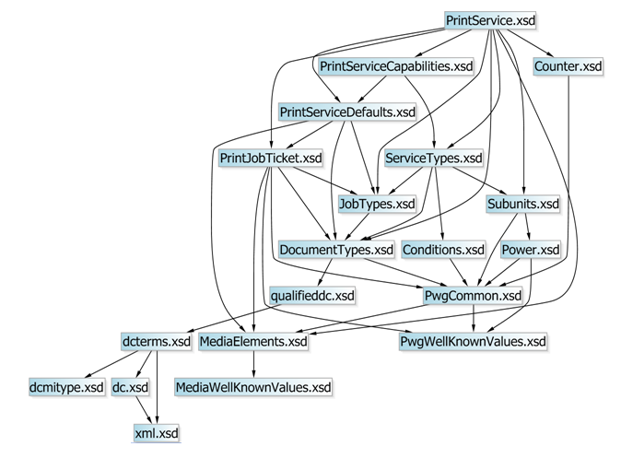
The translation of PrintService object of PWG SM requires element and data type definitions from the files shown below.

- Approach

The translation is achieved in the following steps.
- Data type translation rules and naming rules are defined in control files.
- PWG SM XSD files are parsed to list all elements and its data types.
- Names of the elements are optimized.
- In the list, the elements which are of simple type are converted to parameters and their data types are translated to CWMP data type.
- Elements which are of complex type are converted to objects.
- Redundancy in the hierarchy is removed by applying custom rules.
- Flow Chart
Pass 1:
When provided with a root element, this program searches the given schema for the element. Upon finding the element the name is listed. The data type referred by the element is searched in all the included files. If the type is a simple xs(xml schema) types or a simple type with restrictions, the type parameters are listed along with the element. If the type is complex, the child elements are searched in the files and the procedure is repeated for these elements.
The names of the elements are optimized by one of the following
- Algorithm which removes redundancy in name,
- Manual naming rules supplied from the control file.

Pass 2:
The heirarchial element names are added to the XML as names of objects. The elements which have a type attached to them are added as parameters to their parent object. The attributes of the object and parameter are added based the attributes of the element.

The complete flow is shown below
Start

Parse XSD files

Create list of elements and its types

Create object

Create parameter

Add to the parent object

Simple type ?
Yes
No
Next element exist

No
Yes
Stop

Pass 1
Pass 2

- Control input and algorithm
Translation rules:
Data types in PWG SMData type compatible with CWMP
Example:
string-->string
boolean-->boolean
NMTOKEN-->string
NMTOKENS-->string
int-->int
Find the actual translation in the samples of the output 2.2.1.
Naming rules:
Full element nameshortened name
Example:
PrintServiceCapabilities-->Capabilities
PrintDocumentTicketCapabilities-->DocumentTicketCapabilities
PrintDocumentDescriptionCapabilities-->DocumentDescriptionCapabilities
PrintDocumentProcessingCapabilities-->DocumentProcessingCapabilities
PrintJobDescriptionCapabilities-->JobDescriptionCapabilities
PrintJobProcessingCapabilities-->JobProcessingCapabilities
PrintServiceCapabilitiesReady-->CapabilitiesReady
PrintServiceConfiguration-->Configuration
PrintDocuments-->Documents
PrintDocumentDescription-->DocumentDescription
PrintJob-->Job
PrintDocumentStatus-->DocumentStatus
PrintDocumentCounters-->DocumentCounters
PrintDocumentTicket-->DocumentTicket
PrintJobProcessing-->JobProcessing
PrintJobReceipt-->JobReceipt
PrintServiceDescription-->Description
PrintJobTicketCapabilities-->JobTicketCapabilities
PrintJobStatus-->JobStatus
PrintJobTicket-->JobTicket
PrintDocumentProcessing-->DocumentProcessing
PrintDocumentReceipt-->DocumentReceipt
PrintJobCounters-->JobCounters
PrintDocument-->Document
PrintServiceDefaults-->Defaults
ConsoleDescription-->Description
FinisherSupplies-->Supplies
FinisherSupply-->Supply
FinisherSupplyMediaInputs-->MediaInputs
FinisherSupplyMediaInput-->MediaInput
InputTrayDescription-->Description
InterfaceDescription-->Description
MarkerDescription-->Description
MediaPathDescription-->Description
OutputTrayDescription-->Description
StorageDescription-->Description
VendorSubunitDescription-->Description
JobHistory-->History
Naming algorithm:
The algorithm will be executed if no naming rules are defined.
The algorithm works as follows
1. Divide the element name into sub strings.
2. Discard the substring if it is found in its parent object name.
3. Repeat step 2 for all the substrings except the last substring.
4. Add the result to the name.

Example:

PrintServices.PrintService.{i}.PrintServiceCapabilities.PrintDocumentTicketCapabilities.PrintDocumentDescriptionCapabilities.DocumentFormatDetailsSupplied.AllowedValue.{i}.DocumentFormat

PrintServices.Service.{i}.Capabilities.DocumentTicketCapabilities.DescriptionCapabilities.FormatDetailsSupplied.AllowedValue.{i}.Format
- Parsing schema
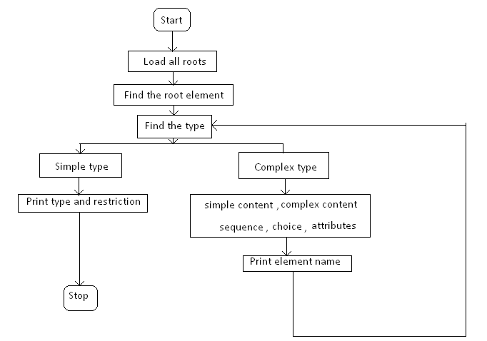
- Output
As on 3’rd of Feb, the program is able to create an XML file with the objects and parameter heirarchy as in CWMP data model.
File 1: Translation rules defined
File 2: Naming rules
File 3: List of all elements of PWG SM
File 4: CWMP data model XML

- Samples
Some sample translated snippets for different data types are below.(before naming optimization)
      - Elements-complextypeobjects
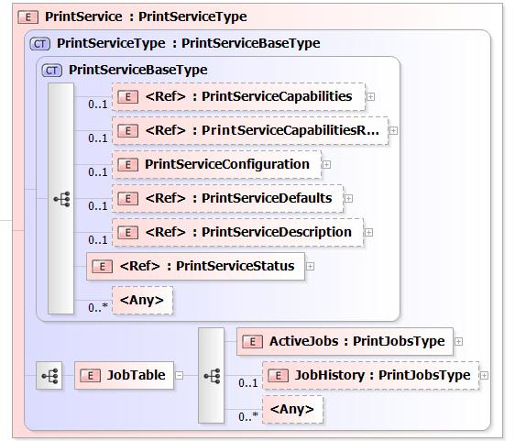

<object name="PrintServices.PrintService.{i}." minEntries="0" maxEntries="unbounded" numEntriesParamter="NumberOfEntries">
<object name="PrintServices.PrintService.{i}.PrintServiceCapabilities." minEntries="0" maxEntries="1">
<object name="PrintServices.PrintService.{i}.PrintServiceCapabilitiesReady." minEntries="0" maxEntries="1">
<object name="PrintServices.PrintService.{i}.PrintServiceCapabilitiesReady." minEntries="0" maxEntries="1">
<object name="PrintServices.PrintService.{i}.PrintServiceDefaults." minEntries="0" maxEntries="1">
<object name="PrintServices.PrintService.{i}.PrintServiceDescription." minEntries="0" maxEntries="1">
<object name="PrintServices.PrintService.{i}.PrintServiceStatus." minEntries="1" maxEntries="1">
<object name="PrintServices.PrintService.{i}.JobTable." minEntries="1" maxEntries="1">

      - Elements-simpletypeparameter
<object name="PrintServices.PrintService.{i}.PrintServiceCapabilitiesReady.PrintDocumentTicketCapabilities.PrintDocumentProcessingCapabilities.MediaColSupported.MediaCol.{i}." minEntries="1" maxEntries="unbounded" numEntriesParamter="MediaColNumberOfEntries">
<parameter name="MediaInfo" access="readonly" activeNotify="forceEnabled">
<description>Write a description about parameter MediaInfo</description>
<syntax><string><size maxLength="255"/></string></syntax>
</parameter>

      - Elements-simpletype-Union
The two simple types are merged based on minimum restrictions which covers the member types.

<object name="PrintServices.PrintService.{i}.JobTable.ActiveJobs.PrintJob.{i}.PrintDocuments.{i}.PrintDocument.{i}.PrintDocumentReceipt.PrintDocumentDescription." minEntries="0" maxEntries="1">
<description>Write a description about object PrintServices.PrintService.{i}.JobTable.ActiveJobs.PrintJob.{i}.PrintDocuments.{i}.PrintDocument.{i}.PrintDocumentReceipt.PrintDocumentDescription</description>
<parameter name="DocumentDigitalSignature" access="readonly" activeNotify="forceEnabled">
<description>Write a description about parameter DocumentDigitalSignature</description>
<syntax>
<string><size maxLength="255"/></string>
</syntax>
</parameter>

      - Element-complextype-choice
All the elements are included.
<object name="PrintServices.PrintService.{i}.JobTable.JobHistory.PrintJob.{i}.PrintJobStatus.JobOriginatingUserAuthenticationInfo." minEntries="1" maxEntries="1">
<description>Write a description about object PrintServices.PrintService.{i}.JobTable.JobHistory.PrintJob.{i}.PrintJobStatus.JobOriginatingUserAuthenticationInfo</description>

<parameter name="AuthenticationType" access="readonly" activeNotify="forceEnabled">
<description>Write a description about parameter AuthenticationType</description><syntax><string><size maxLength="255"/></string></syntax>
</parameter>

<parameter name="Token" access="readonly" activeNotify="forceEnabled">
<description>Write a description about parameter Token</description><syntax><string/></syntax>
</parameter>

<parameter name="Cert" access="readonly" activeNotify="forceEnabled">
<description>Write a description about parameter Cert</description><syntax><string/></syntax>
</parameter>

<parameter name="AuthUri" access="readonly" activeNotify="forceEnabled">
<description>Write a description about parameter AuthUri</description><syntax><string/></syntax>
</parameter>

<parameter name="AuthString" access="readonly" activeNotify="forceEnabled">
<description>Write a description about parameter AuthString</description><syntax><string/></syntax>
</parameter>
</object>

      - Element-complextype-sequence
All the elements are included.
<object name="PrintServices.PrintService.{i}.PrintServiceCapabilities.PrintDocumentTicketCapabilities.PrintDocumentDescriptionCapabilities.DocumentFormatDetailsSupplied.AllowedValue.{i}." minEntries="1" maxEntries="unbounded" numEntriesParamter="NumberOfEntries">
<description>Write a description about object PrintServices.PrintService.{i}.PrintServiceCapabilities.PrintDocumentTicketCapabilities.PrintDocumentDescriptionCapabilities.DocumentFormatDetailsSupplied.AllowedValue.{i}</description>
<parameter name="DocumentFormat" access="readonly" activeNotify="forceEnabled">
<description>Write a description about parameter DocumentFormat</description>
<syntax><string><size maxLength="255"/></string></syntax>
</parameter>

<parameter name="DocumentFormatDeviceId" access="readonly" activeNotify="forceEnabled">
<description>Write a description about parameter DocumentFormatDeviceId</description>
<syntax><string><size maxLength="1023"/></string></syntax>
</parameter>

<parameter name="DocumentFormatVersion" access="readonly" activeNotify="forceEnabled">
<description>Write a description about parameter DocumentFormatVersion</description>
<syntax><string/></syntax>
</parameter>

<parameter name="DocumentNaturalLanguage" access="readonly" activeNotify="forceEnabled">
<description>Write a description about parameter DocumentNaturalLanguage</description>
<syntax><string><size maxLength="63"/></string></syntax>
</parameter>

<parameter name="DocumentSourceApplicationName" access="readonly" activeNotify="forceEnabled">
<description>Write a description about parameter DocumentSourceApplicationName</description>
<syntax><string/></syntax>
</parameter>

<parameter name="DocumentSourceApplicationVersion" access="readonly" activeNotify="forceEnabled">
<description>Write a description about parameter DocumentSourceApplicationVersion</description>
<syntax><string/></syntax>
</parameter>

<parameter name="DocumentSourceOsName" access="readonly" activeNotify="forceEnabled">
<description>Write a description about parameter DocumentSourceOsName</description>
<syntax><string><size maxLength="40"/></string></syntax>
</parameter>

<parameter name="DocumentSourceOsVersion" access="readonly" activeNotify="forceEnabled">
<description>Write a description about parameter DocumentSourceOsVersion</description>
<syntax><string/></syntax>
</parameter>
</object>

      - Element-complextype-simplecontent
The attributes in the simple content are not included.
<object name="PrintServices.PrintService.{i}.PrintServiceCapabilities.PrintDocumentTicketCapabilities.PrintDocumentProcessingCapabilities.CoverBack.Media." minEntries="0" maxEntries="1">
<description>Write a description about object PrintServices.PrintService.{i}.PrintServiceCapabilities.PrintDocumentTicketCapabilities.PrintDocumentProcessingCapabilities.CoverBack.Media</description>

<parameter name="AllowedValue" access="readonly" activeNotify="forceEnabled">
<description>Write a description about parameter AllowedValue</description>
<syntax><list/><string><size maxLength="255"/></string></syntax>
</parameter>

</object>

      - Element-complextype-complexcontent
Attributes and ‚‘any‘ elements are not included.
<object name="PrintServices.PrintService.{i}.JobTable.ActiveJobs.PrintJob.{i}.PrintJobStatus." minEntries="1" maxEntries="1">
- Open Issues
- The ‘access’ and ‘activeNotify’ attributes of parameters are hard coded for now. Help needed on how to assign them.
  - Example: <parameter name="DocumentMessage" access="readonly" activeNotify="forceEnabled">
- Hierarchy optimization-pending.
  - Example: PrintServices.PrintService.{i}.PrintServiceConfiguration.Finishers.Finisher.{i}.FinisherDescription
- Choice in complex type is pending-all the child elements are included in the current model.
  - Refer 2.2.1.4
- Attributes of the elements in the PWG SM is not included in the translation.
  - Example: MustHonor

- All member types of union are assumed as either string or NMTOKEN. These are translated to string type.
- Implementation
Library used: libxml2-2.7.1
Source code: ‘TranslationDM.c’, ‘TranslationDM.h’, ‘Utility.c’ –attached in ‘TranslationDM.zip’.
- Conclusion

With the completion of the current issues, verification of output and validation with the CWMP data model schema, the translation will be completed.

