IPP Everywhere Printer Self-Certification Manual 1.0 (SELFCERT)

Status: Approved

Abstract: This document defines IPP Everywhere Printer self-certification test procedures and the process required for PWG Members to register the test results on the PWG web site in order to use the "IPP Everywhere" logo.
This document is a PWG Candidate Standard. For a definition of a "PWG Candidate Standard", see:
http://ftp.pwg.org/pub/pwg/general/pwg-process30.pdf
This document is available electronically at:
http://ftp.pwg.org/pub/pwg/candidates/cs-ippeveselfcert10-20160219-5100.20.docx
http://ftp.pwg.org/pub/pwg/candidates/cs-ippeveselfcert10-20160219-5100.20.pdf
Copyright © 2013-2016 The Printer Working Group. All rights reserved.
This document may be copied and furnished to others, and derivative works that comment on, or otherwise explain it or assist in its implementation may be prepared, copied, published and distributed, in whole or in part, without restriction of any kind, provided that the above copyright notice, this paragraph and the title of the Document as referenced below are included on all such copies and derivative works. However, this document itself may not be modified in any way, such as by removing the copyright notice or references to the IEEE-ISTO and the Printer Working Group, a program of the IEEE-ISTO.
Title: IPP Everywhere Printer Self-Certification Manual 1.0 (SELFCERT)
The IEEE-ISTO and the Printer Working Group DISCLAIM ANY AND ALL WARRANTIES, WHETHER EXPRESS OR IMPLIED INCLUDING (WITHOUT LIMITATION) ANY IMPLIED WARRANTIES OF MERCHANTABILITY OR FITNESS FOR A PARTICULAR PURPOSE.
The Printer Working Group, a program of the IEEE-ISTO, reserves the right to make changes to the document without further notice. The document may be updated, replaced or made obsolete by other documents at any time.
The IEEE-ISTO takes no position regarding the validity or scope of any intellectual property or other rights that might be claimed to pertain to the implementation or use of the technology described in this document or the extent to which any license under such rights might or might not be available; neither does it represent that it has made any effort to identify any such rights.
The IEEE-ISTO invites any interested party to bring to its attention any copyrights, patents, or patent applications, or other proprietary rights which may cover technology that may be required to implement the contents of this document. The IEEE-ISTO and its programs shall not be responsible for identifying patents for which a license may be required by a document and/or IEEE-ISTO Industry Group Standard or for conducting inquiries into the legal validity or scope of those patents that are brought to its attention. Inquiries may be submitted to the IEEE-ISTO by e-mail at: ieee-isto@ieee.org.
The Printer Working Group acknowledges that the IEEE-ISTO (acting itself or through its designees) is, and shall at all times, be the sole entity that may authorize the use of certification marks, trademarks, or other special designations to indicate compliance with these materials.
Use of this document is wholly voluntary. The existence of this document does not imply that there are no other ways to produce, test, measure, purchase, market, or provide other goods and services related to its scope.

About the IEEE-ISTO
The IEEE-ISTO is a not-for-profit corporation offering industry groups an innovative and flexible operational forum and support services. The IEEE-ISTO provides a forum not only to develop standards, but also to facilitate activities that support the implementation and acceptance of standards in the marketplace. The organization is affiliated with the IEEE (http://www.ieee.org/) and the IEEE Standards Association (http://standards.ieee.org/).
For additional information regarding the IEEE-ISTO and its industry programs visit:
http://www.ieee-isto.org

About the IEEE-ISTO PWG
The Printer Working Group (or PWG) is a Program of the IEEE Industry Standards and Technology Organization (ISTO) with member organizations including printer manufacturers, print server developers, operating system providers, network operating systems providers, network connectivity vendors, and print management application developers. The group is chartered to make printers and the applications and operating systems supporting them work together better. All references to the PWG in this document implicitly mean “The Printer Working Group, a Program of the IEEE ISTO.” In order to meet this objective, the PWG will document the results of their work as open standards that define print related protocols, interfaces, procedures and conventions. Printer manufacturers and vendors of printer related software will benefit from the interoperability provided by voluntary conformance to these standards.
In general, a PWG standard is a specification that is stable, well understood, and is technically competent, has multiple, independent and interoperable implementations with substantial operational experience, and enjoys significant public support.
For additional information regarding the Printer Working Group visit:
http://www.pwg.org
Contact information:

The Printer Working Group
c/o The IEEE Industry Standards and Technology Organization
445 Hoes Lane
Piscataway, NJ 08854
USA

About the Internet Printing Protocol Workgroup
The Internet Printing Protocol (IPP) workgroup has developed a modern, full-featured network printing protocol, which is now the industry standard. IPP allows a print client to query a printer for its supported capabilities, features, and parameters to allow the selection of an appropriate printer for each print job. IPP also provides job information prior to, during, and at the end of job processing.
For additional information regarding IPP visit:
http://www.pwg.org/ipp/
Implementers of this specification are encouraged to join the IPP mailing list in order to participate in any discussions of the specification. Suggested additions, changes, or clarification to this specification, should be sent to the IPP mailing list for consideration.

Table of Contents
1. Introduction 7
1.1 Overview of IPP Everywhere Printer Self-Certification 7
1.2 Updates to This Document 8
1.3 Reporting Problems and Getting Assistance 9
2. Terminology 10
2.1 Conformance Terminology 10
2.2 Protocol Role Terminology 10
2.3 Other Terminology 10
2.4 Acronyms and Organizations 10
3. Requirements 11
3.1 Rationale for the IPP Everywhere Self-Certification Manual 1.0 11
3.2 Use Cases 11
3.2.1 Selection of Printer for Purchase 11
3.3 Out of Scope 11
3.4 Test Requirements and Recommendations 12
4. Test Setup and System Requirements 13
4.1 Printer Configuration 13
4.2 Microsoft Windows Tools 13
4.3 OS X Tools 13
4.4 Linux (Ubuntu) Tools 14
4.5 Test Files 14
5. Bonjour Test Procedure 16
5.1 Test Description and Checklist 16
5.2 Running the Bonjour Tests 16
5.3 Interpreting the Bonjour Test Results 16
6. IPP Test Procedure 18
6.1 Test Description and Checklist 18
6.2 Running the IPP Tests 18
6.3 Interpreting the IPP Test Results 18
7. Document Data Test Procedure 20
7.1 Test Description and Checklist 20
7.2 Running the Document Data Tests 20
7.3 Interpreting Results 20
8. Submission of Test Reports 25
8.1 Exception Process 25
9. References 27
9.1 Normative References 27
9.2 Informative References 28
10. Author's Addresses 28
11. Release History 29
11.1 Version 1.0 29

List of Figures

Figure 1 - Content of "color.jpg" Test Document 22
Figure 2 - Content of "document-a4.pdf" Test Document 23
Figure 3 - Content of "document-letter.pdf" Test Document 24
Figure 4 - IPP Everywhere Self-Certification Submission Form 26

List of Tables
Table 1 - Bonjour Test Checklist 17
Table 2 - IPP Test Checklist 19
Table 3 - Document Test Checklist 21

- Introduction
The Internet Printing Protocol supports all kinds of printing from low-end consumer through multi-room production printers. The IPP Everywhere project developed a new baseline specification [PWG5100.14] that enables printing from arbitrary clients using vendor-neutral driver software. In order to allow PWG Members to market their conformance to the new specification and consumers to easily determine which printers are compatible with their clients, the Printer Working Group has developed this specification which defines a series of self-certification tests that must be performed successfully in order to use the IPP Everywhere logo for a given printer and/or its Product Family (section 2.3). While the software and tests may be used by all organizations and individuals regardless of membership status, use of the IPP Everywhere logo and registration of Product Families on the PWG web site is limited to members of the Printer Working Group [MEMBERS].
  - Overview of IPP Everywhere Printer Self-Certification
The following summarizes IPP Everywhere Printer self-certification:
- Conformance to this manual is voluntary; PWG Members do not need to perform self-certification to claim conformance to the IPP Everywhere [PWG5100.14] specification, but do need to perform self-certification to use the logo.
- Version 1.0 of this process only applies to Printer implementations.
- Because WS-Discovery is only required for certification with Microsoft Windows, Version 1.0 of this process does not test the WS-Discovery capabilities of a PWG Member's IPP Everywhere Printer implementation.
- This manual defines tests for the Bonjour (mDNS and DNS-SD), IPP, and document format capabilities of a PWG Member's IPP Everywhere Printer implementation. The results are stored in XML files that are uploaded to the PWG web site to obtain permission to use the logo with the implementation.
- Only PWG Members may upload test results to the PWG web site and use the logo.
- This manual defines only one conformance level for IPP Everywhere Printer self-certification, and the tests automatically adapt to the capabilities that are reported by the implementation.
- Printer self-certification is generally performed using the most recent version of this process, however PWG Members may use an older approved version of the process if the most recent version was published within the last 12 months. This allows for some flexibility when developing new products.
- Printer self-certification for a Product Family should be performed using the most fully featured model of the Product Family.
- A PWG Member is not required to re-certify an existing Product Family against updated versions of this process.
- Implementors are encouraged to use this process in regression testing of updates to a Product Family.
- Self-certification test results are confidential and are discarded by the web site software after an automatic review.
- Once accepted, the Printers in the certified Product Family will be listed on the PWG web site along with some summary information such as the make, model, version of the process used, color capabilities, and manufacturer web site.
  - Updates to This Document
This document might be updated from time to time to address issues in the testing procedures, testing tools, referenced specifications, and the license agreement as necessary. The version numbers of this document would be updated to reflect these changes according to the following rules:
- Whenever new requirements, new referenced specifications, and/or new license agreement text are introduced, the major version number will be incremented and the minor version number will be reset to 0. For example, major changes to version "1.0" would result in a new "2.0" document.
- Whenever corrections are made to the testing procedures or tools are introduced, the minor version number will be incremented. For example, minor changes to version "1.0" would result in a new "1.1" document.
Major changes will go through the normal PWG Standard process (section 4 of [PROCESS30]), including a IPP Workgroup Last Call, PWG Last Call, and PWG Formal Vote. The IPP Workgroup Last Call and PWG Last Call will include time for testing of the tools used for self-certification.
Minor changes will go through the PWG Errata process (section 9.1 of [PROCESS30]), including a IPP Workgroup Last Call and PWG Call for Objection. The IPP Workgroup Last Call and PWG Call for Objection will include time for testing of the tools used for self-certification.

  - Reporting Problems and Getting Assistance
Problems discovered in this specification are reported using the PWG issue tracking page at:
https://www.pwg.org/issues
Problems in the self-certification tools are reported via the IPP Everywhere Printer Self-Certification project issues page:
https://github.com/istopwg/ippeveselfcert/issues
The "ippeveselfcert@pwg.org" mailing list is provided for asking questions about this specification and IPP Everywhere in general. You must subscribe to this list before you can post questions:
https://www.pwg.org/mailman/listinfo/ippeveselfcert

- Terminology
  - Conformance Terminology
Capitalized terms, such as MUST, MUST NOT, RECOMMENDED, REQUIRED, SHOULD, SHOULD NOT, MAY, and OPTIONAL, have special meaning relating to conformance as defined in Key words for use in RFCs to Indicate Requirement Levels [RFC2119]. The term CONDITIONALLY REQUIRED is additionally defined for a conformance requirement that applies when a specified condition is true.
  - Protocol Role Terminology
Normative definitions and semantics of printing terms are imported from IETF IPP/1.1 [RFC2911]. This document also defines the following protocol roles in order to specify unambiguous conformance requirements:
Client: Initiator of outgoing IPP session requests and sender of outgoing IPP operation requests (Hypertext Transfer Protocol -- HTTP/1.1 [RFC7230] User Agent).
Printer: Listener for incoming IPP session requests and receiver of incoming IPP operation requests (Hypertext Transfer Protocol -- HTTP/1.1 [RFC7230] Server) that represents one or more Physical Devices or a Logical Device.
  - Other Terminology
Product Family: A group of products from a common product platform [PROD-FAMILY], e.g., printers using a common marking engine, OEM products sold by multiple vendors, and print server software supporting printers.
Production Ready Code: Software and/or firmware that is considered ready to be included in products shipped to customers.
PWG Member: An individual or organization that has signed the IEEE-ISTO Printer Working Group membership agreement and paid the corresponding membership fee. More information on the agreement and fees is available on the PWG web site [MEMBERS].
  - Acronyms and Organizations
IANA: Internet Assigned Numbers Authority, http://www.iana.org/
IETF: Internet Engineering Task Force, http://www.ietf.org/
ISO: International Organization for Standardization, http://www.iso.org/
PWG: Printer Working Group, http://www.pwg.org/
- Requirements
  - Rationale for the IPP Everywhere Self-Certification Manual 1.0
Given the need for a vendor-neutral certification of Printers for use by mobile and desktop Clients, the IPP Everywhere Self-Certification Manual 1.0 should:
- Define test procedures and tools for Bonjour discovery of IPP Everywhere Printers;
- Define test procedures and tools to validate conformance of IPP Everywhere Printers to the IPP Everywhere specification [PWG5100.14];
- Define test procedures, tool, and documents to validate the output of IPP Everywhere Printers;
- Define rules and procedures for PWG Members to submit test results; and
- Define rules for the use of an IPP Everywhere Self-Certification logo for marketing purposes.
The IPP Everywhere [PWG5100.14] specification defines a standard profile of IPP to support printing from mobile and desktop Clients without vendor-specific driver software.
  - Use Cases
    - Selection of Printer for Purchase
Jane has gone to her local electronics superstore in order to purchase a new printer that is compatible with her phone, tablet, and laptop computer. A PWG Member has self-certified their printers in order to display a marketing logo on product packaging, advertising, and sales materials. Jane looks for printers that have the logo because she trusts the manufacturer is selling a printer that is compatible with her devices and computer.
  - Out of Scope
The following are considered out of scope for this specification:
- Definition of PWG or vendor marketing programs for IPP Everywhere.
- Definition of WS-Discovery tests.
- Conformance testing of optional discovery protocols.
- Conformance testing of optional operations, attributes, and values.
- Conformance testing of optional OpenXPS document format support.

  - Test Requirements and Recommendations
The test requirements for this specification are:
- Confirm minimum conformance and interoperability of Printer for Bonjour discovery [RFC3927] [RFC6762] [RFC6763]
- Confirm minimum conformance and interoperability of Printer for the HyperText Transport Protocol Version 1.1 [RFC7230]
- Confirm minimum conformance and interoperability of Printer for the Internet Printing Protocol Version 2.0 Second Edition [PWG5100.12]
- Confirm minimum conformance and interoperability of Printer for PWG Raster Format [PWG5102.4] and JPEG [JFIF] document data
- If supported, confirm minimum conformance and interoperability of Printer for PDF document data [ISO32000]
The test recommendations for this specification are:
- Provide realistic document data for print testing

- Test Setup and System Requirements
The test suites require an Intel-based Mac running OS X 10.10 or later or PC running Red Hat Enterprise Linux 7 or later, Ubuntu Server 14.04 LTS or later, or Windows 7 or later. The test tools require up to 24MB of disk space and the test files require up to 1637MB of disk space. The most recent version of the tools and sample PWG Raster files can be downloaded from the IPP Everywhere technology page:
https://www.pwg.org/ipp/everywhere.html
Source code for the tools is hosted on the IPP Everywhere Printer Self-Certification project page:
https://github.com/istopwg/ippeveselfcert
  - Printer Configuration
The Printer in the Product Family being certified MUST be running Production-Ready Code with the default customer configuration. The Printer MUST include all features of the Product Family being certified, e.g., all document formats, duplexing, etc. As with any IPP implementation, the Printer can be a physical device or a spooler.
  - Microsoft Windows Tools
The following files are used to run the tests on Microsoft Windows:
Windows 7 or higher tools: 24MB (8MB for the MSI file, 16MB for the installed software)
https://www.pwg.org/ipp/everywhere.html
Bonjour Print Services for Windows: Provides Bonjour support for Windows
http://support.apple.com/kb/DL999
  - OS X Tools
The following files are used to run the tests on OS X:
OS X 10.10 or higher tools: 20MB (7MB for the DMG file, 13MB for the installed software)
https://www.pwg.org/ipp/everywhere.html

  - Linux (Ubuntu) Tools
Due to TLS library compatibility issues, tools are tied to specific Linux distributions.
The following files are used to run the tests:
RedHat Enterprise Linux 7 - 64-bit tools: 19MB (6MB for the tar file, 13MB for the installed software)
https://www.pwg.org/ipp/everywhere.html
Ubuntu Server 14.04 LTS - 64-bit tools: 19MB (6MB for the tar file, 13MB for the installed software)
https://www.pwg.org/ipp/everywhere.html
  - Test Files
The following sample files are used for the document tests:
150dpi sample files: 58MB (20MB for the zip file, 38MB for the extracted files)
http://ftp.pwg.org/pub/pwg/ipp/examples/pwg-raster-samples-150dpi-20150616.zip
180dpi sample files: 74MB (26MB for the zip file, 48MB for the extracted files)
http://ftp.pwg.org/pub/pwg/ipp/examples/pwg-raster-samples-180dpi-20150616.zip
300dpi sample files: 158MB (53MB for the zip file, 105MB for the extracted files)
http://ftp.pwg.org/pub/pwg/ipp/examples/pwg-raster-samples-300dpi-20150616.zip
360dpi sample files: 209MB (70MB for the zip file, 139MB for the extracted files)
http://ftp.pwg.org/pub/pwg/ipp/examples/pwg-raster-samples-360dpi-20150616.zip
600dpi sample files: 488MB (163MB for the zip file, 325MB for the extracted files)
http://ftp.pwg.org/pub/pwg/ipp/examples/pwg-raster-samples-600dpi-20150616.zip

720dpi sample files: 650MB (212MB for the zip file, 438MB for the extracted files)
http://ftp.pwg.org/pub/pwg/ipp/examples/pwg-raster-samples-720dpi-20150616.zip
PWG Members may request sample files at different resolutions by sending an email to the "ippeveselfcert@pwg.org" mailing list (section 1.3).

- Bonjour Test Procedure
  - Test Description and Checklist
The Bonjour tests verify that the Printer correctly advertises itself using the "_ipp._tcp,_print" sub-type so that the Client can contact the Printer at the given address, port, and resource path. The Printer MUST provide all required TXT record keys and those keys MUST match the values reported by the Printer via the IPP Get-Printer-Attributes operation.
Printers that report support for TLS MUST also support HTTP Upgrade to TLS, correctly advertise themselves using the "_ipps._tcp,_print" sub-type, and support using an "ipps" URI.
  - Running the Bonjour Tests
On Linux or OS X, run the following command to produce the Bonjour test results file:
./bonjour-tests.sh "Printer Name"
where 'Printer Name' is the DNS-SD service name for the Printer in double quotes.
On Windows, run the following command to produce the Bonjour test results file:
bonjour-tests.bat "Printer Name"
where 'Printer Name' is the DNS-SD service name for the Printer in double quotes.
Output is placed in a file named "Printer Name Bonjour Results.plist".
  - Interpreting the Bonjour Test Results
The output of the test is a list of PASS, FAIL, and SKIP results for the named Printer. The generated plist file contains the XML version of those results.
A successful result contains PASS or SKIP results for every test. Any FAIL result causes a failure for self-certification.

Table 1 - Bonjour Test Checklist
PASS/  FAIL/  SKIP | Description
 | B-1. IPP Browse test: Printers appear in a search for "_ipp._tcp,_print" services?
 | B-2. IPP TXT keys test: The IPP TXT record contains all required keys.
 | B-3. IPP Resolve test: Printer responds to an IPP Get-Printer-Attributes request using the resolved hostname, port, and resource path.
 | B-4. IPP TXT values test: The TXT record values match the reported IPP attribute values.
 | B-5. TLS tests: Performed only if TLS is supported.
 | B-5.1 HTTP Upgrade test: Printer responds to an IPP Get-Printer-Attributes request after doing an HTTP Upgrade to TLS.
 | B-5.2 IPPS Browse test: Printer appears in a search for "_ipps._tcp,_print" services.
 | B-5.3 IPPS TXT keys test: The TXT record for IPPS contains all required keys.
 | B-5.4 IPPS Resolve test: Printer responds to an IPPS Get-Printer-Attributes request using the resolved hostname, port, and resource path.
 | B-5.5 IPPS TXT values test: The TXT record values for IPPS match the reported IPPS attribute values.

- IPP Test Procedure
  - Test Description and Checklist
The IPP tests verify that the Printer correctly processes IPP requests and produces the expected IPP responses. Besides basic conformance to the IPP/1.1: Model and Semantics [RFC2911], IPP/2.0 Second Edition [PWG5100.12], and IPP Everywhere [PWG5100.14] specifications, the tests also verify that the printer reports the 'media-needed' value in the "printer-state-reasons" attribute when a Job needs media.
  - Running the IPP Tests
On Linux or OS X, run the following command to produce the IPP test results file:
./ipp-tests.sh "Printer Name"
where 'Printer Name' is the DNS-SD service name for the Printer in double quotes.
On Windows, run the following command to produce the IPP test results file:
ipp-tests.bat "Printer Name"
where 'Printer Name' is the DNS-SD service name for the Printer in double quotes.
Output is placed in a file named "Printer Name IPP Results.plist".
  - Interpreting the IPP Test Results
The output of the test is a list of PASS, FAIL, and SKIP results for the named Printer. The generated plist file contains the XML version of those results.
A successful result contains PASS or SKIP results for every test. Any FAIL result causes a failure for self-certification.

Table 2 - IPP Test Checklist
PASS/  FAIL/  SKIP | Description
 | I-1. RFC 2911 section 3.1.1: Bad request-id value 0
 | I-2. RFC 2911 section 3.1.4: No Operation Attributes
 | I-3. RFC 2911 section 3.1.4: attributes-charset
 | I-4. RFC 2911 section 3.1.4: attributes-natural-language
 | I-5. RFC 2911 section 3.1.4: attributes-natural-language + attributes-charset
 | I-6. RFC 2911 section 3.1.4: attributes-charset + attributes-natural-language
 | I-7. RFC 2911 section 3.1.8: Unsupported IPP version 0.0
 | I-8. RFC 2911 section 3.2: No printer-uri operation attribute
 | I-9. Get-Printer-Attributes Operation (default)
 | I-10. Get-Printer-Attributes Operation (requested-attributes)
 | I-11. Validate-Job Operation
 | I-12. Print-Job Operation (color.jpg)
 | I-13. Get-Jobs Operation (default)
 | I-14. Get-Jobs Operation (requested-attributes)
 | I-15. Get-Jobs Operation (which-jobs=not-completed)
 | I-16. Get-Job-Attributes Until Job Complete
 | I-17. Get-Jobs Operation (which-jobs=completed)
 | I-18. Get-Jobs Operation (which-jobs, requested-attributes)
 | I-19. Cancel-Job Operation (completed job)
 | I-20. Print-Job Operation (color.jpg)
 | I-21. Cancel-Job Operation (pending/processing job)
 | I-22. Get-Job-Attributes Operation
 | I-23. Create-Job Operation
 | I-24. Send-Document Operation (color.jpg)
 | I-25. Get-Job-Attributes Until Job Complete
 | I-26. Print-Job Operation (color.jpg)
 | I-27. Media Needed: Printer correctly reports 'media-needed' when a job is queued.

- Document Data Test Procedure
  - Test Description and Checklist
The Document Data tests verify that the Printer correctly produces hardcopy output from a set of sample documents. The tests are adaptive to the Printer's reported document format, resolution, and color mode capabilities.
  - Running the Document Data Tests
On Linux or OS X, run the following command to produce the Document Data test results file:
./document-tests.sh "Printer Name"
where 'Printer Name' is the DNS-SD service name for the Printer in double quotes.
On Windows, run the following command to produce the Document Data test results file:
document-tests.bat "Printer Name"
where 'Printer Name' is the DNS-SD service name for the Printer in double quotes.
Output is placed in a file named "Printer Name Document Results.plist".
  - Interpreting Results
The output of the test is a list of PASS, FAIL, and SKIP results for the named Printer. The generated plist file contains the XML version of those results.
A successful result contains PASS or SKIP results for every test. Any FAIL result causes a failure for self-certification. In addition, the hardcopy output MUST be inspected by the tester to verify that there are no obvious errors in the output such as incorrect rendering or gross color errors, e.g. all output is green when it should be red. Grayscale output on a B&W printer is not considered an error. Similarly, normal clipping at the Printer's marking engine limits is not considered an error. Figure 1 through Figure 3 show the expected printed content.
Note: PWG Members do not submit hardcopy output for self-certification, nor do they need to retain it.

Table 3 - Document Test Checklist
PASS/  FAIL/  SKIP | Description
 | D-1. PWG Raster Format Tests (mandatory)
 | D-1.1 Print color.jpg-4x6.pwg @ maximum resolution and supported types
 | D-1.2 Print color.jpg-4x6.pwg @ maximum resolution and supported types, deflate, if supported
 | D-1.3 Print color.jpg-4x6.pwg @ maximum resolution and supported types, gzip, if supported
 | D-1.4 Print document-a4.pwg @ maximum resolution and supported types
 | D-1.5 Print document-letter.pwg @ maximum resolution and supported types
 | D-2. JPEG Tests (mandatory)
 | D-2.1 Print color.jpg with defaults
 | D-2.2 Print color.jpg with copies=2
 | D-2.3 Print color.jpg with print-color-mode=monochrome
 | D-2.4 Print color.jpg with media=na_letter_8.5x11in and ipp-attribute-fidelity=true
 | D-2.5 Print color.jpg with media=iso_a4_210x297mm and ipp-attribute-fidelity=true
 | D-3. PDF Tests (if PDF is supported)
 | D-3.1 Print document-letter.pdf with defaults
 | D-3.2 Print document-letter.pdf with copies=2
 | D-3.3 Print document-letter.pdf with page-ranges=3-3 and print-color-mode=monochrome
 | D-3.4 Print document-letter.pdf with sides=two-sided-long-edge, if supported
 | D-3.5 Print document-letter.pdf with media=iso_a4_210x297mm and ipp-attribute-fidelity=true
 | D-3.6 Print document-a4.pdf with media=na_letter_8.5x11in and ipp-attribute-fidelity=true

Figure 1 - Content of "color.jpg" Test Document
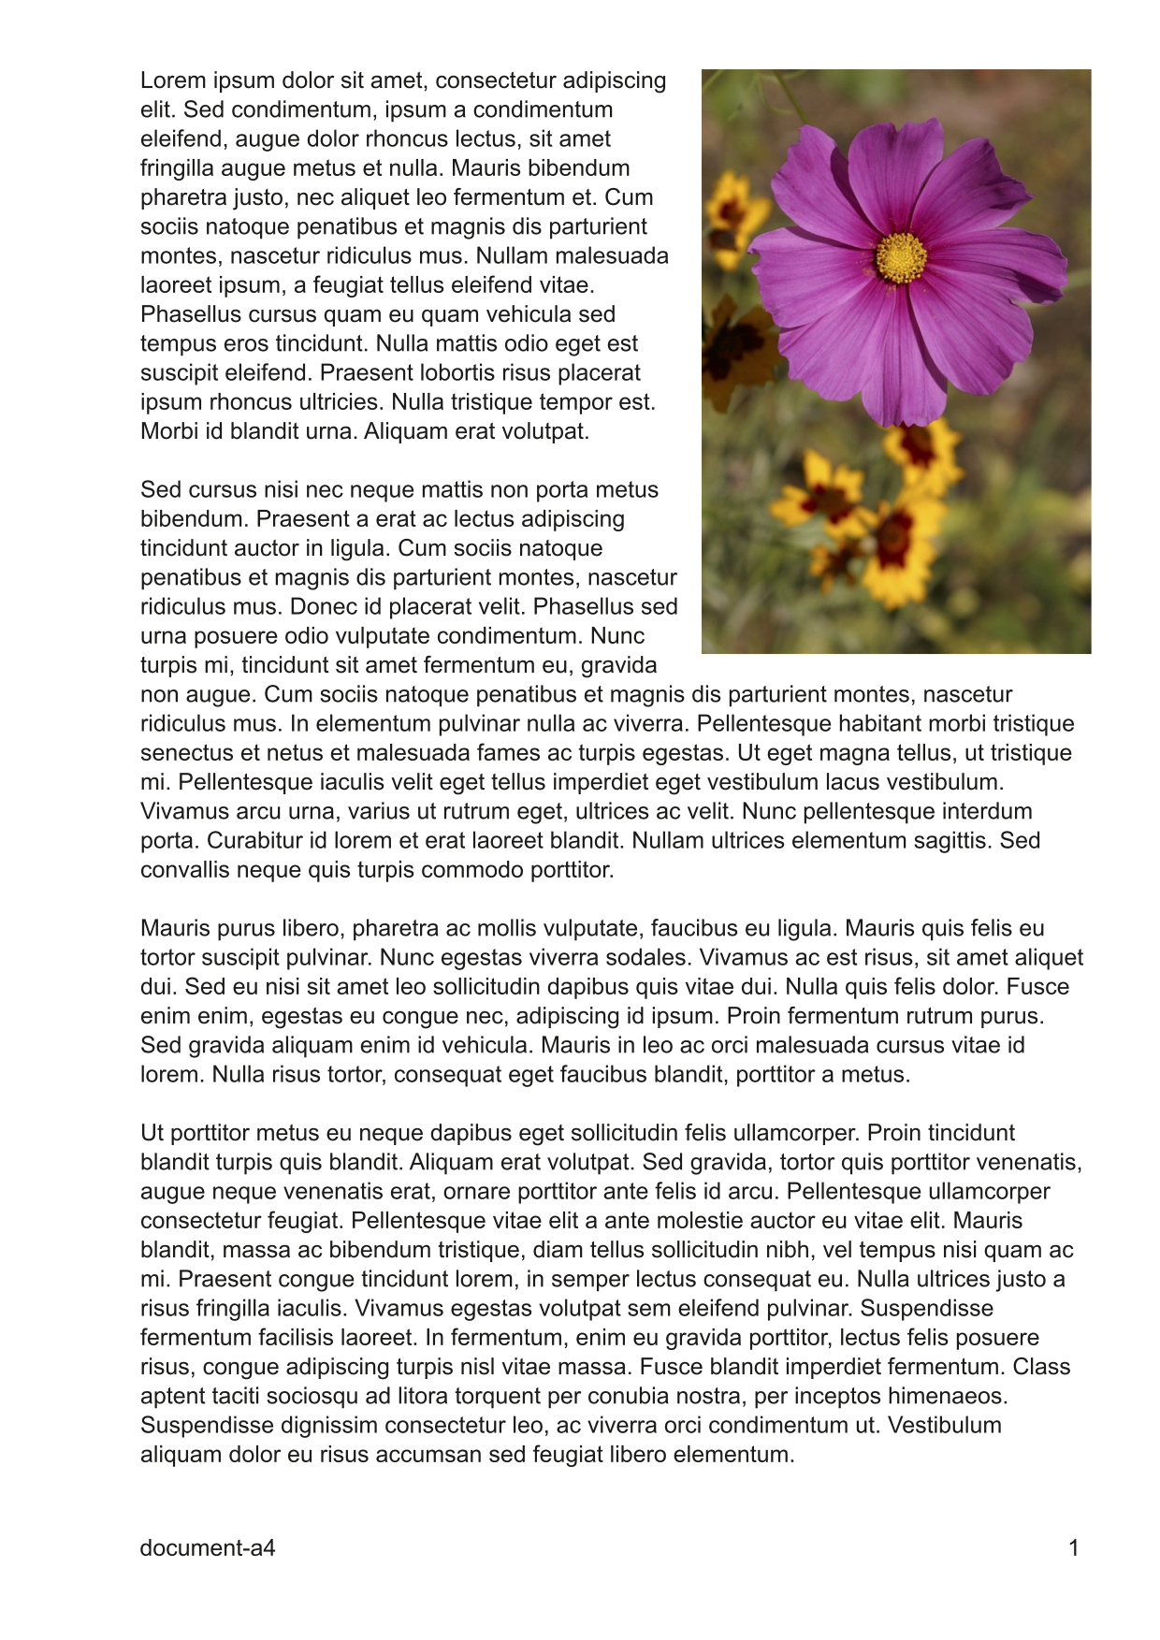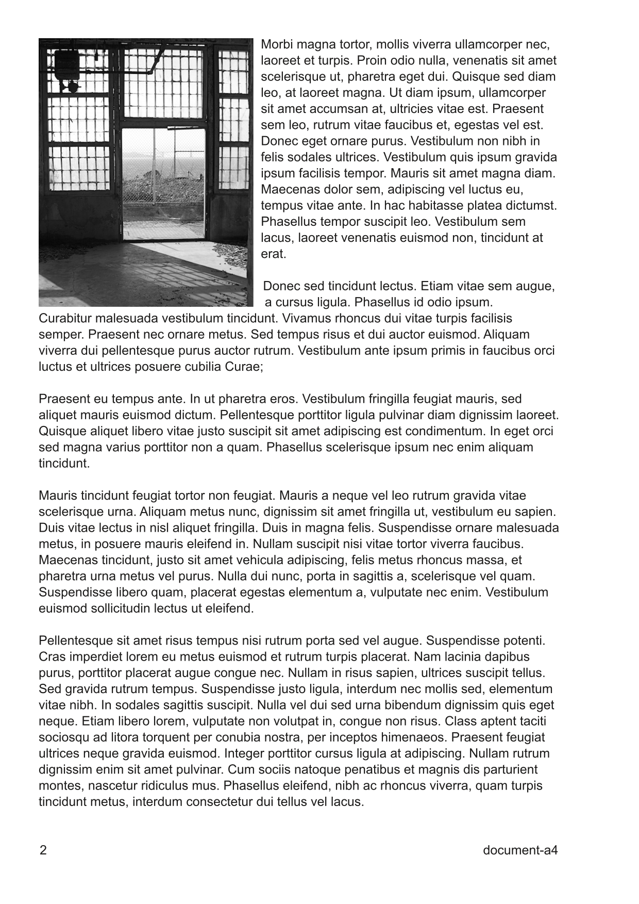
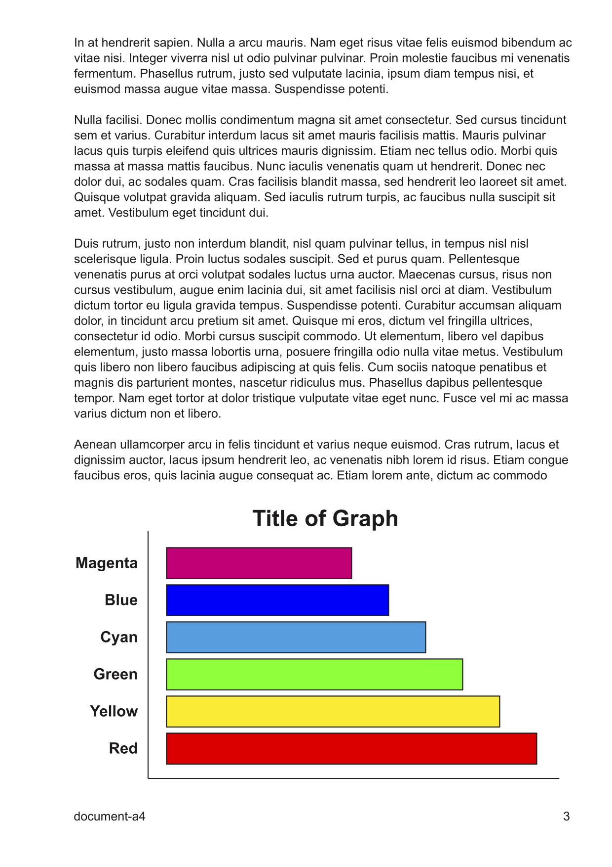

Figure 2 - Content of "document-a4.pdf" Test Document
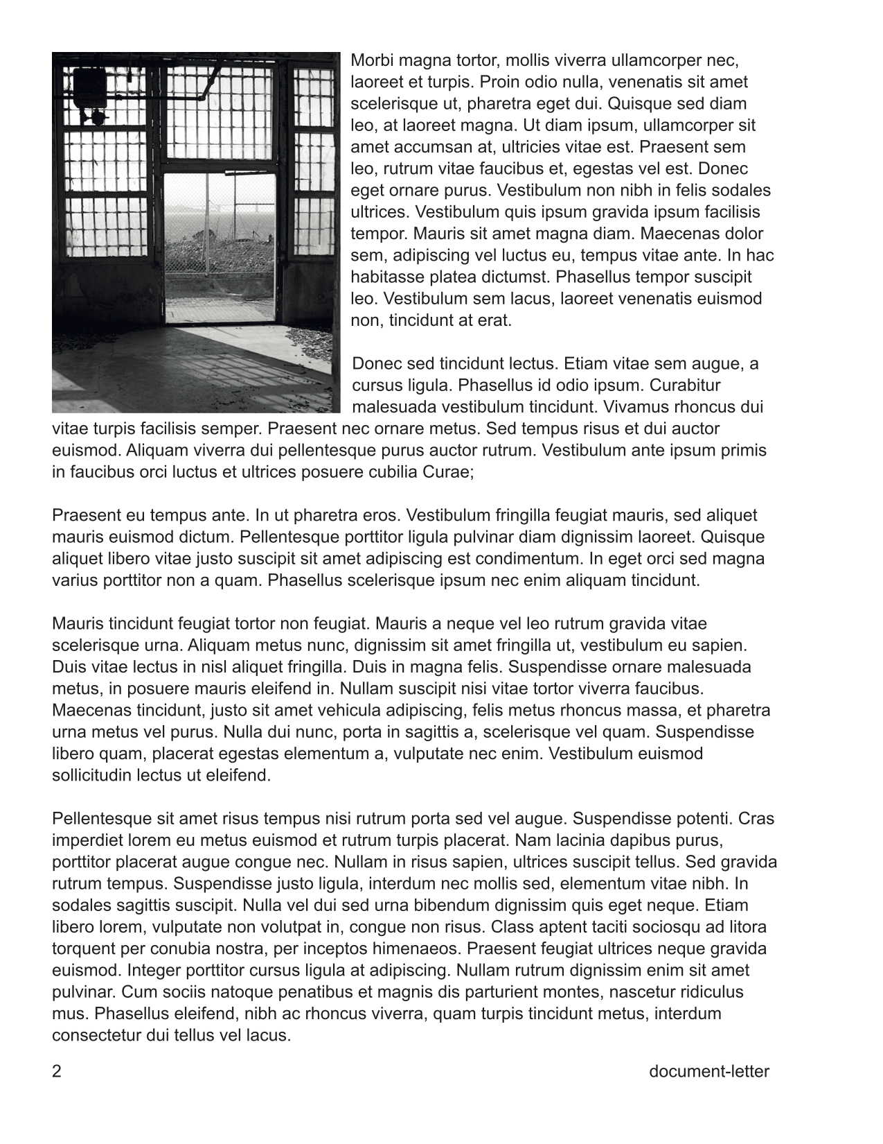
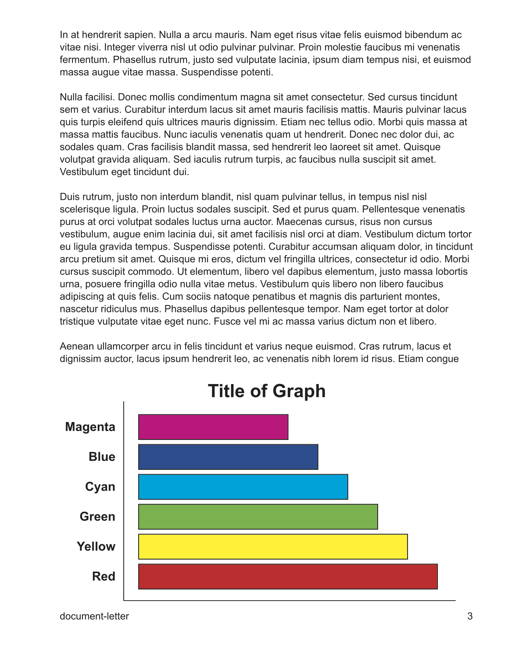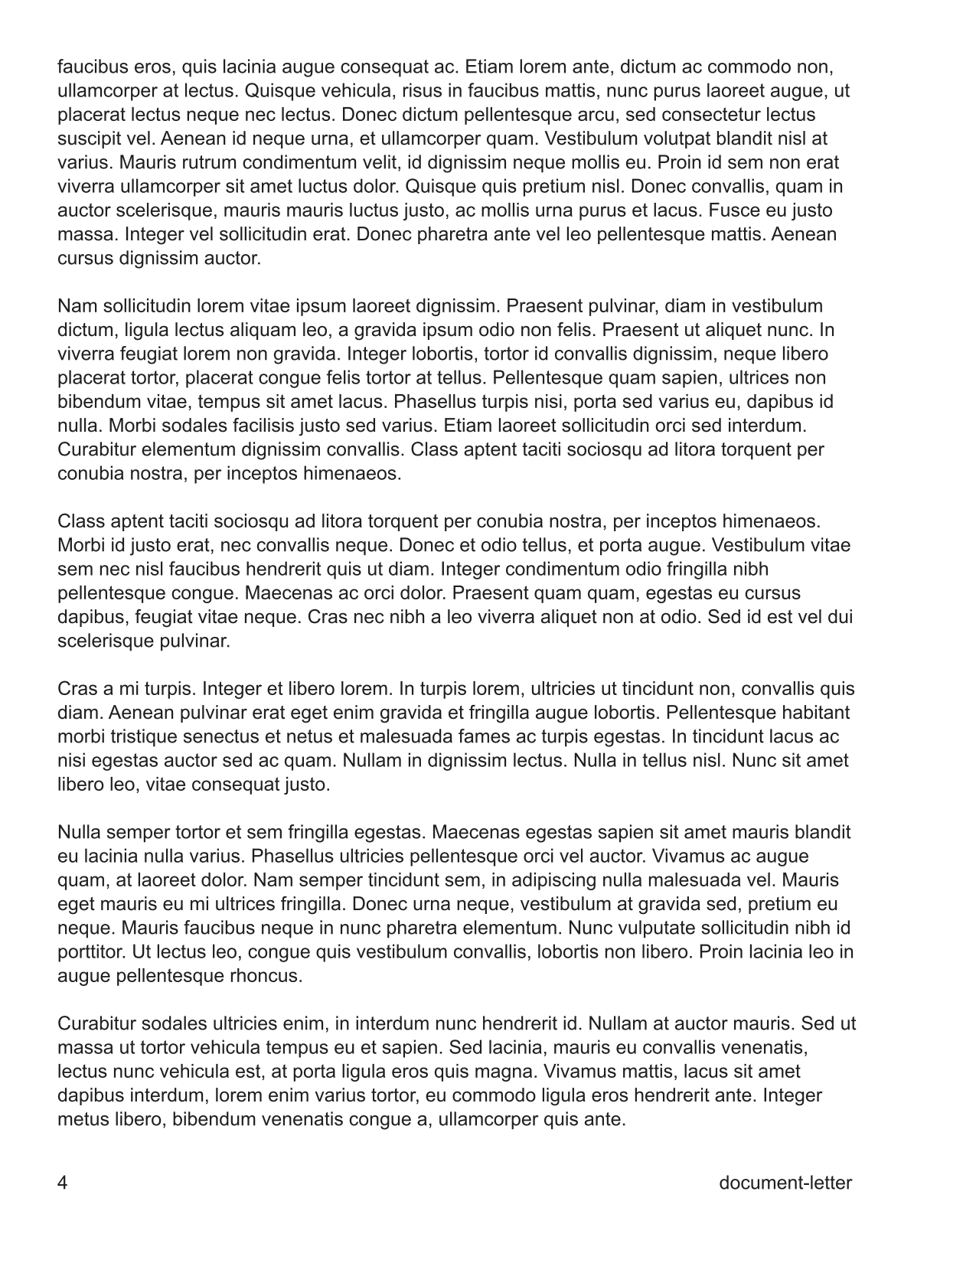

Figure 3 - Content of "document-letter.pdf" Test Document
- Submission of Test Reports
Self-certification test reports are submitted through the PWG web site at:
https://www.pwg.org/ippeveselfcert
Figure 4 shows the submission form, which includes the following fields:
Organization Name; The name of the organization for the submission
Contact Name; The name of a person responsible for the submission
Contact Email; The email address of a person to contact regarding the submission
Product Family Name; The product family being submitted
Product Family URL; The web page for the product family being submitted
Models; A list of make and model names (one per line) that are included
Self-Certification Manual; The version of the IPP Everywhere Printer Self-Certification manual used
Submission Checklist; Check boxes for "Used approved PWG self-certification software", "Used Production-Ready Code", "Documents printed correctly"
Bonjour Test Results; The plist file containing the Bonjour test results
IPP Test Results; The plist file containing the IPP test results
Document Format Test Results; The plist file containing the document data test results
Once submitted, the test results will be validated by the web site software to check for obvious errors or issues and then the listed models will be added to the public directory of available IPP Everywhere Printers.
  - Exception Process
When a Printer fails one or more tests, the PWG Member MAY request an exception by submitting an issue on the IPP Everywhere Printer Self-Certification Tools project page at:
https://github.com/istopwg/ippeveselfcert/issues
The request will be reviewed by the IPP workgroup. Exceptions will only be granted for issues in the self-certification tools, tests that do not apply to the Product Family, or unavoidable race conditions such as a Job completing early.
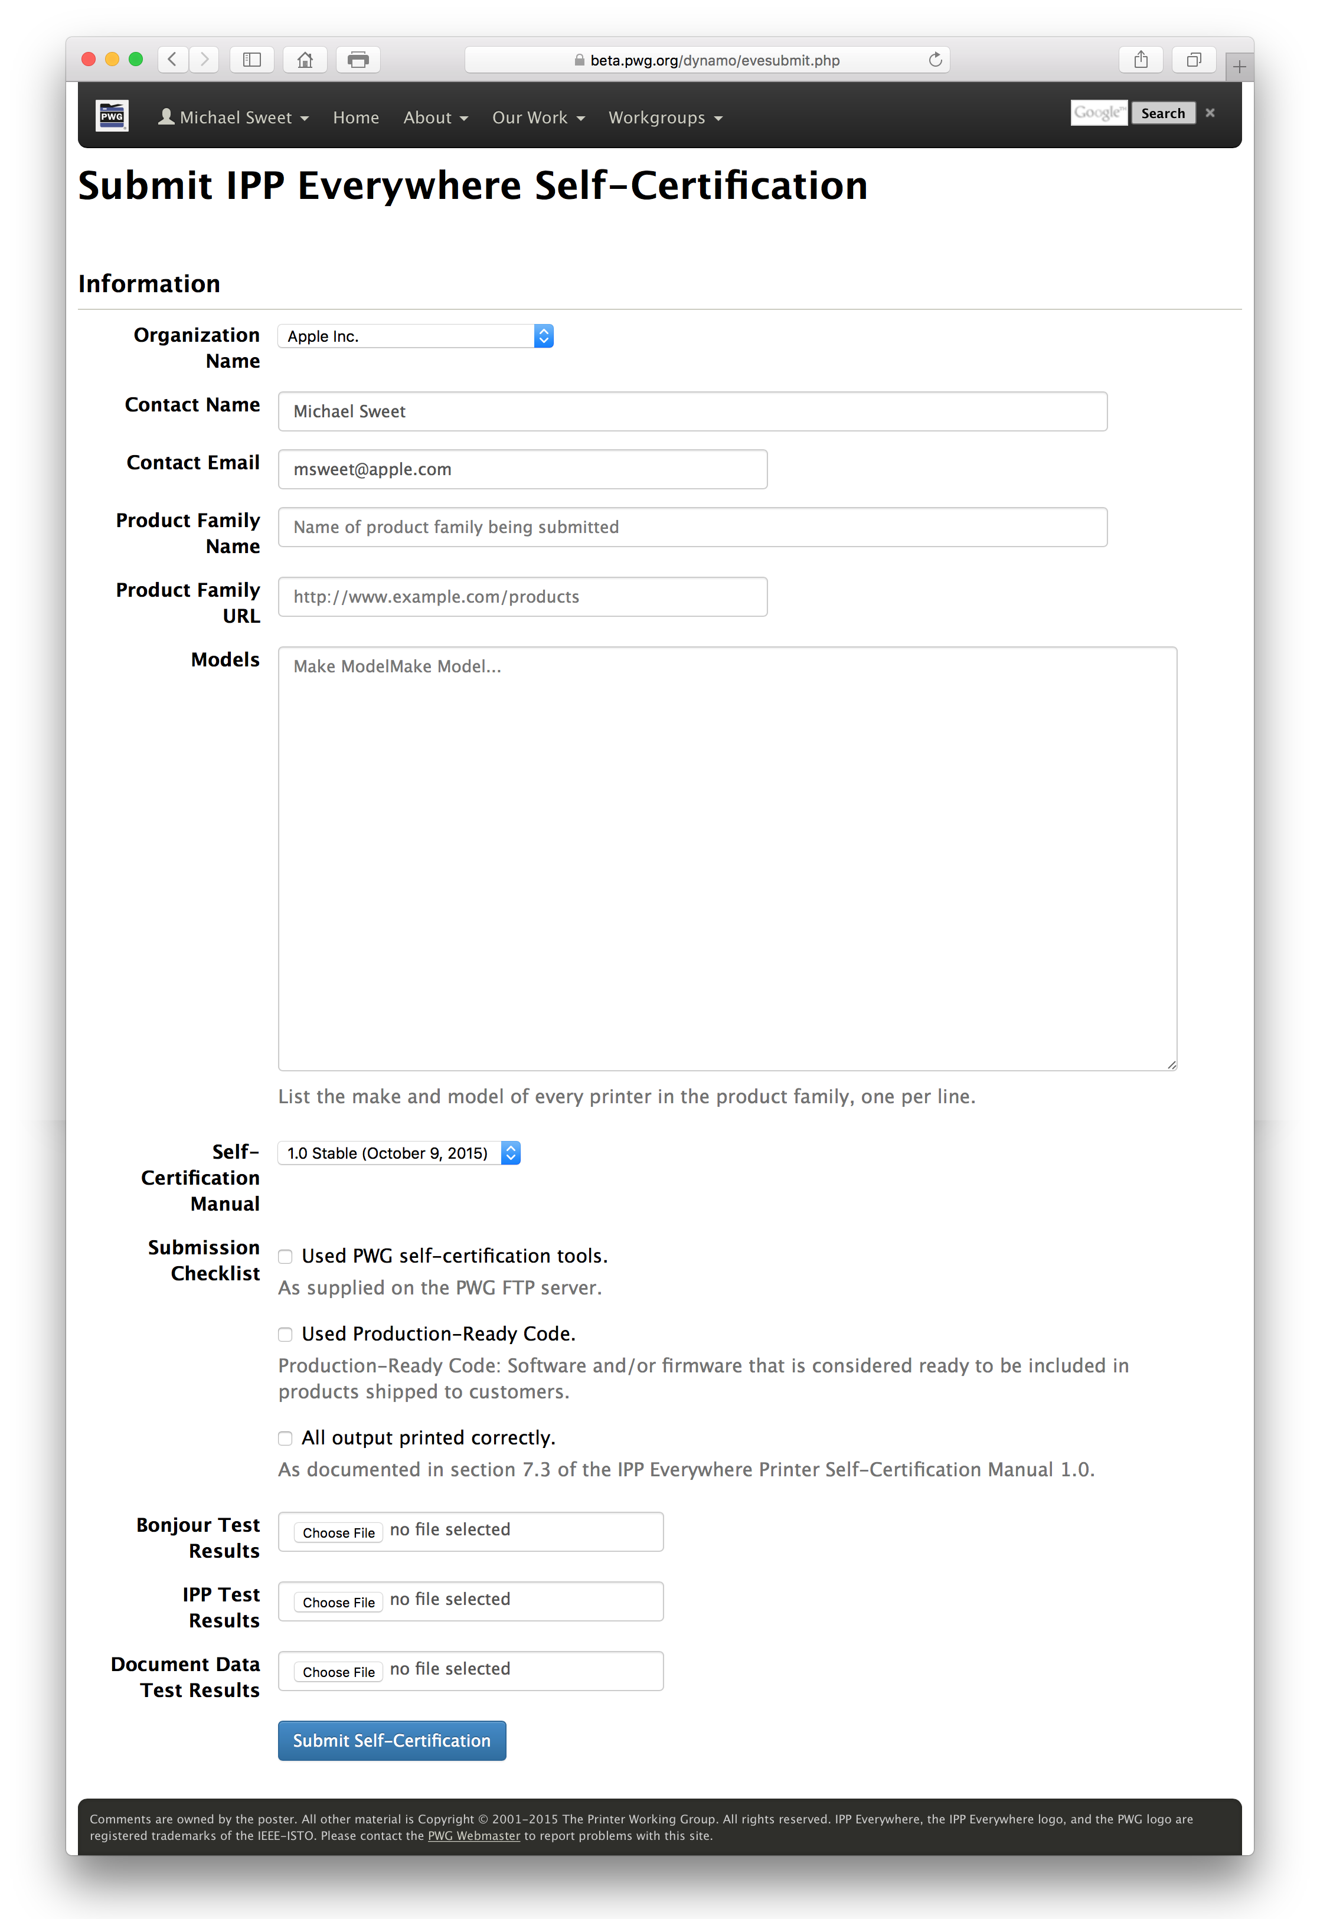

Figure 4 - IPP Everywhere Self-Certification Submission Form
- References
  - Normative References
[IPPEVELOGOPOLICY]
"IPP Everywhere Logo Policy", October 2015, http://ftp.pwg.org/pub/pwg/general/policy/ippevelogo-policy-20160219.txt
[ISO32000] "Document management — Portable document format — Part 1: PDF 1.7", ISO 32000-2008
[JFIF] E. Hamilton, "JPEG File Interchange Format Version 1.02", September 1992, http://www.w3.org/Graphics/JPEG/jfif3.pdf
[PWG5100.12] M. Sweet, I. McDonald, "IPP 2.0, 2.1, and 2.2", PWG 5100.12-2015, October 2015, http://ftp.pwg.org/pub/pwg/standards/std-ipp20-20151030-5100.12.pdf
[PWG5100.14] M. Sweet, I. McDonald, "IPP Everywhere", PWG 5100.14-2013, January 2013, http://ftp.pwg.org/pub/pwg/candidates/cs-ippeve10-20130128-5100.14.pdf
[PWG5102.4] M. Sweet, "PWG Raster Format", PWG 5102.4-2012, April 2012, http://ftp.pwg.org/pub/pwg/candidates/cs-ippraster10-20120420-5102.4.pdf
[RFC2119] S. Bradner, "Key words for use in RFCs to Indicate Requirement Levels", RFC 2119/BCP 14, March 1997, http://tools.ietf.org/html/rfc2119
[RFC2911] T. Hastings, R. Herriot, R. deBry, S. Isaacson, P. Powell, "Internet Printing Protocol/1.1: Model and Semantics", RFC 2911, September 2000, http://tools.ietf.org/html/rfc2911
[RFC3927] S. Cheshire, B. Aboba, E. Guttman, "Dynamic Configuration of IPv4 Link-Local Addresses", RFC 3927, May 2005, http://tools.ietf.org/html/rfc3927
[RFC6762] S. Cheshire, M. Krochmal, "Multicast DNS", RFC 6762, Februrary 2013, http://tools.ietf.org/html/rfc6762
[RFC6763] S. Cheshire, M. Krochmal, "DNS-Based Service Discovery", RFC 6763, February 2013, http://tools.ietf.org/html/rfc6763
[RFC7230] R. Fielding, J. Reschke, "Hypertext Transfer Protocol (HTTP/1.1): Message Syntax and Routing", June 2014, http://tools.ietf.org/html/rfc7230
  - Informative References
[MEMBERS] "Members - Printer Working Group", http://www.pwg.org/pwg-logos/members.html
[PROCESS30] "The Printer Working Group Definition of the Standards Development Process Version 3.0", January 2009, http://ftp.pwg.org/pub/pwg/general/pwg-process-30.pdf
[PROD-FAMILY] "Definition of Product Family", http://www.businessdictionary.com/definition/product-family.html
- Author's Addresses
Primary author:
Michael Sweet
Apple Inc.
1 Infinite Loop
Cupertino, CA 95014
msweet@apple.com
The author would also like to thank the following individuals for their contributions to this standard:
Daniel Manchala - Xerox
Ira McDonald - High North
Glen Petrie - Epson
William Wagner - TIC
- Release History
This section will contain a list of high-level changes for each release of the document.
  - Version 1.0
Initial version of the self-certification manual.

