
A Project of the PWG-IPP Working Group

Printer Working Group (PWG):
Semantic Model

IEEE-ISTO Printer Working Group
Standard XXXX.X-200X

September 9, 2002
Version 0.09

Abstract

This document is a high level overview of the Semantic Model defined by the PWG. This document briefly describes the semantic elements defined in various PWG documents and PWG documents submitted to the IETF. The Semantic Model also incorporates additions made by other groups addressing print systems. With every semantic element included a reference is provided to the document and section that details the semantic definition.
The Semantic Model contains a high level description of the Actions that operate on the objects and attributes in the model. This document does not describe the mapping of the semantics onto a specific protocol or network environment.
Copyright (C) 2001, IEEE Industry Standards and Technology Organization. All rights reserved.

This document may be copied and furnished to others, and derivative works that comment on, or otherwise explain it or assist in its implementation may be prepared, copied, published and distributed, in whole or in part, without restriction of any kind, provided that the above copyright notice, this paragraph and the title of the Document as referenced below are included on all such copies and derivative works. However, this document itself may not be modified in any way, such as by removing the copyright notice or references to the IEEE-ISTO and the Printer Working Group, a program of the IEEE-ISTO.
Title: Printer Working Group (PWG): Semantic Model
The IEEE-ISTO and the Printer Working Group DISCLAIM ANY AND ALL WARRANTIES, WHETHER EXPRESS OR IMPLIED INCLUDING (WITHOUT LIMITATION) ANY IMPLIED WARRANTIES OF MERCHANTABILITY OR FITNESS FOR A PARTICULAR PURPOSE.
The Printer Working Group, a program of the IEEE-ISTO, reserves the right to make changes to the document without further notice. The document may be updated, replaced or made obsolete by other documents at any time.
The IEEE-ISTO takes no position regarding the validity or scope of any intellectual property or other rights that might be claimed to pertain to the implementation or use of the technology described in this document or the extent to which any license under such rights might or might not be available; neither does it represent that it has made any effort to identify any such rights.
The IEEE-ISTO invites any interested party to bring to its attention any copyrights, patents, or patent applications, or other proprietary rights which may cover technology that may be required to implement the contents of this document. The IEEE-ISTO and its programs shall not be responsible for identifying patents for which a license may be required by a document and/or IEEE-ISTO Industry Group Standard or for conducting inquiries into the legal validity or scope of those patents that are brought to its attention. Inquiries may be submitted to the IEEE-ISTO by e-mail at:
ieee-isto@ieee.org.
The Printer Working Group acknowledges that the IEEE-ISTO (acting itself or through its designees) is, and shall at all times, be the sole entity that may authorize the use of certification marks, trademarks, or other special designations to indicate compliance with these materials.
Use of this document is wholly voluntary. The existence of this document does not imply that there are no other ways to produce, test, measure, purchase, market, or provide other goods and services related to its scope.

Table of Contents
1 Introduction 7
2 Terminology 7
3 Model Overview 8
4 Data Classes 9
4.1 Printer Object Class 9
4.1.1 Printer State Attributes 9
4.1.2 Printer Description Attributes 11
4.1.3 Printer Defaults, Supported and Ready Processing Attributes 12
4.2 Job Object Class 13
4.2.1 Job State Attributes 13
4.2.2 Job Description Attributes 15
4.3 Document Object Class 15
4.3.1 Document State Attributes 15
4.3.2 Document Description Attributes 17
4.4 Processing Attributes 17
4.4.1 Job Processing Attributes 18
4.4.2 Document Processing Attributes 18
5 Actions 20
5.1 Action Summary 20
5.2 Job Creation and document submission Actions 20
5.2.1 PrintJob 22
5.2.2 PrintUri 22
5.2.3 CreateJob 22
5.2.4 SendDocument 22
5.2.5 SendUri 23
5.2.6 ValidateJob 23
5.3 Job Control Actions 23
5.3.1 CancelJob 23
5.3.2 HoldJob 23
5.3.3 ReleaseJob 23
5.3.4 RestartJob 23
5.4 Status and information Actions 23
5.4.1 GetJobs 23
5.4.2 GetPrinterAttributes 23
5.4.3 GetJobAttributes 24
5.5 Printer Control Actions 24
5.5.1 PausePrinter 24
5.5.2 ResumePrinter 24
5.5.3 PurgeJobs 24
6 Summary of attributes 24
6.1 Processing Attributes (Job and Document) 24
6.2 Job Attributes (State and Description) 31
6.3 Document Attributes (State and Description) 35
6.4 Printer Attributes (State and Description) 38
7 Status Strings 42
8 Change Log 44
9 References 45
Author's Addresses 45
10 Appendix A – UPnP Definitions 46
10.1 DeviceID 46
11 Appendix B – IPP Mapping 47
11.1 Action Parameter Overview 47
11.2 Job Creation Actions 47
11.2.1 PrintJob 47
11.2.2 PrintUri 48
11.2.3 CreateJob 48
11.2.4 SendDocument 48
11.2.5 SendUri 49
11.2.6 ValidateJob 49
11.3 Job Control Actions 49
11.3.1 CancelJob 49
11.3.2 HoldJob 50
11.3.3 ReleaseJob 50
11.3.4 RestartJob 50
11.4 Status and information Actions 50
11.4.1 GetJobs 50
11.4.2 GetPrinterAttributes 51
11.4.3 GetJobAttributes 51
11.5 Printer Control Actions 52
11.5.1 PausePrinter 52
11.5.2 ResumePrinter 52
11.5.3 PurgeJobs 52
11.6 Changes to remove some IPP specific aspects 52

Table of Figures
Figure 1 Model Overview 8
Figure 2 Data Classes 9
Figure 3 Printer State Attributes 10
Figure 4 - The "PrinterState" attribute and the Printer Life Cycle 11
Figure 5 Printer Description Attributes 12
Figure 7 Job State Attributes 14
Figure 8 The "JobState" Job Attribute and the Job object life Cycle 14
Figure 9 Job Description Attributes 15
Figure 10 Document State Attributes 16
Figure 11 "DocumentState" Attribute and Document object life Cycle 16
Figure 12 Document Attributes 17
Figure 13 - Processing Attribute Groups 18
Figure 14 Job Processing Attributes 18
Figure 15 Finishing Attributes 19
Figure 16 Imposition Attributes 19
Figure 17 Rendering Attributes 20
Figure 18 Processing Instruction Processing 21

Table of Tables
Table 1-Integer syntaxes whose ProcessingAttributeSupported syntax isn’t RangeOfInteger 12
Table 2 - Summary of Actions 20
Table 3 - Processing Attributes (Job and Document) 24
Table 4- Job Attributes (State and Description) 31
Table 5 – Document Attributes (State and Description) 35
Table 6 - Printer Attributes (State and Description) 38

Introduction

This document is a high level overview of the Semantic Model defined by the PWG. This document briefly describes the semantic elements defined in various PWG documents and PWG documents submitted to the IETF. The Semantic Model also incorporates additions made by other groups addressing print systems. With every semantic element included a reference is provided to the document and section that details the semantic definition.
The Semantic Model contains a high level description of the Actions that operate on the objects and attributes in the model. This document does not describe the mapping of the semantics onto a specific protocol or network environment.
ISSUE 01: Need a real Terminology section badly, right here. Explain Processing Attributes (supplied only in a request), Production Instructions (represented by Processing Attributes and PDL content), Data Classes, Job Ticket, operation (or action?), object, etc. Is must, should, and may to be used?

Terminology
Type 1 keyword | All the values are defined in the specification. Additional values require a new specification.
Type 2 keyword | An initial set of values is defined in the specification. This working group registers additional values after review. The initial versions of the specification will contain the values registered so far. After the specification is approved, this working group will register additional values after approval.
Type 3 keyword | An initial set of values is defined in the specification. Additional values are registered without working group review. The initial versions of the specification contain the values registered so far. After the specification is approved, this working group will register additional values without approval.
End User | A print client that has no special rights on the printer. The End User typically submit jobs. The End User is allowed to query the printer, jobs and documents and control jobs based on policy.
Operator | A print client that has special rights on the printer. The Operator typically oversees the printer. The Operator is allowed to query and control the printer, jobs and documents based on site policy.
MediaSheet | A sheet of paper, or other material, used for printing
Impression | Everything printed on a single side of a media
Page | A logical entity that represents the information contained on a single side of a sheet of media. Note that this is the electronic form and that multiple pages can be rendered into a single impression through N-Up printing

Model Overview
The Printer Working Group (PWG) has defined a simplified printing model. It represents printing in either a client/server print paradigm or a peer-to-peer print paradigm. The PWG model describes the device as a Printer object. A Printer object may represent one or more physical Printers. Another object is the Job. A Printer can contain zero or more Jobs and a Job is contained in only one Printer. Each Job can contain zero or more documents. A Job can contain zero or more Documents and a Document is contained in only one Printer. The PWG model contains methods that act upon these objects.
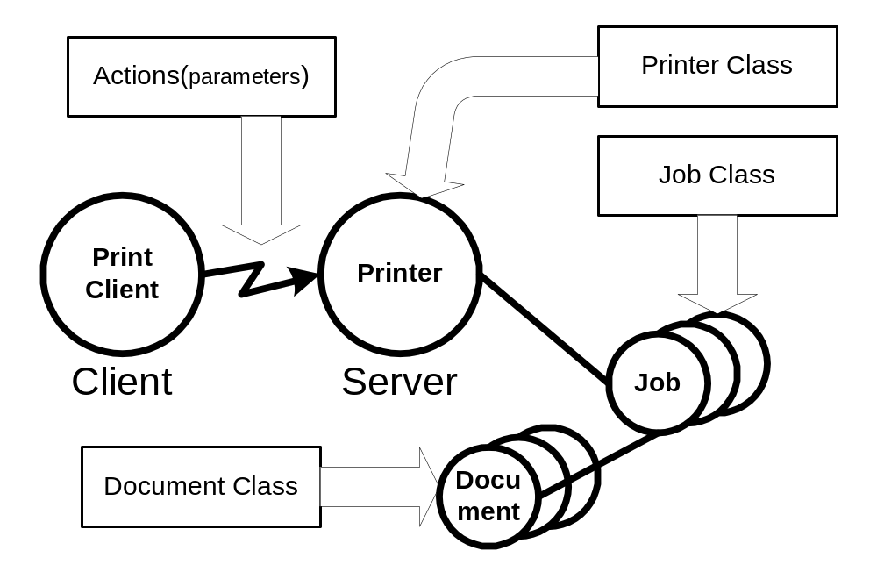
Figure 1 Model Overview
The objects are represented in the semantic model as data classes. The methods are represented as a set of actions that act upon those data classes. The actions permit the creation and control of Jobs and documents as well as the submission of Document data. The content of a Document is included in the submission or can be accessed via a URL reference. There are also actions to query a Printer, Job or Document to access their attributes or to list their contained objects.
The model uses a number of terms with specific meaning for a printer.

Data Classes
This section describes the data classes in the PWG semantic model. Some of the classes are taken from the model and semantics of IPP [rfc2911]. Figure 2 Shows the data classes, their attribute groups and the containment relationship between the classes
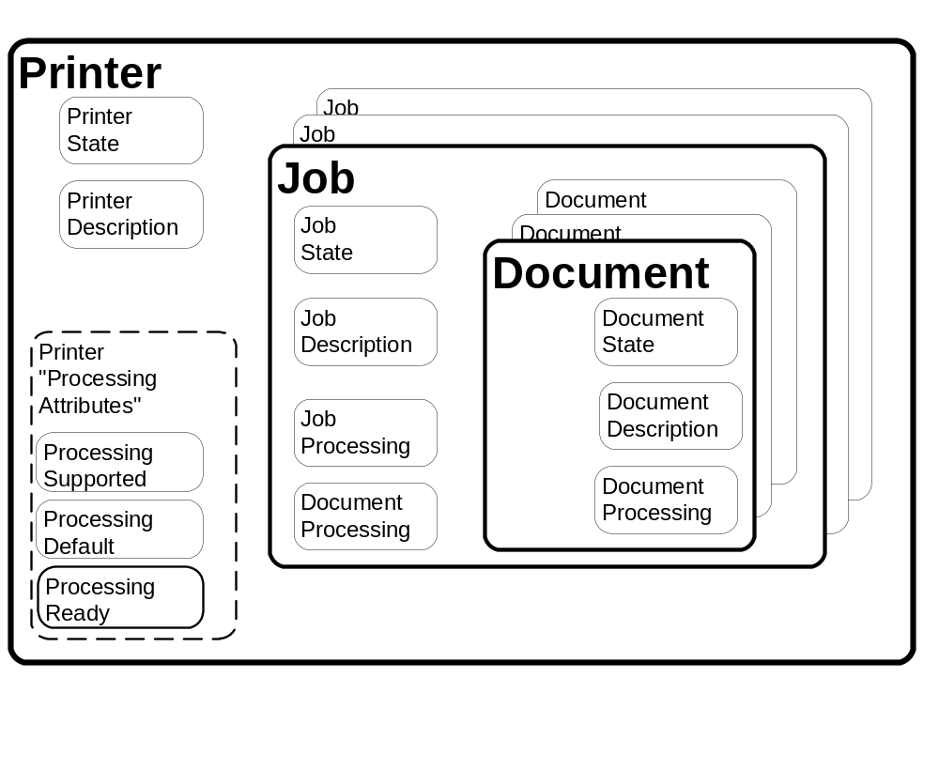
Figure 2 Data Classes

Printer Object Class
The Printer class is represented by a collection of attributes as shown in Figure 2. The Printer Attributes are presented in detail in Table 6. The printer object also contains attributes that describe the valid processing attribute values. (See section 4.3.2for processing attributes) The Printer class is the container for Job

Printer State Attributes
Figure 3 below shows the Printer State Attributes. These attributes represent the state of the printerdsuch as the number of jobs or existing error conditions. Automata primarily control the attributes in this group. End Users cannot directly modify their values. The End User can affect the values of these attributes through actions (e.g. PausePrinter can change the value of PrinterIsAcceptingJobs”). The semantics of the attributes are summarized in Table 6.

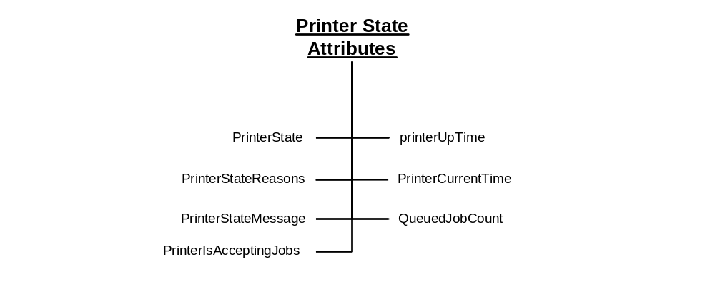
Figure 3 Printer State Attributes

The Printer Life Cycle
The “PrinterState” attribute is one of the most important Printer Description attributes. shows the values of the “PrinterState” attribute and the Printer life cycle as affected by actions on the Printer and job processing.
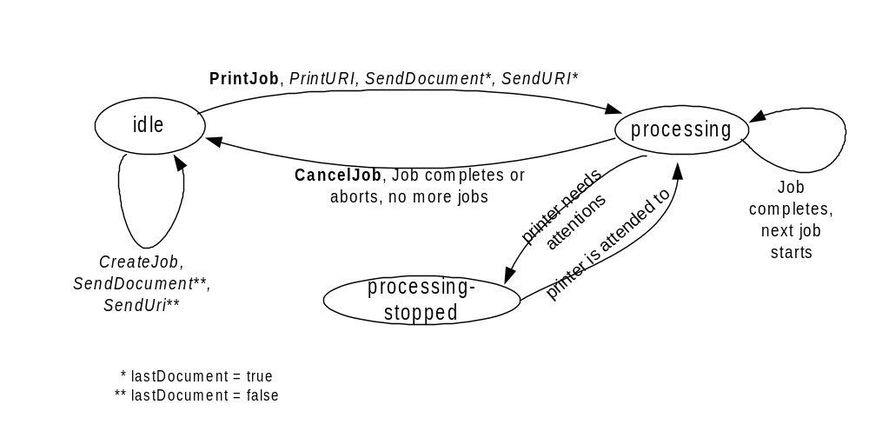
Figure 4 - The "PrinterState" attribute and the Printer Life Cycle

Printer Description Attributes
Figure 5 below shows the Printer Description Attributes. These attributes contain information that describes the printer such as its make, where it’s located and its speed. An automaton controls some of the attributes in this group (e.g. “PagesPerMinute”). Others attributes in this group can be modified by Operators or Administrators (e.g. “PrinterName”). The semantics of the attributes are summarized in Table 6.

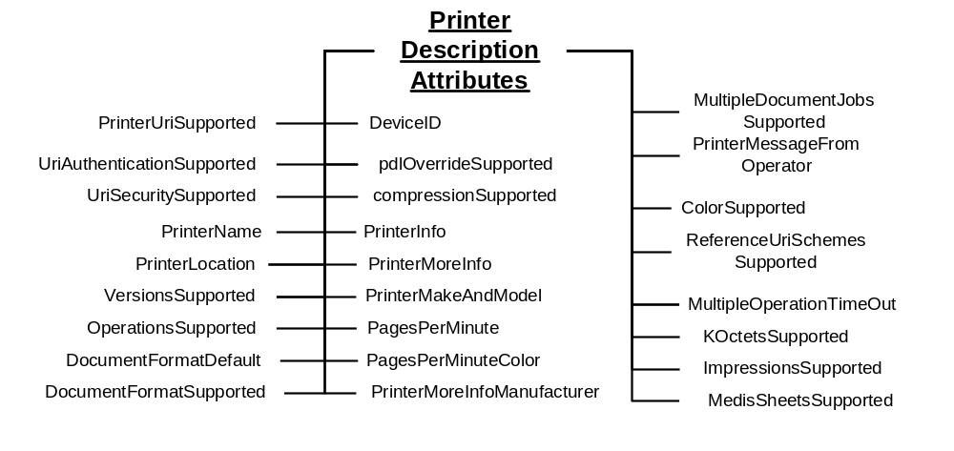
Figure 5 Printer Description Attributes

Printer Defaults, Supported and Ready Processing Attributes
See section 4.3.2 below for the attributes that may comprise these groups. Processing Attributes are the union of Job Processing Attributes and Document Processing Attributes.If a Processing attribute (e.g. Media) is supported, the Printer must have an associated Processing Supported Attribute (e.g. MediaSupported) and Processing Default Attribute (e.g. MediaDefault) Printer attribute. There may be an associated Processing Ready Attribute (e.g. MediaReady) Printer attribute. By retrieving the Printer Processing attributes, a Client can determine all the Job and Document Processing attributes and values that may be used in creating Jobs and Documents.

Processing Supported Attributes
These attributes list all the currently configured valid values for each Job Processing Attribute and Document Processing Attribute. Though the Printer is configured to support the feature, human intervention may be required to process the job (e.g. selected paper may have to be loaded into a tray). The syntax for Processing Attributes Supported is multi-valued when the associated processing attribute is a string. When syntax of the processing attribute is an integer, the syntax of the corresponding Procdessing Supported Attribute is usually RangeOfInteger which indicates the minimum and maximum values supported by the Printer. However, there are some exceptions as indicated in Table 1.
Table 1-Integer syntaxes whose ProcessingAttributeSupported syntax isn’t RangeOfInteger
“xxx” attribute name | “xxx” syntax | “xxxSupported” syntax
JobPriority | Integer | Integer (Max value)
Copies | Integer | Integer (Max value)
PageRanges | RangeOfInteger (multivalued) | Boolean (are PageRanges supported)

Processing Default Attributes
These attributes give the default value for the associated processing instruction if the Processing Attribute of the job and document are not supplied and the instructions is not embedded in the PDL. The syntax for the Processing Default Attributes is the same as the corresponding Processing Attribute. The only exception is that the PageRanges attribute does not have a PageRangesDefault attribute.

Processing Ready Attributes
These attributes give the features available without human intervention. The syntax for a Processing Ready Attribute is the same as the corresponding Processing Attribute.

Job Object Class
The Job object class is represented by a collection of attributes divided into four groups as shown in Figure 2. The Job class also contains the document class
Job State Attributes – See Section 4.2.1
Job Description Attributes – See section 4.2.2.
Job Processing Attributes – See section 4.4.1 Table 3 - Processing Attributes
Document Processing Attributes – See section 4.4.2

Job State Attributes
Figure 6 below shows the Job State Attributes. Automata primarily control the attributes in this group. End Users cannot directly modify their values. The End User can affect the values of these attributes through actions (e.g. CancelJob can change the value of JobStateReasons”). The semantics of the attributes are summarized in Table 4.
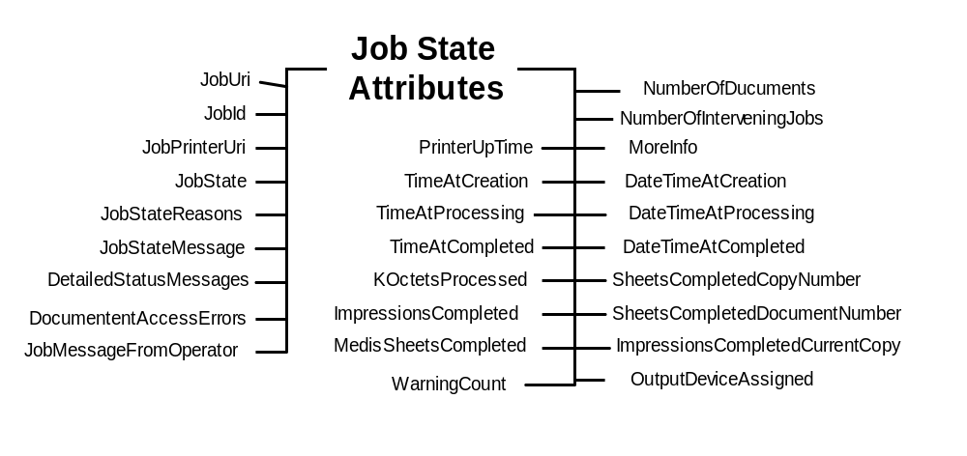
Figure 6 Job State Attributes

The Job Life Cycle
The “JobState” attribute is one of the most important Job State attributes. Figure 7 shows the values of the “JobState” attribute and the Job life cycle as affected by actions on the Job, Printer, and job processing.
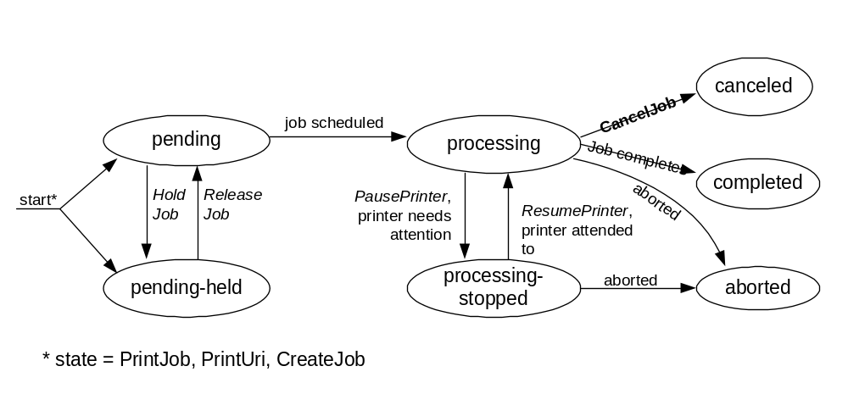
Figure 7 The "JobState" Job Attribute and the Job object life Cycle

Job Description Attributes
Figure 8 below shows the Job Attributes. These attributes contain information from the End User at Job creation that describes the Job such as its name. Automaton may modify the value of some of the attributes in this group (e.g. “KOctets”) if more reliable data is obtained. The semantics of the attributes are summarized in Table 4.
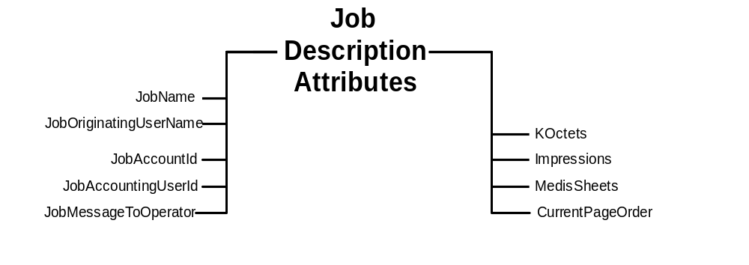
Figure 8 Job Description Attributes

Document Object Class
The Document object class is represented by a collection of attributes divided into Three groups as shown in Figure 2. The Document class contains the document class
Document State Attributes – See Section 4.3.1.
Document Description Attributes – See section .
Document Processing Attributes – See section 4.4.2

Document State Attributes
Figure 9 shows the Document State Attributes. Automata primarily control the attributes in this group. End Users cannot directly modify their values. The End User can affect the values of these attributes through actions (e.g. CancelDocument can change the value of DocumentsState”) The semantics of the attributes are summarized Table 5
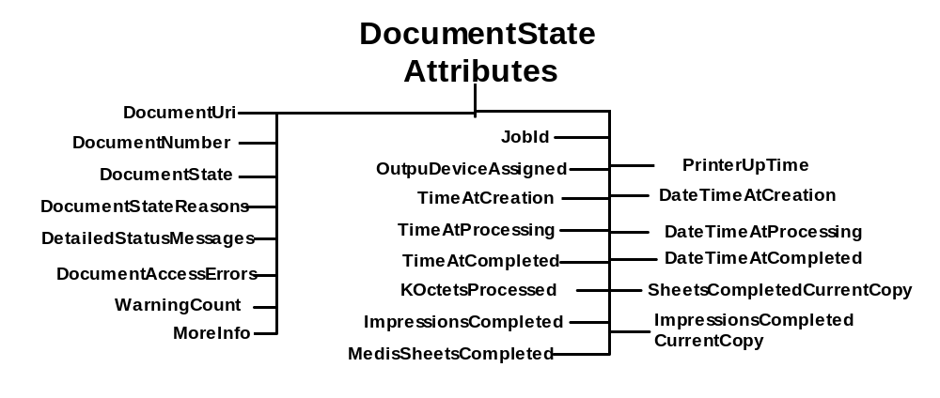
Figure 9 Document State Attributes

The Document Life Cycle
The “DocumentState” attribute is one of the most important Document State Attributes. Figure 10 shows the values of the “DocumentState” attribute and the Document life cycle as affected by Actions and job processing. Documents are not active objects and their life cycle is closely tied to the lifecycle of a Job. Documents basically have three states. The first is waiting to be processed by a Job (i.e. pending). The second state is from the time the Job first starts processing the Document(i.e processing) and until it reaches its terminating state. The last state for a Document is its terminal state (i.e. completed, canceled, aborted)
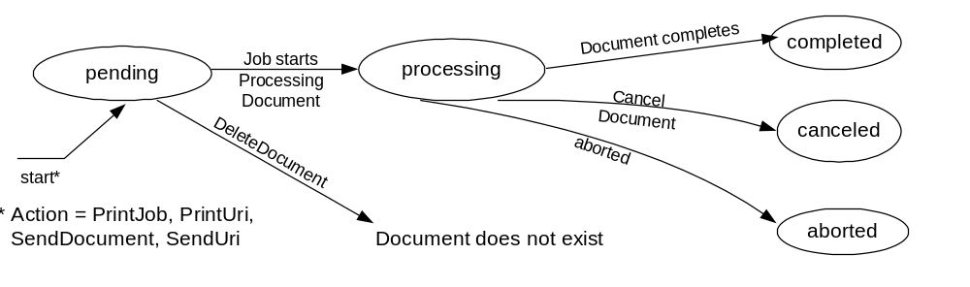
Figure 10 "DocumentState" Attribute and Document object life Cycle

Document Description Attributes
Figure 9 shows the Document Description Attributes. These attributes contain information from the End User at Document creation that describes the document such as its size. Automaton may modify the value of some of the attributes in this group (e.g. “KOctets”) if more reliable data is obtained. The semantics of the attributes are summarized in Table 5
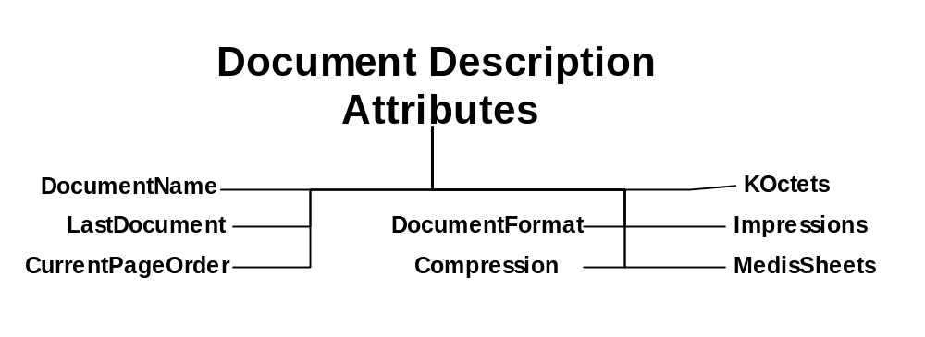
Figure 11 Document Attributes

Processing Attributes
Processing attributes are instructions to be applied to jobs and documents. They indicate such things as the priority for scheduling a job or the number of copies for a documents. A Printer should support each Processing Attribute that represents a feature of the Printer. The Processing attributes are split intr tws groups. One groups applies to Jobs and the other to Documents. The Document Processing group contains three sub-groups. (Sin Figure 12 :
- Job Processing Attributes are processing instructions applied the Job level. See section 4.4.1.
- Document Processing Attributes are specific to documents. See section 4.4.2.

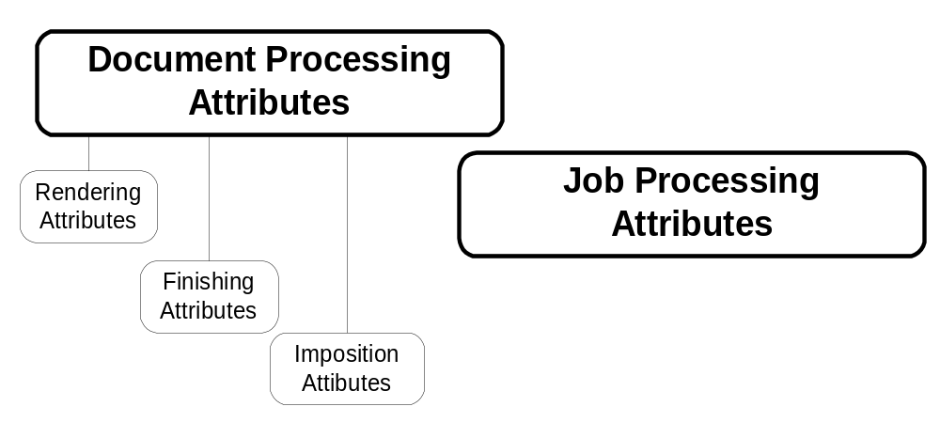
Figure 12 - Processing Attribute Groups

Job Processing Attributes
Figure 13 shows the Job Processing Attributes. These attributes apply to the job as a whole as opposed to each document in the job. The semantics of the attributes are summarized in Table 3 along with a brief description of each attribute.

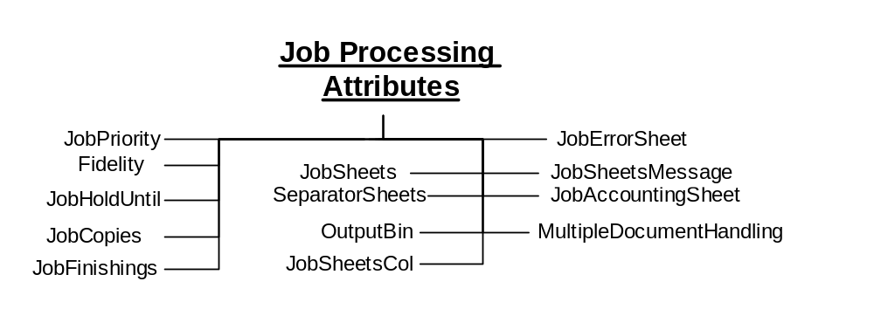
Figure 13 Job Processing Attributes

Document Processing Attributes
Document Processing Attributes are attributes that are applied to documents (e.g. “copies”). The Document Processing Attributes can be applied at the Job or Document level. If the attributes are applied at the Job level they are the default values for all the Documents in the Job. If the attributes are applied at the Document level they apply only to that Document. The semantics of the Processing attributes are summarized in Table 3. The Document Processing attributes are split into three groups as shown in Figure 12:
- Finishing Attributes define how multiple physical sheets are manipulated to create final output products. See section 4.4.2.1.
- Imposition Attributes identify how the logical pages look on the output media. See section 4.4.2.2.
- Rendering Attributes determine the quality and resolution of how marks are made on the page. See section 4.4.2.3.

Finishing Attributes
Figure 14 shows the Finishing Attributes. Finishing Attributes define how multiple physical sheets are manipulated to create final output products. See Table 3 for summary of attribute semantics.

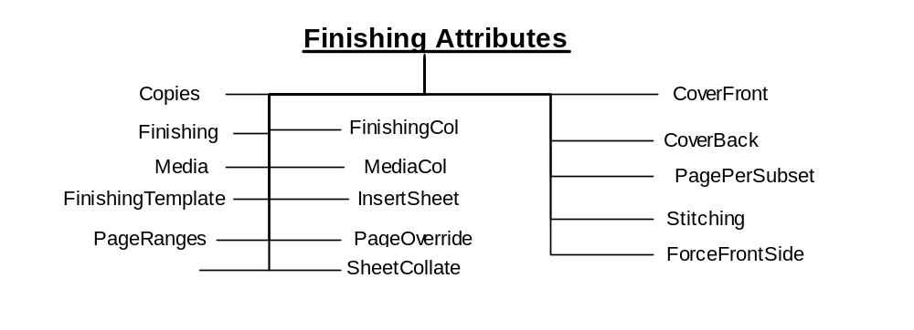

Figure 14 Finishing Attributes

Imposition Attributes
Figure 15 shows the Imposition Attributes. Imposition Attributes identify how the logical pages look on the output media. See Table 3 for summary of attribute semantics.

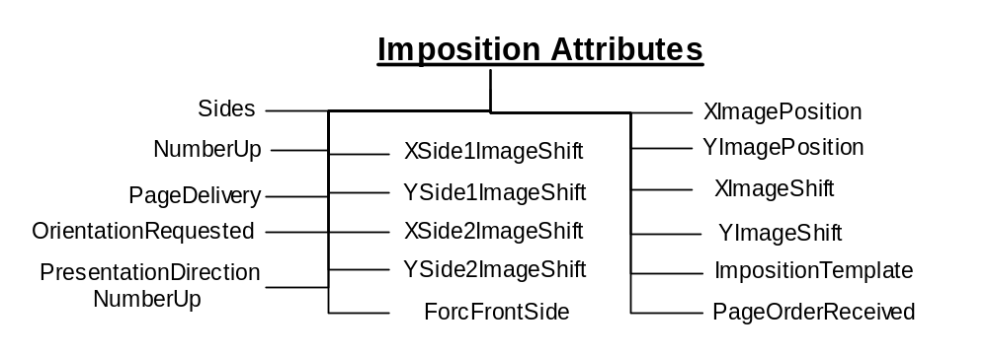

Figure 15 Imposition Attributes

Rendering Attributes
Figure 16 shows the Rendering Attributes. Rendering Attributes determine the quality and resolution of how marks are made on the page. See Table 3 for summary of attribute semantics.
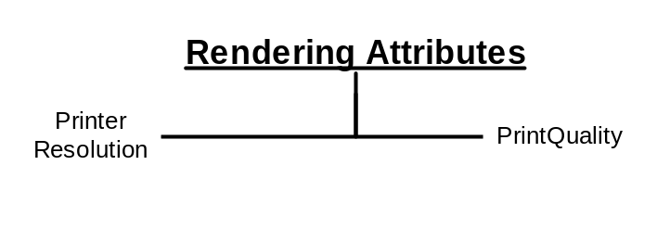

Figure 16 Rendering Attributes

Actions
The PWG has defined a number of operations that affect Printers, Jobs and their document. Below is a description of the semantics of these Actions. Naturally different protocol bindings will use differing subsets of the Actions or define new ones. Another difference will be the precise parameters to the Actions. Below is an abstract definition of the Actions. ISSUE 2: Need to add Document actions(GetDocumentAttribute, CancelDocument, CancelCurrentDocument, DeleteDocument, GetDocuments, SetDocumentAttribute, ValidateDocument from PSI and PWG Document object work in progress.

Action Summary
This table summarizes the actions defined for the Job and Printer. See section 4.4.2 for more details.
Job Creation and Document submission | Job Control | Status and Information access | Printer Control
PrintJob | CancelJob | GetJobs | PausePrinter
PrintUri | HoldJob | GetPrinterAttributes | ResumePrinter
CreateJob | ReleaseJob | GetJobAttributes | PurgeJobs
SendDocument | RestartJob
SendURI
ValidateJob
Table 2 - Summary of Actions

Job Creation and document submission Actions
This section describes the Job Creation actions that create a Job and the ones that create add Document to a Job. The Job Creation actions are: PrintJob, PrintUri, and CreateJob. The PrintJob action also submits the Document. The PrintUri action submits a URI reference to the Document which the Printer then retrieves when needed at a later time. The CreateJob action only creates the job and the Client must issue subsequent SendDocument and SendUri actions in order to submit document content or a URI reference, respectively, for a job.
Processing instructions and descriptive information contained in the arguments of the Job Creation action are combined with Printer supplied information to create a Job instance.
The last action in this section is ValidateJob. This operation allows a Client to send a request with all the information to create a Job, except the document content. The Printer does not create a Job but informs the client whether a CreateJob, PrintJob or PrintUri with the same information would have succeeded. This is useful for allowing a Client to verify the processing instructions before sending a large PrintJob request.
A concept that is important in the PWG model is a set of instructions that can be applied to a print job. Examples of these instructions include the number of copies and the media to use. These instructions are referred to as Processing Attributes. The Processing Attributes are made up of the Job Processing Attributes (see section 4.4.1) and the Document Processing Attributes (see section 4.4.2) sent in a Job or Document Creation Action.
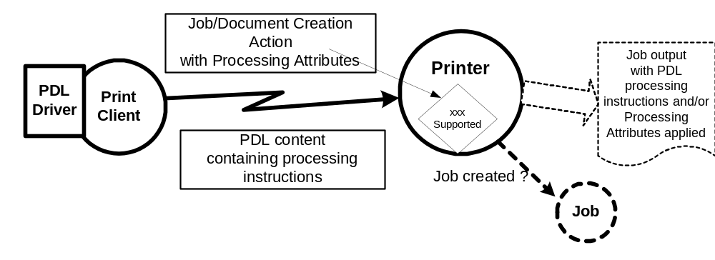
Figure 17 Processing Instruction Processing
In the real world, processing instructions are also contained in the document content for a job. Page Description Languages (PDL) such as PostScript® and PCL® often contain processing instructions. Some environments use a printer specific driver to generate the PDL stream based on feature selections made through a user interface. Given that processing instructions can occur in both the PDL and in an associated Job, the PWG model allows a Printer to declare its capability to resolve this conflict. The Printer’s attribute “PdlOverride” declares if an attempt will be made to override the instructions in the PDL with the instructions in the Job.
There is a wide variety of capabilities in Printers. An instance of a Printer is to subject to changes in its configured capabilities. An example would be an administrative change in the media the Printer supports or disabling two-sided printing. Clients need not check the capabilities of a Printer before creating their Job Processing Attributes and submitting a job. Since this is a client/server paradigm, it is always possible that the capabilities could change after checking a Printer’s capabilities and before a Job is submitted. On the other hand, a client may use the Printer’s configured capabilities to create their Job Processing Attributes and submit a job.
The PWG model allows a client to control the Printer’s acceptance of a job submission based on the job request and the Printer’s current configured capabilities as follows. When the client supplies a ‘true’ value for the “AttributeFidelity” Job Processing attribute, the Printer must reject the job unless the Printer supports all of the supplied Job Processing attributes and values. When the client supplies a ‘false’ value or omits the attribute, the Printer must accept the job submission and ignore or substitute attributes and values, respectively, that it does not support. Note that the “AttributeFidelity” Job Processing attribute covers only the creation of the Job. It is implementation specific how a Printer handles processing a job when the Printer encounters unsupported processing instructions in the document content.

PrintJob
([rfc2911] §3.2.1) Submit a print job with only one document and supply the document content data. If the Printer accepts the job, it creates the Job object and returns a unique “JobId” attribute for the Printer and a globally unique “JobUri” attribute. The Printer also sets the corresponding Job attributes with these values.

PrintUri
([rfc2911] §3.2.2) Identical to the PrintJob operation (see section 5.2.1) except that a client supplies a URI reference to the document data.

CreateJob
([rfc2911] §3.2.4) Similar to the PrintJob operation (see section 5.2.1), except that in the CreateJob request the Client does not supply Document Data. The client supplies a single set of Job Processing attributes that the Printer applies to the Output Document(s) of the job. The “MultipleDocumentHandling” Job Processing attribute controls whether the Printer produces separate Output Documents or combines the Input Documents into a single Output Document (see section 22).

The “MultipleDocumentHandling” Job Processing attribute
When a client submits a job with more than one Input Document, the “MultipleDocumentHandling” Job attribute allows the client to specify whether the Printer is to (1) produce corresponding separate Output Documents or (2) combine the Input Documents into a single Output Document. For example, the ‘single-document’ and ‘single-document-new-sheet’ values allow the client to staple all of the Input Documents into a single Output Document, with the latter value forcing each Input Document to start on a new sheet (useful when doing two-sided printing). When requesting multiple Copies, the ‘separate-document-uncollated-Copies’ value results in the Copies of each Input Document being together in an Output set, while the ‘separate-document-collated-Copies’ value keeps a copy of each Input Document together in an Output set. For example, a job with Input Documents A, B, C and “Copies” = 2 will result in A, A, B, B, C, C or A, B, C, A, B, C, respectively. If the Printer supports multiple documents per job, the Printer must support this Job Processing attribute with at least one value.

SendDocument
([rfc2911] §3.3.1) Submits the entire Document Content for the next Input Document of a job created by a previous CreateJob action (see section 5.2.3).

SendUri
([rfc2911] §3.3.2) Identical to the SendDocument operation (see section 5.2.4) except that a client supplies a URI reference to the Document Content data, instead of supplying the document content.

ValidateJob
([rfc2911] §3.2.3) This operation is used only to verify capabilities of a Printer object against whatever attributes are supplied by the client in the ValidateJob request. By using the ValidateJob action a client can validate that an identical PrintJob, PrintUri or CreateJob would be accepted.

Job Control Actions
This section describes the actions that allow a client to control a Job after it has been submitted: CancelJob, HoldJob, ReleaseJob, and RestartJob.

CancelJob
([rfc2911] §3.3.3) Allows a client to cancel a Print Job from the time the Job is created up to the time it is completed, canceled, or aborted.

HoldJob
([rfc2911] §3.3.5) Allows a client to hold a pending Job in the Printer so that it is not eligible for scheduling.

ReleaseJob
([rfc2911] §3.3.6) Release a previously held Job so that it is again eligible for scheduling.

RestartJob
([rfc2911] §3.3.7) Restart a job that is retained in the Printer after processing has completed.

Status and information Actions
This section describes the actions that allow a client to obtain status and attributes of Jobs and PrinterS: GetJobs, GetPrinterAttributes, and GetJobAttributes.

GetJobs
([rfc2911] §3.3.4) Retrieve the list of Jobs belonging to the Printer. The Client may supply some simple filters (e.g. “MyJobs, “Limit) to control which jobs will be returned. The Client may supply a list of Job attribute and/or attribute group names to be returned in the response (See 5.4.3). A group of Job attributes will be returned for each returned Job.

GetPrinterAttributes
([rfc2911] §3.2.5) Returns the values of the requested printer attributes and/or attribute groups of a Printer (i.e. Printer State, Printer Description, Processing Supported, Processing Default, Processing Ready).

GetJobAttributes
([rfc2911] §3.3.4) Returns the values of the requested job attributes and/or attribute groups of a Job (i.e Job Description, Job State, Job Processing and Document Processing).

Printer Control Actions
This section describes actions which allow a client to control a Printer and may require operator credentials: PausePrinter, ResumePrinter, and PurgeJobs.

PausePrinter
([rfc2911] §3.2.7) Stops the Printer object from scheduling jobs. Job processing should also cease.

ResumePrinter
([rfc2911] §3.2.8) Resume the processing and scheduling of Jobs in the Printer.

PurgeJobs
([rfc2911] §3.2.9) Removes all jobs from the Printer, regardless of their state.

Summary of attributes
This section summarizes the attributes for the Document, Job and Printer objects. Included in the definition are the processing attributes that can be applied at either the Job or Document level. For each attribute, the tables contain the attribute name, whether the attribute is multi-valued, its syntax, constraints, a short description and a reference to the Document where the semantics of the attribute is completely specified:

Processing Attributes (Job and Document)
Table 3 - Processing Attributes (Job and Document)
Attribute Name |  | Multivalued |  |  |  |  |  |  | Syntax |  |  | Constraint |  | Group |  |  |  |  |  | Reference
 | Description (values)
Copies |  |  |  |  |  |  |  |  | Integer |  |  | 1:MAX |  |  |  |  |  |  |  | [rfc2911] §4.2.5
 | The number of copies of the Output Document(s) to be printed.
CoverBack |  |  |  |  |  |  |  |  | complex |  |  |  |  |  |  |  |  |  |  | [PWG5100.3] §3.1
 | The back cover to apply to document or job. (Includes Media/MediaCol, CoverType)
CoverFront |  |  |  |  |  |  |  |  | complex |  |  |  |  |  |  |  |  |  |  | [PWG5100.3] §3.1
 | The front cover to apply to document or job. (Includes Media/MediaCol, CoverType)
CoverType |  |  |  |  |  |  |  | String |  |  | Type2 keyword |  |  |  |  |  |  |  | [PWG5100.3] §3.1.2
 | Indicates if covers are requested and which sides will contain print stream pages. (Keywords: no-cover, print-none, print-front, print-back, print-both)
DocumentCopies |  | Yes |  |  |  |  | RangeOfInteger |  |  |  |  |  |  |  |  |  |  |  | [PWG5100.4] §5.1.3
 | Specifies the output document copies for override processing.
DocumentOverride |  |  |  |  |  |  |  |  | complex |  |  |  |  |  |  |  |  |  |  | [PWG5100.4] §5.1
 | Provides for the overriding of processing instructions on a document basis. <may also be applied only to a portion of a document. Applied to job, see PageOverride for overrides at the document level. (Includes InputDocuments/OutputDocuments, DocumentCopies, DocumentFormat, DocumentName, Compression, DocumentNaturalLanguage, PageRanges, and any other processing attribute that affects documents) NOTE: Deprecated in favor of Document Object
Finishing |  |  |  |  | Yes |  |  |  | String |  |  | Type2 keyword |  |  |  |  |  |  |  | [rfc2911] §4.2.6
 | Identifies the finishing that the Printer uses for each copy of each printed Output Document in the Job (Keywords: none, staple, punch, cover, bind, saddle-stitch, edge-stitch, staple-top-left, staple-bottom-left, staple-top-right, staple-bottom-right, edge-stitch-left, edge-stitch-top, edge-stitch-right, edge-stitch-bottom, staple-dual-left, staple-dual-top, staple-dual-right, staple-dual-bottom)
FinishingCol |  |  |  |  |  |  |  |  | complex |  |  |  |  |  |  |  |  |  |  | [PWG5100.3] §3.2
 | Enables an end user to specify detailed finishing options not possible with the “Finishing” attribute (Includes FinishingTemplate, Stitching)
FinishingTemplate |  |  |  |  |  |  |  |  | String |  | Maxlength=1023 |  |  |  |  |  |  |  |  | [PWG5100.3] §3.1
 | A string specifying some particular finishing operation.
ForceFrontSide |  |  |  |  | yes |  |  |  | Integer |  |  |  |  |  |  |  |  | [PWG5100.3] §3.3
 | Forces the specified pages to be printed on the front side of a sheet of media. The pages of the output document start at 1.
ImpositionTemplate |  |  |  |  |  |  |  |  | String |  | Type2 keyword |  |  |  |  |  |  |  | [PWG5100.3] §3.4
 | Specifies imposition method for laying out finished page images onto the surface of output media. (Keywords: none, signature)
InputDocuments |  | Yes |  |  |  |  | RangeOfInteger |  |  |  |  |  |  |  |  |  |  |  | [PWG5100.4] §5.1.1
 | Specifies the input documents for override processing.
InsertAfterPageNumber |  |  |  |  |  |  |  |  | Integer |  |  |  |  |  |  |  |  |  | [PWG5100.3] §3.5.1
 | Specifies the input page after which the Insert Sheet will be placed.
InsertAfterPageNumber |  |  |  |  |  |  |  |  | Integer |  |  |  |  |  |  |  |  |  | [PWG5100.3] §3.5.2
 | Specifies the number of Insert Sheet to insert.
InsertSheet |  |  |  |  | Yes |  |  |  | complex |  |  |  |  |  |  |  |  |  | [PWG5100.3] §3.5
 | Specifies how Insert Sheets are to be inserted into the sequence of media sheets that are produced for each copy of the documents in a job. (Includes InsertAfterPageNumber, InsertCount, Media/MediaCol)
JobAccountingOutputBin |  |  |  |  |  |  |  |  | String |  | Type3 keyword |  |  |  |  |  |  |  | [PWG5100.3] §3.8.3
 | Specifies the output bin where the accounting sheet is to be placed. (keywords: top, middle, bottom, side, left, right, center, rear, face-up, face-down large-capacity, my-mailbox, stacker-N, mailbox-N, tray-N *Note:N is replaced by a cardinal number, *Note: See [PWG5100.2 §2.1 for description of keywords)
JobAccountingSheet |  |  |  |  |  |  |  |  | complex |  |  |  |  |  |  |  |  |  |  | [PWG5100.3] §3.8
 | Specifies the accounting sheet for a job. (Includes JobAccountingSheetType, Media/ MediaCol, JobAccountingOutputBin).
JobAccountingSheetType |  |  |  |  |  |  |  |  | String |  | Type3 keyword |  |  |  |  |  |  |  | [PWG5100.3] §3.8.1
 | Specifies the accounting sheet format for a job. (keywords: none, standard)
JobCopies |  |  |  |  |  |  |  |  | Integer |  |  | 1:MAX |  |  |  |  |  |  |  | [rfc2911] §4.2.5
 | The number of copies of the Job to be printed. NOTE: New attribute to differentiate job and document level copies.
JobErrorSheet |  |  |  |  |  |  |  |  | complex |  |  |  |  |  |  |  |  |  |  | [PWG5100.3] §3.9
 | Specifies the error sheet for a job. (Includes JobErrorSheetType, JobErrorSheetWhen, Media/MediaCo).
JobErrorSheetType |  |  |  |  |  |  |  |  | String |  | Type3 keyword |  |  |  |  |  |  |  | [PWG5100.3] §3.9.1
 | Specifies the error sheet format for a job. (keywords: none, standard)
JobErrorSheetWhen |  |  |  |  |  |  |  |  | String |  | Type2 keyword |  |  |  |  |  |  |  | [PWG5100.3] §3.9.2
 | Specifies the accounting sheet format for a job. (keywords: on-error, always)
JobFinishing |  |  |  |  | Yes |  |  |  | String |  |  | Type2 keyword |  |  |  |  |  |  |  | [rfc2911] §4.2.6
 | Identifies the finishing that the Printer uses for each job copy of the Job (Keywords: none, staple, punch, cover, bind, saddle-stitch, edge-stitch, staple-top-left, staple-bottom-left, staple-top-right, staple-bottom-right, edge-stitch-left, edge-stitch-top, edge-stitch-right, edge-stitch-bottom, staple-dual-left, staple-dual-top, staple-dual-right, staple-dual-bottom) NOTE: New attribute to differentiate job and document level finishing.
JobHoldUntil |  |  |  |  |  |  |  |  | String |  | Type3 keyword |  |  |  |  |  |  |  |  | [rfc2911] §4.2.2
 | Specifies the named time period during which the Job must become a candidate for printing. (keywords: no-hold, indefinite, day-time, evening, night, weekend, second-shift, third-shift)
JobPriority |  |  |  |  |  |  |  |  | Integer |  |  | 1:100 |  |  |  |  |  |  |  | [rfc2911] §4.2.1
 | Priority for scheduling the Job. A higher value specifies a higher priority.
JobSheets |  |  |  |  |  |  |  |  | String |  | type3 keyword |  |  |  |  |  |  |  |  | [rfc2911] §4.2.3
 | Specifies which job start/end sheet(s), will be printed with a job.. (Keywords: none, standard)
JobSheetsCol |  |  |  |  |  |  |  |  | complex |  |  |  |  |  |  |  |  |  | [PWG5100.3] §3.11
 | Augments the “JobSheets” attribute. (Includes JobSheets, Media/MediaCol)
JobSheetMessage |  |  |  |  |  |  |  |  | String |  | Maxlength=1023 |  |  |  |  |  |  |  | [PWG5100.3] §3.12
 | Conveys a message that is delivered with the job.
Media |  |  |  |  |  |  |  |  | String |  | type3 keyword |  |  |  |  |  |  |  |  | [rfc2911] §4.2.11
 | The medium that the Printer uses for all impressions of the Job. (Keywords: na_letter_8.5x11in. See [pwg5101.1])
MediaCol |  |  |  |  |  |  |  |  | complex |  |  |  |  |  |  |  |  |  | [PWG5100.3] §3.13
 | Enables a client end user to submit a list of media characteristics to the Printer as a way to more completely specify the media to be used.. (Includes MediaKey, MediaType, MediaInfo, MediaColor, MediaPreprinted, MediaHoleCount, MediaOrderCount, MediaSize, MediaWeightMetric, MediaBackCoating, MediaFrontCoating, MediaRecycled).
MediaBackCoating |  |  |  |  |  |  | String |  |  | Type3 keyword |  |  |  |  |  |  | [PWG5100.3] §3.13.10
 | Indicates the pre-process coating applied to the back of the media. (Keywords: none, glossy, high-gloss, semi-gloss, satin, matte)
MediaColor |  |  |  |  |  |  | String |  |  | Type3 keyword |  |  |  |  |  |  |  | [PWG5100.3] §3.13.4
 | Indicates the desired color of the media being specified. . (Keywords: no-color, white, pink, yellow, blue, green, buff, goldenrod, red, gray, ivory, orange)
MediaFrontCoating |  |  |  |  |  |  | String |  |  | Type3 keyword |  |  |  |  |  |  | [PWG5100.3] §3.13.10
 | Indicates the pre-process coating applied to the front of the media. (Keywords: none, glossy, high-gloss, semi-gloss, satin, matte)
MediaHoleCount |  |  |  |  |  |  | Integer |  |  |  |  |  |  |  |  |  |  | [PWG5100.3] §3.13.6
 | Indicates the number of pre-drilled holes in the desired media.
MediaInfo |  |  |  |  |  |  | String |  |  |  | Maxlength=255 |  |  |  |  |  |  | [PWG5100.3] §3.13.3
 | Specifies information that helps describe the media instance. Intended for human consumption.
MediaInputTrayCheck |  |  |  |  |  |  | String |  |  |  | Type3 keyword |  |  |  |  |  | [PWG5100.3] §3.13.14
 | Indicates that the characteristics of the media in the identified input tray must match the characteristics of the media identified by the "media" or "media-col" attribute. (keywords: top, middle, bottom, side, large-capacity, envelope, main, manual. See [RFC2911] Appendix C)
MediaKey |  |  |  |  |  |  |  |  | String |  | Type3 keyword |  |  |  |  |  |  | [PWG5100.3] §3.13.1
 | The name of the media represented as a keyword.
MediaOrderCount |  |  |  |  |  |  |  |  | Integer |  |  |  |  |  |  |  |  | [PWG5100.3] §3.13.7
 | Indicates the number of sheets, within an ordered sequence of sheets; after which the sequence begins to repeat..
MediaPrePrinted |  |  |  |  |  |  |  |  | String |  | Type3 keyword |  |  |  |  |  | [PWG5100.3] §3.13.11
 | Indicates the pre-printed characteristics of the desired media. (Keywords: blank, pre-printed, letter-head)
MediaRecycled |  |  |  |  |  |  |  |  | String |  | Type3 keyword |  |  |  |  |  | [PWG5100.3] §3.13.10
 | Indicates the recycled characteristics of the media. (Keywords: none, standard)
MediaSize |  |  |  |  |  |  |  |  | Complex |  |  |  |  |  |  |  |  | [PWG5100.3] §3.13.8
 | Explicitly specifies the numerical media width and height dimensions. (Includes XDimension, YDimension)
XDimension |  |  |  |  |  |  |  |  | Integer |  |  |  |  |  |  |  | [PWG5100.3] §3.13.8.1
 | Size of the media in hundredths of a millimeter along the bottom edge.
YDimension |  |  |  |  |  |  |  |  | Integer |  |  |  |  |  |  |  | [PWG5100.3] §3.13.8.2
 | Size of the media in hundredths of a millimeter along the left edge.
MediaSize |  |  |  |  |  |  |  |  | String |  | Type3 keyword |  |  |  |  |  |  |  |  | Need UPnP ref
 | The medium size that the Printer uses for all impressions of the Job. (Keywords: na_letter_8.5x11in. See [pwg5101.1] §5) ISSUE3: Resolve definition of media size (string(UpnP) vs. xy(PWG) vs. xy&unit(??))
MediaType |  |  |  |  |  |  |  |  | String |  | Type3 keyword |  |  |  |  |  |  | [PWG5100.3] §3.13.2
 | The medium type that the Printer uses for all impressions of the Job. (Keywords: stationery, transparency envelope, envelope-plain, envelope-window, continuous, continuous-long, continuous-short, tab-stock, pre-cut-tabs, full-cut-tabs, multi-part-forms, labels, multi-layer, screen, screen-paged, photographic, cardstock, other See also [pwg5101.1] §3)
MediaWeightMetric |  |  |  |  |  |  |  |  | Integer |  |  |  |  |  |  |  |  | [PWG5100.3] §3.13.9
 | Indicates the weight of the desired media rounded to the nearest whole number of grams per square meter.
MultipleDocumentHandling |  |  |  |  |  |  |  |  | String |  | type2 keyword |  |  |  |  |  |  |  |  | [rfc2911] §4.2.4
 | Controls whether Input Document in multi-Document jobs are combined into a single Output Document or are kept as separate Output Document Useful for application of Finishings and the placement of one or more print-stream pages into impressions and onto media sheets for multi-Document Jobs. (keywords: single-Document, separate-Document-uncollated-Copies, separate-Document-collated-Copies, single-Document-new-sheet)
NumberUp |  |  |  |  |  |  |  |  | Integer |  |  | 1:MAX |  |  |  |  |  |  |  | [rfc2911] §4.2.9
 | Indicates the number of pages in an impression.
OrientationRequested |  |  |  |  |  |  |  |  | String |  | type2 keyword |  |  |  |  |  |  |  |  | [rfc2911] §4.2.10
 | The desired orientation for printed pages. (keywords: portrait, landscape, reverse-landscape, reverse-portrait)
OutputBin |  |  |  |  |  |  |  |  | String |  | Type2 keyword |  |  |  |  |  |  |  | [PWG5100.2] §2.1
 | Specifies the output bin where the job is to be delivered. (keywords: top, middle, bottom, side, left, right, center, rear, face-up, face-down large-capacity, my-mailbox, stacker-N*, mailbox-N*, tray-N*. *Note: N is replaced by a cardinal number)
OutputDocuments |  | Yes |  |  |  |  |  | RangeOfInteger |  |  |  |  |  |  |  |  |  |  | [PWG5100.4] §5.1.2
 | Specifies the output documents for override processing.
PageDelivery |  |  |  |  |  |  |  |  | String |  | Type2 keyword |  |  |  |  |  |  |  | [PWG5100.3] §3.15
 | Indicates if the pages of the job are to be delivered to the output bin or finisher in the same page order as the original document and, if the pages are delivered face up or face down. (keywords: same-order-face-up, same-order-face-down, reverse-order-face-up, reverse-order-face-down, system-specified)
PageOrderReceived |  |  |  |  |  |  |  |  | String |  | Type2 keyword |  |  |  |  |  |  |  | [PWG5100.3] §3.16
 | Specifies the page order of the pages in the document data. (keywords: 1-to-n-order, n-to-1-order)
PageOverride |  |  |  |  | Yes |  |  |  | complex |  |  |  |  |  |  |  |  |  |  | [PWG5100.4] §5.2
 | Provides for the overriding of processing instructions on a page basis. (Includes InputDocuments/OutputDocuments, DocumentCopies, Page, Sides, media and any other processing attribute that affects pages) ISSUE4: Check FSG definition of PageOverride
Pages |  | yes |  |  |  |  | RangeOfInteger |  |  |  |  |  |  |  |  |  |  |  | [PWG5100.4] §5.2.4
 | Specifies a range of pages in the document data.
PagesPerSubset |  | yes |  |  |  |  | RangeOfInteger |  |  |  |  |  |  |  |  |  |  |  | [PWG5100.4] §5.3
 | Partitions one or more Input-Documents into contiguous subsets of Input-Pages. Each subset is defined to be an Output-Document.
PageRanges |  | yes |  |  |  |  | RangeOfInteger |  |  |  |  |  |  |  |  |  |  |  | [RFC2911] §4.2.7
 | Specifies a range of pages in the document data.
PresentationDirectionNumberUp |  |  |  |  |  |  |  |  | String |  | Type2 keyword |  |  |  |  |  |  |  | [PWG5100.3] §3.17
 | Specifies the placement order of the page images on a Finished-Page Image with the "number-up" attribute. (keywords: toright-tobottom, tobottom-toright, toleft-tobottom, tobottom-toleft, toright-totop, totop-toright, toleft-totop)
PrintQuality |  |  |  |  |  |  |  |  | String |  | type2 keyword
 | The print quality that the Printer uses for the Job. (keyword: draft, normal, high)
PrinterResolution |  |  |  |  |  |  |  |  | resolution |  |  |  |  |  |  |  |  |  |  | RFC2911] §4.2.12
 | The resolution that Printer uses for the Job in cross-feed and feed direction in units of dpi or dpc.
Sides |  |  |  |  |  |  |  |  | String |  | type2 keyword |  |  |  |  |  |  |  |  | [rfc2911] §4.2.8
 | Indicates how an impression is to be placed upon the side(s) of the media (keyword: one-sided, two-sided-long-edge, two-sided-short-edge, two-sided-long-edge, tumble)
SeparatorSheets |  |  |  |  |  |  |  |  | complex |  |  |  |  |  |  |  |  |  | [PWG5100.3] §3.18
 | Specifies the separator sheets to be printed with the job. (Includes SeparatorSheetType, Media/MediaCol)
SeparatorSheetsType |  |  |  |  |  |  |  |  | String |  | Type3 keyword |  |  |  |  |  |  | [PWG5100.3] §3.18.1
 | Specifies the separator sheets type. (keywords: none, slip-sheets, start-sheet, end-sheet, both-sheets)
SheetCollate |  |  |  |  |  |  |  |  | String |  | Type2 keyword |  |  |  |  |  |  | [job-prog] §3.1
 | Specifies if the media sheets of each copy of each printed document in a job are to be in sequence. (keywords: uncollated, collated)
Stitching |  |  |  |  |  |  |  |  | complex |  |  |  |  |  |  |  |  |  | [PWG5100.3] §3.2.2
 | Provides detailed stitching parameters. (Includes StitchingReferenceEdge, StitchingOffset, StitchingLocations)
StitchingLocations |  |  |  |  | yes |  |  |  | Integer |  |  |  |  |  |  |  |  | [PWG5100.3] §3.2.2.3
 | The distance along the stitching axis where a stitch will be placed in hundredths of a millimeter.
StitchingOffset |  |  |  |  |  |  |  |  | Integer |  |  |  |  |  |  |  |  | [PWG5100.3] §3.2.2.2
 | The perpendicular distance from the reference edge to the stitching axis in hundredths of a millimeter.
StitchingReferenceEdge |  |  |  |  |  |  |  |  | String |  | type2 keyword |  |  |  |  |  |  | [PWG5100.3] §3.2.2.1
 | Specifies the stitching reference edge of the output media. (keyword: bottom, top, left, right)
XImagePosition |  |  |  |  |  |  |  |  | String |  | type2 keyword |  |  |  |  |  |  | [PWG5100.3] §3.19.2
 | Causes the specified point of the Finished-Page Image to be positioned at a specified location. (keyword: none, center, left, right)
XImageShift |  |  |  |  |  |  |  |  | Integer |  |  |  |  |  |  |  |  | [PWG5100.3] §3.19.3
 | Causes the Finished-Page Image to be shifted in position with respect to the x-axis of the media. The unit of measure for this attribute is hundredths of a millimeter. The sign of the value indicates the direction of the shift.
Xside1ImageShift |  |  |  |  |  |  |  |  | Integer |  |  |  |  |  |  |  |  | [PWG5100.3] §3.19.4
 | Causes each Finished-Page Image that would be placed on the front side of a sheet to be shifted in position with respect to the x-axis of the media. The unit of measure for this attribute is hundredths of a millimeter. The sign of the value indicates the direction of the shift.
Xside2ImageShift |  |  |  |  |  |  |  |  | Integer |  |  |  |  |  |  |  |  | [PWG5100.3] §3.19.5
 | Causes each Finished-Page Image that would be placed on the back side of a sheet to be shifted in position with respect to the x-axis of the media. The unit of measure for this attribute is hundredths of a millimeter. The sign of the value indicates the direction of the shift.
YImagePosition |  |  |  |  |  |  |  |  | String |  | type2 keyword |  |  |  |  |  |  | [PWG5100.3] §3.19.6
 | Causes the specified point of the Finished-Page Image to be positioned at a specified location. (keyword: none, center, top, bottom)
YImageShift |  |  |  |  |  |  |  |  | Integer |  |  |  |  |  |  |  |  | [PWG5100.3] §3.19.7
 | Causes the Finished-Page Image to be shifted in position with respect to the y-axis of the media. The unit of measure for this attribute is hundredths of a millimeter. The sign of the value indicates the direction of the shift.
Yside1ImageShift |  |  |  |  |  |  |  |  | Integer |  |  |  |  |  |  |  |  | [PWG5100.3] §3.19.8
 | Causes each Finished-Page Image that would be placed on the front side of a sheet to be shifted in position with respect to the y-axis of the media. The unit of measure for this attribute is hundredths of a millimeter. The sign of the value indicates the direction of the shift.
Yside2ImageShift |  |  |  |  |  |  |  |  | Integer |  |  |  |  |  |  |  |  | [PWG5100.3] §3.19.9
 | Causes each Finished-Page Image that would be placed on the back side of a sheet to be shifted in position with respect to the y-axis of the media. The unit of measure for this attribute is hundredths of a millimeter. The sign of the value indicates the direction of the shift.

Job Attributes (State and Description)
Table 4- Job Attributes (State and Description)
Attribute Name |  |  | Multivalued |  |  |  |  |  |  | Syntax |  |  |  | Constraint | Group |  |  |  | Reference
 | Description (values)
AttributeFidelity |  |  |  |  |  |  |  |  |  | Boolean |  |  |  |  |  |  |  |  | [rfc2911] §15.1
 | Allows a user to control the Printer’s acceptance of the job submission based on whether or not the Printer supports all the supplied job Processing attributes and values. Default = ‘false’
Compression |  |  |  |  |  |  |  |  |  | String |  |  | Type2 keyword |  |  |  |  |  | [rfc2911] §4.4.32
 | Compression algorithm used on the Document Data, if any. (keywords: none, defate, gzip, compress)
CurrentPageOrder |  |  |  |  |  |  |  |  |  | String | Type2 keyword |  |  |  |  |  |  | [PWG5100.3] §4.1
 | Represents the current page order of the document data supplied with the job. (keywords: 1-to-n-order, n-to-1-order)
DateTimeAtCreation |  |  |  |  |  |  |  |  |  | String | DateTime [rfc1123] |  |  |  |  |  |  |  | [rfc2911] §4.3.14.5
 | Indicates the date and time at which the Job was created . (example: Fri, 03 May 2002 08:49:37 GMT)
DateTimeAtProcessing |  |  |  |  |  |  |  |  | String |  |  | DateTime [rfc1123] |  |  |  |  |  |  | [rfc2911] §4.3.14.6
 | Indicates the date and time at which the Job first began processing. (example: Fri, 03 May 2002 08:49:37 GMT)
DateTimeAtCompleted |  |  |  |  |  |  |  |  | String |  |  | DateTime [rfc1123] |  |  |  |  |  |  | [rfc2911] §4.3.14.7
 | Indicates the date and time at which the Job completed. (example: Fri, 03 May 2002 08:49:37 GMT)
DetailedStatusMessage |  |  |  | Yes |  |  |  |  |  | String |  | Maxlength=1023 |  |  |  |  |  |  | [rfc2911] §4.3.10
 | Specifies additional detailed and technical information about the job. Intended for use by the system administrator or other experienced technical persons. (example: “PostScript error: stack overflow”) (Was JobDetailedStatusMessage)
DocumentAccessErrors |  |  |  |  | Yes |  |  |  |  | String |  | Maxlength=1023 |  |  |  |  |  |  | [rfc2911] §4.3.11
 | Information about each Document access error for this job encountered by the Printer. (example: “(404) http://www.company.com/pub/fileToPrint.pdf ”) (Was JobDocumentAccessErrors)
DocumentState |  |  |  |  |  |  |  |  |  | String |  | Type1 keyword |  |  |  |  |  |  | TBD
 | The current state of the job (see section 4.2.1.1). See also DocumentStateReasons attribute below. (keywords: pending, processing, canceled, aborted, completed)
DocumentStateMessage |  |  |  |  |  |  |  |  |  | String |  | Maxlength=127 |  |  |  |  |  |  | TBD
 | Specifies information about the "DocumentState" and "DocumentStateReasons" attributes in human readable text. (example: “Document completed successfully with warnings")
DocumentStateReasons |  |  | Yes |  |  |  |  |  |  | String |  | type2 keyword |  |  |  |  |  |  | TBD
 | Provides additional information about the Document’scurrent state. (keywords: none, incoming, data-insufficient, document-access-error, submission-interrupted, outgoing, resources-are-not-ready, interpreting, queued, transforming, queued-for-marker, printing, canceled-by-user, canceled-by-operator, canceled-at-device, aborted-by-system, unsupported-compression, compression-error, unsupported-Document-format, Document-format-error, completed-successfully, completed-with-warnings, completed-with-errors, restartable, queued-in-device))
Impressions |  |  |  |  |  |  |  |  |  | Integer |  |  |  | 0:MAX |  |  |  |  | [rfc2911] §4.3.17.2
 | The total size in number of impressions in all the Job’s Document(s). (Was JobImpressions)
ImpressionsCompleted |  |  |  |  |  |  |  | Integer |  |  |  |  |  | 0:MAX |  |  |  |  | [rfc2911] §4.3.18.2
 | The number of impressions completed for the job so far. (Was JobImpressionsCompleted)
ImpressionsCompletedCurrentCopy |  |  |  |  |  |  |  | Integer |  |  |  |  |  | 0:MAX |  |  |  |  | [job-prog] §4.4
 | The number of impressions completed for the current iteration of the job so far.
JobAccountId |  |  |  |  |  |  |  |  |  | String | Maxlength=1023 |  |  |  |  |  |  | [PWG5100.3] §3.6
 | Account associated with the job.
JobAccountingUserID |  |  |  |  |  |  |  |  | String |  | Maxlength=1023 |  |  |  |  |  |  | [PWG5100.3] §3.7
 | Specifies the User ID associated with the “JobAccountId”.
JobId |  |  |  |  |  |  |  |  |  | Integer |  |  |  | 1:MAX |  |  |  |  | [rfc2911] §4.3.2
 | The Printer sets this to the ID of the job that is unique for the Printer.
JobMessageFromOperator |  |  |  |  |  |  |  |  |  | String | Maxlength=127 |  |  |  |  |  |  |  | [rfc2911] §4.3.16
 | Message to the end user indicating the reasons for any management action taken on a job. (example: “Job canceled due to length”, “Pick job up in mailbox”)
JobMessageToOperator |  |  |  |  |  |  |  |  |  | String | Maxlength=127 |  |  |  |  |  |  | [PWG5100.3] §3.10
 | Message from the end user to indicate something about the processing of the job. (example: “Call 555-1234 before running this job”)
JobName |  |  |  |  |  |  |  |  |  | String | Maxlength=127 |  |  |  |  |  |  |  | [rfc2911] §4.3.5
 | The Printer sets this to the client-supplied end-user friendly name for the Job, else the Printer must generate a name from other information. (example: “license agreement memo”)
JobOriginatingUserName |  |  |  |  |  |  |  |  |  | String |  | Maxlength=1023 |  |  |  |  |  |  | [rfc2911] §4.3.6
 | The Printer sets this attribute to the most authenticated printable name that it can obtain (example: “John Doe”, \authDomain\John Doe”)
JobPrinterUri |  |  |  |  |  |  |  |  |  | String |  |  |  | uri |  |  |  |  | [rfc2911] §4.3.3
 | The Printer set this to the URI of Printer that created this Job. (example: ipp://www.company.com/printer)
JobState |  |  |  |  |  |  |  |  |  | String |  | Type1 keyword |  |  |  |  |  |  | [rfc2911] §4.3.7
 | The current state of the job (see section 4.2.1.1). See also JobStateReasons attribute below. (keywords: pending, pending-held, processing, processing-stopped, canceled, aborted, completed)
JobStateMessage |  |  |  |  |  |  |  |  |  | String |  | Maxlength=127 |  |  |  |  |  |  | [rfc2911] §4.3.6
 | Specifies information about the "JobState" and "jobStateReasons" attributes in human readable text. (example: “Job completed successfully with warnings")
JobStateReasons |  |  | Yes |  |  |  |  |  |  | String |  | type2 keyword |  |  |  |  |  |  | [rfc2911] §4.3.8
 | Provides additional information about the job's current state. (keywords: none, incoming, data-insufficient, Document-access-error, submission-interrupted, outgoing, job-hold-until-specified, resources-are-not-ready, printer-stopped-partly, printer-stopped, interpreting, queued, transforming, queued-for-marker, printing, canceled-by-user, canceled-by-operator, canceled-at-device, aborted-by-system, unsupported-compression, compression-error, unsupported-Document-format, Document-format-error, processing-to-stop-point, service-off-line, completed-successfully, completed-with-warnings, completed-with-errors, restartable, queued-in-device))
JobUri |  |  |  |  |  |  |  |  |  | String |  |  |  | uri |  |  |  |  | [rfc2911] §4.3.1
 | The Printer sets this to the URI for the job. (example: ipp://www.company.com/printer/jobs/22)
KOctets |  |  |  |  |  |  |  |  |  | Integer |  |  |  | 0:MAX |  |  |  |  | [rfc2911] §4.3.17.1
 | The total size of the Job’s Document(s) in integral units of 1024 octets. (Was JobKOctets)
KOctetsProcessed |  |  |  |  |  |  |  | Integer |  |  |  |  |  | 0:MAX |  |  |  |  | [rfc2911] §4.3.18.1
 | the total number of octets processed in integral units of 1024 octets so far. (Was JobKOctetsProcessed)
MediaSheets |  |  |  |  |  |  |  | Integer |  |  |  |  |  | 0:MAX |  |  |  |  | [rfc2911] §4.3.17.3
 | The total number of media sheets to be produced for this job. . (Was JobMediaSheets)
MediaSheetsCompleted |  |  |  |  |  |  |  |  |  | Integer |  |  |  | 0:MAX |  |  |  |  | [rfc2911] §4.3.18.3
 | The media-sheets completed marking and stacking for the entire job so far. (Was JobMediaSheetsCompleted)
MoreInfo |  |  |  |  |  |  |  |  |  | String |  |  |  | uri |  |  |  |  | [rfc2911] §4.3.4
 | URI used to obtain information intended for end user consumption about this specific Job. (example: “http://www.company.com/printer/embededjobpage”) . (Was JobMoreInfo)
NumberOfDocuments |  |  |  |  |  |  |  |  |  | Integer |  |  |  | 0:MAX |  |  |  |  | [rfc2911] §4.3.12
 | The number of Documents in the job.
NumberOfInterveningJobs |  |  |  |  |  |  |  |  |  | Integer |  |  |  | 0:MAX |  |  |  |  | [rfc2911] §4.3.15
 | The number of jobs that are "ahead" of this job assuming the current scheduled order.
OutputDeviceAssigned |  |  |  |  |  |  |  |  |  | String |  | Maxlength=127 |  |  |  |  |  |  | [rfc2911] §4.3.13
 | Identifies the output device to which the Printer has assigned this job (example: “Pete’s Printer”)
PrinterUpTime |  |  |  |  |  |  |  |  |  | Integer |  |  |  | 1:MAX |  |  |  |  | [rfc2911] §4.3.14.4
 | The amount of time (in seconds) that the Printer has been up and running. See Printer attribute “PrinterUpTime” (Was JobPrinterUpTime)
SheetsCompletedCopyNumber |  |  |  |  |  |  |  | Integer |  |  |  |  |  | 0:MAX |  |  |  |  | [job-prog] §4.2
 | Number of the copy being stacked for the current document.
SheetsCompletedDocumentNumber |  |  |  |  |  |  |  | Integer |  |  |  |  |  | 0:MAX |  |  |  |  | [job-prog] §4.3
 | Number of the document in the jobcurrently being stacked.
TimeAtCreation |  |  |  |  |  |  |  |  |  | Integer |  |  |  | MIN:MAX |  |  |  |  | [rfc2911] §4.3.14.1
 | The time at which the Job was created in “PrinterUpTime” seconds.
TimeAtProcessing |  |  |  |  |  |  |  |  |  | Integer |  |  |  | MIN:MAX |  |  |  |  | [rfc2911] §4.3.14.2
 | The time at which the Job first began processing.
TimeAtCompleted |  |  |  |  |  |  |  |  |  | Integer |  |  |  | MIN:MAX |  |  |  |  | [rfc2911] §4.3.14.3
 | The time at which the Job completed.
WarningCount |  |  |  |  |  |  |  |  |  | Integer |  |  |  | MIN:MAX |  |  |  |  | [PWG5100.4 §6.1
 | total number of warnings that a Printer has generated while processing and printing the Job.. (Was JobWarningCount)

Document Attributes (State and Description)
Table 5 – Document Attributes (State and Description)
Attribute Name |  |  | Multivalued |  |  |  |  |  | Syntax |  |  | Constraint |  | Group |  |  |  |  | Reference
 | Description (values)
AttributeFidelity |  |  |  |  |  |  |  |  | Boolean |  |  |  |  |  |  |  |  |  | [rfc2911] §15.1
 | Allows a user to control the Printer’s acceptance of the document submission based on whether or not the Printer supports all the supplied document Processing attributes and values. Default = ‘false’
Compression |  |  |  |  |  |  |  |  | String |  |  | Type2 keyword |  |  |  |  |  |  | [rfc2911] §4.4.32
 | Compression algorithm used on the Document Data, if any. (keywords: none, defate, gzip, compress)
CurrentPageOrder |  |  |  |  |  |  |  |  | String |  |  | Type2 keyword |  |  |  |  |  | [PWG5100.3] §4.1
 | Represents the current page order of the document data. (keywords: 1-to-n-order, n-to-1-order)
DateTimeAtCreation |  |  |  |  |  |  |  |  | String | DateTime [rfc1123] |  |  |  |  |  |  |  |  | [rfc2911] §4.3.14.5
 | Indicates the date and time at which the Document was created . (example: Fri, 03 May 2002 08:49:37 GMT)
DateTimeAtProcessing |  |  |  |  |  |  | String |  |  | DateTime [rfc1123] |  |  |  |  |  |  |  |  | [rfc2911] §4.3.14.6
 | Indicates the date and time at which the Document first began processing. (example: Fri, 03 May 2002 08:49:37 GMT)
DateTimeAtCompleted |  |  |  |  |  |  | String |  |  | DateTime [rfc1123] |  |  |  |  |  |  |  |  | [rfc2911] §4.3.14.7
 | Indicates the date and time at which the Document completed. (example: Fri, 03 May 2002 08:49:37 GMT)
DetailedStatusMessage |  |  |  | Yes |  |  |  | String |  | Maxlength=1023 |  |  |  |  |  |  |  |  | [rfc2911] §4.3.10
 | Specifies additional detailed and technical information about the job. Intended for use by the system administrator or other experienced technical persons. (example: “PostScript error: stack overflow”) (Was JobDetailedStatusMessage)
DocumentAccessErrors |  |  |  |  | Yes |  |  |  | String | Maxlength=1023 |  |  |  |  |  |  |  |  | [rfc2911] §4.3.11
 | Information about each Document access error for this job encountered by the Printer. (example: “(404) http://www.company.com/pub/fileToPrint.pdf ”) (Was JobDocumentAccessErrors)
DocumentFormat |  |  |  |  |  |  |  | String |  | MimeMediaType [rfc2046], [rfc2048] |  |  |  |  |  |  |  |  | [rfc2911] §3.2.1.1
 | The Document format (i.e. PDL) for the Document. The value “application/octet-stream” has a special meaning. This value is used to indicate that a Printer is capable of auto-sensing the format of the Document. (examples: application/octet-stream, application/postscript, application/vnd.hp-PCL, “text/plain; charset=utf-8”)
DocumentName |  |  |  |  |  |  |  | String |  | Maxlength=127 |  |  |  |  |  |  |  |  | [rfc2911] §3.2.1.1
 | Name for the Document to be used in an implementation specific manner.
DocumentNaturalLanguage |  |  |  |  |  |  |  |  | String |  |  | Maxlength=127 |  |  |  |  |  |  | [rfc2911] §3.2.1.1
 | Identifies the Natural Language of the Document
DocumentState |  |  |  |  |  |  |  |  | String |  |  | Type1 keyword |  |  |  |  |  |  | ISSUE5: New
 | The current state of the document. See also DocumentStateReasons attribute below. (keywords: pending, processing, canceled, aborted, completed)
DocumentStateMessage |  |  |  |  |  |  |  |  | String |  | Maxlength=127 |  |  |  |  |  |  |  | ISSUE6: New
 | Specifies information about the "DocumentState" and "DocumentStateReasons" attributes in human readable text. (example: “Documentcompleted successfully with warnings")
DocumentStateReasons |  |  | Yes |  |  |  |  |  | String |  |  | type2 keyword |  |  |  |  |  |  | ISSUE7: New
 | Provides additional information about the document state. (keywords: none, incoming, document-access-error, submission-interrupted, outgoing, resources-are-not-ready, interpreting, transforming, warnings-detected, queued-for-marker, printing, canceled-by-user, canceled-by-operator, canceled-at-device, aborted-by-system, unsupported-compression, compression-error, unsupported-Document-format, Document-format-error, completed-successfully, completed-with-warnings, completed-with-errors, queued-in-device)
DocumentUri |  |  |  |  |  |  |  |  | String |  | Maxlength=1023 |  |  |  |  |  |  |  | [rfc2911] §3.2.2
 | Reference to document to be printed (Print by reference)
Impressions |  |  |  |  |  |  |  |  | Integer |  |  | 0:MAX |  |  |  |  |  |  | [rfc2911] §4.3.17.2
 | The total size in number of impressions in the Document. (Was JobImpressions)
ImpressionsCompleted |  |  |  |  |  |  |  | Integer |  |  |  | 0:MAX |  |  |  |  |  |  | [rfc2911] §4.3.18.2
 | The number of impressions completed for the document so far. (Was JobImpressionsCompleted)
ImpressionsCompletedCurrentCopy |  |  |  |  |  |  |  | Integer |  |  |  | 0:MAX |  |  |  |  |  |  | [job-prog] §4.4
 | The number of impressions completed for the current iteration of the document so far.
InputDocumentNumber |  |  |  |  |  |  |  |  | integer |  |  |  |  |  |  |  |  |  | [PWG5100.4] §9.2
 | The order of the document within a job starting at a base of 1.
KOctets |  |  |  |  |  |  |  |  | Integer |  |  | 0:MAX |  |  |  |  |  |  | [rfc2911] §4.3.17.1
 | The total size of the Document in integral units of 1024 octets. (Was JobKOctets)
KOctetsProcessed |  |  |  |  |  |  |  | Integer |  |  |  | 0:MAX |  |  |  |  |  |  | [rfc2911] §4.3.18.1
 | the total number of octets processed in integral units of 1024 octets so far. (Was JobKOctetsProcessed)
LastDocument |  |  |  |  |  |  |  |  | Boolean |  |  |  |  |  |  |  |  |  | [rfc2911] §4.?.?
 | ‘true’ if this is the last Input Document for the job. Default = ‘false’.
PrinterUpTime |  |  |  |  |  |  |  |  | Integer |  |  | 1:MAX |  |  |  |  |  |  | [rfc2911] §4.3.14.4
 | The amount of time (in seconds) that the Printer has been up and running. See Printer attribute “PrinterUpTime” (Was JobPrinterUpTime)
MediaSheets |  |  |  |  |  |  |  | Integer |  |  |  | 0:MAX |  |  |  |  |  |  | [rfc2911] §4.3.17.3
 | The total number of media sheets to be produced for this document. (ISSUE3q: was JobMediaSheets)
MediaSheetsCompleted |  |  |  |  |  |  |  |  | Integer |  |  | 0:MAX |  |  |  |  |  |  | [rfc2911] §4.3.18.3
 | The media-sheets completed marking and stacking for the document so far. (Was JobMediaSheetsCompleted)
MoreInfo |  |  |  |  |  |  |  |  | String |  |  | uri |  |  |  |  |  |  | [rfc2911] §4.3.4
 | URI used to obtain information intended for end user consumption about this specific Job. (example: “http://www.company.com/printer/embededjobpage”) . (Was JobMoreInfo)
PageRanges |  |  | Yes |  |  |  |  |  | RangeOfInteger
 | Identifies the range(s) of pages that are to be printed by the Printer for each copy of each Output Document.
SheetsCompletedCopyNumber |  |  |  |  |  |  |  | Integer |  |  |  | 0:MAX |  |  |  |  |  |  | [job-prog] §4.2
 | Number of the copy being stacked for the current document.
TimeAtCreation |  |  |  |  |  |  |  |  | Integer |  |  | MIN:MAX |  |  |  |  |  |  | [rfc2911] §4.3.14.1
 | The time at which the Document was created in “PrinterUpTime” seconds.
TimeAtProcessing |  |  |  |  |  |  |  |  | Integer |  |  | MIN:MAX |  |  |  |  |  |  | [rfc2911] §4.3.14.2
 | The time at which the Document first began processing.
TimeAtCompleted |  |  |  |  |  |  |  |  | Integer |  |  | MIN:MAX |  |  |  |  |  |  | [rfc2911] §4.3.14.3
 | The time at which the Document completed.
WarningCount |  |  |  |  |  |  |  |  | Integer |  |  | MIN:MAX |  |  |  |  |  |  | [PWG5100.4 §6.1
 | total number of warnings that a Printer has generated while processing and printing the Document. (Was Job WarningCount)

Printer Attributes (State and Description)
Table 6 - Printer Attributes (State and Description)
Attribute Name |  | Multivalued |  |  |  |  |  |  | Syntax |  | Constraint | reference
 | Description (values)
ColorSupported |  |  |  |  |  |  |  |  | boolean |  |  | [rfc2911] §4.4.26
 | Indicates if the device is capable of any type of color printing at all, including highlight color.
CompressionSupported |  | Yes |  |  |  |  |  |  | String |  | Type3 keyword | [rfc2911] §4.4.32
 | Identifies the set of supported Compression algorithms for Document content. (keywords: none, deflate, gzip, compress)
DeviceId |  |  |  |  |  |  |  |  | String |  |  | See Appendix 10.1
 | An identifier based on IEEE1284 to identify the device. Often used to load an appropriate driver on the client device. (example: “MANUFACTURER:ACME;COMMAND SET:PCL,PJL,PS,XHTML-Print+xml;MODEL:LaserBeam 9;COMMENT:example;ACTIVE COMMAND SET:PCL;”)
DocumentFormatDefault |  |  |  |  |  |  |  |  | String |  | MimeMediaType [rfc2046], [rfc2048] | [rfc2911] §4.4.21
 | The document format (i.e. PDL) that the Printer has been configured to assume if the client does not specify a document format in any of the actions that supply document content for a Job. The value “application/octet-stream” has a special meaning. This value is used to indicate that a Printer is capable of auto-sensing the format of the document. (examples: application/octet-stream, application/postscript, application/vnd.hp-PCL, “text/plain; charset=utf-8”)
DocumentFormatSupported |  |  |  | YES |  |  |  |  | String |  | MimeMediaType
Identifies both the Document and Image formats supported by the Printer. Specifies the set of Document formats that the Printer supports. (examples: application/octet-stream, application/postscript, application/vnd.hp-PCL, “text/plain; charset=utf-8”). Also specifies the set of Image formats that the Printer supports. (examples: ‘image/jpeg’ which is a registered MIME Media Type with IANA.
JobImpressionsSupported |  |  |  |  |  |  |  | RangOfInteger |  |  | 0:MAX | [rfc2911] §4.4.34
 | Specifies the upper and lower bounds for the number of impressions allowed per job.
JobKOctetsSupported |  |  |  |  |  |  |  | RangOfInteger |  |  | 0:MAX | [rfc2911] §4.4.33
 | Specifies the allowable upper and lower bounds of the total size per job in integral units of 1024 octets.
JobMediaSheetsSupported |  |  |  |  |  |  |  | RangOfInteger |  |  | 0:MAX | [rfc2911] §4.4.35
 | Specifies the upper and lower bounds for the number of media sheets allowed per job.
MultipleDocumentJobsSupported |  |  |  |  |  |  |  |  |  | boolean |  | [rfc2911] §4.4.16
 | Indicates whether the Printer supports more than one Document per job, i.e., more than one SendDocument and/or SendUri request per job. A multi-Document per job Printer must implement this attribute and have a value of ‘true’. A single Document per job Printer may either not support this attribute or support it with a value of ‘false’.
MultipleOperationTimeOut |  |  |  |  |  |  |  |  | Integer |  | 1:MAX | [rfc2911] §4.4.31
 | Identifies the minimum time (in seconds) that a multi-Document per job Printer must wait between actions on an open job. The actions can add Document to the open Job or close the Job. Timeouts are handled in an implementation specific manner. Multi-Document per job PrinterS must implement this attribute. The recommended value is greater than 60 and less than 240.
OperationsSupported |  | Yes |  |  |  |  |  |  | String |  | type2 keyword | [rfc2911] §4.4.15
 | The set of supported actions for the Printer and Job. (keywords: PrintJob, PrintUri, ValidateJob, CreateJob, SendDocument, SendUri, CancelJob, GetJobAttributes, GetJobs, GetPrinterAttributes, HoldJob, ReleaseJob, RestartJob, PausePrinter, ResumePrinter, PurgeJobs).
PagesPerMinute |  |  |  |  |  |  |  |  | Integer |  | 0:MAX | [rfc2911] §4.4.36
 | Specifies the nominal number of pages per minute which may be generated by this printer.
PagesPerMinuteColor |  |  |  |  |  |  |  |  | Integer |  | 0:MAX | [rfc2911] §4.4.37
 | Specifies the nominal number of pages per minute which may be generated by this printer when printing color.
PdlOverrideSupported |  |  |  |  |  |  |  |  | String |  | type2 keyword | [rfc2911] §4.4.28
 | Expresses the ability of a Printer to either attempt to override a Document’s processing instructions with Job Processing Attributes or not. (keywords: attempted, not-attempted)
PrinterCurrentTime |  |  |  |  |  |  |  |  | String |  | DateTime [rfc1123] | [rfc2911] §4.4.30
 | Indicates the current date and time. (example: Fri, 03 May 2002 08:49:37 GMT)
PrinterDriverInstaller |  |  |  |  |  |  |  |  | String |  | Uri | [rfc2911] §4.4.8
 | Intended for consumption by automata to locate the driver installer for this Printer object. Note: This attribute has not been used by any known implementation. (example: “http://www.company.com/printer/installerProgram”
PrinterInfo |  |  |  |  |  |  |  |  | String |  | Maxlength=127 | [rfc2911] §4.4.6
 | Descriptive information about this Printer object.(example: “Out of courtesy for others, please print only small (1-5 page) jobs at this printer")
PrinterIsAcceptingJobs |  |  |  |  |  |  |  |  | Boolean |  |  | [rfc2911] §4.4.23
 | Indicates whether the printer is currently able to accept jobs.
PrinterLocation |  |  |  |  |  |  |  |  | String |  | Maxlength=127 | [rfc2911] §4.4.5
 | Identifies the location of the device. (example: Pete’s Office)
PrinterMakeAndModel |  |  |  |  |  |  |  |  | String |  | Maxlength=127 | [rfc2911] §4.4.9
 | Identifies the make and model of the device. (example: “Xerox Phaser 7700”, “HP LaserJet 1000”, “Lexmark Optra Color 45”)
PrinterMessageFromOperator |  |  |  |  |  |  |  |  | String |  | Maxlength=127 | [rfc2911] §4.4.25
 | End user information for the printer. (example: “printer unavailable until 1pm due to preventive mainanance”)
PrinterMoreInfo |  |  |  |  |  |  |  |  | String |  | uri | [rfc2911] §4.4.7
 | URI used to obtain information intended for end user consumption about this specific Printer. (example: “http://www.company.com/printer/embeddedwebpage”)
PrinterMoreInfoManufacturer |  |  |  |  |  |  |  |  | String |  | uri | [rfc2911] §4.4.10
 | URI used to obtain more information for end user consumption about this type of device. (example: “http://www.xerox.com/go/xrx/template/012.jsp?Xcntry=USA&Xlang=en_US&prodID=7700”, “http://www.lexmark.com/US/products/overview/0,1224,MjQ5fDE=,00.html”)
PrinterName |  |  |  |  |  |  |  |  | String |  | Maxlength=127 | [rfc2911] §4.4.4
 | The end-user friendly name of the Printer object. (example: “Pete’s Printer”)
PrinterState |  |  |  |  |  |  |  |  | String |  | type1 keyword | [rfc2911] §4.4.11
 | Identifies the current state of the device (see section4.1.1.1). See “PrinterStateReasons” below. (keywords: idle, processing, stopped)
PrinterStateMessage |  |  |  |  |  |  |  |  | String |  | Maxlength=1023 | [rfc2911] §4.4.13
 | Information about the "printer- state" and "printer-state-reasons" attributes in human readable text. (example: “Printer stopped due to paper jam”)
PrinterStateReasons |  | Yes |  |  |  |  |  |  | String |  | type2 keyword | [rfc2911] §4.4.12
 | Augments the "printer-state" attribute to give more detailed information about the Printer state. Each keyword value may have a suffix to indicate its level of severity. The three suffixes (levels) are: “Report” (least severe), “Warning”, and “Error” (most severe). Keywords without suffixes are assumed to be “Error” (most severe). See reference sor semantics of defined keywords. (keywords: other, none, media-needed, media-jam, moving-to-paused, paused, shutdown, connecting-to-device, timed-out, stopping, stopped-partly, toner-low, toner-empty, spool-area-full, cover-open, interlock-open, door-open, input-tray-missing, media-low, media-empty, output-tray-missing, output-area-almost-full, output-area-full, marker-supply-low, marker-supply-empty, marker-waste-almost-full, marker-waste-full, fuser-over-temp, fuser-under-temp, opc-near-eol, opc-life-over, developer-low, developer-empty, interpreter-resource-unavailabl)
PrinterUpTime |  |  |  |  |  |  |  |  | integer |  | 1:MAX | [rfc2911] §4.4.29
 | The amount of time (in seconds) that a Printer has been up and running
PrinterUriSupported |  | Yes |  |  |  |  |  |  | String |  | uri | [rfc2911] §4.4.1
 | Contains at least one URI for the Printer object. The PrinterUriSupported, UriAuthenticationSupported and the UriSecuritySupported are parallel attributes. Each of these attributes must have the same cardinality. The “i”th value of each of these attributes describes the URI for the printer, the authentication mechanism used and the security method used. (example: ipp://www.company.com/printer)
QueuedJobCount |  |  |  |  |  |  |  |  | integer |  | 0:MAX | [rfc2911] §4.4.24
 | The number of jobs that the Printer has accepted but has not yet completed.
ReferenceUriSchemesSupported |  |  |  |  |  |  | Yes |  | String |  | UriScheme | [rfc2911] §4.4.27
 | Which URI schemes are supported by the printer to retrieve Document This attribute must be supported if the Printer is capable of print by reference. (example: ftp, http)
UriAuthenticationSupported |  |  |  |  | Yes |  |  |  | String |  | type2 keyword | [rfc2911] §4.4.2
 | The Client authentication mechanism that the Printer object uses to identify the user. See PrinterUriSupported for additiona information. (keywords: none, requesting-user-name, basic, digest and certificate)
UriSecuritySupported |  | Yes |  |  |  |  |  |  | String |  | type2 keyword | [rfc2911] §4.4.3
 | Identifies the security mechanisms used for accessing the Printer object. See PrinterUriSupported for additiona information. (keywords: none, ssl3, tls)

Status Strings
This Appendix lists the status strings that the Printer returns in each action response.
The following status strings are returned when the Printer accepts the action request and indicates some degree of success:
successful-ok - Action succeeded and no requested attribute were substituted or ignored.
successful-ok-ignored-or-substituted-attributes - Action succeeded but some unsupported attributes were ignored or substituted.
successful-ok-conflicting-attributes - Action succeeded but some attributes were conflicting and have been substituted or ignored.

The following status strings are returned when the Printer rejects the action indicating some error on the part of the Client:
client-error-bad-request - malformed syntax or constraint exceeded.
client-error-forbidden - The Printer understood the request, but is refusing to fulfill it for authentication and/or authorization reasons. The client should not try again even with credentials.
client-error-not-authenticated - The request requires user authentication. The client may try again with suitable authentication.
client-error-not-authorized - The requester is not authorized to perform the request. The Client should not try again.
client-error-not-possible - The action cannot be performed, because of the state of the target object.
client-error-timeout - The client did not produce a subsequent request within the time that the Printer was prepared to wait.
client-error-not-found - The target object was not found.
client-error-gone - The target object is no longer available.
client-error-request-entity-too-large - The request and/or the Document Content is too large.
client-error-request-value-too-long - A attribute value in the request is longer than the Printer supports.
client-error-document-format-not-supported - The document format is not supported.
client-error-attributes-or-values-not-supported - An attribute and/or value is not supported and must be in order to carry out the request. The Printer must return the unsupported attributes or values in the Unsupported Attributes group.
client-error-uri-scheme-not-supported - The URI scheme is not supported.
client-error-charset-not-supported - The charset is not supported.
client-error-conflicting-attributes - Some supplied attributes are conflicting. The Printer must return them in the Unsupported Attributes group.
client-error-compression-not-supported - The compression of the Document Content is not supported.
client-error-compression-error - An error occurred when uncompressing the Document Content.
client-error-document-format-error - An error occurred when interpreting the Document Content.
client-error-document-access-error - An error occurred when the Printer attempted to access the Document Content through the URI supplied.

The following status strings are returned when the Printer rejects the action indicating some error on the part of the Printer:
server-error-internal-error - An unexpected internal error occurred.
server-error-operation-not-supported - The Printer does not support the requested action.
server-error-service-unavailable - The Printer is unable to service the request at this time due to overloading or maintenance. The client should try again later as per the “message” Operation attribute.
server-error-version-not-supported - The Printer doesn’t support the requested major version of the protocol and returns the closest version that it does support.
server-error-device-error - The Printer encountered a device error that causes it to be unable to accept a new request. For example, a paper jam for a Printer that doesn’t spool and so cannot accept a new job submission until the jam is fixed.
server-error-temporary-error - A temporary error such as a buffer full write error, a memory overflow, or a disk full condition.
server-error-not-accepting-jobs - The Printer is not currently accepting jobs. Its “PrinterIsAcceptingJobs” Printer Description attribute is ‘false’.
server-error-busy - A temporary error indicating that the Printer is too busy processing jobs and/or other requests. A Client should try again later.
server-error-job-canceled - The job has been canceled by an operator or aborted by the system. For example, while the Client is transmitting the Document Content to the Printer.
server-error-multiple-document-jobs-not-supported - The Printer doesn’t support multiple document jobs and the client attempted to supply a second SendDocument or SendUri request. The Printer’s “MultipleDocumentJobsSupported” Printer Description attribute is ‘false’.

Change Log
5/16/02 PJZ original draft
5/23/02 TH re-organize draft with comments from Melinda Grant
5/26/02 TH detailed review of the draft
5/29/02 PJZ Incorporated comments prior to initial release
6/4/02 SAA Modified to split the Job Attributes into 3 categories:
- Processing Attributes
- Content Attributes
- Job Attributes

The Processing Attributes were further split into 3 subcategories:
- Rendering attributes
- Imposition Attributes
- Finishing Attributes
Added attributes from UPnP Print Basic service template: MediaSize, MediaType, DeviceId attributes.
Removed references to Mandatory vs. Optional since a semantic model should not dictate what is used or not used by the future solutions targeted at specific markets. For example, UPnP picked specific attributes for the SOHO market and did not need all of the Mandatory IPP attributes.
Modified Printer Description Attributes with the following:
- Added in DeviceId.
- Changed Document* to Content*.
- Removed VersionsSupported and OperationsSupported since these are dependent on the interface used in specific solutions.
6/17/02 PJZ Added high level description of PWG Action semantics and Printer state transitions. Returned VersionsSupported and OperationsSupported.
8/16/02 PJZ Changed Content back to document, Added PWG5100.1, PWG5100.2, PWG5100.3, PWG5100.4, job-progress to model. Filled out document object, added “Job Level” subcategory to Processing attributes
9/1/02 PJZ Changes from email input and PWG meeting. Printer/Job/Document Attribute groups broken out into State and Description groups
9/9/02 PJZ Final edits to ready document for review. Updated all figures and added highlighting of sections to review.

References
[rfc1123] RFC 1123 " Requirements for Internet Hosts -- Application and Support ", October 1989, Branden, R.
[rfc2046] RFC 2046 "Multipurpose Internet Mail Extensions (MIME) Part Two: Media Types", November 1996, Freed, N. and N. Borenstein
[rfc2048] RFC 2048 "Multipurpose Internet Mail Extension (MIME) Part Four: Registration Procedures", November 1996, Freed, N., Klensin, J. and J. Postel
[rfc2911] RFC 2566 “Internet Printing Protocol/1.0 Model and Semantics”, March 1999 and RFC 2911 “Internet Printing Protocol/1.1 Model and Semantics”, September 2000, T. Hastings, R. Herriot, R. Debry, S. Isaacson, P. Powell
[PWG5100.2] IEEE-ISTO 5100.2-2001, “Internet Printing Protocol (IPP): output-bin attribute extension”, February 7, 2001, Hastings, T., and R. Bergman, ftp://ftp.pwg.org/pub/pwg/standards/pwg5100.2.pdf
[PWG5100.3] IEEE-ISTO 5100.3-2001, "Internet Printing Protocol (IPP): Production Printing Attributes - Set1", February 12, 2001, Ocke, K., Hastings, T., ftp://ftp.pwg.org/pub/pwg/standards/pwg5100.3.pdf
[PWG5100.4] IEEE-ISTO 5100.4-2001, "Internet Printing Protocol (IPP): Override Attributes for Documents and Pages", February 7, 2001, Herriot, R., Ocke, K., ftp://ftp.pwg.org/pub/pwg/standards/pwg5100.4.pdf
[PWG5101.1] IEEE-ISTO 5101.1-2001 Media Standardized Names <work in progress>, ftp://ftp.pwg.org/pub/pwg/standards/pwg5101.1.pdf , .doc, .rtf for standardized names
[job-prog]"Internet Printing Protocol (IPP): Job Progress Attributes", July 17, 2001, Hastings, T., Lewis, H., and R. Bergman, <draft-ietf-ipp-job-prog-03.txt> work in progress.
[ntfy] "Internet Printing Protocol/1.1: Event Notifications and Subscriptions", November 19, 2001, Herriot, R., Hastings, T., Shepherd, M., deBry, R., Isaacson, S., Martin, J., and R. Bergman,<draft-ietf-ipp-not-spec-08.txt>.
[ops-set2] "Internet Printing Protocol (IPP): Job and Printer Administrative Operations", July 17, 2001, Kugler, C, Hastings, T., Lewis, H., <draft-ietf-ipp-ops-set2-03.txt>.

Author's Addresses

Peter Zehler
Xerox Corporation
800 Phillips Road
Webster, NY 14580

Phone: 585 265-8755
Fax: 585-265-8871
e-mail: pzehler@crt.xerox.com

IPP Web Page: http://www.pwg.org/sm/
IPP Mailing List: sm@pwg.org

To subscribe to the sm mailing list, send the following email:
1) send it to majordomo@pwg.org
2) leave the subject line blank
3) put the following two lines in the message body:
subscribe sm
end

Implementers of this specification document are encouraged to join IPP Mailing List in order to participate in any discussions of clarification issues and review of registration proposals for additional attributes and values.

Other Participants:
Harry Lewis - IBM | Tom Hastings - Xerox
William Wagner - NetSilicon/DPI | Lee Farrell - Canon Information Systems
 | Gail Songer - Netreon
ZZZ add other names ZZZ

Appendix A – UPnP Definitions

DeviceID
The value of this variable MUST exactly match the IEEE 1284-2000 Device ID string, except the length field MUST not be specified.. The value is assigned by the Printer vendor and MUST NOT be localized by the Print Service.
The IEEE 1284-2000 Device ID is a length field followed by a case-sensitive string of ASCII characters defining peripheral characteristics and/or capabilities. For the purposes of this specification, the length bytes MUST NOT be included. The Device ID sequence is composed of a series of keys and values of the form:
key: value {,value} repeated for each key
As indicated, each key will have one value, and MAY have more than one value. The minimum necessary keys (case-sensitive) are MANUFACTURER, COMMAND SET, and MODEL. (These keys MAY be abbreviated as MFG, CMD, and MDL respectively.) Each implementation MUST supply these three keys and possibly additional ones as well. Each key (and each value) is a string of characters. Any characters except colon (:), comma (,), and semi-colon (;) MAY be included as part of the key (or value) string. Any leading or trailing white space (SPACE[x'20'], TAB[x'09'], VTAB[x'0B'], CR[x'0D'], NL[x'0A'], or FF[x'0C']) in the string is ignored by the parsing program (but is still counted as part of the overall length of the sequence).
An example ID String, showing optional comment and active command set keys and their associated values (the text is actually all on one line):

MANUFACTURER:ACME Manufacturing;
COMMAND SET:PCL,PJL,PS,XHTML-Print+xml;
MODEL:LaserBeam 9;
COMMENT:Anything you like;
ACTIVE COMMAND SET:PCL;

(See IEEE 1284-2000 clause 7.6)
Note: One of the purposes of the DeviceId variable is to select a printer driver for those clients that need a printer driver. The values of the COMMAND SET key are interpreted by the printer driver provided by the vendor and so are vendor-defined, rather than being standardized.

Appendix B – IPP Mapping

Action Parameter Overview
IPP Actions may contain a number of parameters. The first parameter is always the Operation Attributes for the Action. The Operation Attributes contains common information such as the target of the action (Job or Printer), a version number, or a sequence id to tie the request and response together. Other information is Action-specific such as the name of the Job to be created or a filter that controls the information to be returned in a query. The sections below describe the Operation Attributes and any other Action specific parameters.

Job Creation Actions

PrintJob
([rfc2911] §3.2.1)
PrintJobRequest(Operation Attributes, [Job Processing Attributes], [Job Finishing Attributes], [Document Attributes],Document Data)
Operation Attributes:
PrinterUri(uri): The target printer for the job
[Document Attributes)]: [requestingUserName], [JobName], [DocumentFormat], [JobKOctets], [jobImpressions], [JobMediaSheets]: see section 4.2.1.
[Job Processing Attributes]:
Any Job Processing Attribute (see section 4.3.2) or vendor/site specific extension.
[Job Describtion Attributes]:
Any Job Description Attribute (see section 3.2.2) or vendor/site specific extension.

[Job Finishing Attributes]:
Any Job Finishing Attribute (see section 4.3.2) or vendor/site specific extension.
[Document Attributes]:
Any Document Attributes for the single document sent (see section 4.3.2) or vendor/site specific extension.

Document data: The document to print.

PrintJobResponse(Operation Attributes, [Unsupported Attributes], Job Attributes)
Operation Attributes :
statusCode: Results of the action (see Appendix section 11.6).
[statusMessage]: Localized text description of the status code.
[detailedStatusMessage]: Text for detailed and technical information about the job.
[Unsupported Attributes]: any unsupported or conflicting attributes and or attribute values. May be returned on success or failure.
Job Attributes:
JobUri, JobId, JobState, JobStateReasons, [JobStateMessage], [NumberOfInterveningJobs] See section 4.2.1.

PrintUri
([rfc2911] §3.2.2) The calling sequence is the same as PrintJob () except that the Operation Attributes in the request contains the “documentUri” attribute and the Document Data is omitted.

CreateJob
([rfc2911] §3.2.4) Similar to the PrintJob operation (see section11.2), except that in the CreateJob request the Client does not supply Document Data. The client supplies a single set of Job Processing attributes that the Printer applies to the Output Document(s) of the job.

SendDocument
([rfc2911] §3.3.1) Submits the entire Document Content for the next Input Document of a job created by a previous CreateJob action (see section 11.2.3).
SendDocumentRequest(Operation Attributes, Document Data)
Operation Attributes:
JobUri(uri) or (PrinterUri(uri) and jobId(integer)): The target job.
[requestingUserName]: see section 4.2.1.
[Document Attributes]:
Document data: The document to print.

SendDocumentResponse(Operation Attributes, [Unsupported Attributes], Job Attributes)
Operation Attributes :
statusCode: Results of the action (see Appendix section 11.6).
[statusMessage]: Localized text description of the status code
[detailedStatusMessage]: Text for detailed and technical information.
[Unsupported Attributes]: any unsupported or conflicting attributes and or attribute values. May be returned on success or failure.
Job Attributes:
JobUri, JobId, JobState, JobStateReasons, [JobStateMessage], [NumberOfInterveningJobs] See section .

SendUri
([rfc2911] §3.3.2) The calling sequence is the same as SendDocument () except that the Operation Attributes in the request contains the “documentUri” attribute and the Document Data is omitted.

ValidateJob
([rfc2911] §3.2.3) The calling sequence is similar to PrintJob (see section 11.2) except the request does not contain the Document Data and the response does not contain the Job Attributes.

Job Control Actions
This section describes the actions that allow a client to control a Job after it has been submitted: CancelJob, HoldJob, ReleaseJob, and RestartJob.

CancelJob
([rfc2911] §3.3.3)
CancelJobRequest(Operation Attributes)
Operation Attributes:
JobUri(uri) or (PrinterUri(uri) and JobId(integer)): The target job.
[requestingUserName]: see section 4.2.1.
[message(string)]: Message from the Client to the Printer Operator. Utilized in an implementation specific manner.

CancelJobResponse(Operation Attributes, [Unsupported Attributes])
Operation Attributes :
statusCode: Results of the action (see Appendix section 11.6).
[statusMessage]: Localized text description of the status code.
[detailedstatusMessage]: Text for detailed and technical information about the job
[Unsupported Attributes]: any unsupported or conflicting attributes and or attribute values. May be returned on success or failure.

HoldJob
([rfc2911] §3.3.5) The request calling sequence is similar to CancelJob (see section 11.3.1) except that the “jobHoldUntil” attribute may be in the “Operation Attributes”. The response sequence is the same as CancelJob.

ReleaseJob
([rfc2911] §3.3.6) The calling sequence is the same as CancelJob (see section 11.3.1).

RestartJob
([rfc2911] §3.3.7) The request calling sequence is similar to CancelJob except that the “jobHoldUntil” attribute may be in the “Operation Attributes”. The response sequence is the same as CancelJob (see section 11.3.1).

Status and information Actions
This section describes the actions that allow a client to obtain status and attributes of Jobs and PrinterS: GetJobs, GetPrinterAttributes, and GetJobAttributes.

GetJobs
([rfc2911] §3.3.4)
GetJobsRequest(Operation Attributes)
Operation Attributes:
PrinterUri(uri): The target printer containing the jobs
[requestingUserName]: see section 4.2.1.
[requestedAttributes (string(multivalued))]: set of Job Attribute and/or Attribute Group names to be returned for each Job. Default = ‘JobUri’ and ‘JobId’.
[whichJobs(string)]:Allows user to restrict jobs returned to completed or active/queued states. (keywords: completed, not-completed (Default)).
[myJobs(boolean)]: Allows user to restrict jobs returned to just the user’s jobs or all jobs. Default = ‘false’.
[limit(integer)]: Sets maximum number of jobs to return. Default = no limit.
GetJobsResponse(Operation Attributes, [Unsupported Attributes], Job Attributes)
Operation Attributes :
statusCode: Results of the action (see Appendix section 11.6).
[statusMessage]: Localized text description of the status code.
[detailedstatusMessage]: Text for detailed and technical information about the job.
Unsupported Attributes: any unsupported or conflicting attributes and or attribute values. May be returned on success or failure.
Job Attributes(sequence of requested attributes/values (multivalued)): A list of jobs each containing the requested attributes

GetPrinterAttributes
([rfc2911] §3.2.5)
GetPrinterAttributesRequest(Operation Attributes)
Operation Attributes:
PrinterUri(uri): The target printer
[requestingUserName]: see section 4.2.1.
[requestedAttributes (string(multivalued))]: set of Printer Attribute and/or Attribute Group names to be returned. Default = ‘all’.
[DocumentFormat(string)]: Since some capabilities can be PDL specific, this optional attributes allows the Printer to return capabilities based on PDL if known to the Printer.
GetPrinterAttributesResponse(Operation Attributes, [Unsupported Attributes], Printer Attributes)
Operation Attributes :
statusCode: Results of the action (see Appendix section 11.6).
[statusMessage]: Localized text description of the status code.
[detailedstatusMessage]: Text for detailed and technical information about the Printer.
[Unsupported Attributes]: any unsupported or conflicting attributes and or attribute values. May be returned on success or failure.
Printer Attributes(requested attributes/values (multivalued)): The requested attributes

GetJobAttributes
([rfc2911] §3.3.4) .
GetJobAttributesRequest(Operation Attributes)
Operation Attributes:
JobUri(uri) or (PrinterUri(uri) and JobId(integer)): The target job
[requestingUserName]: see section 4.2.1.
[requested-attributes (string(multivalued))]: set of Job Attribute and/or Attribute Group names to be returned for each Job. Default = ‘all’.
GetJobAttributesResponse(Operation Attributes, [Unsupported Attributes], Job Attributes)
Operation Attributes :
statusCode: Results of the action (see Appendix section 11.6).
[statusMessage]: Localized text description of the status code.
[detailedstatusMessage]: Text for detailed and technical information about the job.
[Unsupported Attributes]: any unsupported or conflicting attributes and or attribute values. May be returned on success or failure.
Job Attributes(requested attribute/values(multivalued)): The requested attributes and their values)

Printer Control Actions
This section describes actions which allow a client to control a Printer and may require operator credentials: PausePrinter, ResumePrinter, and PurgeJobs.

PausePrinter
([rfc2911] §3.2.7)
PausePrinterRequest(Operation Attributes)
Operation Attributes:
PrinterUri(uri): The target printer for the job
[requestingUserName]: see section 4.2.1.
PausePrinterResponse(Operation Attributes, [Unsupported Attributes])
Operational Attributes :
statusCode: Results of the action (see Appendix section 11.6).
[statusMessage]: Localized text description of the status code.
[detailedStatusMessage]: Text for detailed and technical information.
[Unsupported Attributes]: any unsupported or conflicting attributes and or attribute values. May be returned on success or failure.

ResumePrinter
([rfc2911] §3.2.8) The calling sequence is the same as PausePrinter (see section 11.5.1).

PurgeJobs
([rfc2911] §3.2.9) The calling sequence is the same as PausePrinter (see section 11.5.1).

Changes to remove some IPP specific aspects
This section lists some changes to remove some IPP specific aspects from the PWG Semantic Model. Any attribute name containing “ipp” has had the “ipp” removed. The IPP operation names have the hyphens removed to be the PWG action names and the operations supported are mixed keywords, not integer enum values. All attributes names have had the first letter capitalized and the ‘-‘ character removed and the character following the ‘-‘ has been capitalized. The keyword attribute values defined remain unchanged and are all lower case, except for the ones that specify other attributes names (which are changed to be the mixed case without hyphens). ISSUE8: What about the case and hyphens in status code names (and removing the integer values)? The term “object” is sometimes changed to “data class”. ISSUE8: Why? and Why not done consistently? The term “operation” has been changed to “action” to use the term more frequently used with XML.
The aspects of the model that deal with globalization (i.e. character set & language) have been removed. ISSUE9: Should this be described generically in this document Globalization will be addressed in a protocol specific binding of this semantic model. The Printer globalization attributes are charsetConfigured, charsetSupported, naturalLanguageConfigured, naturalLanguageSupported and generatedNaturalLanguageSupported.
The types of the attributes have been simplified. All keyword, text, name, DateTime, uri, UriScheme, enum and mimeMediaType are represented by the simple string type. The term “keyword” continues to be used for string values enumerated as part of the PWG Model. The integer enums values are replaced by their associated keyword. The “1setOf X” types are represented as the base type and the “Multivalued” field in the tables below set to “Yes”. Integers and Boolean types remain the same. Any applicable constraints placed on the attribute values has been noted in the tables below.
The following IPP attributes are not included: operation-id, attributes-charset, attributes-natural-language, page-overrides, request-id, version-number

